|  |  |
| --- | --- |
| AUE-8200-Perception  Homework-2 | Siddharth Thorat  CU-ICAR |

First Name: Siddharth

Last Name: Thorat



.

Question 1) [Sampling/2D-Convolution – 15 pts] Download the image “Lenna.jpg” from the hyperlink. (Lenna or Lena image is a standard test image widely used for image processing since 1973.)

* 1. Convert the image from RGB to gray, using a standard RGB-intensity conversion approach like NTSC, and store the converted image “LennaGray.jpg” as an 8-bit gray image. (2 pts)
  2. Down-sampling image “LennaGray.jpg” from size 256x256 to 64x64. (3 pts) Perform the down-sampling and visualize your result.
  3. Implement the convolution (using basic arithmetic operations only, rather than build-in conv()) of Sobel kernel on the “LennaGray.jpg” for edge detection, visualize and comment your detection result. (10 pts)



Figure

1-2)

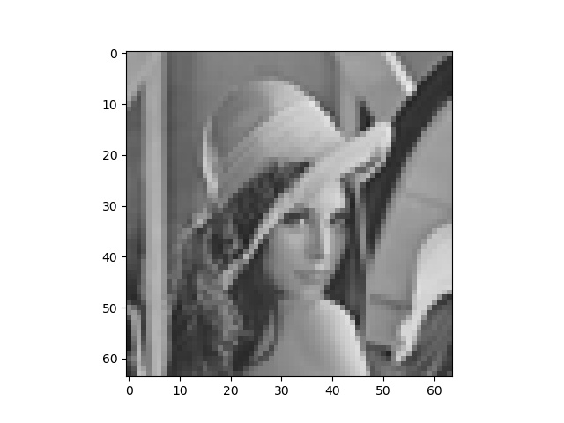

Figure

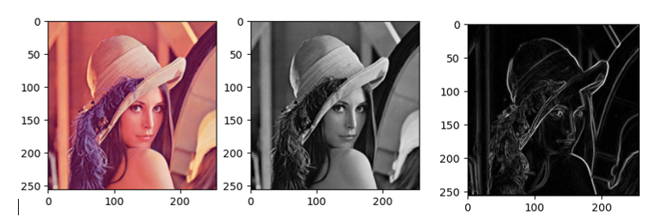

* The above Lenna image is converted into the gray scale image then the gray scale image is converted into Sobel kernel on the “LennaGray.jpg” for edge detection.

Question 2) [Histogram Equalization – 15 pts.] Take the converted gray image “LennaGray.jpg”.

2-1) Perform histogram analysis and visualize histogram distribution.

2-2) Calculate and visualize accumulative histogram distribution.

2-3) Implement a function to perform histogram equalization for this image, visualize your histogram-equalized image and its histogram distribution. Comments the difference between the two images before/after histogram equalization.

2-1)

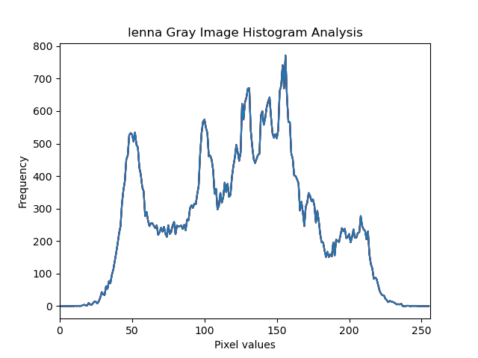

2-2)

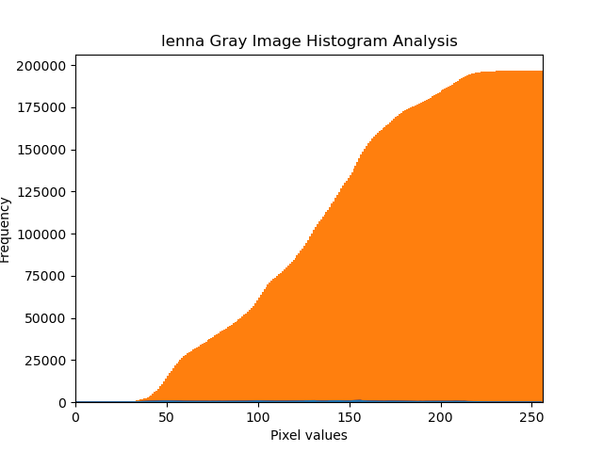

2-3)

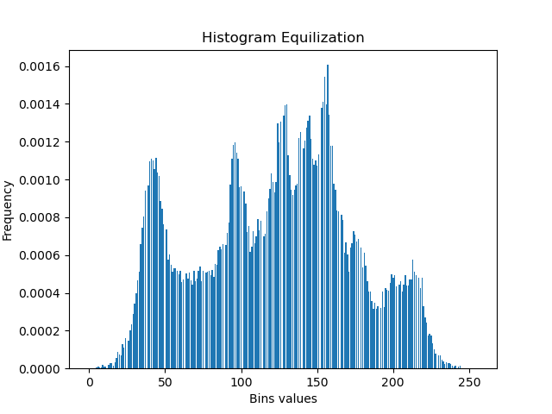

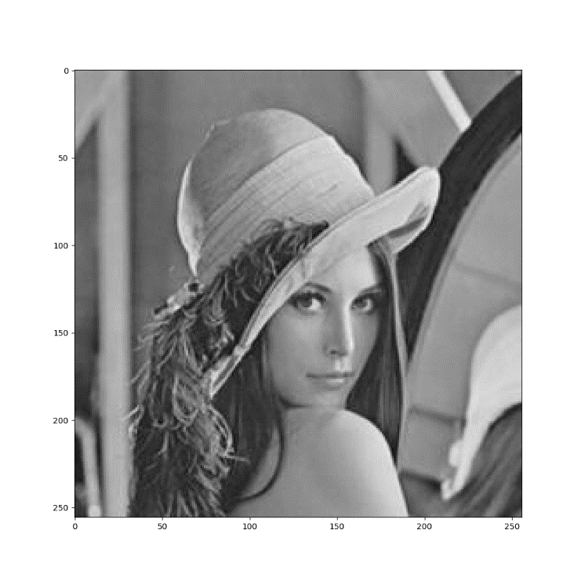

Question 3) [Line Detection – 30 pts] Download the image “ParkingLot.jpg” from the hyperlink. Note: For this question, you are free to use any 3 rd party libraries.

3-1) Apply and visualize histogram analysis, then find a proper threshold to convert the image to a binary image.

3-2) Apply Hough transformation or other line detection approach to detect multiple lines in the image (You select a threshold for the voting matrix). Visualize the lines in the image space (just as: we saw lines there) and in the transformed space (like in Polar space that we introduced in the class) respectively.

3-3) Comment on: will the two lines as two sides of a particular park space be parallel or not, explain why?

3-4) Design and implement the approaches to find all parking space polygons with the four vertex points for each parking space. Describe your approaches and visualize all detected polygons with different colors overlaid on the original image. The TA will check your code.

3-1)

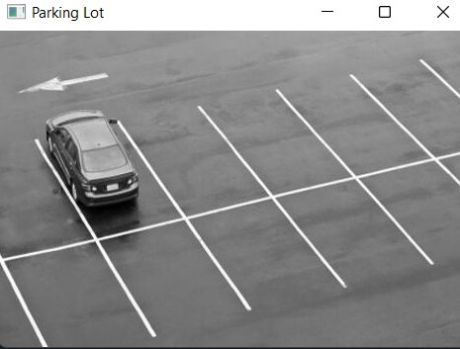

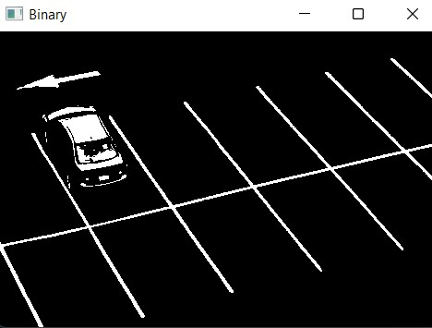

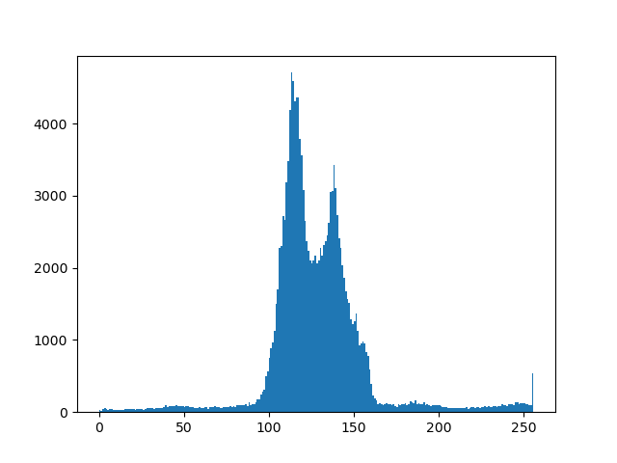

3-2)

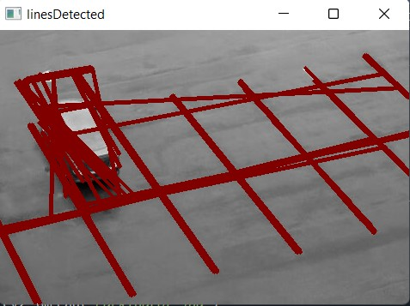

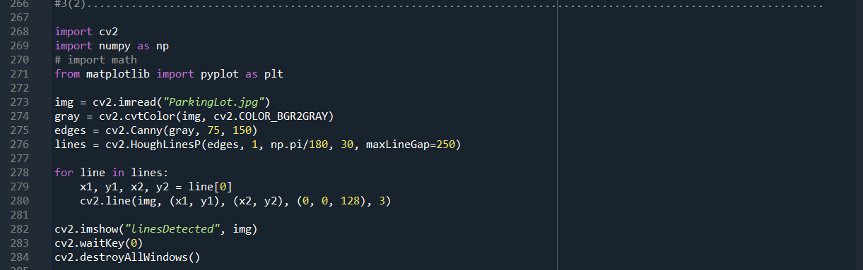

3-3)

* Yes, the two lines of two sides of a particular park space are parallel. The lines present are the limits of the parking space. Basically, the vehicle should be correspondingly parked between the lines so that the vehicle beside will have equal space to park.

3-4)

