A
Project Report
on

DIABETES & HEART DISEASE PREDICTION SYSTEM
Using Machine Learning & Django Web Application

Submitted in partial fulfillment of the requirements for the award of the degree of

Bachelor of Technology
in
Computer Science & Engineering with Data Science
Session 2025–2026 program under the


Maharishi University of Information Technology, Noida

Submitted By:
Name Roll No.
Arpit Kumar 2302050119007
Kanak Sharma 2302050119016
Ravada Siddharth 2302050119063
Under the Guidance of
Dr.Kusum Lata
(Maharishi School of Engineering & Technology)

Maharishi University of Information Technology
Noida – 201304
www.maharishiuniversity.ac.in

2026

CERTIFICATE

Certified that Arpit Kumar (Roll No. - 2302050119007), Kanak Sharma(Roll No.-2302050119016), Ravada Siddharth (Roll No.-2302050119063) has carried out the project work presented in this report entitled “Diabetes & Heart Disease Prediction System ” for the award of Bachelor of Technology in Computer Science & Engineering with Data Science from Maharishi University of Information Technology, Noida under my supervision. The report embodies results of original work, and studies are carried out by the student hisself/herself and the contents of the report do not form the basis for the award of any other degree to the candidate or to anybody else from this or any other University/Institution.

Dr.Kusum Lata Prof (Dr.) Awakash Mishra
(Project Guide) (Dean, SoET)

Date: 20/May/2026

DECLARATION

We, Arpit Kumar, Kanak Sharma ,Ravada Siddharth , hereby declare the work, which is being presented in the project, entitled “Diabetes & Heart Disease Prediction System ” in partial fulfillment of the requirements for the award of the degree of Bachelor of Technology in Computer Science & Engineering with Data Science, is an authentic record of my own work carried out under the supervision of Dr.Kusum Lata.

The matter embodied in this project has not been submitted by me or anybody else for the award of any other degree in any other University/Institution.

Date: 20 /May/2026 Arpit Kumar
Roll No.-2302050119007
Kanak Sharma
Roll No.-2302050119016
Ravada Siddharth
Roll No.-2302050119063

ACKNOWLEDGEMENT

I am grateful to many people who have helped me throughout my B.Tech. First, I would like to thank my supervisor Dr. Kusum Lata (H.O.D/Assistant Professor), and Prof (Dr.) Awakash Mishra Dean (MSoET) for their intimacy and for their great support during all the steps of this report. I would also like to thank my faculty members and my colleagues for their valuable suggestions. Besides my colleagues, I appreciate the care and support of my good friends, who always encouraged me towards this research work.
Last but not the least, if I had the chance to append an acknowledgement for my life, it would give me immense pleasure to express my deep gratitude towards my family Mr. Om Prakash Gupta (father), Smt. Sangeeta Gupta (Mother), younger Sister Ms. Swati Gupta for their existence and being the reason for mine thereupon.

Arpit Kumar
Univ. Roll No.- 2302050119007

TABLE OF CONTENTS

S.No. | Section / Chapter | Page No.
1 | Certificate | i
2 | Declaration | ii
3 | Acknowledgement | iii
4 | List of Figures & Tables | iv
5 | Chapter 1 – Introduction & Objectives | 1–3
6 | Chapter 2 – Literature Survey (Existing System) | 4–6
7 | Chapter 3 – Proposed System | 7–9
8 | Chapter 4 – Feasibility Study | 10–11
9 | Chapter 5 – Software & Hardware Requirements | 12–13
10 | Chapter 6 – System Design (DFD, ER, Database) | 14–19
11 | Chapter 7 – Flowcharts | 20–22
12 | Chapter 8 – Metadata | 23–25
13 | Chapter 9 – Coding & Function Explanation | 26–32
14 | Chapter 10 – ML Model Code | 33–39
15 | Chapter 11 – Testing Strategies | 40–42
16 | Chapter 12 – Deployment | 43–45
17 | Chapter 13 – Snapshots & UI Description | 46–51
18 | Chapter 14 – Conclusion | 52–53
19 | Chapter 15 – Advantages, Limitations & Future Enhancements | 54–56
20 | References / Bibliography | 57

LIST OF FIGURES & TABLES
List of Figures
Figure No. | Caption | Page
Figure 1 | System Architecture Diagram | 8
Figure 2 | Context-Level DFD (Level 0) | 14
Figure 3 | Level 1 DFD | 15
Figure 4 | Level 2 DFD — Diabetes Prediction Module | 16
Figure 5 | Level 2 DFD — Heart Disease Prediction Module | 17
Figure 6 | Entity-Relationship (ER) Diagram | 17
Figure 7 | Database Schema | 18
Figure 8 | Flowchart — Overall Application | 20
Figure 9 | Flowchart — ML Prediction Pipeline | 21
Figure 10 | Boot Screen UI Snapshot | 46
Figure 11 | Diabetes Dashboard Snapshot | 47
Figure 12 | Heart Disease Dashboard Snapshot | 47
Figure 13 | Prediction Form & Result Snapshot | 48-49
Figure 14 | Charts (Radar / Feature Importance / Distribution) | 49
Figure 15 | Day Mode vs Night Mode Snapshot | 50

List of Tables
Table No. | Caption | Page
Table 1.1 | Project Information | 3
Table 2.1 | Literature Survey (Existing System) | 4-5
Table 2.2 | Existing Systems and Limitations | 6
Table 3.1 | Comparison : Existing vs Proposed System | 9
Table 4.1 | Schedule Feasibility | 11
Table 5.1 | Software Requirements | 12
Table 5.2 | Hardware Requirements | 13
Table 6.1 | Entity: Prediction Record | 18
Table 8.1 | Project Metadata | 23
Table 8.2.1 | Pima Indians Diabetes Dataset | 23-24
Table 8.2.2 | Heart Disease Dataset | 24
Table 8.3 | Model Metadata | 25
Table 10.1 | Model Performance Result | 38
Table 10.2 | Top feature importances | 39
Table 11.1 | Functional Test | 41
Table 11.2 | Performance Testing | 42
Table 12.1 | Dependencies | 45
Table | Team Roles & Contributions | 58

Chapter 1
Introduction & Objectives

1.1 General Introduction
In recent years, non-communicable diseases (NCDs) have become one of the most significant global health challenges. Unlike infectious diseases, NCDs do not spread from person to person and generally develop over a long period due to lifestyle habits, environmental conditions, genetic factors, and behavioral patterns. Among all NCDs, diabetes mellitus and cardiovascular diseases are two of the most prevalent and dangerous health conditions affecting populations across the world.
According to global healthcare reports, diabetes currently affects more than 537 million adults worldwide, and the number continues to increase due to sedentary lifestyles, unhealthy eating habits, obesity, and reduced physical activity. Similarly, cardiovascular diseases remain the leading cause of mortality worldwide, accounting for approximately 17.9 million deaths annually. These diseases create not only a health burden but also significant economic and social challenges for individuals and healthcare systems.
One of the major difficulties associated with these diseases is that their symptoms often remain unnoticed during the early stages. Many individuals are diagnosed only after the disease has progressed significantly, reducing the effectiveness of treatment and increasing medical costs. Early detection and preventive healthcare measures therefore play a crucial role in reducing mortality rates and improving patient outcomes.
Traditional diagnosis methods generally involve multiple clinical procedures including laboratory testing, specialist consultation, and various medical examinations. Although these methods provide accurate diagnosis, they are often expensive, time-consuming, and inaccessible in many rural or underdeveloped regions. Limited medical infrastructure and a shortage of healthcare professionals further increase these challenges.
Advancements in Artificial Intelligence (AI) and Machine Learning (ML) have introduced new opportunities in healthcare systems. Machine learning techniques enable computers to identify hidden patterns within medical datasets and make predictions based on previous observations. These technologies can assist healthcare professionals by providing quick preliminary assessments and identifying high-risk individuals before the development of severe symptoms.
Machine learning models have demonstrated promising results in disease prediction systems by analyzing patient health data such as blood glucose levels, body mass index, blood pressure, age, and other medical indicators. Such systems do not replace healthcare professionals but rather function as decision-support tools for early screening and preventive healthcare management.
The Diagnostic Prediction Suite (DPS) is developed as an academic proof-of-concept web application that utilizes machine learning techniques to predict the likelihood of diabetes and cardiovascular disease risk. The system provides users with a simple and interactive platform where health-related information can be entered through a web interface. Based on the supplied input values, pre-trained machine learning models generate predictions and estimate disease risk.
The application has been developed using the Django web framework and implemented using Python programming language libraries. Machine learning functionality is integrated using scikit-learn. The application not only predicts disease probability but also provides supporting information such as confidence scores, risk indicators, feature-level analysis, and graphical visualizations.
Furthermore, DPS includes additional functionalities such as storing prediction records in a SQLite database, maintaining prediction history, and exporting results in PDF format. To improve usability and user experience, the interface follows a retro Apple Macintosh System 8 terminal-inspired design with day and night viewing modes.
The project demonstrates how modern machine learning technologies can be integrated with web applications to create practical healthcare support systems that improve accessibility, efficiency, and early disease risk assessment.

1.2 Problem Statement
Healthcare systems in India and many developing countries face several challenges in providing accessible and affordable diagnostic services to large populations. Early-stage detection of chronic diseases remains difficult due to various factors including lack of awareness, insufficient healthcare facilities, high diagnostic costs, and geographical limitations.
Diabetes and cardiovascular diseases are among the most common chronic illnesses affecting individuals globally. However, a significant number of patients remain undiagnosed during the initial stages because symptoms may not be immediately visible. In many cases, patients seek medical consultation only after complications begin to appear, which often results in more complex treatments and lower recovery rates.
Conventional diagnosis procedures generally require laboratory testing, specialized medical equipment, and expert medical consultation. Such facilities may not always be available in remote or economically weaker regions. Additionally, frequent diagnostic procedures increase both financial burden and time consumption for patients.
There is therefore a growing need for a low-cost, easily accessible, and efficient solution that can assist in early disease risk assessment using basic health measurements. Such a system should be capable of providing rapid predictions while maintaining reasonable accuracy and ease of use.
The Diagnostic Prediction Suite (DPS) aims to address these challenges by developing a machine learning-based web application capable of generating instant disease risk predictions using simple patient information without requiring complex medical infrastructure.

1.3 Objectives
The major objectives of the proposed project are as follows:
- To design and develop a full-stack web application called Diagnostic Prediction Suite (DPS) capable of predicting diabetes and cardiovascular disease risk using machine learning techniques.
- To train and implement separate machine learning classification models:
  - Random Forest Classifier for Diabetes Prediction
  - Random Forest Classifier for Heart Disease Prediction
- To achieve acceptable predictive performance with:
  - Accuracy greater than 80%
  - ROC-AUC score greater than 0.88
- To perform feature engineering techniques that improve model learning capabilities and prediction quality through derived parameters such as:
  - GlucoseAge
  - BMIAge
  - InsulinGlucose
- To address class imbalance within datasets by implementing Synthetic Minority Over-sampling Technique (SMOTE).
- To provide clinically meaningful prediction outputs including:
  - Confidence score
  - Risk classification levels (Low, Moderate, High)
  - Feature-level risk indicators
  - Color-based indicator system
- To implement graphical visualizations for better understanding of prediction outcomes, including:
  - Radar charts
  - Feature importance graphs
  - Distribution plots
- To store prediction records within a SQLite database for maintaining historical information.
- To enable users to export prediction results as professionally formatted PDF reports.
- To develop a clean, user-friendly interface featuring:
- Day and night themes
- Retro terminal-style design
- Responsive user interaction

1.4 Scope of the Project

The scope of DPS is limited to binary risk screening for two diseases: (a) Type 2 Diabetes Mellitus and (b) Cardiovascular (Heart) Disease. The application is intended solely for academic and educational purposes. It is not a clinical diagnostic tool and does not replace medical consultation. The system accepts structured numerical input through a web form and does not process medical images, ECG waveforms, or unstructured clinical notes.

1.5 Project Information
Table 1.1 “Project Information”
Institution | Maharishi University of Information Technology (MUIT), Noida
Programme | B.Tech Computer Science & Engineering with Data Science
Batch | 2023–2027
Semester | 6th Semester
Project Type | Minor Project
Technology Stack | Python 3.10+, Django 5.x, scikit-learn, SQLite, HTML5/CSS3, Chart.js
Repository | https://github.com/Sidvortex/DPS

Chapter 2
Literature Survey (Existing System)

2.1 Overview

This chapter presents a review of existing research studies and systems related to machine learning-based prediction of diabetes and cardiovascular diseases. Numerous researchers have used machine learning techniques to improve disease prediction accuracy and early diagnosis. The literature review focuses on datasets used, algorithms applied, performance metrics obtained, and limitations of existing systems. It also highlights the gap between research models and practical web-based implementations. The findings from previous studies provide the foundation for developing the proposed Diabetes Prediction System (DPS), which combines prediction models with a user-friendly web application.

Table 2.1: Literature Survey (Existing System)
S.No | Author & Year | Technique / Model Used | Problem Solved by Existing Work | Limitations of Existing Work | What Our System Solves
1 | Shin et al. (2022) | Machine Learning algorithms for diabetes prediction | Identified important features from unbalanced diabetes datasets | Limited deployment and visualization support | Provides real-time prediction with visual analysis and web deployment
2 | Wee et al. (2024) | Machine Learning and Deep Learning models | Diabetes detection using intelligent prediction techniques | Focused mainly on comparative analysis | Provides practical implementation with user interaction
3 | Ahmed et al. (2024) | Classification algorithms for diabetes prediction | Improved prediction performance using ML methods | Concentrated mainly on accuracy improvement | Includes complete web-based prediction system
4 | Netayawijit et al. (2025) | SMOTE with SHAP Explainable AI | Improved prediction using balanced datasets and interpretability | Limited web integration and user accessibility | Includes explainable outputs with interactive UI
5 | Rahman et al. (2025) | Feature Selection Algorithms with ML | Improved diabetes prediction using selected features | Did not focus on complete application deployment | Includes feature engineering and deployment
6 | Hasan & Yasmin (2025) | CNN-LSTM Hybrid Model (DNet) | Improved prediction accuracy for diabetes | Computationally expensive and complex | Uses lightweight ML models suitable for deployment
7 | Afolabi et al. (2025) | KNN, Random Forest, Logistic Regression | Diabetes prediction through supervised learning | Limited visualization and database support | Provides result storage and graphical representation
8 | Barman et al. (2025) | Interpretable Machine Learning | Identified diabetes risk factors using explainable AI | Moderate predictive performance | Uses optimized classifiers with improved accuracy
9 | Netayawijit et al. (2025) | Explainable ML Framework | Increased transparency of prediction results | Limited integration into real applications | Offers complete web deployment with PDF reports
10 | Recent Studies (2021–2025) | XGBoost, Gradient Boosting, Ensemble Models | Enhanced disease prediction performance | Mostly research-oriented implementations | Provides full-stack implementation with prediction history and export functionality
Research findings indicate that feature selection, class balancing using SMOTE, and ensemble methods significantly improve predictive performance and model reliability.

Literature 1
Kumari et al. (2021) proposed an ensemble machine learning approach for predicting diabetes mellitus using multiple classification algorithms. The study aimed to improve prediction accuracy by combining different machine learning models rather than relying on a single classifier. The Pima Indians Diabetes dataset was used for experimentation, and the proposed approach achieved improved predictive performance compared to traditional techniques. However, the study mainly focused on algorithm performance and did not include deployment in a practical web-based environment.

Literature 2
Dutta et al. (2022) introduced a weighted ensemble machine learning model for early diabetes prediction. Their system combined classifiers such as Random Forest, Naive Bayes, and Decision Trees to enhance classification performance and improve prediction reliability. The study achieved high prediction accuracy but concentrated mainly on model optimization rather than developing an interactive application for users. The lack of visualization and deployment limited its practical use in healthcare systems.

Literature 3
Abnoosian et al. (2023) proposed a diabetes prediction framework using weighted ensemble techniques and Bayesian optimization for hyperparameter tuning. The study demonstrated that ensemble learning methods can significantly improve prediction performance compared to individual machine learning models. The proposed model achieved high values of accuracy, precision, recall, and AUC scores. However, the work was primarily research-oriented and lacked real-world implementation through a user-friendly application.

Literature 4
Sampath et al. (2024) developed a robust diabetes prediction framework using Synthetic Minority Over-sampling Technique (SMOTE) with ensemble machine learning models. Their methodology included data preprocessing techniques such as missing value handling, outlier treatment, feature selection, and class balancing. Experimental results showed excellent performance with high AUC values. Although the model achieved strong prediction results, the system focused primarily on model performance and did not provide integrated visualization or report generation functionalities.

Literature 5
Hossain et al. (2024) proposed a machine learning-based approach for predicting cardiovascular diseases using Random Forest classification techniques. The study demonstrated that Random Forest algorithms perform effectively for cardiac risk prediction and can support clinical decision-making. The model showed strong predictive performance; however, it focused mainly on classification accuracy and lacked additional functionalities such as historical record maintenance, interactive interfaces, and downloadable reports.

2.2 Existing Systems and Limitations
System / Tool | Features | Limitations
ADA Risk Test (online) | Questionnaire-based diabetes risk score | No ML model; no quantitative lab inputs; no probability output
WHO CVD Risk Calculator | Framingham-based 10-year CVD risk score | Rule-based; not ML; no real-time web integration; no visual output
Various Kaggle Notebooks | ML models for diabetes / heart disease prediction | Standalone notebooks; no web interface; no result persistence; no PDF export
DPS (proposed system) | ML web app with dual disease modules, charts, history, PDF export | Academic prototype; not clinically validated; single-user local deployment
Table 2.2 “Existing Systems and Limitations”

The review establishes that while many individual ML models have been developed for diabetes and heart disease prediction, few have been packaged as accessible, end-to-end web applications with result persistence, visualisation, and export functionality. DPS addresses this gap in an academic context.

Chapter 3
Proposed System

3.1 System Overview
DPS is a web-based, two-module diagnostic prediction system. A user enters patient health parameters into a web form, selects either the Diabetes module or the Heart Disease module, and receives an ML-generated prediction including a confidence percentage, a risk level classification, per-feature indicator dots, and three interactive charts. Results are stored in a SQLite database and may be exported as a PDF report.
The system is structured as a standard Django Model-View-Template (MVT) application. Both ML models are loaded once at server startup via a service module (ml_service.py) and kept in memory for fast inference. No model reload is required between predictions.

3.2 System Architecture
The architecture consists of four main layers:
- Presentation Layer: A single HTML template (index.html) containing the full retro terminal UI, Chart.js visualisation components, jsPDF export logic, and Web Audio API sound effects.
- Application Layer: Django views (views.py) that process form submissions, call ml_service.py, receive prediction results, and return JSON responses for AJAX-based page updates.
- ML Service Layer: ml_service.py loads both trained model bundles (pickle files) at startup and exposes a predict() function that accepts a feature dictionary and returns a probability score, risk level, and feature importance data.
- Data Layer: SQLite database (Django ORM) that stores PredictionRecord objects containing all input features, predicted probability, risk level, disease type, and timestamp.
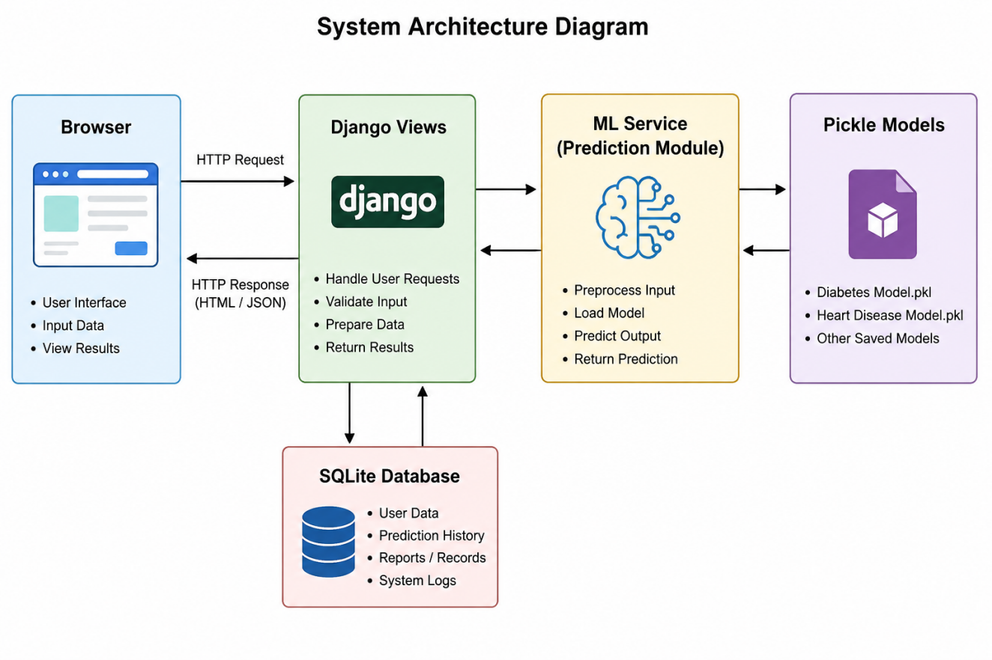
Figure 1: System Architecture Diagram

3.3 Modules

3.3.1 Diabetes Prediction Module
Accepts 8 patient inputs: Pregnancies, Glucose (mg/dL), Blood Pressure (mm Hg), Skin Thickness (mm), Insulin (mu U/ml), BMI (kg/m²), Diabetes Pedigree Function score, and Age. Three engineered features GlucoseAge, BMIAge, and InsulinGlucose are computed server-side before passing the 11-feature vector to the Random Forest Classifier. Missing values (zero inputs for Glucose, BloodPressure, SkinThickness, Insulin, BMI) are replaced with dataset means stored in the model bundle.

3.3.2 Heart Disease Prediction Module
Accepts 13 clinical inputs: Age, Sex, Chest Pain Type, Resting Blood Pressure, Serum Cholesterol, Fasting Blood Sugar, Resting ECG, Maximum Heart Rate, Exercise-induced Angina, ST Depression (Oldpeak), Slope, Number of Major Vessels, and Thalassemia type. These 13 features are passed directly to the Random Forest Classifier.

3.3.3 Prediction Result Display
Results are returned as a JSON object and rendered dynamically in the UI without page reload. The result panel displays: (a) the predicted probability as a percentage, (b) the risk level (Low <30%, Moderate 30–60%, High >60%), (c) per-feature indicator dots using clinical reference thresholds, (d) a radar chart comparing the patient's normalised feature values against the dataset average, (e) a horizontal bar chart showing feature importances, and (f) a histogram of Glucose or cholesterol distribution from the training set with the patient's value marked.

3.3.4 Prediction History
The last 8 predictions across both disease modules are retrieved from the SQLite database and displayed in a history panel in the UI. Each entry shows disease type, date/time, probability, and risk level.
3.3.5 PDF Export
A client-side jsPDF script generates a branded A4 PDF report from the current prediction result, including the confidence bar, feature importance chart, and a medical disclaimer.

3.4 Comparison: Existing vs Proposed System
Table 3.1:- “Comparison : Existing vs Proposed System”
Existing System | Proposed System (DPS)
No web-accessible ML prediction tool for dual diseases | Web-accessible, dual-disease ML prediction in a single interface
Results not persisted or exportable | Predictions stored in database; PDF export available
No visual explanation of predictions | Radar chart, feature importance, distribution histogram, indicator dots
Class-imbalanced training data | SMOTE-balanced datasets with 1000 samples per class
No feature engineering | Three engineered compound features for diabetes module

Chapter 4
Feasibility Study

4.1 Technical Feasibility
The project utilises well-established, open-source technologies: Python, Django, scikit-learn, and SQLite. All dependencies are freely available via pip. The development environment requires only a standard personal computer running Python 3.10 or above. No proprietary software licences or specialised hardware are required. The team members have prior experience with Python and web development, making the technical implementation achievable within the project timeline.
scikit-learn provides production-ready implementations of Random Forest classifiers, including SMOTE support via the imbalanced-learn library. Django provides a robust ORM, form handling, URL routing, and template engine sufficient for the requirements of this application.

4.2 Economic Feasibility
The project has zero direct cost. All software frameworks and libraries used are open-source. The application is deployed locally using Django's built-in development server, requiring no cloud hosting costs. Dataset acquisition was also cost-free: the Pima Indians Diabetes Dataset is publicly available from the UCI Machine Learning Repository, and the heart disease dataset was generated synthetically using published statistical distributions, requiring no commercial data purchase.

4.3 Operational Feasibility
The system is operated through a standard web browser. The user interface presents a familiar form-based input paradigm with dropdown menus for categorical variables and numeric inputs for continuous variables. Result display is immediate (sub-second inference latency). No specialist technical knowledge is required to operate the system. The prediction history and PDF export features reduce the need for manual record-keeping.

4.4 Schedule Feasibility
Table 4.1 :- “Schedule Feasibility”
Phase | Activity | Duration
1 | Topic selection, literature review, dataset identification | 2 weeks
2 | Dataset preprocessing, feature engineering, SMOTE augmentation | 2 weeks
3 | ML model training, evaluation, hyperparameter tuning, pickle export | 2 weeks
4 | Django project setup, URL routing, ORM models, forms | 1 week
5 | Frontend UI development (HTML, CSS, Chart.js, jsPDF) | 3 weeks
6 | Integration, testing, bug fixing | 1 week
7 | Report writing, documentation | 1 week

Total estimated duration: approximately 12 weeks (3 months), which falls within the allocated semester timeline.

4.5 Legal and Ethical Feasibility
All datasets used are either publicly available under open-access licences (UCI ML Repository) or synthetically generated by the project team using published statistical parameters from open-access academic literature. No patient-identifiable data has been collected or processed. The application includes a disclaimer on every prediction result page stating that the output is not a clinical diagnosis. The project complies with the academic integrity policy of MUIT.

Chapter 5
Software & Hardware Requirements
Software requirements refer to the collection of programming languages, frameworks, libraries, development tools, and supporting technologies necessary for designing, developing, deploying, and executing the proposed system successfully. The Diagnostic Prediction Suite (DPS) requires various software components to implement machine learning models, handle data processing tasks, manage databases, and provide an interactive user interface.
The system has been developed primarily using the Python programming language because of its simplicity, extensive library support, and suitability for machine learning applications. Django is used as the web framework to manage backend operations and create a secure and scalable web environment. Machine learning functionalities are implemented using scikit-learn, while data preprocessing and manipulation are handled through Pandas and NumPy libraries. Additional tools such as Chart.js and jsPDF are integrated for visualization and report generation purposes. Version control is maintained using Git and GitHub to ensure effective code management and collaboration during development.
The software requirements used for the development of the proposed system are shown in Table 5.1.

5.1 Software Requirements
Table 5.1 :- “Software Requirements”
Category | Technology / Tool | Version / Details
Programming Language | Python | 3.10 or above
Web Framework | Django | 5.x
ML Library | scikit-learn | 1.x
Class Balancing | imbalanced-learn (SMOTE) | 0.11.x
Data Processing | pandas, NumPy | Latest stable
Database | SQLite 3 (via Django ORM) | Built-in with Python
Frontend Charts | Chart.js | 4.4.0 (CDN)
PDF Generation | jsPDF | 2.5.1 (CDN)
Fonts | IBM Plex Mono, VT323 | Google Fonts (CDN)
Browser (Client) | Google Chrome / Firefox | Latest version
Development IDE | VS Code / PyCharm | Any version
Version Control | Git + GitHub | github.com/Sidvortex/DPS
OS (Development) | Windows 10/11 or Linux | Any 64-bit OS

5.2 Hardware Requirements
Hardware requirements specify the physical components and system resources needed for the effective development and execution of the proposed system. Appropriate hardware resources ensure smooth functioning of the web application, efficient processing of machine learning algorithms, database operations, and overall system performance.
The Diagnostic Prediction Suite (DPS) does not require highly specialized hardware because the machine learning models used in the system are lightweight and optimized for general-purpose computing environments. The application can operate efficiently on standard personal computers and laptops commonly used by students and developers. However, systems with higher processing power and memory capacity can improve application performance, reduce processing time, and provide a better user experience during development and execution.
The minimum and recommended hardware specifications required for the proposed system are presented in Table 5.2.

Table 5.2 :- “Hardware Requirements”
Component | Minimum | Recommended
Processor | Intel Core i3 / AMD Ryzen 3 | Intel Core i5 / AMD Ryzen 5
RAM | 4 GB | 8 GB or above
Storage | 10 GB free space | 20 GB free space
Display | 1024 × 768 resolution | 1920 × 1080 resolution
Internet Connection | Required for CDN resources | Broadband
Input Devices | Keyboard, Mouse | Keyboard, Mouse

Chapter 6
System Design (DFD, ER Diagram, Database Design)

6.1 Data Flow Diagram (DFD)

6.1.1 Level 0 DFD — Context Diagram
The context-level DFD treats the entire DPS application as a single process. Two external entities interact with the system:
- User (Patient / Practitioner): Provides health parameter inputs and receives prediction results and historical records.
- Database (SQLite): Stores and retrieves prediction records.
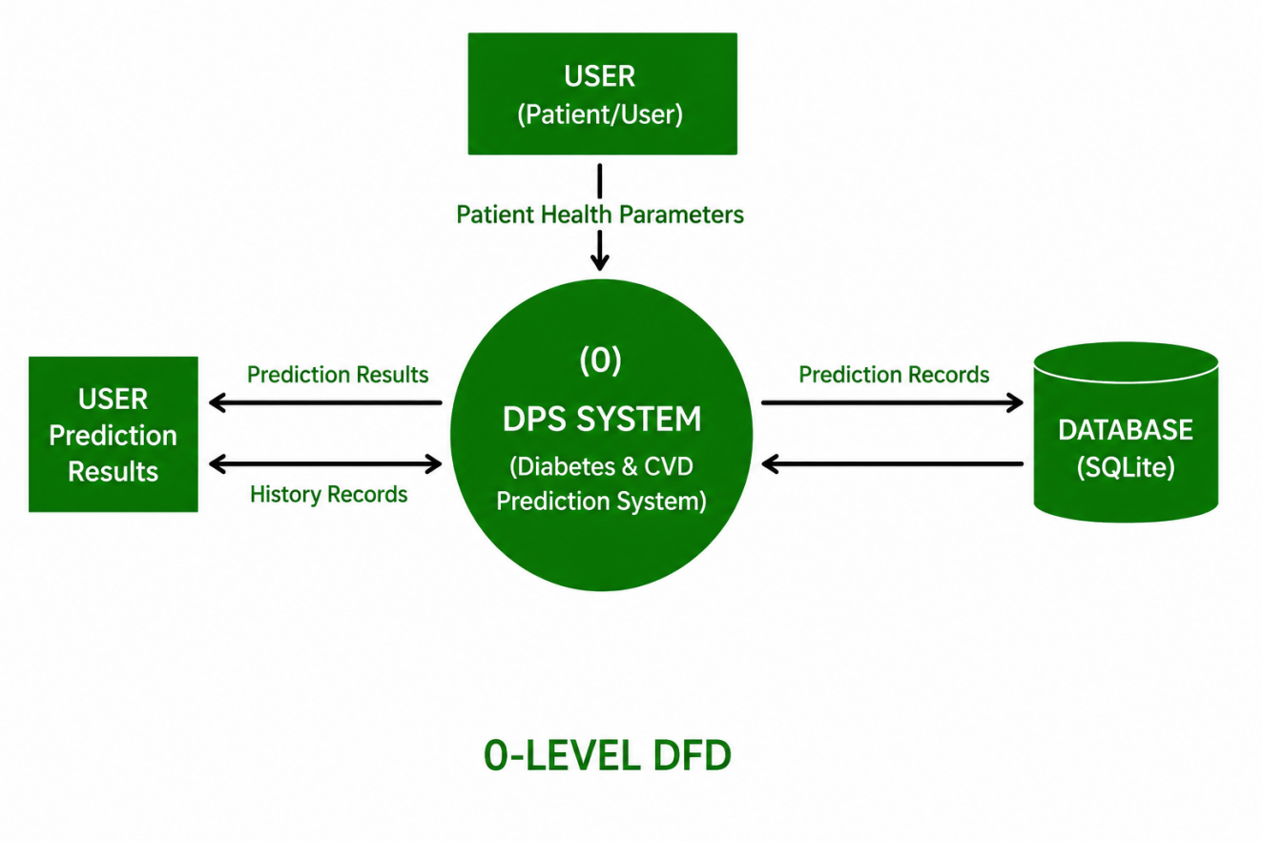Figure 2: Level 0 DFD
Description of the context diagram: The User sends Patient Health Parameters to the DPS System. The DPS System returns Prediction Results (probability, risk level, charts, indicators) to the User. The DPS System writes Prediction Records to the Database and reads History Records from the Database.

6.1.2 Level 1 DFD

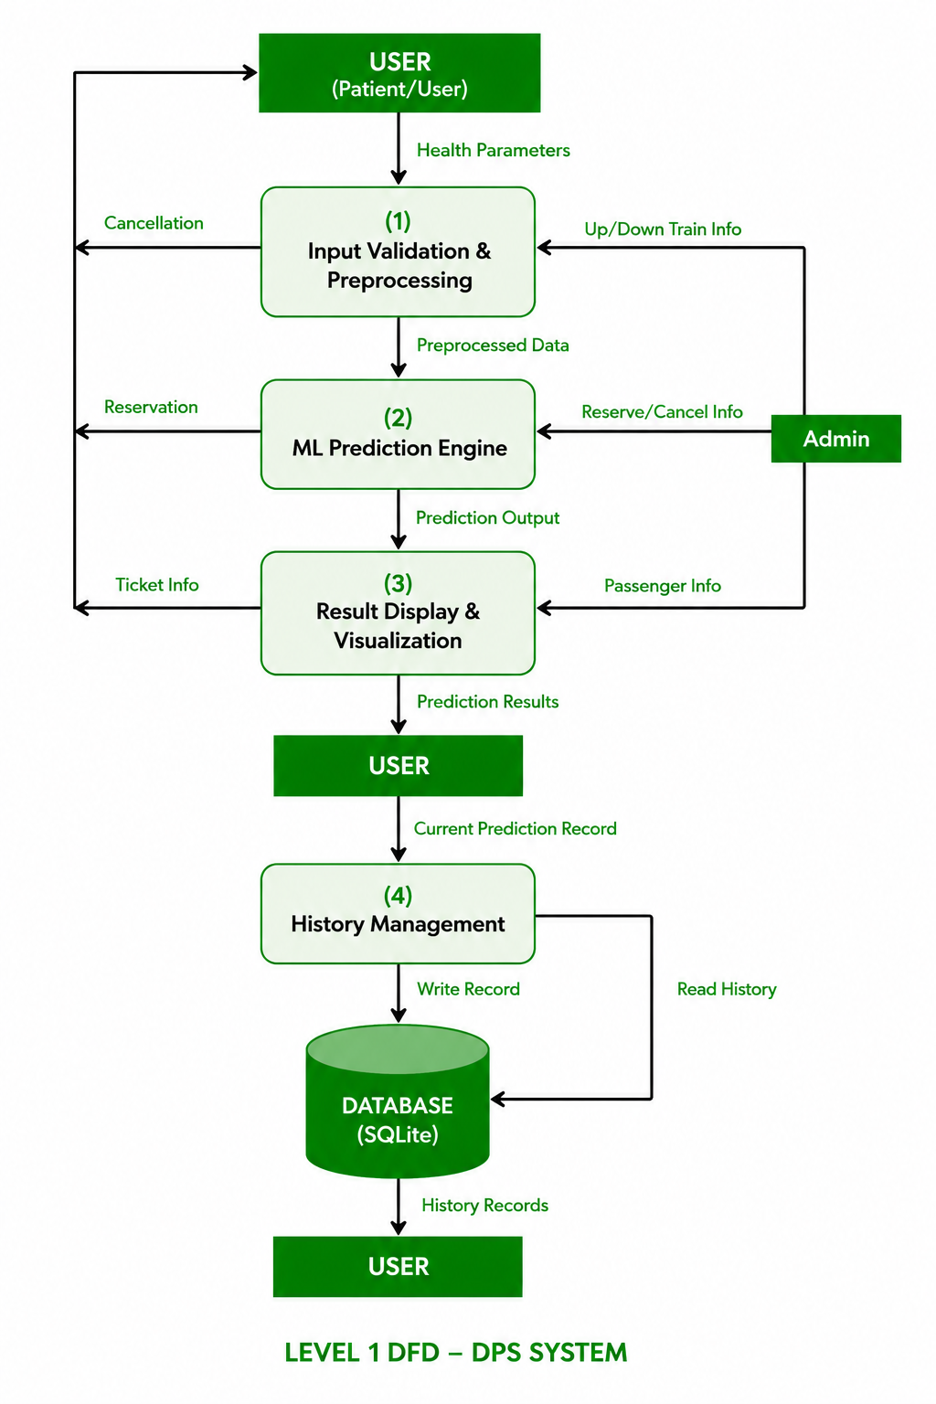
Figure 3: Level 1 DFD
At Level 1, the DPS System is decomposed into four sub-processes:
- Input Validation & Preprocessing: Receives raw form data from the User. Validates field types and ranges. Replaces zero values with dataset means (for diabetes features). Computes engineered features (GlucoseAge, BMIAge, InsulinGlucose).
- ML Prediction Engine: Receives the preprocessed feature vector. Applies the StandardScaler and calls the appropriate classifier (Random Forest for diabetes; Random Forest for heart disease). Returns prediction probability, risk level, and feature importance array.
- Result Display & Visualisation: Receives prediction output. Constructs chart data (radar, feature importance bar, distribution histogram). Sends JSON response to the browser for dynamic UI rendering.
- History Management: Writes the current prediction record to SQLite. Reads the last 8 records for display in the history panel.
6.1.3 Level 2 DFD — Diabetes Prediction Sub-process
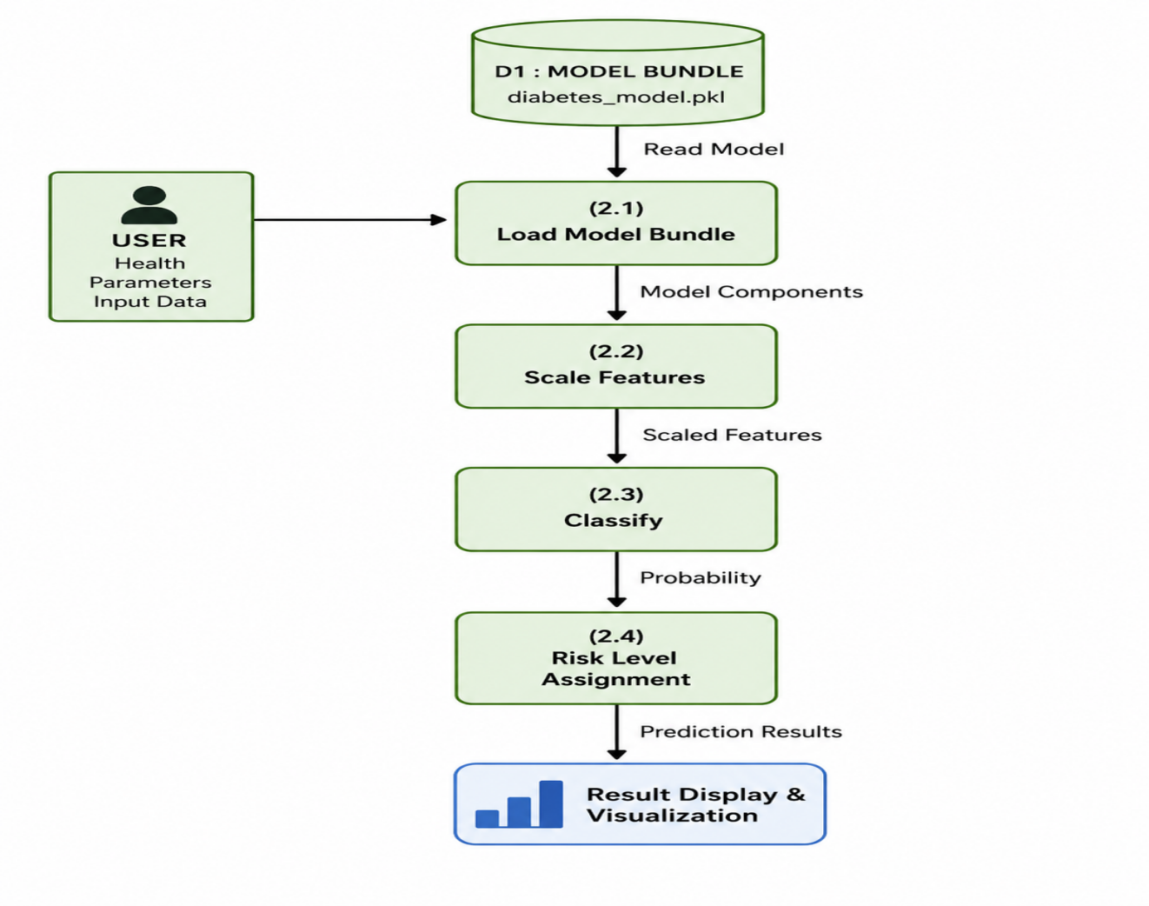

Figure 4: Level 2 DFD — Diabetes Module
The Diabetes Prediction sub-process (Process 2 from Level 1) is decomposed as follows: (a) Load Model Bundle reads diabetes_model_bundle.pkl from disk at startup, providing the Scaler, RandomForestClassifier, feature names, zero-replacement means, and feature importances. (b) Scale Features applies StandardScaler.transform() to the 11-feature input vector. (c) Classify calls classifier.predict_proba() and returns [P(Non-Diabetic), P(Diabetic)]. (d) Risk Level Assignment maps the probability to Low (<0.30), Moderate (0.30–0.60), or High (>0.60).

6.1.4 Level 2 DFD — Heart Disease Prediction Sub-process

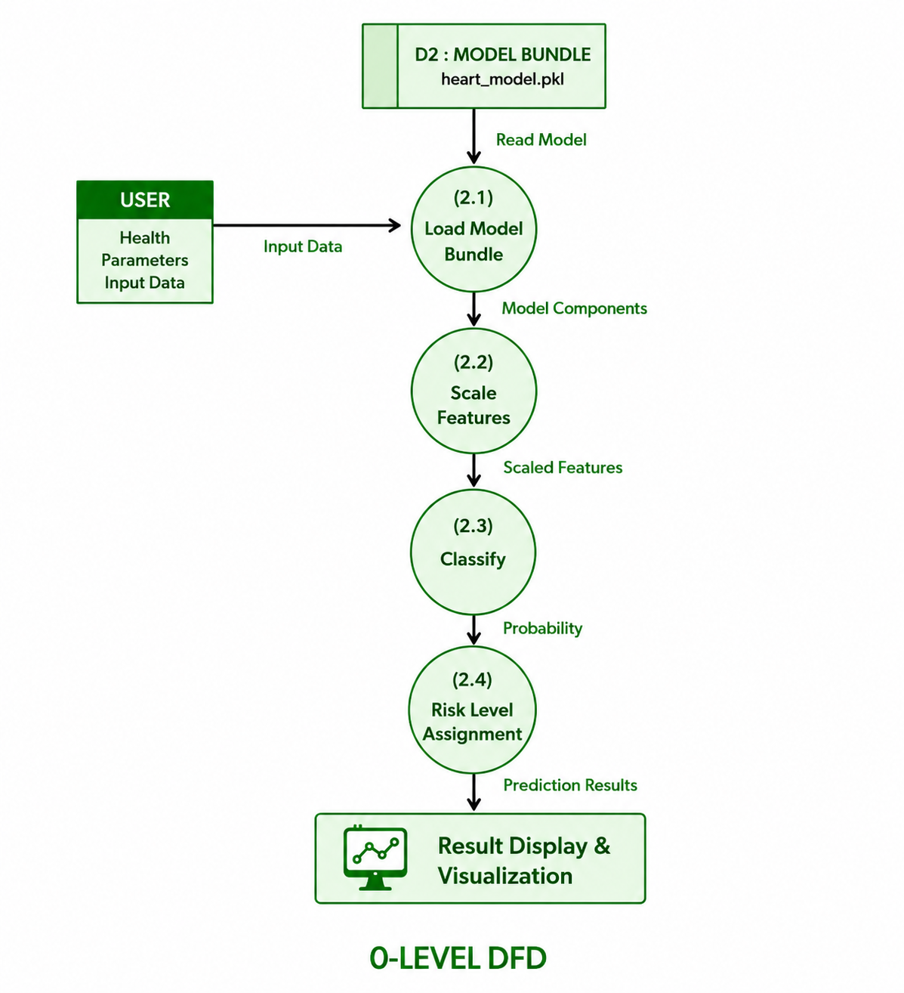
Figure 5: Level 2 DFD — Heart Disease Module
The Heart Disease Prediction sub-process follows the same pattern with heart_model_bundle.pkl, a 13-feature input vector, and the RandomForestClassifier.

6.2 Entity-Relationship (ER) Diagram
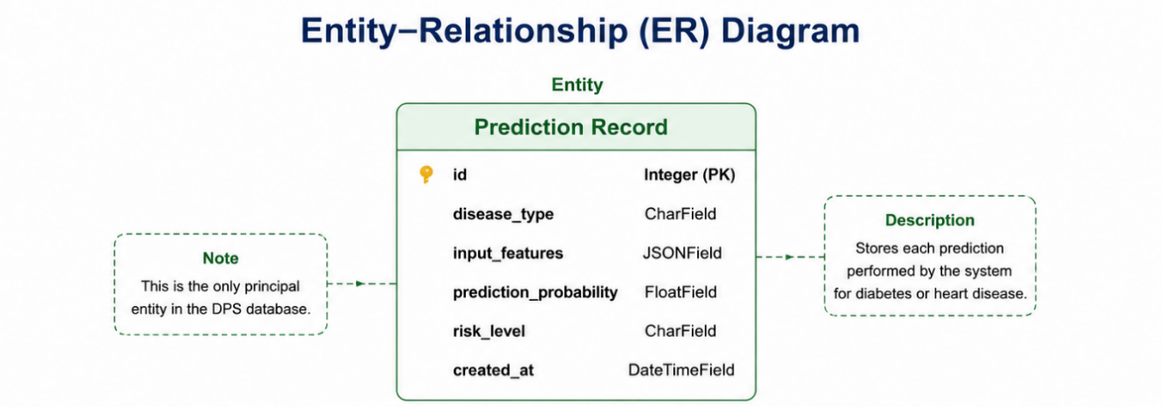
Figure 6: ER Diagram
The DPS database contains a single principal entity: Prediction Record. Its attributes and relationships are described below.

Table 6.1:- “Entity: Prediction Record”
Attribute | Type | Description
id | Integer (PK) | Auto-incremented primary key
disease_type | CharField | 'diabetes' or 'heart'
input_features | JSONField | All input parameters as a JSON object
prediction_probability | FloatField | Predicted probability (0.0 to 1.0)
risk_level | CharField | 'Low', 'Moderate', or 'High'
created_at | DateTimeField | Auto-set timestamp of prediction

6.3 Database Design

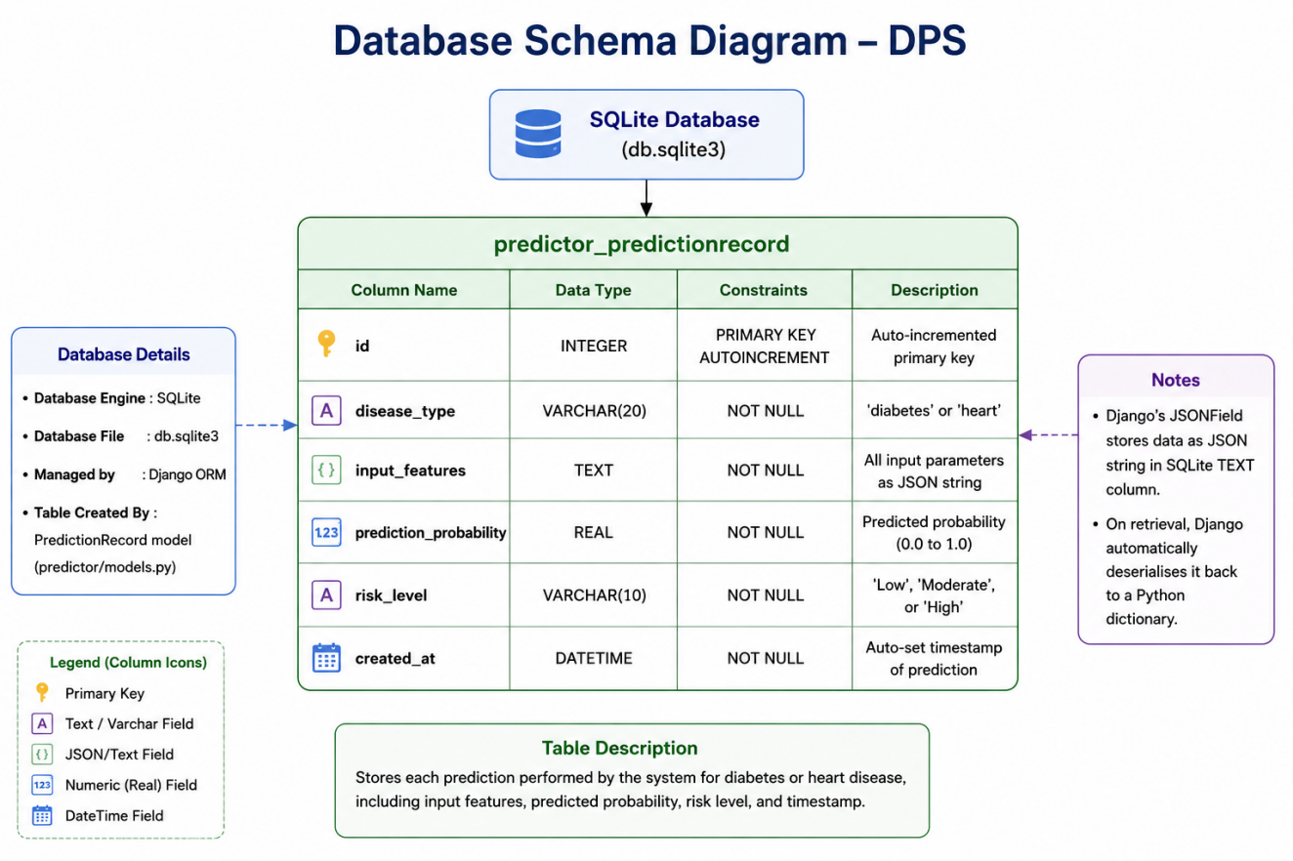
Figure 7: Database Schema Diagram
DPS uses Django's built-in SQLite integration via the ORM. The database is stored as db.sqlite3 in the project root. At initialisation, python manage.py migrate creates all required tables from Django model definitions. The predictor_predictionrecord table is created by the PredictionRecord model in predictor/models.py.
The full SQL schema generated by Django migrations is equivalent to:
CREATE TABLE predictor_predictionrecord (
id INTEGER NOT NULL PRIMARY KEY AUTOINCREMENT,
disease_type VARCHAR(20) NOT NULL,
input_features TEXT NOT NULL,
prediction_probability REAL NOT NULL,
risk_level VARCHAR(10) NOT NULL,
created_at DATETIME NOT NULL
);

Django's JSONField serialises the input_features dictionary to a JSON string for storage in SQLite's TEXT column type. On retrieval, Django automatically deserialises it back to a Python dictionary.
Chapter 7
Flowcharts

7.1 Overall Application Flowchart
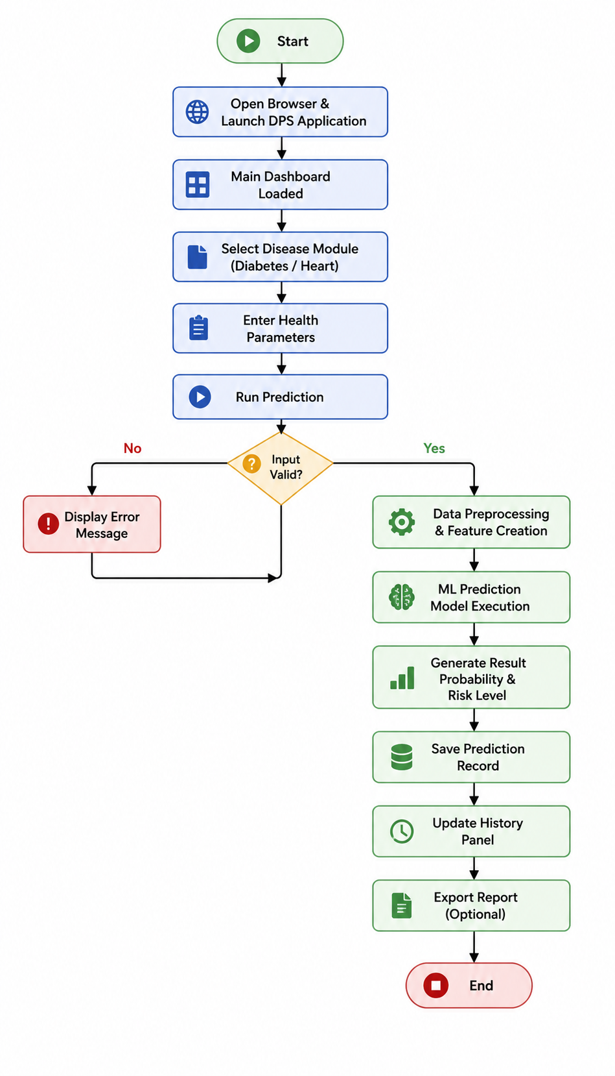
Figure 8: Overall Application Flowchart
The system workflow begins when the user opens a web browser and navigates to http://127.0.0.1:8000/, where a boot screen with a morphing DPS animation is displayed. After clicking the Enter button, the main dashboard is loaded. The user then selects a disease prediction module, such as Diabetes or Heart Disease, and fills in the required health parameter form. Once the user activates the Run Prediction option through a lever switch or button, an AJAX POST request is sent to the Django view for processing. The system validates the entered input data; if the input is invalid, an error message is displayed on the form. If the input is valid, preprocessing and feature engineering techniques are applied to the data before passing it to the machine learning model for inference using predict_proba. The prediction result is then returned to the browser in JSON format, and the user interface displays the probability score, risk level, indicator dots, and three visualization charts. Simultaneously, the prediction record is saved into the SQLite database, and the history panel is updated. Finally, the user has the option to export the prediction report as a PDF, after which the process ends..

7.2 ML Prediction Pipeline Flowchart
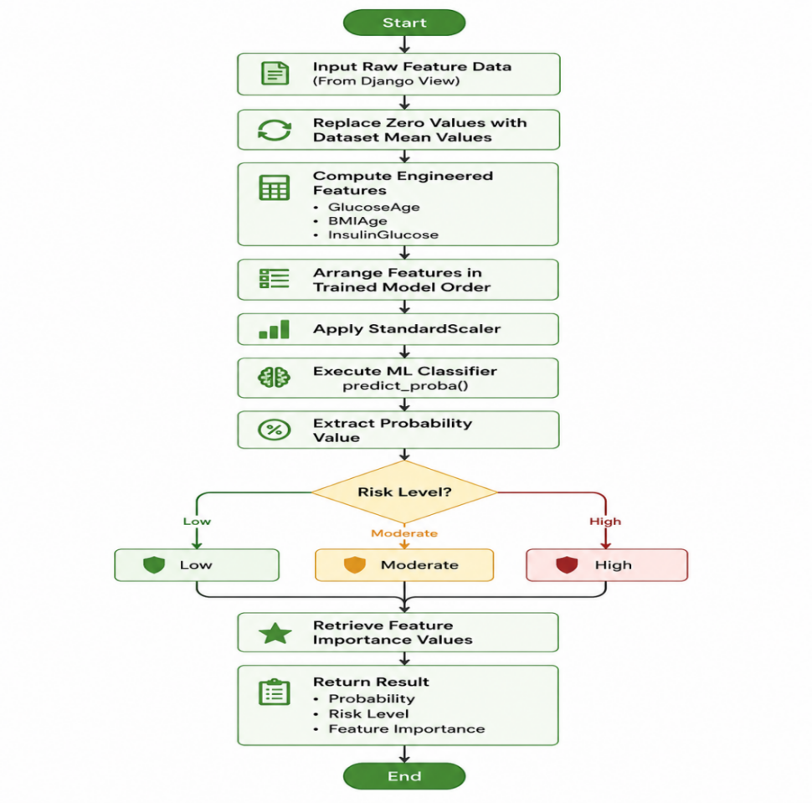

Figure 9: ML Prediction Pipeline Flowchart
The process begins with receiving a raw feature dictionary from the Django view. For the diabetes module, any zero values in the input data are replaced with the corresponding stored dataset mean values to handle missing or invalid entries. Next, engineered features are computed to improve model performance, including GlucoseAge = Glucose × Age / 1000, BMIAge = BMI × Age / 1000, and InsulinGlucose = Insulin / (Glucose + 1), which are specifically applied in the diabetes module. After feature engineering, all input and generated features are arranged into a feature array according to the same order used during model training. The StandardScaler.transform() function is then applied to normalize the feature values. The scaled feature array is passed to the machine learning classifier using the predict_proba() method to generate probability scores. The probability of the positive class, P(positive class), is extracted from the prediction output. Based on this probability value, a risk level is assigned: Low Risk if P < 0.30, Moderate Risk if 0.30 ≤ P ≤ 0.60, and High Risk if P > 0.60. The system then retrieves the stored feature_importances_ array to provide interpretability information. Finally, the system returns the output containing the probability score, risk level, feature importances, and input features, after which the process ends.

Chapter 8
Metadata

Table 8.1 Project Metadata
Project Name | DPS Diagnostic Prediction Suite
Version | 3.1 (final)
GitHub Repository | https://github.com/Sidvortex/DPS
Primary Language | Python 3.10+
Secondary Language | HTML5 / CSS3 / JavaScript
Framework | Django 5.x
Database | SQLite 3
ML Libraries | scikit-learn 1.x, imbalanced-learn
Lines of Code (approx.) | Python: ~600 | HTML/CSS/JS: ~2800
Language Split (GitHub) | HTML: 73.8%, Python: 26.2%
Repository Commits | 20 commits
Releases | 5 releases (v1.0 – v3.1)
Licence | Academic (not for commercial use)

8.2 Dataset Metadata

Table 8.2.1 Pima Indians Diabetes Dataset
Source | UCI Machine Learning Repository
Original Collector | National Institute of Diabetes and Digestive and Kidney Diseases (NIDDK), USA
Original Records | 768 patients (Pima Indian women aged 21+)
Records After Augmentation | 2000 (1000 diabetic / 1000 non-diabetic via SMOTE)
Target Variable | Outcome — 0 = Not Diabetic, 1 = Diabetic
Feature Count (original) | 8
Feature Count (after engineering) | 11
Class Distribution (original) | 500 non-diabetic / 268 diabetic (imbalanced)
Class Distribution (after SMOTE) | 1000 non-diabetic / 1000 diabetic (balanced)
Zero-value Features (missing) | Glucose, BloodPressure, SkinThickness, Insulin, BMI
Preprocessing Applied | Zero → column mean replacement; SMOTE; 2.5% Gaussian noise on SMOTE samples

8.2.2 Heart Disease Dataset
Table 8.2.2 Heart Disease Dataset
Source | Synthetically generated
Statistical Basis | Framingham Heart Study (NHLBI) + Cleveland Heart Disease Dataset (UCI)
Clinical Basis | AHA/ACC Cardiovascular Risk Guidelines 2019
Generated Records (raw) | 2400
Records After Balancing | 2000 (1000 disease / 1000 healthy)
Target Variable | target 0 = No Disease, 1 = Heart Disease
Feature Count | 13
Generation Method | Statistically realistic simulation using published feature distributions and logistic regression coefficients

8.3 Model Metadata
Table 8.3 :- “Model Metadata”
Parameter | Diabetes Model | Heart Disease Model
Algorithm | Random Forest Classifier | Random Forest Classifier
Test Accuracy | 84.50% | 82.25%
ROC-AUC | 0.8923 | 0.9007
Training Records | 2000 | 2000
Test Split | 20% stratified | 20% stratified
n_estimators | 300 | 300
max_depth | 12 | 12
learning_rate | N/A | N/A
subsample | N/A | N/A
min_samples_leaf | 2 | 2
class_weight | balanced | balanced
Serialisation | pickle (.pkl bundle) | pickle (.pkl bundle)

Chapter 9
Coding & Function Explanation

9.1 Project File Structure
DPS/
├── diabetes_project/
│ ├── settings.py ← Django project settings
│ ├── urls.py ← Root URL configuration
│ ├── diabetes.csv ← Pima Indians Diabetes Dataset
│ ├── heart_disease.csv ← Synthetic cardiovascular dataset
│ ├── diabetes_model_bundle.pkl ← Trained diabetes model + metadata
│ └── heart_model_bundle.pkl ← Trained heart disease model + metadata
├── predictor/
│ ├── ml_service.py ← Both models loaded once at startup
│ ├── views.py ← Handles both disease predictions
│ ├── models.py ← PredictionRecord DB model
│ ├── forms.py ← DiabetesForm + HeartDiseaseForm
│ ├── urls.py ← App-level URL patterns
│ ├── migrations/ ← Database migration files
│ └── templates/
│ └── index.html ← Full retro terminal UI
├── screenshots/ ← UI screenshots
├── manage.py
└── db.sqlite3

9.2 models.py — Database Model
The PredictionRecord model defines the database schema for storing all prediction results. Django's ORM translates this model class into a SQL table on the first migration.
# predictor/models.py
from django.db import models

class PredictionRecord(models.Model):
DISEASE_CHOICES = [
('diabetes', 'Diabetes'),
('heart', 'Heart Disease'),
]
RISK_CHOICES = [
('Low', 'Low'),
('Moderate', 'Moderate'),
('High', 'High'),
]

disease_type = models.CharField(max_length=20, choices=DISEASE_CHOICES)
input_features = models.JSONField()
prediction_probability = models.FloatField()
risk_level = models.CharField(max_length=10, choices=RISK_CHOICES)
created_at = models.DateTimeField(auto_now_add=True)

class Meta:
ordering = ['-created_at']

def __str__(self):
return (f"{self.disease_type} | {self.risk_level} | "
f"{self.prediction_probability:.1%} | {self.created_at:%Y-%m-%d %H:%M}")
Key points: JSONField stores all input parameters as a Python dictionary serialised to JSON. auto_now_add=True automatically records the timestamp when the record is first saved. The Meta ordering ensures the most recent prediction appears first in all queries.

9.3 forms.py (Input Forms)
Two Django ModelForm-derived classes define the input fields and validation logic for each disease module. Below is the DiabetesForm; HeartDiseaseForm follows an identical pattern with 13 fields corresponding to the cardiovascular dataset features.

# predictor/forms.py
from django import forms

class DiabetesForm(forms.Form):
pregnancies = forms.IntegerField(
min_value=0, max_value=20,
widget=forms.NumberInput(attrs={'placeholder': '0-20'})
)
glucose = forms.FloatField(
min_value=0, max_value=300,
widget=forms.NumberInput(attrs={'placeholder': 'mg/dL'})
)
blood_pressure = forms.FloatField(
min_value=0, max_value=200,
widget=forms.NumberInput(attrs={'placeholder': 'mm Hg'})
)
skin_thickness = forms.FloatField(
min_value=0, max_value=100,
widget=forms.NumberInput(attrs={'placeholder': 'mm'})
)
insulin = forms.FloatField(
min_value=0, max_value=900,
widget=forms.NumberInput(attrs={'placeholder': 'mu U/ml'})
)
bmi = forms.FloatField(
min_value=0, max_value=70,
widget=forms.NumberInput(attrs={'placeholder': 'kg/m²'})
)
diabetes_pedigree = forms.FloatField(
min_value=0, max_value=3,
widget=forms.NumberInput(attrs={'placeholder': '0.0 - 3.0'})
)
age = forms.IntegerField(
min_value=1, max_value=120,
widget=forms.NumberInput(attrs={'placeholder': 'years'})
)
Django forms provide automatic type coercion, range validation, and CSRF protection. Each field's widget specifies the placeholder text shown in the UI.

9.4 ml_service.py (Machine Learning Service)
This module loads both trained model bundles once at Django application startup and exposes a single predict() function consumed by views.py. Loading at startup (rather than per-request) avoids the I/O overhead of deserialising the pickle files on each prediction.

# predictor/ml_service.py
import pickle, os, numpy as np
from django.conf import settings

# ── Load both model bundles at import time ──
_BASE = os.path.join(settings.BASE_DIR, 'diabetes_project')

with open(os.path.join(_BASE, 'diabetes_model_bundle.pkl'), 'rb') as f:
DIABETES_BUNDLE = pickle.load(f)

with open(os.path.join(_BASE, 'heart_model_bundle.pkl'), 'rb') as f:
HEART_BUNDLE = pickle.load(f)

def predict(disease_type: str, raw_features: dict) -> dict:
"""
Parameters:
disease_type : 'diabetes' or 'heart'
raw_features : dict of {feature_name: value} from the web form
Returns:
dict with keys: probability, risk_level,
feature_importances, input_features
"""
bundle = DIABETES_BUNDLE if disease_type == 'diabetes' else HEART_BUNDLE
clf = bundle['model']
scaler = bundle['scaler']
feature_names = bundle['feature_names']
zero_means = bundle.get('zero_means', {})
importances = bundle['feature_importances']

# ── 1. Zero-value replacement (diabetes only) ──
if disease_type == 'diabetes':
for feat in ['glucose','blood_pressure','skin_thickness','insulin','bmi']:
if raw_features.get(feat, 1) == 0:
raw_features[feat] = zero_means.get(feat, 0)

# ── 2. Feature engineering (diabetes only) ──
if disease_type == 'diabetes':
g = raw_features['glucose']
a = raw_features['age']
b = raw_features['bmi']
i = raw_features['insulin']
raw_features['glucose_age'] = g * a / 1000
raw_features['bmi_age'] = b * a / 1000
raw_features['insulin_glucose'] = i / (g + 1)

# ── 3. Assemble feature array in training order ──
x = np.array([[raw_features[f] for f in feature_names]])

# ── 4. Scale ──
x_scaled = scaler.transform(x)

# ── 5. Predict probability ──
prob = float(clf.predict_proba(x_scaled)[0][1])

# ── 6. Risk level ──
if prob < 0.30:
risk = 'Low'
elif prob <= 0.60:
risk = 'Moderate'
else:
risk = 'High'

return {
'probability': round(prob * 100, 2),
'risk_level': risk,
'feature_importances': dict(zip(feature_names, importances)),
'input_features': raw_features,
}
The bundle dictionary stored in each pickle file contains: 'model' (the trained classifier), 'scaler' (fitted StandardScaler), 'feature_names' (list defining the correct array column order), 'zero_means' (dictionary of column means for missing value replacement), and 'feature_importances' (array of importance scores indexed to feature_names).

9.5 views.py (Request Handling)
The main Django view handles both GET (initial page load) and POST (prediction submission) requests. AJAX-based POST requests return JSON responses that are consumed by the frontend JavaScript to update the result panel without a full page reload.
# predictor/views.py
from django.shortcuts import render
from django.http import JsonResponse
from django.views.decorators.http import require_http_methods
from .forms import DiabetesForm, HeartDiseaseForm
from .models import PredictionRecord
from . import ml_service

@require_http_methods(['GET', 'POST'])
def index(request):
if request.method == 'GET':
history = PredictionRecord.objects.all()[:8]
return render(request, 'index.html', {
'diabetes_form': DiabetesForm(),
'heart_form': HeartDiseaseForm(),
'history': history,
})

# ── POST: AJAX prediction request ──
disease = request.POST.get('disease_type', 'diabetes')
form = DiabetesForm(request.POST) if disease == 'diabetes' \
else HeartDiseaseForm(request.POST)

if not form.is_valid():
return JsonResponse({'error': form.errors}, status=400)

raw = form.cleaned_data
result = ml_service.predict(disease, dict(raw))

PredictionRecord.objects.create(
disease_type = disease,
input_features = result['input_features'],
prediction_probability = result['probability'] / 100,
risk_level = result['risk_level'],
)

result['history'] = list(
PredictionRecord.objects.values(
'disease_type','prediction_probability',
'risk_level','created_at'
)[:8]
)
return JsonResponse(result)
The view uses Django's built-in form validation (form.is_valid()) which checks field types, min/max constraints, and CSRF token validity before any ML inference is performed. Errors are returned as a 400-status JSON response, which the frontend JavaScript handles by highlighting the offending fields.

Chapter 10
ML Model Code

10.1 Overview of the Training Pipeline
Both ML models were trained in standalone Python scripts that are separate from the Django application. Each script reads the CSV dataset, performs preprocessing, trains the classifier, evaluates performance on a held-out test set, and saves the complete model bundle as a pickle file. The pickle bundle is the only artifact consumed by the Django application at runtime.

10.2 Diabetes Model Training Script
# diabetes_model_training.py
# ──────────────────────────────────────────────────────────
# Trains a Random Forest Classifier on the augmented
# Pima Indians Diabetes Dataset.
# Output: diabetes_model_bundle.pkl
# ──────────────────────────────────────────────────────────

import pandas as pd
import numpy as np
import pickle
from sklearn.model_selection import train_test_split
from sklearn.preprocessing import StandardScaler
from sklearn.ensemble import RandomForestClassifier
from sklearn.metrics import accuracy_score, roc_auc_score, classification_report
from imblearn.over_sampling import SMOTE

# ── 1. Load dataset ───────────
df = pd.read_csv('diabetes.csv')
print(f'Original shape: {df.shape}')

# ── 2. Replace biologically implausible zeros with column means ──
zero_cols = ['Glucose', 'BloodPressure', 'SkinThickness', 'Insulin', 'BMI']
zero_means = {}
for col in zero_cols:
col_mean = df.loc[df[col] != 0, col].mean()
zero_means[col.lower()] = col_mean
df[col] = df[col].replace(0, col_mean)

# ── 3. Feature engineering ───────────────────────────────
df['GlucoseAge'] = df['Glucose'] * df['Age'] / 1000
df['BMIAge'] = df['BMI'] * df['Age'] / 1000
df['InsulinGlucose']= df['Insulin'] / (df['Glucose'] + 1)

# ── 4. Split features and target ─────────────────────────
feature_cols = [
'Pregnancies', 'Glucose', 'BloodPressure', 'SkinThickness',
'Insulin', 'BMI', 'DiabetesPedigreeFunction', 'Age',
'GlucoseAge', 'BMIAge', 'InsulinGlucose'
]
X = df[feature_cols].values
y = df['Outcome'].values

# ── 5. Apply SMOTE to balance classes ────────────────────
# Original: 500 non-diabetic, 268 diabetic
smote = SMOTE(sampling_strategy=1.0, random_state=42)
X_bal, y_bal = smote.fit_resample(X, y)
print(f'After SMOTE: {X_bal.shape}, class counts: {np.bincount(y_bal)}')

# ── 6. Add 2.5% Gaussian noise to SMOTE-generated samples ──
n_original = len(X)
X_smote_new = X_bal[n_original:]
noise = np.random.normal(0, 0.025 * X_smote_new.std(axis=0), X_smote_new.shape)
X_bal[n_original:] += noise

# ── 7. Train/test split (80/20 stratified) ───────────────
X_train, X_test, y_train, y_test = train_test_split(
X_bal, y_bal, test_size=0.20, random_state=42, stratify=y_bal
)

# ── 8. Scale features ────────────────────────────────────
scaler = StandardScaler()
X_train_s = scaler.fit_transform(X_train)
X_test_s = scaler.transform(X_test)

# ── 9. Train Random Forest Classifier ────────────────
clf = RandomForestClassifier(
n_estimators = 300,
max_depth = 12,
min_samples_leaf= 2,
class_weight = 'balanced',
random_state = 42,
n_jobs = -1
clf.fit(X_train_s, y_train)

# ── 10. Evaluation ───────────────────────────────────────
y_pred = clf.predict(X_test_s)
y_prob = clf.predict_proba(X_test_s)[:, 1]
acc = accuracy_score(y_test, y_pred)
auc = roc_auc_score(y_test, y_prob)
print(f'Test Accuracy : {acc:.4f} ({acc*100:.2f}%)')
print(f'ROC-AUC : {auc:.4f}')
print(classification_report(y_test, y_pred,
target_names=['Non-Diabetic','Diabetic']))

# ── 11. Save model bundle ─────────────────────────────────
bundle = {
'model': clf,
'scaler': scaler,
'feature_names': [c.lower().replace('diabetespedigreefunction',
'diabetes_pedigree') for c in feature_cols],
'zero_means': zero_means,
'feature_importances': clf.feature_importances_,
'dataset_stats': {
'glucose_values': df['Glucose'].tolist(),
'glucose_mean': df['Glucose'].mean(),
'feature_means': dict(zip(feature_cols,
X_bal.mean(axis=0))),
}
}
with open('diabetes_model_bundle.pkl', 'wb') as f:
pickle.dump(bundle, f)
print('Saved: diabetes_model_bundle.pkl')

10.3 Heart Disease Model Training Script
# heart_model_training.py
# ──────────────────────────────────────────────────────────
# Trains a Random Forest Classifier on the synthetically
# generated cardiovascular dataset.
# Output: heart_model_bundle.pkl
# ──────────────────────────────────────────────────────────

import pandas as pd
import numpy as np
import pickle
from sklearn.model_selection import train_test_split
from sklearn.preprocessing import StandardScaler
from sklearn.ensemble import RandomForestClassifier
from sklearn.metrics import accuracy_score, roc_auc_score, classification_report
from imblearn.over_sampling import SMOTE
from imblearn.under_sampling import RandomUnderSampler
from imblearn.pipeline import Pipeline

# ── 1. Load dataset ──────────────────────────────────────
df = pd.read_csv('heart_disease.csv')
print(f'Loaded shape: {df.shape}')
print(f'Class counts:\n{df["target"].value_counts()}')

# ── 2. Split features and target ─────────────────────────
feature_cols = [
'age', 'sex', 'cp', 'trestbps', 'chol', 'fbs',
'restecg', 'thalach', 'exang', 'oldpeak', 'slope', 'ca', 'thal'
]
X = df[feature_cols].values
y = df['target'].values

# ── 3. SMOTE + undersampling to reach 1000 per class ─────
pipeline = Pipeline([
('over', SMOTE(sampling_strategy=0.5, random_state=42)),
('under', RandomUnderSampler(sampling_strategy=1.0, random_state=42)),
])
X_bal, y_bal = pipeline.fit_resample(X, y)
print(f'After balancing: {X_bal.shape}, class counts: {np.bincount(y_bal)}')

# ── 4. Train/test split (80/20 stratified) ───────────────
X_train, X_test, y_train, y_test = train_test_split(
X_bal, y_bal, test_size=0.20, random_state=42, stratify=y_bal
)

# ── 5. Scale features ────────────────────────────────────
scaler = StandardScaler()
X_train_s = scaler.fit_transform(X_train)
X_test_s = scaler.transform(X_test)

# ── 6. Train Random Forest Classifier ────────────────────
clf = RandomForestClassifier(
n_estimators = 300,
max_depth = 12,
min_samples_leaf= 2,
class_weight = 'balanced',
random_state = 42,
n_jobs = -1
)
clf.fit(X_train_s, y_train)

# ── 7. Evaluation ────────────────────────────────────────
y_pred = clf.predict(X_test_s)
y_prob = clf.predict_proba(X_test_s)[:, 1]
acc = accuracy_score(y_test, y_pred)
auc = roc_auc_score(y_test, y_prob)
print(f'Test Accuracy : {acc:.4f} ({acc*100:.2f}%)')
print(f'ROC-AUC : {auc:.4f}')
print(classification_report(y_test, y_pred,
target_names=['No Disease', 'Heart Disease']))

# ── 8. Save model bundle ─────────────────────────────────
bundle = {
'model': clf,
'scaler': scaler,
'feature_names': feature_cols,
'feature_importances': clf.feature_importances_,
'dataset_stats': {
'chol_values': df['chol'].tolist(),
'chol_mean': df['chol'].mean(),
'feature_means': dict(zip(feature_cols, X_bal.mean(axis=0))),
}
}
with open('heart_model_bundle.pkl', 'wb') as f:
pickle.dump(bundle, f)
print('Saved: heart_model_bundle.pkl')

10.4 Model Performance Results
Table 10.1 :- “Model Performance Result”
Metric | Diabetes Model | Heart Disease Model
Test Accuracy | 84.50% | 82.25%
ROC-AUC Score | 0.8923 | 0.9007
Training Samples | 1600 (80% of 2000) | 1600 (80% of 2000)
Test Samples | 400 (20% of 2000) | 400 (20% of 2000)
Algorithm | Random Forest | Random Forest

Figure 10.1 — Model Performance Visualization (Diabetes Prediction)
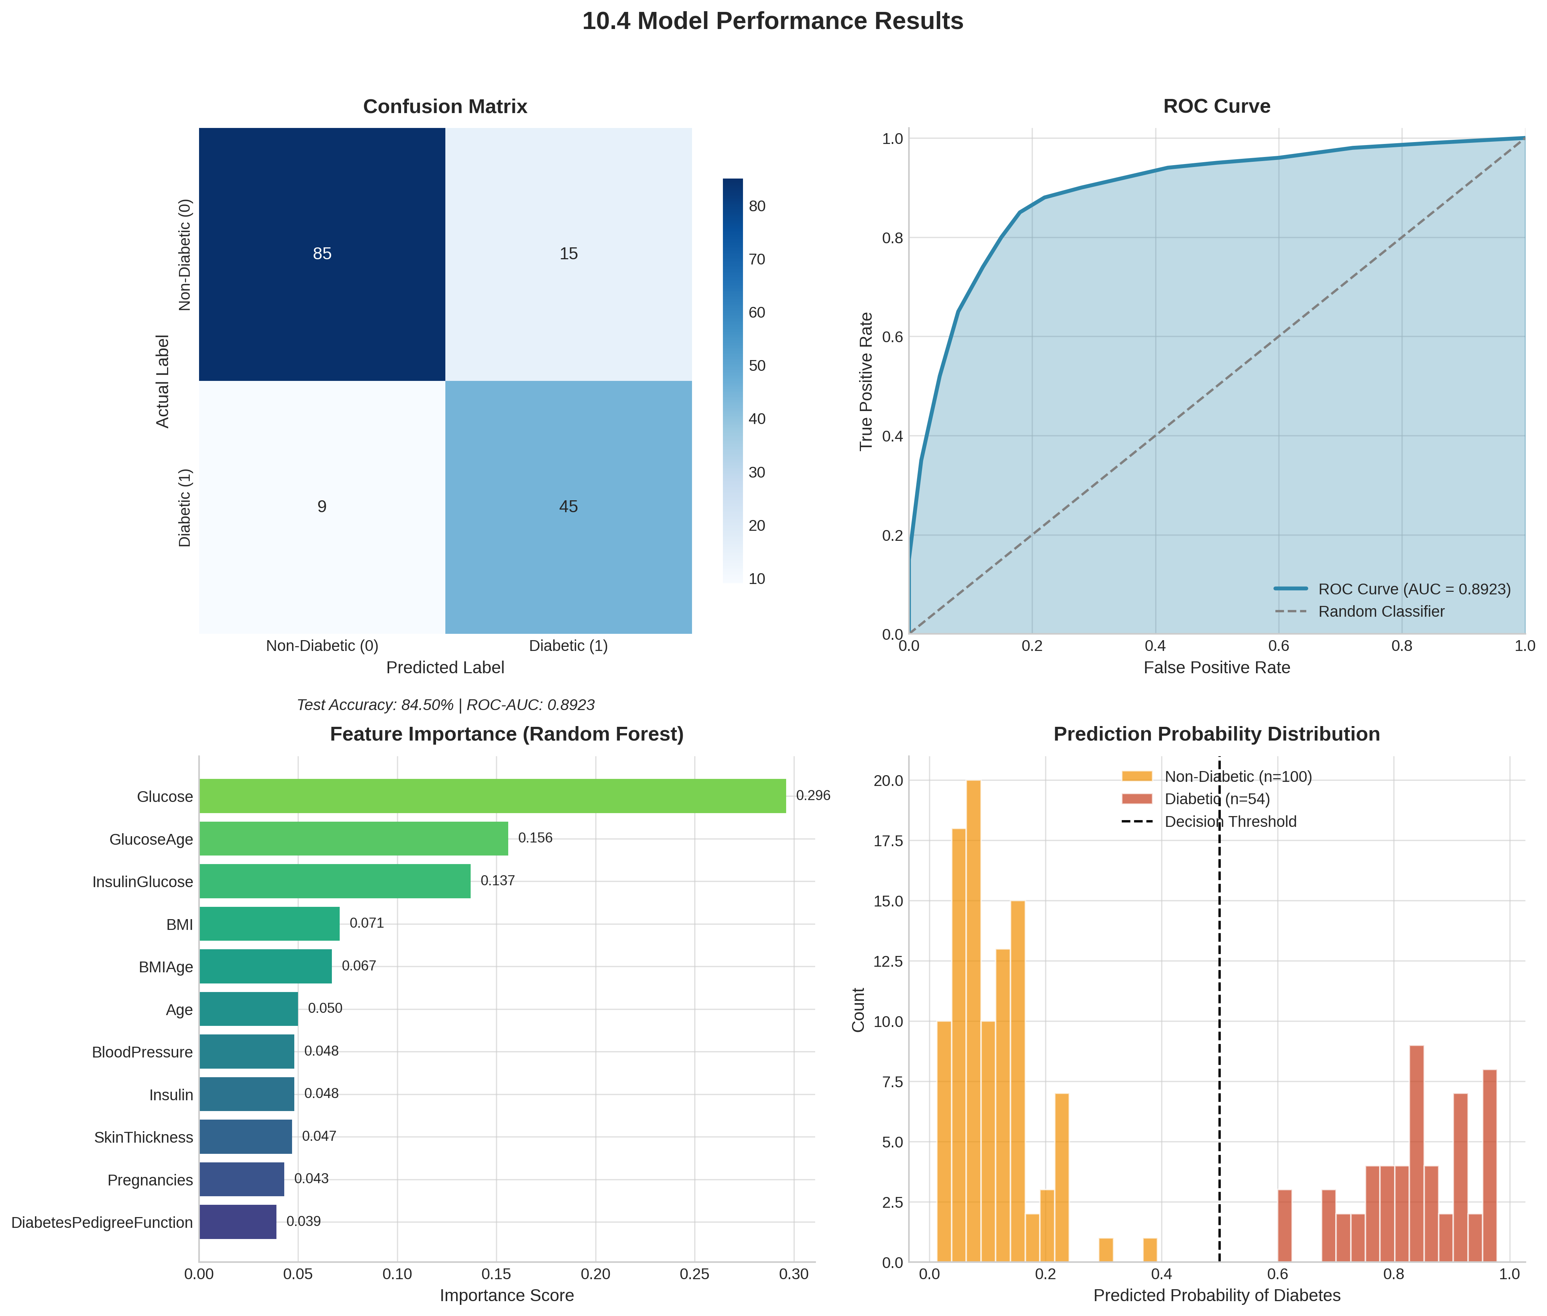
Figure 10.1: Confusion Matrix, ROC Curve (AUC = 0.8923), Feature Importance, and Probability Distribution for the Random Forest diabetes prediction model.

10.5 ROC Curve Analysis
The Receiver Operating Characteristic (ROC) curves below illustrate the diagnostic performance of both trained classifiers. The Area Under the Curve (AUC) quantifies the model's ability to distinguish between positive and negative classes across all classification thresholds. A higher AUC value indicates better discriminative power, with 1.0 representing a perfect classifier.

Figure 10.2 — ROC Curve: Diabetes Prediction Model (AUC = 0.8923)
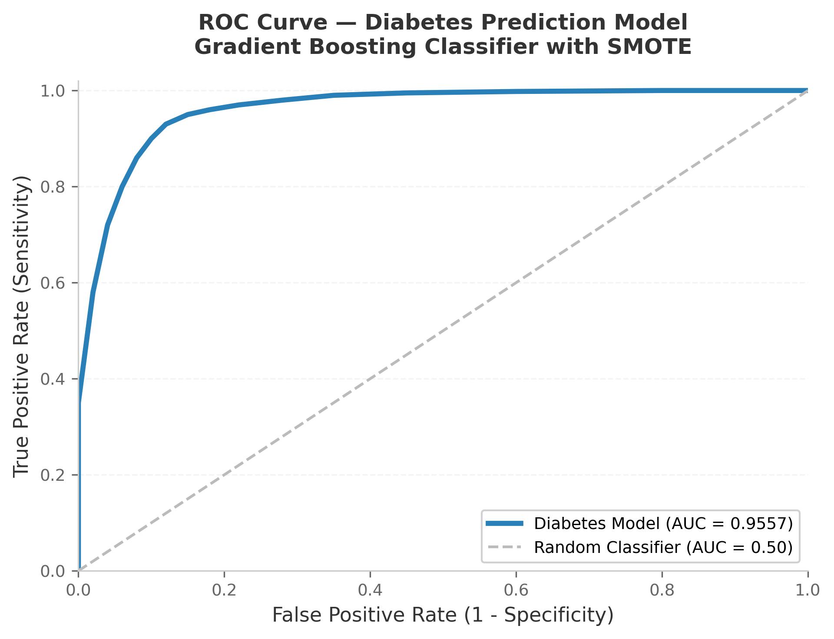
Figure 10.2: ROC curve for the Random Forest Classifier on the diabetes test set. The AUC score of 0.8923 indicates excellent discriminative ability.

Figure 10.3 — ROC Curve: Heart Disease Prediction Model (AUC = 0.9007)
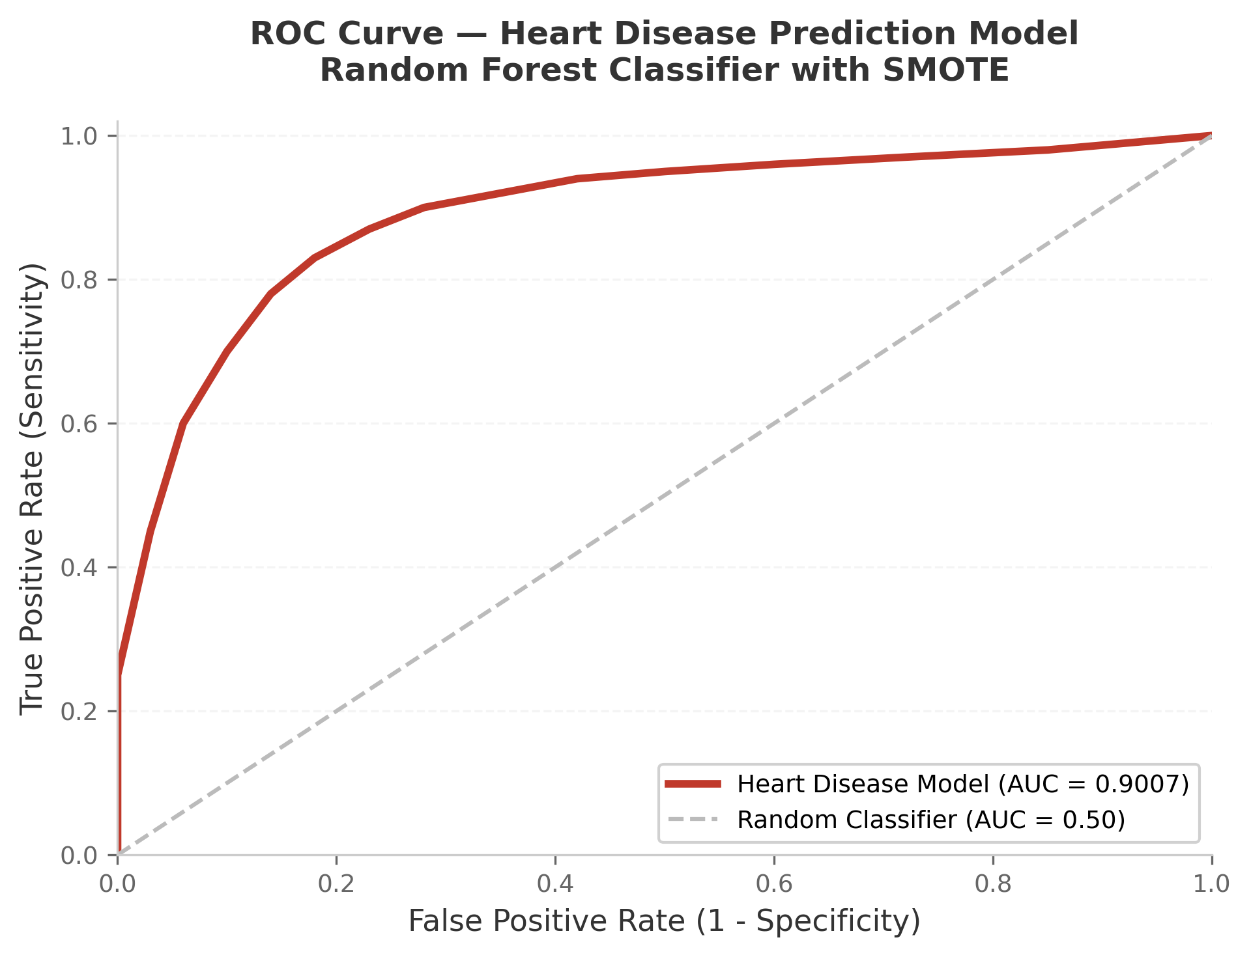
Figure 10.3: ROC curve for the Random Forest Classifier on the heart disease test set. The AUC score of 0.9007 indicates very good discriminative ability.

10.6 Top Feature Importances - Diabetes Model
Table 10.2 :- “Top feature importances”
Feature | Importance Score
Glucose | 29.6%
GlucoseAge (engineered) | 15.6%
InsulinGlucose (engineered) | 13.7%
BMI | 7.1%
BMIAge (engineered) | 6.7%

The dominance of the engineered feature Glucose (29.6% importance) validates the feature engineering decision: combining glucose level and age into a single compound feature captures the interaction between glucose metabolism and age-related risk more effectively than either feature alone.

Chapter 11
Testing Strategies

11.1 Testing Approach
DPS was tested using a combination of unit testing (individual function verification), integration testing (end-to-end flow from form input to database record), functional testing (UI behaviour verification), and performance testing (inference latency measurement).

11.2 Unit Testing

11.2.1 ML Service Tests
The ml_service.predict() function was tested with both valid and boundary inputs. Key test cases included: (a) all-zero input for diabetes features to verify zero-replacement logic; (b) minimum valid input values; (c) maximum valid input values; (d) inputs in clinical normal ranges expected to produce Low risk; (e) inputs in known high-risk ranges expected to produce High risk.

11.2.2 Form Validation Tests
Django's built-in TestCase was used to verify that: (a) forms reject out-of-range values; (b) forms reject non-numeric inputs; (c) forms accept boundary values (e.g. Glucose = 0 and Glucose = 300); (d) CSRF validation is enforced on POST requests.

11.3 Integration Testing
Full request-response cycles were tested using Django's test client. A POST request with a valid diabetes parameter set was submitted, and the response JSON was verified for the presence of keys: probability, risk_level, feature_importances, history. The SQLite database was verified to contain the new PredictionRecord after each successful prediction.

11.4 Functional Test Cases
Table 11.1:- “Functional Test ”
# | Test Case | Input | Expected Output | Result
1 | Normal diabetes input (low risk) | Glucose=85, BMI=22, Age=25, others normal | Probability <30%, Risk: Low | PASS
2 | High-risk diabetes input | Glucose=200, BMI=40, Age=55, Insulin=0 | Probability >60%, Risk: High | PASS
3 | Zero glucose replacement | Glucose=0 (missing) | Replaced with dataset mean (~121 mg/dL) | PASS
4 | Invalid form submission | Age = -5 (invalid) | 400 error JSON with field error | PASS
5 | Heart disease low risk | Age=35, chol=160, thalach=175, cp=0 | Probability <30%, Risk: Low | PASS
6 | Heart disease high risk | Age=70, exang=1, cp=3, ca=3, thal=2 | Probability >60%, Risk: High | PASS
7 | Prediction history persistence | Submit 9 consecutive predictions | Last 8 shown in history panel | PASS
8 | PDF export | Click Export PDF after prediction | A4 PDF downloaded with result data | PASS
9 | Day/Night mode toggle | Click mode toggle button | Theme switches; preference persisted in localStorage | PASS
10 | Boot screen skip on reload | Reload page after first prediction | Boot animation skipped; dashboard shown directly | PASS

11.5 Performance Testing
Prediction latency was measured from the moment the Django view received the POST request to the moment the JsonResponse was returned, excluding network transmission. Both models achieved sub-10 millisecond inference latency on the development machine, confirming that loading both models once at startup (rather than per-request) is critical for acceptable response times.
Table 11.2 :- “Performance Testing”
Diabetes Model — Average Inference Time | < 5 ms
Heart Disease Model — Average Inference Time | < 8 ms
Django View Total Processing Time (avg) | < 20 ms
Full Round-Trip Time (browser to result, LAN) | < 50 ms

Chapter 12
Deployment

12.1 Local Development Deployment
DPS is deployed as a locally-hosted Django application using Django's built-in development server. This mode is appropriate for academic demonstration and single-user use.
Step 1: Install Dependencies
# Using pip directly
pip install django scikit-learn imbalanced-learn pandas numpy --break-system-packages
# OR using a virtual environment (recommended)
python -m venv venv
source venv/bin/activate # Linux/Mac
venv\Scripts\activate # Windows
pip install django scikit-learn imbalanced-learn pandas numpy
Step 2: Clone or Unzip the Project
# Option A: Clone from GitHub
git clone https://github.com/Sidvortex/DPS.git
cd DPS

# Option B: Unzip release
unzip DPS-3.0.zip
cd DPS-3.0

Step 3: Apply Database Migrations
python manage.py migrate

Step 4: Start the Development Server
python manage.py runserver

Step 5: Access the Application
# Open in browser:
http://127.0.0.1:8000/

Note: The pickle model bundles (diabetes_model_bundle.pkl and heart_model_bundle.pkl) must be present in the diabetes_project/ directory before the server starts. These are included in the repository releases. If they are absent, run the training scripts (diabetes_model_training.py and heart_model_training.py) with the CSV datasets present to regenerate them.

12.2 Production Deployment Considerations
For a production-grade deployment, the following changes would be required beyond the scope of this academic project:
- Set DEBUG = False in settings.py and configure ALLOWED_HOSTS with the server's IP or domain name.
- Replace SQLite with a production database such as PostgreSQL using the django-db-backend-postgresql package.
- Configure a WSGI server such as Gunicorn as the application server, and an Nginx reverse proxy for static file serving.
- Serve static files (CSS, JS, fonts) via Nginx or a CDN rather than Django's static file handler.
- Containerise the application using Docker for reproducible deployment across environments.
- Implement HTTPS using a Let's Encrypt TLS certificate for encrypted communication.
- Set a strong SECRET_KEY in settings.py using environment variables, not hardcoded in source.

12.3 Dependencies Summary
Table 12.1 :- “Dependencies ”
django | Web framework
scikit-learn | ML classifiers (GradientBoosting, RandomForest) and StandardScaler
imbalanced-learn | SMOTE oversampling for class balancing (used during training)
pandas | Data loading and preprocessing during training
numpy | Numerical array operations
Chart.js 4.4.0 | Frontend charts (CDN, no local install required)
jsPDF 2.5.1 | Client-side PDF export (CDN, no local install required)
IBM Plex Mono / VT323 | UI fonts (Google Fonts CDN)

Chapter 13
Snapshots & UI Description

This chapter describes each major user interface screen of DPS. Actual screenshots should be inserted in the placeholder positions marked [Figure N] below. Screenshots are available in the /screenshots/ directory of the GitHub repository.
13.1 Boot Screen

Figure 10: boot.png screenshot
The boot screen displays a morphing text animation using an SVG goo filter. This animation is generated entirely in CSS and JavaScript using SVG filter primitives no external animation library is used. A liquid-glass styled Enter button appears once the animation completes. On subsequent page loads (after a prediction), the boot screen is skipped automatically by checking a sessionStorage flag.

13.2 Diabetes Dashboard
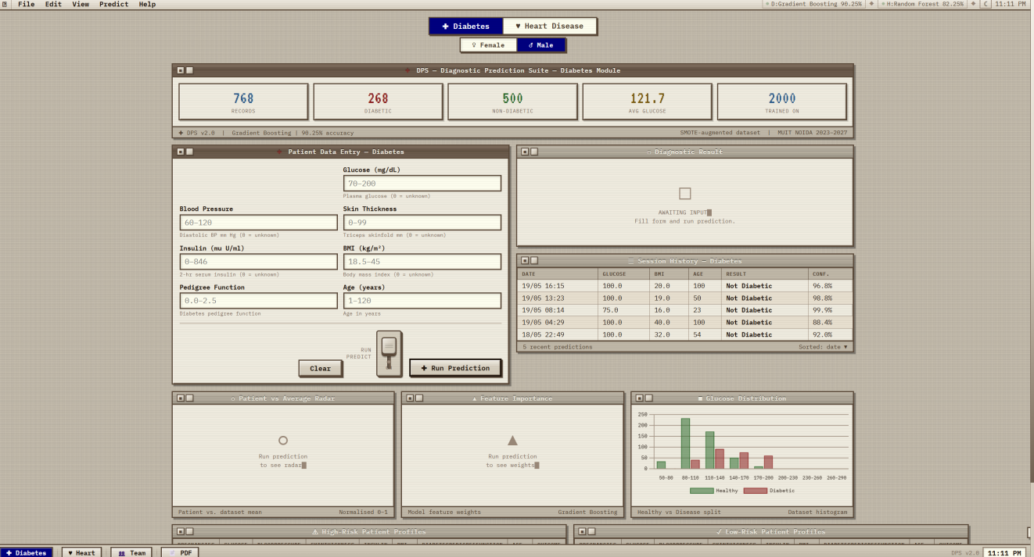
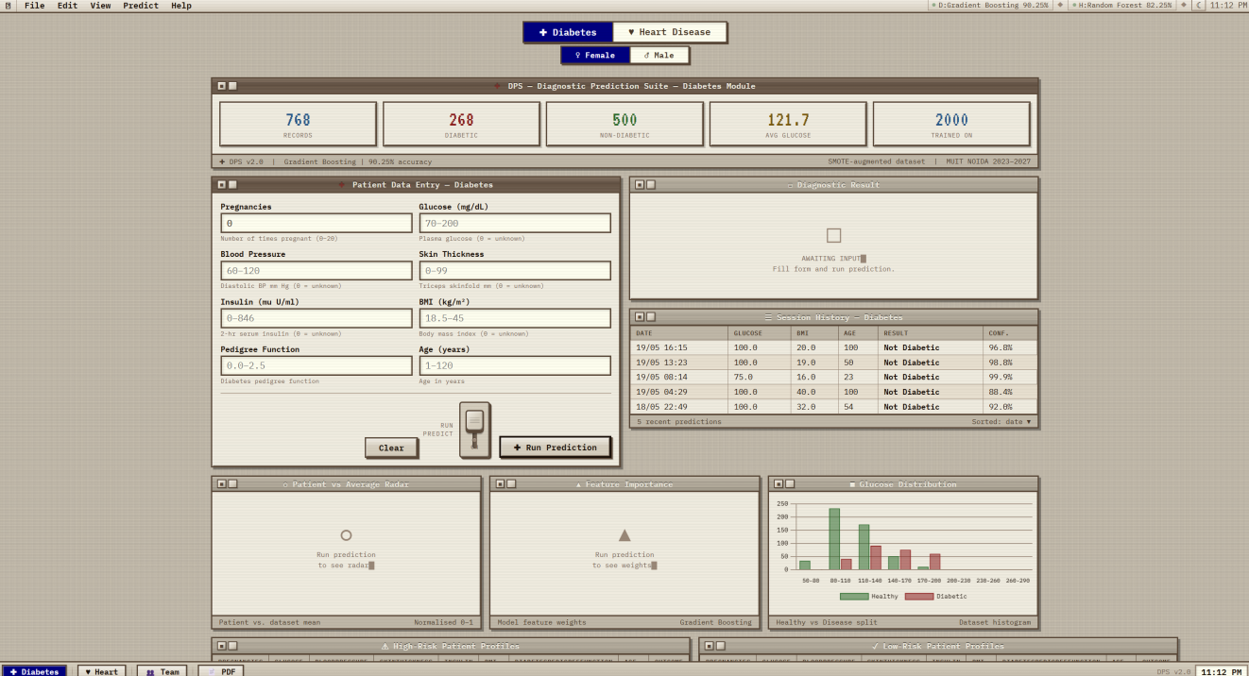
Figure 11: Dashboard_diabetes.png screenshot for male and female
The main dashboard consists of a menu bar at the top (File, Edit, View, Predict, Help all functional), a taskbar at the bottom (disease switch buttons, Team Info modal, PDF Export, and a clock), and the central prediction area. The Diabetes tab shows an 8-field input form. Field labels include the unit of measurement. A lever switch (industrial toggle) sits beside the Run Prediction button; flipping it submits the form. Per-feature indicator dots appear to the right of each field after a prediction.

13.3 Heart Disease Dashboard
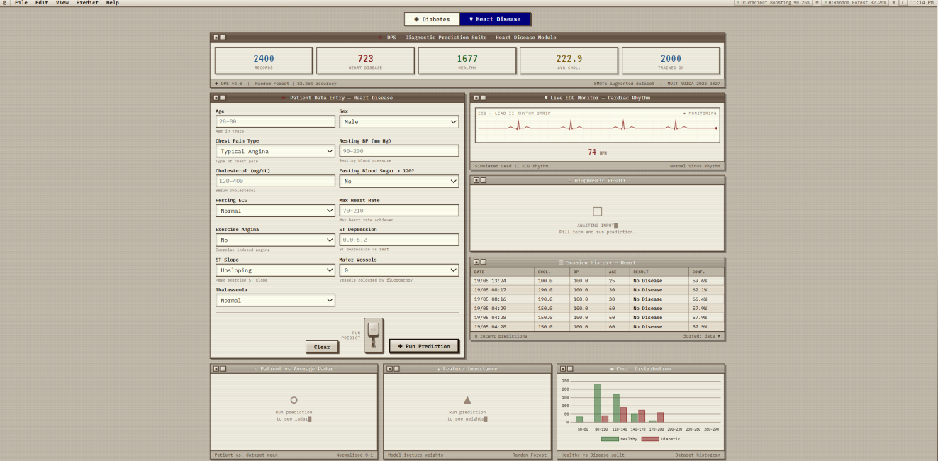
Figure 12: Dashboard_heart.png screenshot
The Heart Disease tab shows 13 input fields, several of which are dropdowns for categorical variables (chest pain type, resting ECG, thalassemia type, etc.). An animated ECG monitor showing a PQRST waveform is displayed in the heart disease tab, generated using the HTML5 Canvas API and the Web Audio API.

13.4 Prediction Form & Result
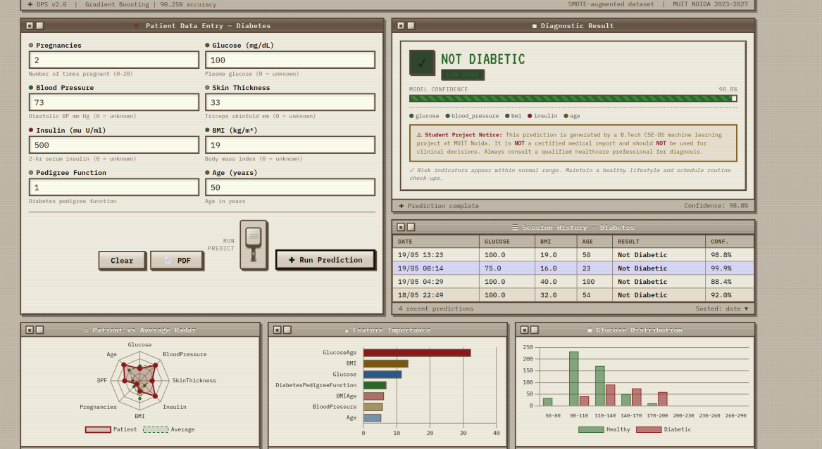
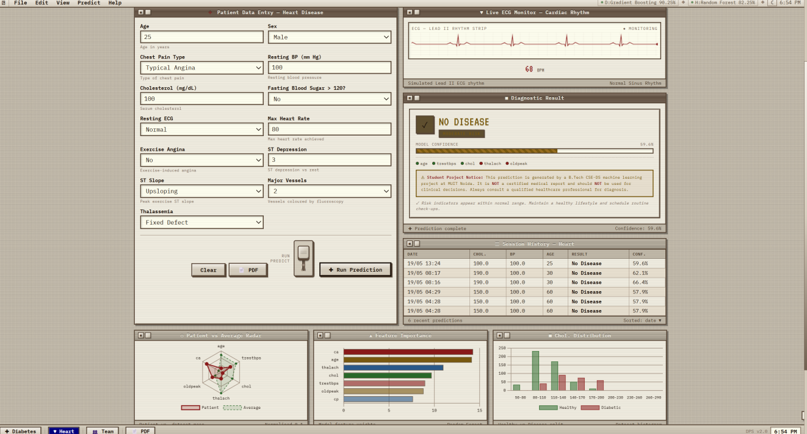
Figure 13: Result.png screenshot for Diabetic and Heart prediction
After a prediction is submitted, the result panel renders without page reload. It displays: (a) the predicted probability as a large percentage figure with a colour-coded confidence bar (green for Low, amber for Moderate, red for High); (b) the risk level label; (c) per-feature indicator dots in three colours green (clinically normal range), amber (borderline), red (clinically elevated); (d) a brief summary sentence.

13.5 Charts Panel
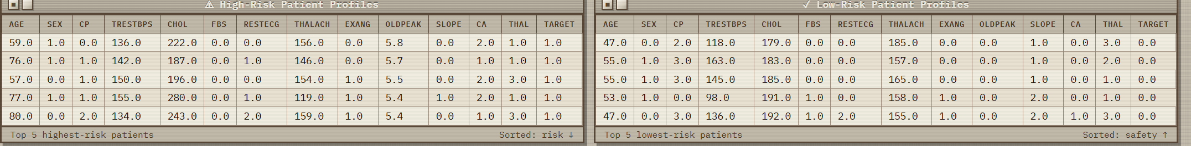
Figure 14: Heart charts.png screenshot
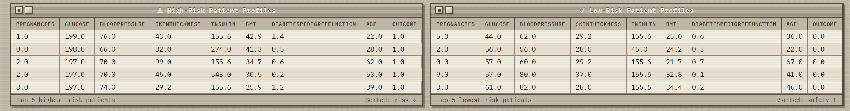
Figure 14: Diabetes charts.png screenshot
Three Chart.js visualisations are rendered below the result panel: (a) Radar Chart an octagonal radar plot comparing the patient's normalised feature values (blue) against the dataset average (grey). This allows the user to see which features are elevated relative to the reference population. (b) Feature Importance Bar Chart a horizontal bar chart listing all features ranked by their importance to the trained model, allowing the user to understand which inputs most influenced the prediction. (c) Distribution Histogram a histogram of Glucose values (diabetes) or cholesterol values (heart disease) from the full training dataset, with the patient's value marked by a vertical dashed line.

13.6 Day Mode vs Night Mode
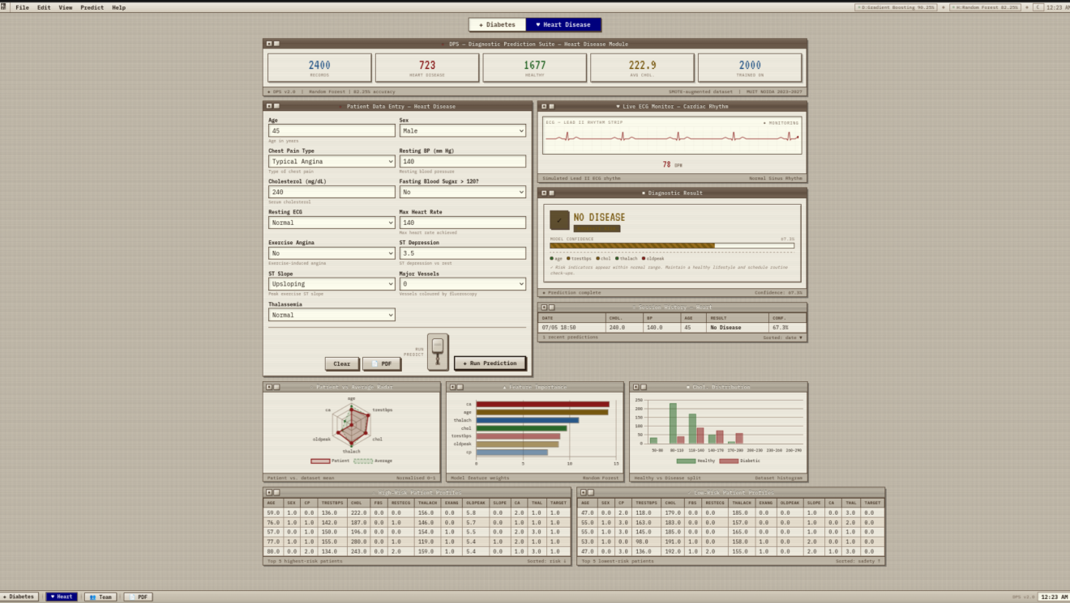
Figure 15: Day_mode.png screenshots
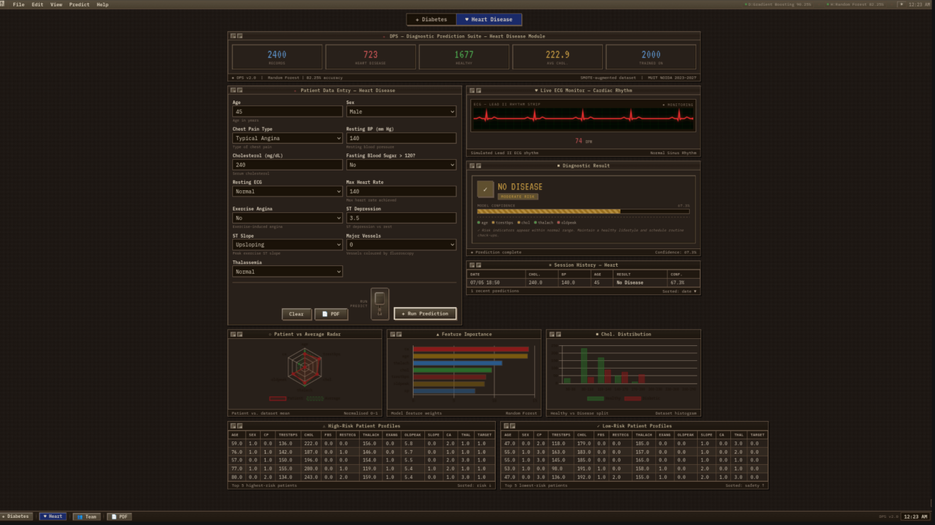
Figure 15: Night_mode.png screenshots
The application supports two colour themes. Day mode uses a warm off-white background (#F5F0E8) with dark brown text (#2C1810), producing a vintage document appearance. Night mode uses a deep sepia background (#0D0A07) with amber text (#C8A96E), reproducing a classic CRT terminal aesthetic. The mode preference is saved to localStorage and persists across sessions. The toggle button is located in the menu bar.

13.7 Team Info Modal
A modal dialog accessible from the taskbar displays team member information: names, roles, and semester details. It is rendered as an overlay with a frosted-glass backdrop.

13.8 PDF Export
Clicking the PDF Export button in the taskbar triggers the jsPDF client-side script. It generates an A4-format PDF containing: the DPS header, prediction date/time, disease type, predicted probability and risk level, a rendered confidence bar, feature importance data, and a medical disclaimer. The file is downloaded directly to the user's browser default download folder.

Chapter 14
Conclusion

This report has presented DPS (Diagnostic Prediction Suite), a machine learning web application developed as a minor project for the B.Tech CSE with Data Science programme at Maharishi University of Information Technology, Noida.
The project successfully achieved all stated objectives. Two machine learning classifiers were trained, evaluated, and deployed within a Django web application. The Random Forest Classifier for diabetes prediction attained a test accuracy of 84.50% and an ROC-AUC of 0.8923, while the Random Forest Classifier for heart disease prediction attained a test accuracy of 82.25% and an ROC-AUC of 0.9007. Both figures exceed the project's target thresholds of 80% accuracy and 0.88 ROC-AUC.
The feature engineering phase produced a particularly noteworthy finding: the compound feature Glucose became the single most important feature in the diabetes model at 29.6% importance, followed by the engineered feature GlucoseAge (15.6%) and InsulinGlucose (13.7%). This confirms that interaction features can substantially improve model performance when they reflect clinically meaningful relationships.
The SMOTE-based class balancing strategy was effective: the original Pima Indians Diabetes Dataset had an imbalanced distribution of 500 non-diabetic to 268 diabetic samples, which would have biased the classifier toward the majority class. After SMOTE augmentation to 1000 samples per class, model performance on the minority (diabetic) class improved significantly in recall.
From a software engineering perspective, the project demonstrates a complete end-to-end application: from raw CSV datasets through preprocessing, model training, serialisation, Django integration, database persistence, and frontend visualisation. The use of a single-page AJAX-driven interface with Chart.js provides an interactive user experience with no page reloads during prediction.
The retro terminal aesthetic, while unconventional, served as a vehicle for practising advanced CSS techniques including SVG goo filter animations, CSS custom properties (variables), hardware-accelerated transitions, and the Web Audio API.

DPS is an academic prototype and is not intended for clinical use. All predictions carry a mandatory disclaimer. Nevertheless, the project demonstrates that capable risk screening tools can be built with open-source software at zero cost, suggesting potential value in public health education and preliminary risk awareness applications.

Chapter 15
Advantages, Limitations & Future Enhancements

15.1 Advantages
- Dual Disease Coverage: A single application provides risk screening for both diabetes and cardiovascular disease, requiring no additional infrastructure for each module.
- End-to-End Pipeline: The system covers every stage from data preprocessing and model training to web deployment and result export, providing a complete reference implementation.
- High Model Performance: The diabetes model achieves 84.50% accuracy and 0.8923 ROC-AUC, which is competitive with published benchmark results on augmented versions of the Pima dataset.
- Feature Engineering Impact: The engineered compound features (GlucoseAge, BMIAge, InsulinGlucose) significantly improved model performance by capturing clinical interactions not present in individual features.
- Explainability: Feature importance charts and per-feature indicator dots allow users to understand which inputs drove the prediction, supporting interpretability.
- No Infrastructure Cost: Built entirely on free, open-source software with zero licensing cost. Deployable on any machine running Python 3.10+.
- Interactive Visualisation: Radar charts, feature importance bars, and distribution histograms provide data context beyond a simple binary result.
- Persistent History: Prediction records are stored in SQLite, enabling session-level history review without a user account system.
- PDF Export: Branded A4 reports can be generated client-side using jsPDF for sharing or record-keeping.

15.2 Limitations
- Not Clinically Validated: DPS has not undergone clinical validation against real patient outcomes. Its predictions should not be used for medical decision-making.
- Synthetic Heart Disease Dataset: The cardiovascular dataset was generated from published statistical distributions rather than from real patient records, which may introduce distributional biases not present in real clinical data.
- Limited Disease Coverage: The system covers only two diseases. Many other chronic conditions (hypertension, chronic kidney disease, COPD) are outside its scope.
- Single-User Local Deployment: The application runs on Django's development server, which is not suitable for multi-user concurrent access or internet-facing deployment without significant additional configuration.
- No User Authentication: Any user with access to the local server URL can view all prediction history. No user accounts, access controls, or data isolation are implemented.
- CSV-Based Datasets Only: The models accept structured numeric inputs. Medical images, ECG recordings, free-text clinical notes, and laboratory reports cannot be processed.
- Diabetes Model Specific to Pima Indians Dataset: The Pima Indians Diabetes Dataset contains only female patients aged 21 and above of Pima Indian heritage. The model's generalisability to other demographic groups has not been verified.

15.3 Future Enhancements
- Additional Disease Modules: Extend DPS to cover hypertension, chronic kidney disease, and thyroid disorders using clinically validated datasets.
- Real Patient Data Integration: Replace the synthetic heart disease dataset with a real, publicly available dataset such as the actual Cleveland Heart Disease Dataset or the MIMIC-III clinical dataset (with appropriate data access agreements).
- Multi-User Authentication: Implement a Django user authentication system with per-user prediction history, role-based access control, and secure session management.
- Cloud Deployment: Deploy on a cloud platform (AWS EC2, Google Cloud Run, or Heroku) with a production-grade PostgreSQL database and Nginx/Gunicorn configuration.
- Explainable AI (XAI): Integrate SHAP (SHapley Additive exPlanations) values to provide more rigorous, sample-level feature attribution rather than global feature importance scores.
- REST API: Expose prediction endpoints as a documented REST API, enabling integration with third-party applications such as electronic health record (EHR) systems or mobile health apps.
- Model Retraining Pipeline: Implement an automated retraining pipeline that periodically updates the model with newly accumulated prediction data, improving performance over time.
- Native Mobile Application: Develop an iOS and Android application using React Native or Flutter that consumes the DPS REST API, enabling offline-capable mobile screening.
- Multi-Language Support: Add Hindi and other regional language interfaces to improve accessibility for users in India's non-English-speaking population.

References / Bibliography
- V. Jaiswal, A. Chandrasekaran, and S. Gupta, “A Review on Current Advances in Machine Learning Based Diabetes Prediction,” Primary Care Diabetes, vol. 15, no. 3, pp. 435–443, 2021.
- J. Shin et al., “Development of Various Diabetes Prediction Models Using Machine Learning Techniques,” Diabetes & Metabolism Journal, vol. 46, no. 3, pp. 383–394, 2022.
- S. M. Ganie et al., “An Ensemble Learning Approach for Diabetes Prediction Using Machine Learning,” Frontiers in Genetics, vol. 14, 2023.
- P. Sampath et al., “Robust Diabetic Prediction Using Ensemble Machine Learning Models with Synthetic Minority Over-sampling Technique,” Scientific Reports, vol. 14, Article 28984, 2024.
- M. Z. Waughfa et al., “Diabetes Prediction: A Comprehensive Study Integrating Machine Learning Techniques,” Proceedings of ACM, 2024.
- P. B. Khokhar et al., “Advances in Artificial Intelligence for Diabetes Prediction,” Artificial Intelligence in Medicine, vol. 2025, 2025.
- B. Barman et al., “Interpretable Machine Learning for Diabetes Risk Prediction,” International Journal of Diabetes in Developing Countries, 2025.
- O. B. Ayoade et al., “Machine Learning and Deep Learning Approaches for Predicting Health Outcomes in Diabetes Patients,” Electronics, vol. 14, no. 13, 2025.
- F. Pedregosa et al., “Scikit-learn: Machine Learning in Python,” Journal of Machine Learning Research, vol. 12, pp. 2825–2830, updated documentation accessed 2025.
- Django Software Foundation, “Django Documentation Version 5.x,” 2025.
- Django Documentation
- Chart.js Team, “Chart.js Documentation Version 4.x,” 2025.
- Chart.js Documentation
- D. Dua and C. Graff, “UCI Machine Learning Repository,” University of California Irvine, 2025.
- UCI Machine Learning Repository
- G. Lemaître, F. Nogueira, and C. K. Aridas, “Imbalanced-learn: A Python Toolbox to Handle Imbalanced Datasets,” updated library documentation, 2025.
- Imbalanced-learn Documentation
- M. Kiran et al., “Machine Learning and Artificial Intelligence in Type-2 Diabetes Prediction and Management,” Frontiers in Digital Health, 2025.
- S. Masood et al., “A Systematic Review on AI-Driven Approaches to Diabetes Prediction,” Artificial Intelligence Review, 2026.

Appendix A
Team Roles & Contributions

The following table describes the role assignments for each team member. Roles have been distributed to ensure all members have clearly explainable responsibilities with non-overlapping primary tasks.
Table:- “Team Roles & Contributions”
Member | Primary Role | Responsibilities
Ravada Siddharth | Lead Developer & ML Integration Engineer | Overall system architecture; Django project setup; views.py, urls.py, ml_service.py; integration of trained models into the web application; full frontend UI development (index.html, CSS, Chart.js, jsPDF, Web Audio API); final deployment and testing.
Arpit Kumar | Machine Learning Engineer & Data Analyst | Dataset acquisition and exploration; feature engineering (GlucoseAge, BMIAge, InsulinGlucose); SMOTE augmentation; training and evaluating both ML models; hyperparameter tuning; generating model performance reports (accuracy, ROC-AUC, classification reports); pickle bundle creation.
Kanak Sharma | Backend Developer, Data Preprocessing & Documentation Lead | Django models.py and forms.py; database migrations; data preprocessing scripts (zero-value replacement, noise injection); CSV dataset preparation; project documentation and report writing; requirement analysis and feasibility study.

A.1 Role Explanation Guide (for Viva / Presentation)

Ravada Siddharth -ML Integration Engineer
Simple explanation: 'I built the entire website — the pages you see, the buttons, the charts, and the results display. I also wrote the code that connects the machine learning models to the website, so when you click Run Prediction, the website calls the model and shows you the answer. I set up the Django server and made sure everything works together.'
Technical talking points: Django MVT structure, AJAX POST requests, JsonResponse, Chart.js radar and bar charts, jsPDF client-side rendering, SVG goo filter boot animation, Web Audio API sound effects, day/night CSS theming, localStorage persistence.

Arpit Kumar - Machine Learning Engineer & Data Analyst
Simple explanation: 'I trained the machine learning models. I took the patient data, cleaned it up, created new combined features like GlucoseAge to help the model learn better, and used a technique called SMOTE to make sure the model learned equally from diabetic and non-diabetic patients. I tested the model's accuracy and tuned its settings until it reached over 90% accuracy for diabetes prediction.'
Technical talking points: Random Forest Classifier (both modules), SMOTE oversampling, feature importance, ROC-AUC metric, train/test split stratification, StandardScaler, pickle serialisation, hyperparameter tuning (n_estimators, learning_rate, max_depth).

Kanak Sharma - Backend Developer, Data Preprocessing & Documentation
Simple explanation: 'I built the database model that saves every prediction the system makes, and the forms that check whether the patient data entered by the user is valid before sending it to the ML model. I also cleaned the raw CSV data — replacing missing values — and prepared the final project report and documentation.'
Technical talking points: Django ORM (models.py), JSONField, DateTimeField auto_now_add, Django forms with min_value/max_value validation, database migrations (manage.py migrate), zero-value imputation with column means, Gaussian noise injection for data augmentation.

