1. AutoEncoder Function

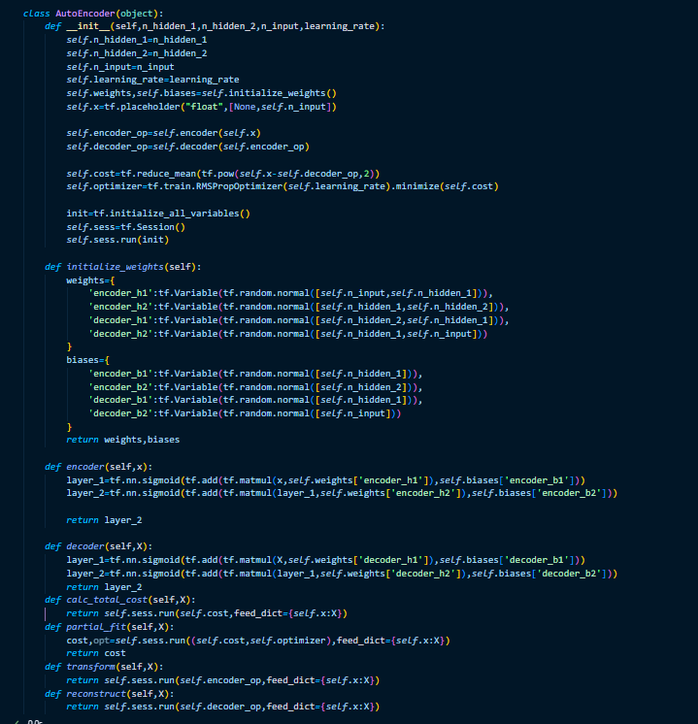

1. Epoch

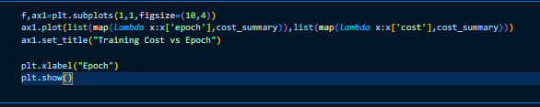

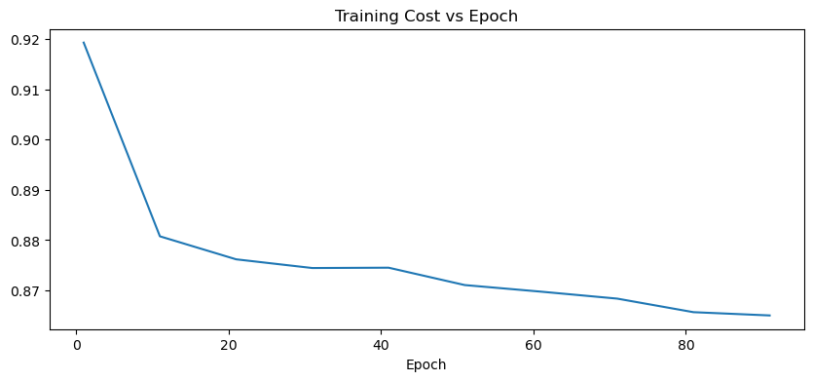

1. Classification Model Evaluation  
   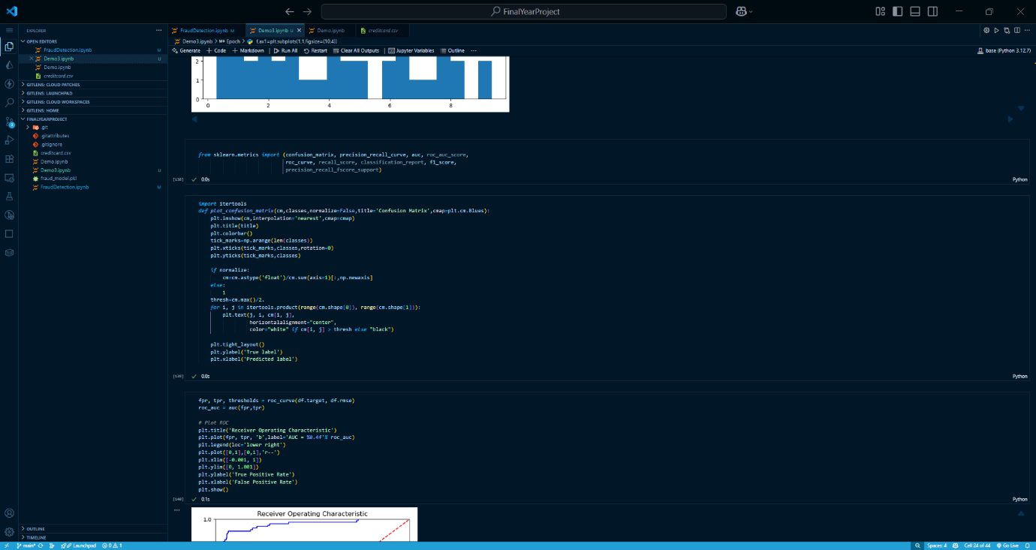
2. Confusion Matrix
3. y_pred *=* [1 *if* p *>* 2 *else* 0 *for* p *in* df.rmse.values]
4. cnf_matrix *=* confusion_matrix(df.target, y_pred)
5. np.set_printoptions(precision*=*2)
6. print("Recall metric in the testing dataset: ", float(cnf_matrix[1,1])*/*(cnf_matrix[1,0]*+*cnf_matrix[1,1]))
7. class_names *=* ['false','true']
8. plt.figure()
9. plot_confusion_matrix(cnf_matrix, classes*=*class_names, title*=*'Confusion matrix')
10. plt.show()

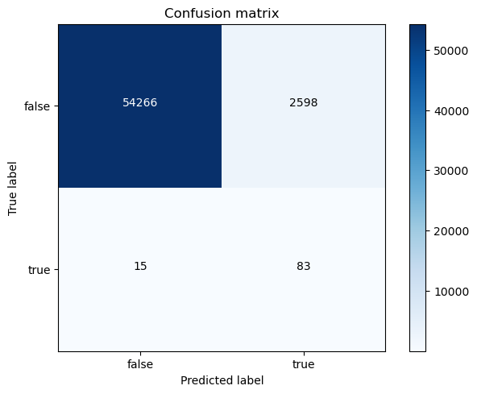

5. Evaluation Metrics(Precision,Accuracy,F1 Score):  
*from* sklearn.metrics *import* precision_recall_fscore_support

*import* pandas *as* pd

*# Get metrics*

precision, recall, fscore, support *=* precision_recall_fscore_support(

    y_true*=*df.target,

    y_pred*=*y_pred

)

*# Put into a DataFrame*

results_df *=* pd.DataFrame({

    "Class": [0, 1],

    "Precision": precision,

    "Recall": recall,

    "F1-score": fscore,

    "Support": support

})

print(results_df)



6. Accuracy:  
