Results
Home Page:
- Landing Page: A visually engaging page showcasing available bikes, reviews from users, and information about the rental service.
- Navigation Bar: Provides links to key pages like “Home,” “Login,” “Register,” and possibly user/admin dashboards.
- Responsive Design: Built with HTML, CSS, and likely Bootstrap to ensure compatibility across desktops, tablets, and smartphones.
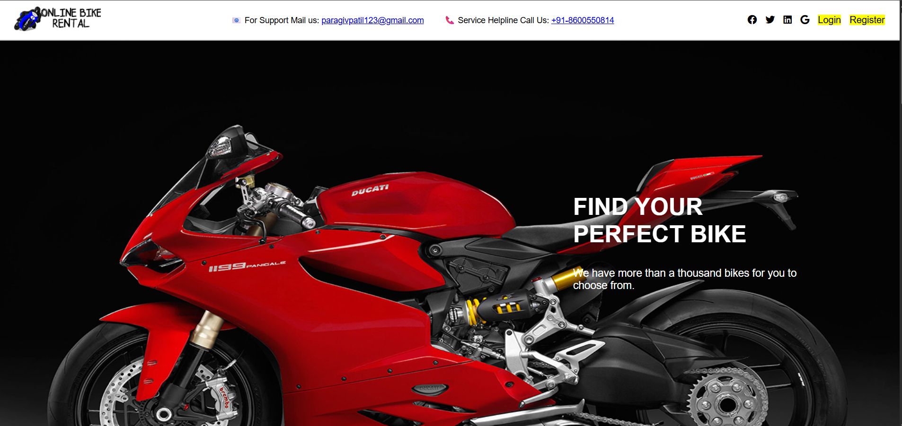

User Authentication:
- Login/Signup Forms: Secure login and registration with password hashing using Werkzeug.
- Session Management: Flask sessions used to track logged-in users and control access to features.
- Admin Login: Admin credentials are hardcoded (bike123@gmail.com / bike123) for management functionality.
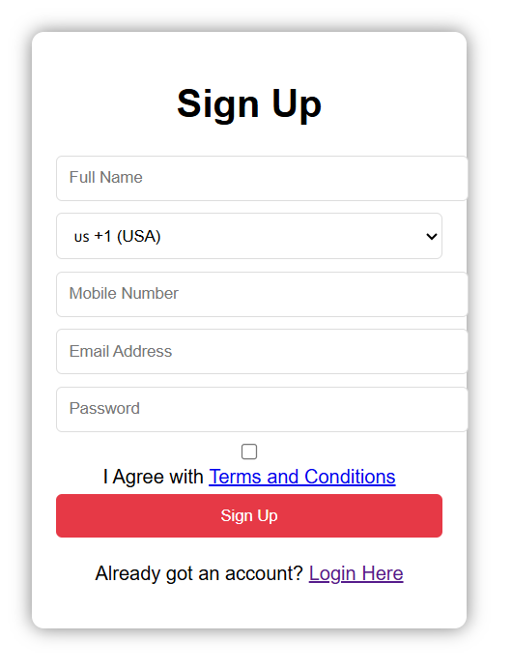

Bike Rental Features:
- Bike Listing Page: Displays available bikes with images, possibly using a MongoDB collection.
- Booking System: Users can select and rent bikes based on availability.
- Rental History: Stores and displays past bookings for each user.
- Review System: Users can leave reviews and ratings, stored in MongoDB and shown on the homepage.
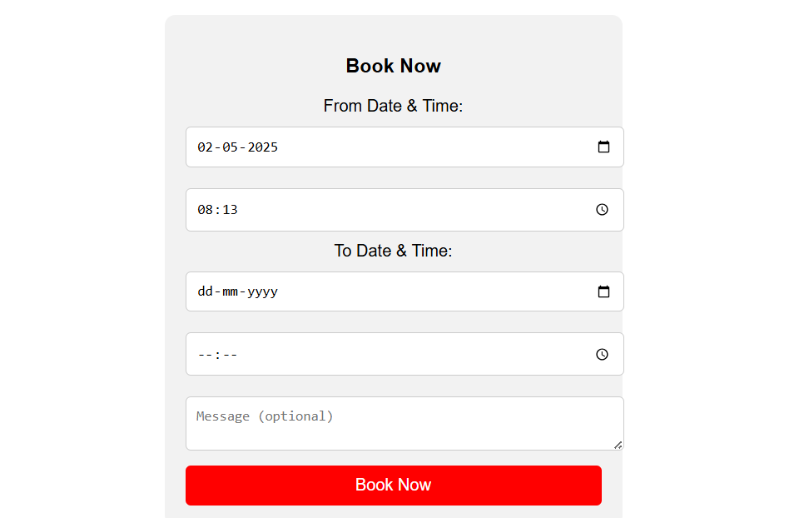

Backend Logic:
- Flask Framework: Manages routing, user sessions, and communication with MongoDB.
- MongoDB: Used for storing user info, reviews, bookings, and bike inventory.
- Routes Include:
  - /: Homepage displaying reviews
  - /login, /register: Authentication
  - /dashboard, /book, etc.: User and booking actions

Frontend Design:
- HTML & Jinja Templates: Dynamic pages rendered with user-specific data.
- CSS Styling: Custom styling in style.css for a clean, modern interface.
- Image Assets: Rich visuals using images of bikes, UI icons, and backgrounds.

Tools & Technologies Used:
- Frontend: HTML, CSS, Bootstrap (for responsiveness)
- Backend: Flask (Python)
- Database: MongoDB
- Authentication: Session-based login with password hashing

