1. **Overview of the Project**

A large company called Pewlett Hackard has several thousands of employees and it has been around for long time. The company is having a number of people who will be retiring in the future and it is introducing a retirement package for employees who meet certain criteria. The company is interested to have list of all employees eligible for the retirement package, number of retiring people per title and identify who are eligible to participate in a mentorship program. Using SQL, list of all employees eligible for the retirement package was completed in another similar exercise. Likewise, using SQL, this task mainly focuses on generating the number of retiring people per title and identify who are eligible to participate in a mentorship program.

Purpose of the project:

1. Develop SQL script to generate the number of retiring people per title
2. Develop SQL script to identify who are eligible to participate in a mentorship program
3. Analyze the results
4. **Results**
   1. The number of retiring people per title

The results in Table below shows that there are

* 25916 retiring senior engineers
* 24926 retiring senior staffs
* 9285 retiring engineers
* 7636 retiring staff
* 3603 retiring technical leaders
* 1090 retiring assistant engineers
* 2 retiring mangers

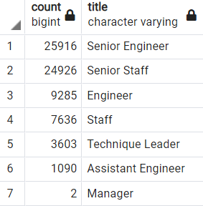

* 1. **Eligible employees who can participate in a mentorship program**

There are 1549 employees are identified for mentorship program composed of different titles which includes senior staff, engineers, technical leaders, and etc. A snipped image of the first 9 rows is displayed below.

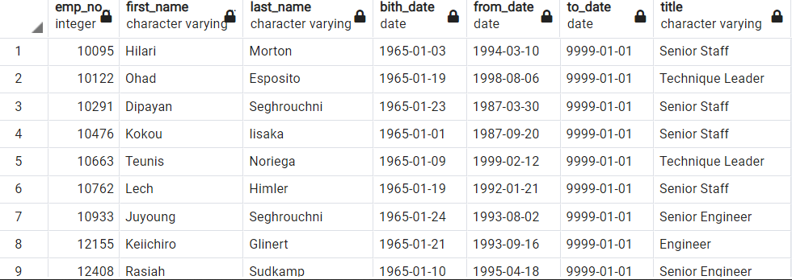

1. Summary

The findings of this exercise showed that Pewlett Hackard will have 72458 vacant positions which will be like “silver tsunami”. These are at different levels of titles. There will be 25916 vacant positions at retiring senior engineers levels , 24926 senior staffs levels, 9285 engineers level, 7636 staff levels, 3603 technical leader levels, 1090 assistant engineer levels and 2 manger levels.

Father, there are 1549 eligible retirement ready employees who can give mentorship training for the upcoming younger generations.

,