

Cairo University Faculty of Engineering
Department of Electronics & Electrical Communications Engineering
Spring, 2026

Method of Images — Point Charge Above a Grounded Conducting Plane
EECG252 — Course Assignment

Prepared by:
Sief Khaled Refaat
ID: 91240376
Presented to: Dr. Mohamed A. Nasr

Abstract
This project investigates the electrostatic problem of a point charge placed above a grounded conducting plane using both analytical and numerical methods. The method of images was applied to derive the theoretical expressions for the electric potential and the induced electric flux density on the conducting surface. CST Studio Suite was then used to simulate the electrostatic field distribution and verify the analytical results. The simulated potential and electric flux density distributions were exported to MATLAB for post-processing, visualization, and comparison with the theoretical calculations. The comparison showed good agreement between CST simulations and the analytical image-method solution, confirming the validity of the theoretical model and the correctness of the electrostatic boundary conditions.

Contents
- Introduction 3
- Theoretical Analysis 4
  - Problem Analysis 4
  - Theoretical Implementation 5
- Simulation Setup 6
- CST Model 8
  - Potential Simulation 8
  - Electric Field Simulation 9
- Simulation Results 12
  - Results Extraction 12
  - Results Analysis 12
- Theory versus Reality 15
  - Mismatch Reasons 15
  - Potential Comparison 15
  - Displacement Comparison 16

2

INTRODUCTION

This work investigates the electrostatic behavior of a point charge placed above a grounded conducting
plane using both analytical calculations and numerical simulation. The problem was solved theoretically using the method of images, where the conducting plane is replaced by an equivalent image charge to satisfy the grounded boundary condition.

First, the electrostatic potential and electric flux density equations were derived analytically. Then, the problem was modeled and simulated using CST Studio Suite with the electrostatic solver. The electric potential and electric flux density distributions were extracted from CST and exported for further processing in MATLAB.

MATLAB was used to visualize the simulation results through contour plots, 3D potential maps, radial field distributions, and centerline profiles. Analytical results were also implemented in MATLAB and compared directly with CST data to validate the numerical simulation.

Finally, comparisons between theoretical and CST results were performed for both the electric potential and the electric flux density distributions. The obtained results showed strong agreement between analytical predictions and numerical simulations, confirming the validity of the image-method solution and the accuracy of the CST electrostatic model.

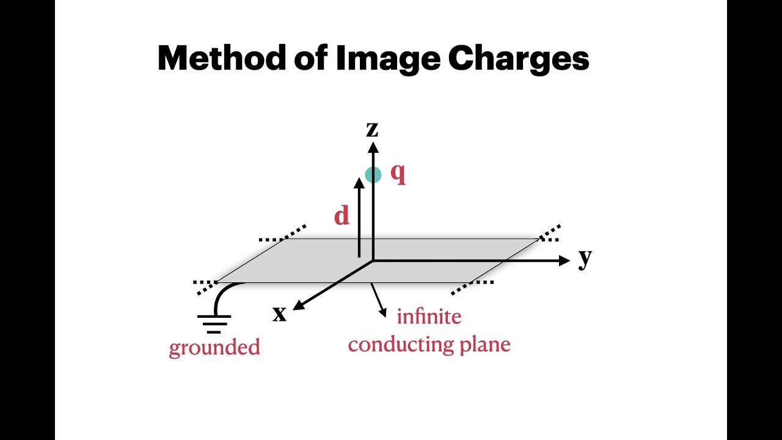
Figure 1: Problem Visual Interpretation

Theoretical Analysis

Problem Analysis

Electric Potential Analysis
Since the potential function generated due to point charge Q at radial distance r from it in free space is:
$$V(r)= \frac{q}{4πε_{o}r}$$
By calling our problem conditions:
$$V_{+q}(x,y,z)= \frac{q}{4πε_{o}\sqrt{x^{2}+ y^{2}+{(z-d)}^{2}}}$$
By applying imaging solution:
$$V_{-q}(x,y,z)= \frac{-q}{4πε_{o}\sqrt{x^{2}+ y^{2}+{(z+d)}^{2}}}$$

Therefore the potential everywhere in space can be calculated from there superposition but its only valid at region $z >0$
$$V(x,y,z)= \frac{q}{4πε_{o}}(\frac{1}{\sqrt{x^{2}+ y^{2}+{\left(z-d\right)}^{2}}}- \frac{1}{\sqrt{x^{2}+ y^{2}+{(z+d)}^{2}}})$$

Which ensure that at $d=0 cm ,$ the potential is zero (grounded plate)

Displacement Analysis
Since the electrostatic field is the negative gradient of electrostatic potential
$$E= -∇V$$
Thus the electric field in z direction can be calculated from:
$$E_{z}= -\frac{∂V}{∂z}$$
Therefore the electric field equation is:
$$E_{z}= \frac{-q}{4πε_{o}}(\frac{z-d}{{(\sqrt{x^{2}+ y^{2}+{\left(z-d\right)}^{2}} )}^{3}}- \frac{z+d}{{(\sqrt{x^{2}+ y^{2}+{\left(z+d\right)}^{2}})}^{3}})$$

Since displacement is related to the electric field as the following :
$$D= ε_{o}E$$
Therefore the electric field equation is:
$$D_{z}= \frac{-q}{4π}(\frac{z-d}{{(\sqrt{x^{2}+ y^{2}+{\left(z-d\right)}^{2}} )}^{3}}- \frac{z+d}{{(\sqrt{x^{2}+ y^{2}+{\left(z+d\right)}^{2}})}^{3}})$$
    - Surface charge analysis
By applying boundary conditions at plane surface:
$$D_{2N}-D_{1N}= ρ_{s}$$
Since no displacement exists inside the conductor:
$$D_{2N}= 0$$
Thus
$$D_{1N}= - ρ_{s}$$
By substituting z = 0 at the plane:

$$ρ_{s}= \frac{-q}{2π}(\frac{d}{{(\sqrt{x^{2}+ y^{2}+{\left(d\right)}^{2}} )}^{3}}$$

Theoretical Implementation
By implementing these equations on MATLAB to get the analytical solution:

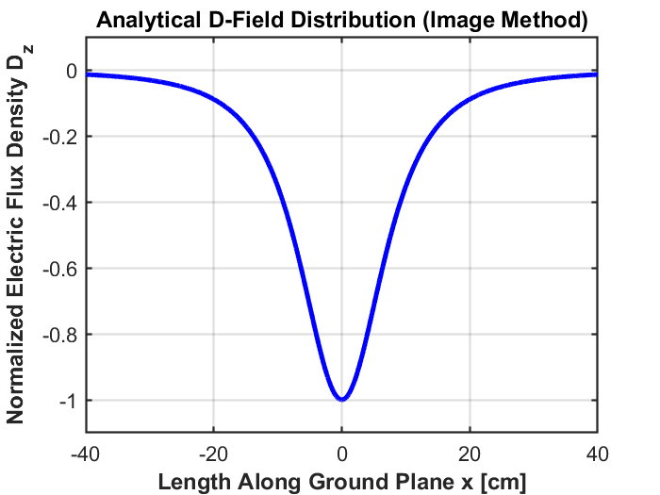
Figure 2: Normalized Analytical Displacement Solution
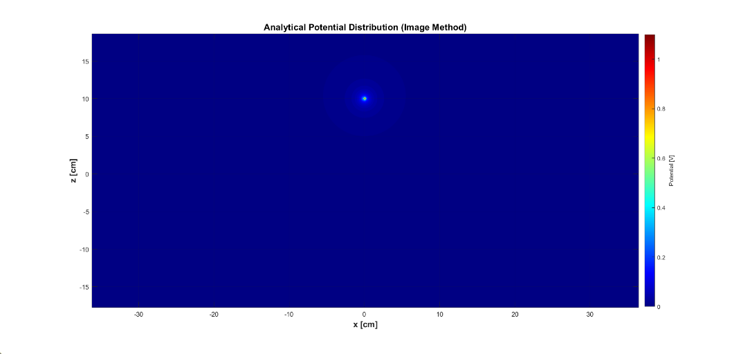
Figure 3: Analytical Potential Distribution

Simulation Setup

The project was implemented using CST Studio Suite to simulate the classical electrostatic problem of a charged object positioned above a grounded conducting plane. The electrostatic solver workflow was selected from:
- Statics & Low Frequency
- High Voltage / Heavy Current
- Insulators
- E-Static Solver
This solver was chosen because the problem involves static electric fields with no time-varying electromagnetic behavior.

The simulation units were configured using centimeters for geometry dimensions and volts for electrostatic excitation. A professional project structure was also created to organize CST files, exported data, MATLAB scripts, generated figures, and report documents. Git and GitHub version control were additionally initialized for project backup and workflow management.

To approximate an infinite electrostatic environment, all CST boundaries were configured as:
$$Open (Add Space)$$
instead of the default electric-wall boundaries. This allowed electric fields to decay naturally in free space and improved agreement with the analytical image-method solution. The open-boundary distance factor was adjusted to balance numerical accuracy and mesh complexity.

The grounded conducting plane was modeled using a thin PEC brick placed at:
$$Z=0$$
The plane dimensions were selected sufficiently large to approximate an infinite conducting surface while maintaining acceptable computational cost. The conducting plane was assigned a fixed electrostatic potential of:
$$V=0 volt$$
to reproduce the grounded boundary condition assumed analytically.

Since CST cannot directly simulate an ideal mathematical point charge, the source was approximated using a small PEC sphere located at:
$$(0,0,10 cm)$$
above the grounded plane. The sphere was excited using a fixed electrostatic potential of:
$$V=1 volt$$
which generated the electric field distribution and induced surface charges on the conducting plane.

The electrostatic problem was discretized using a tetrahedral low-frequency finite-element mesh. Several engineering optimizations were introduced to satisfy CST Learning Edition mesh limitations, including reducing the plane dimensions, increasing the sphere radius slightly for numerical stability, disabling adaptive mesh refinement, and adjusting the open-region size. These optimizations allowed the simulation to converge successfully while preserving the dominant electrostatic behavior of the problem.

After successful solver convergence, CST generated the numerical electrostatic solution, including:
- electric potential distribution,
- electric field vectors,
- induced conductor interaction effects.

The electrostatic potential and electric flux density data were then exported from CST and processed in MATLAB for visualization and comparison with the analytical image-method solution. Contour plots, 3D field maps, radial distributions, and CST-versus-theoretical validation curves were generated to verify the numerical results.

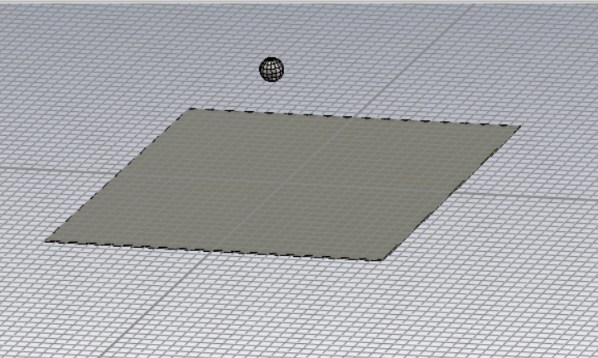
Figure 4: Problem Model After Finishing CST Setup

CST Model

Potential Simulation
The potential map is displayed on the cross-section plane B with the color scale ranging from 0 V (dark blue, corresponding to the grounded plane) to 1 V (red, at the surface of the charge sphere).
The potential decreases monotonically from the charge location outward. The grounded conducting plane
(V = 0) is correctly shown in uniform dark blue. The small red sphere marks the location of the lumped charge, and the glowing gradient around it represents the rapid potential variation in the near field.
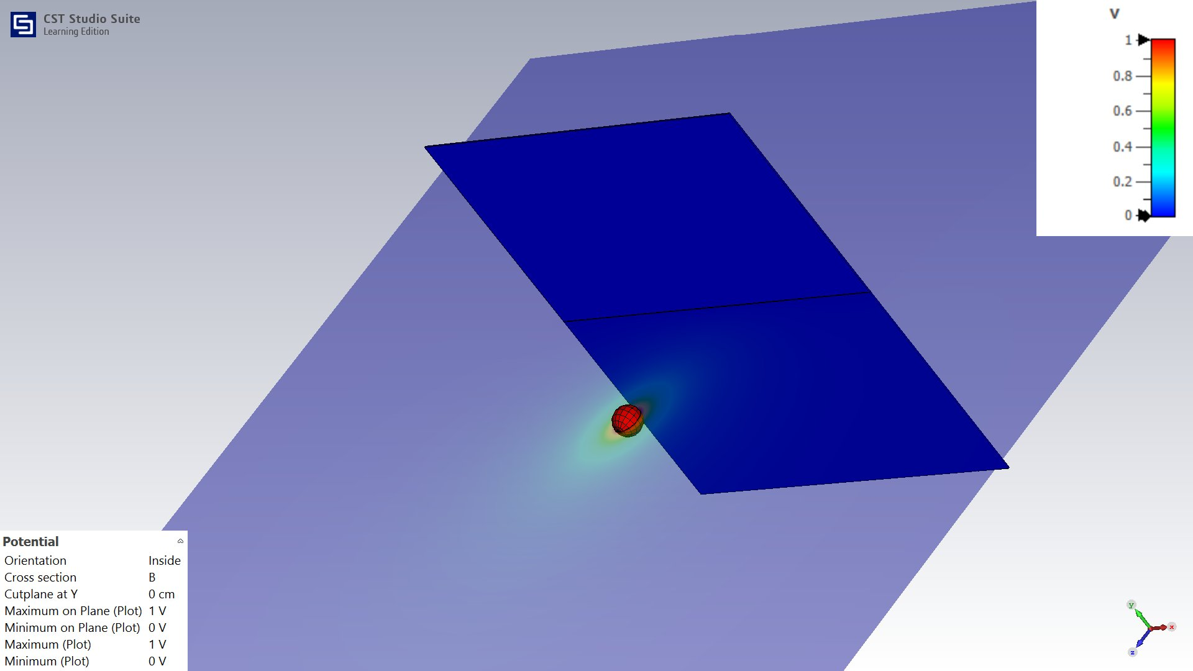
Figure 5: Electric Potential Color Map — Cross Section B at Y = 0 cm (Max = 1 V, Min = 0 V)

Electric Field Simulation
The arrow plot displays the magnitude and direction of the electric field at sampled points in the cross-section plane. Arrow length and color encode the field magnitude, while direction indicates the field orientation. The field is strongest (orange/red arrows) in the immediate vicinity of the point charge, radiating outward from the charge and bending toward the conducting plane below. Far from the source, the field weakens significantly (blue arrows) and becomes nearly uniform in the downward direction near the lower boundary of the domain.

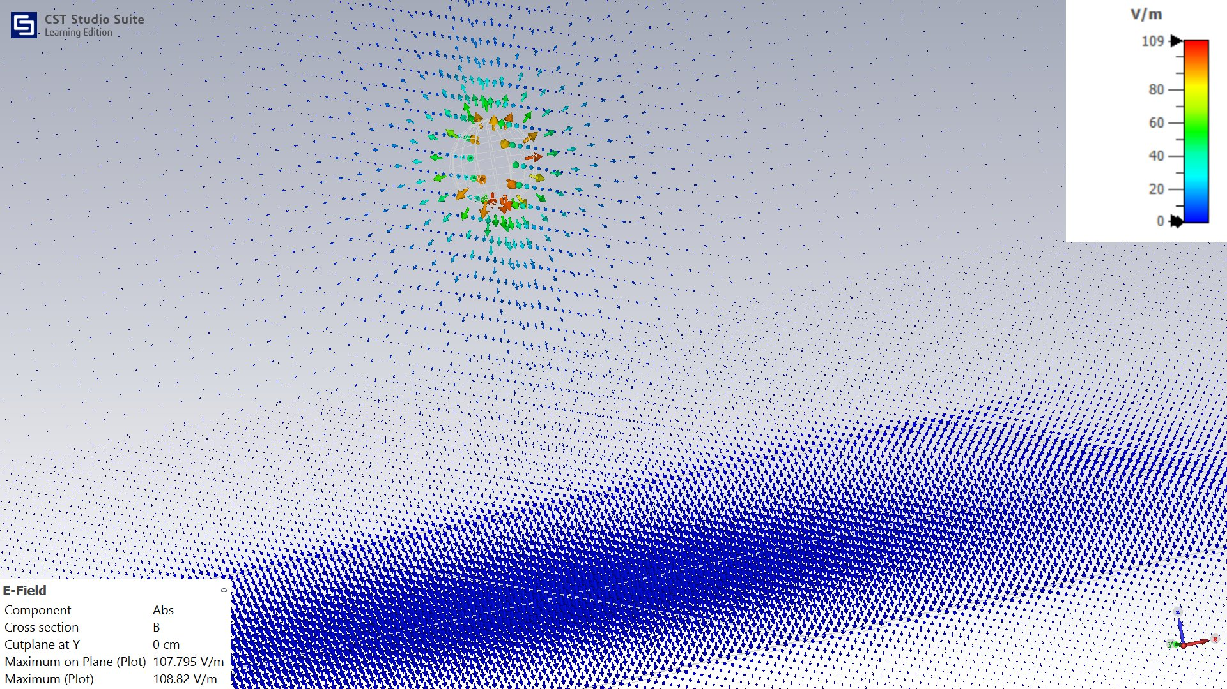
Figure 6: E-Field Arrow Plot — Cross Section B at Y = 0 cm (Max = 108.82 V/m)

The bubble plot provides an alternative visualization in which each sample point is represented by a sphere whose size is proportional to the field magnitude and whose color follows the same color map. This representation makes it easier to identify regions of high field concentration. The cluster of large orange-red bubbles centered near the charge location confirms that the field is strongly localized around Q, while the dense array of very small blue bubbles in the lower half of the domain indicates a nearly zero field inside the conductor region.

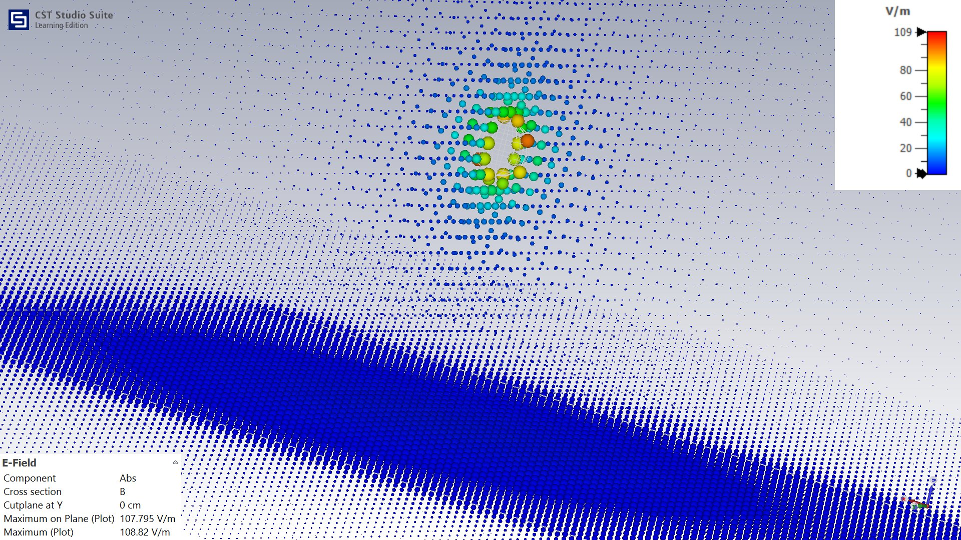
Figure 7:E-Field Bubble Plot — Cross Section B at Y = 0 cm

The dot plot encodes only the field magnitude at each sampling point through dot size and color, without showing directionality. This plot clearly reveals the spatial extent of the high-field region and its rapid decay with distance from the point charge. The transition from the colored (upper) region to the uniformly blue lower region corresponds to the interface at the conducting plane.

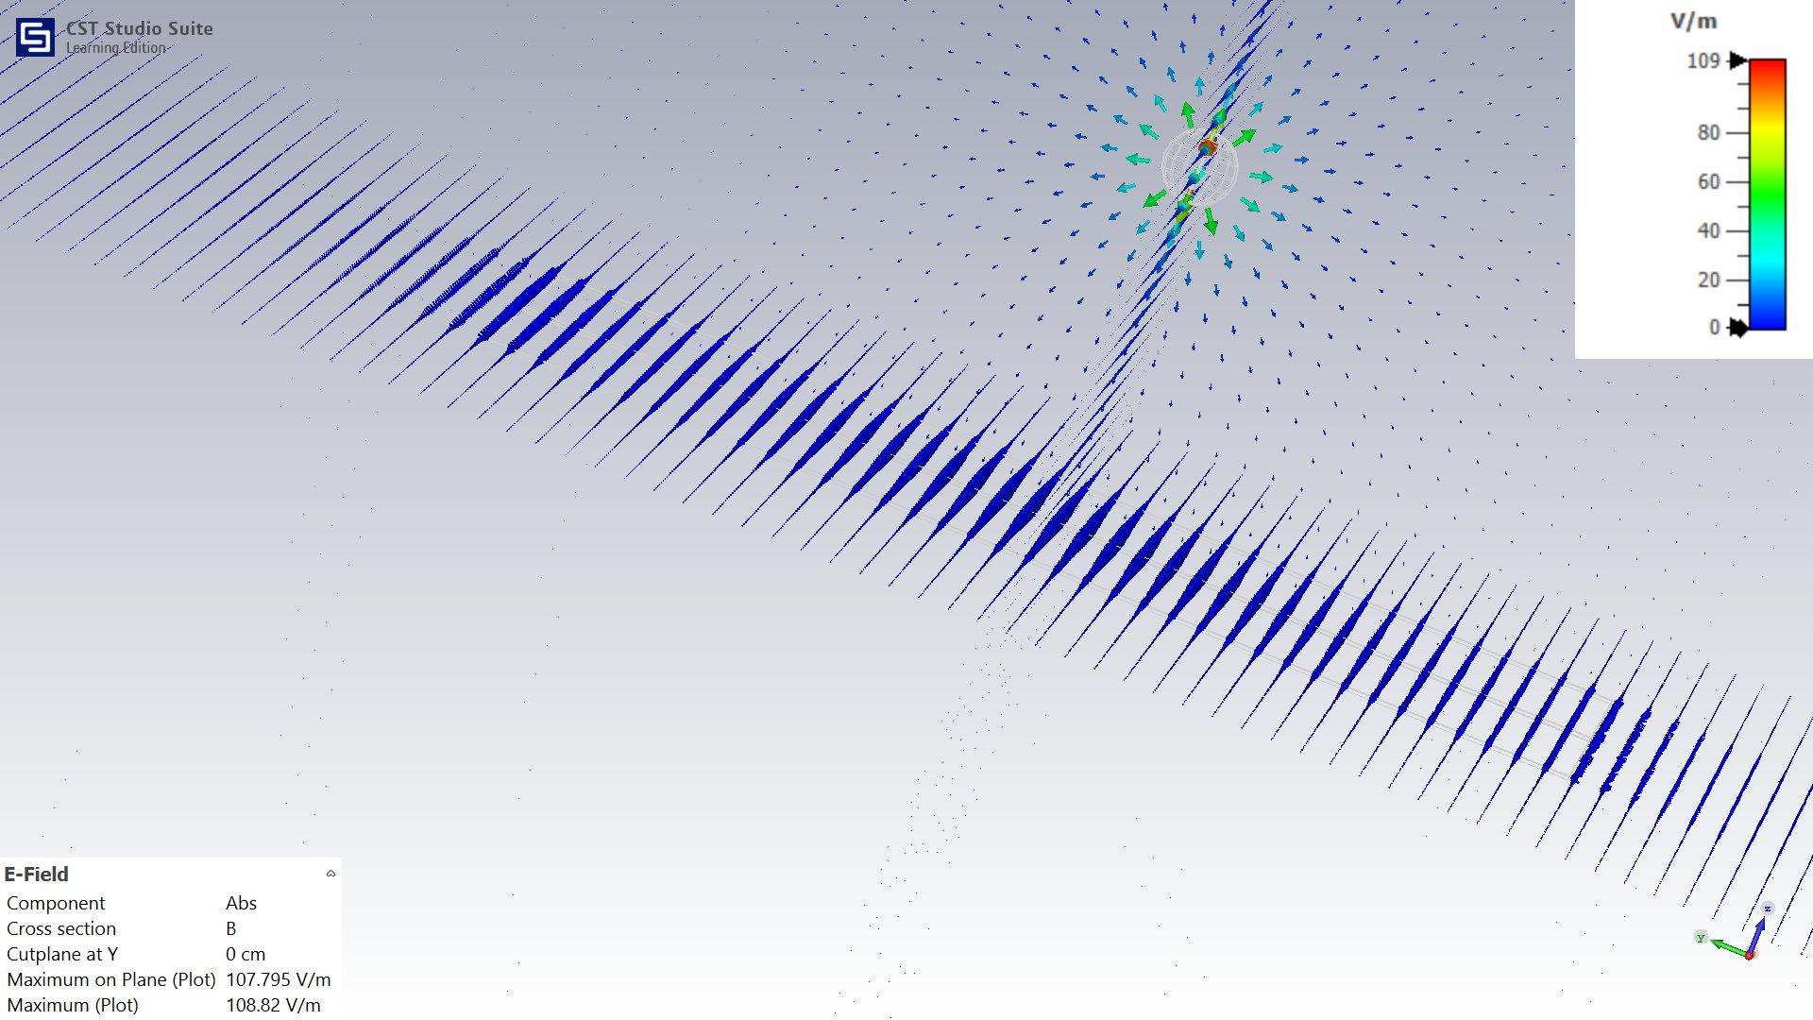
Figure 8:E-Field Dot Plot — Cross Section B at Y = 0 cm

My cleaner vector field visualization uses a uniform sampling grid to display the electric field lines. The characteristic pattern is clearly visible: field lines originate radially from the point charge in the upper half-space and terminate perpendicularly on the grounded conducting plane, consistent with the boundary condition E_tangential = 0 on the PEC surface. The field lines are denser near the foot of the charge, reflecting the higher surface charge density at that location.

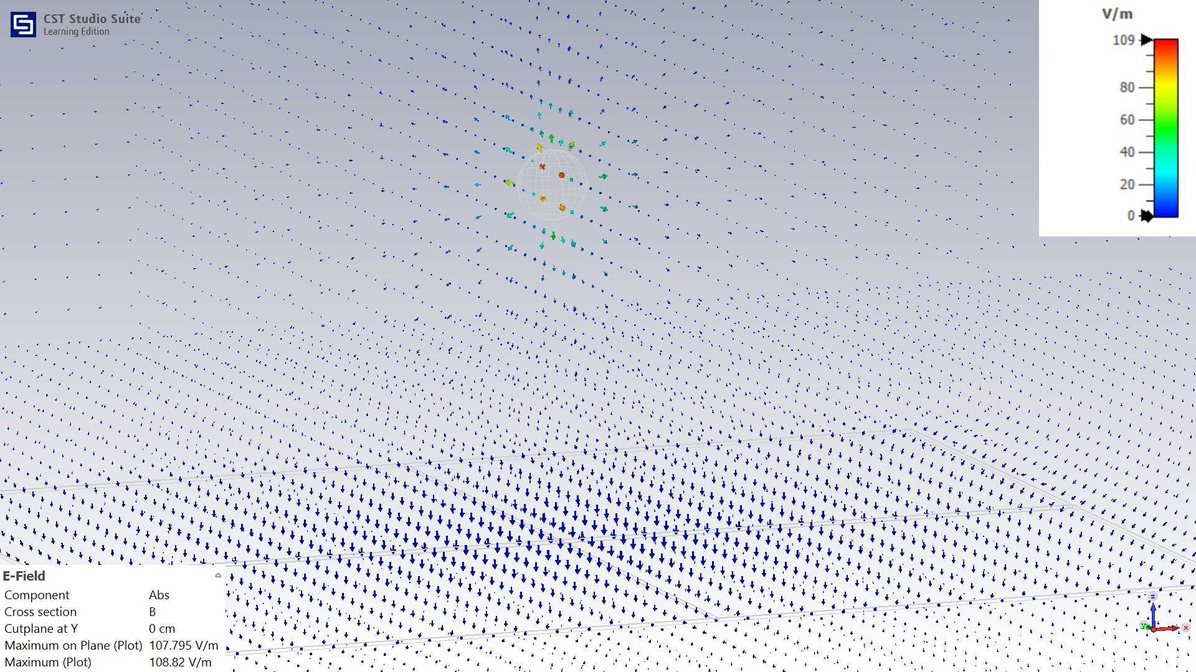
Figure 9:E-Field Vector Plot (Cleaner View) — Cross Section B at Y = 0 cm

This perspective view highlights the behavior of the electric field in the vicinity of the conducting plane and the point charge from a different viewing angle. The field lines are clearly seen curving toward the surface and terminating normally on the plane, demonstrating that no tangential component exists at the conductor boundary. This perspective also reveals the three-dimensional nature of the field distribution around the charge.
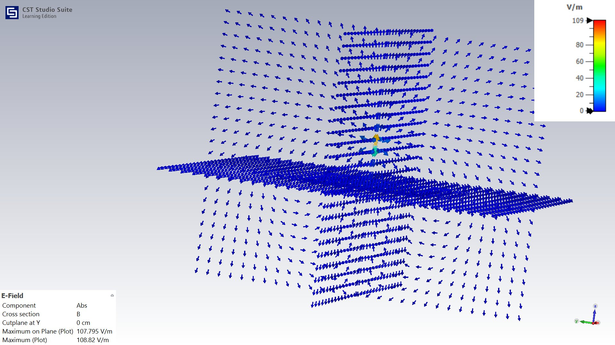
Figure 10:E-Field Field Curling Near Conducting Plane — Perspective View

Simulation Results

Results Extraction
After successful electrostatic solver convergence in CST Studio Suite, the numerical field results were extracted for post-processing and comparison with the analytical image-method solution.
Two main categories of data were exported from CST:
- Electrostatic potential data
- Electric flux density data

The electrostatic potential results were exported as volumetric field samples in the form:
$$(x,y,z,V)$$
Where $\left(x,y,z\right)$ represent the spatial coordinates and$V$ represents the electrostatic potential at each sampled location.

Similarly, the electric flux density data were exported as vector-field samples in the form:
$$(x,y,z,D_{x},D_{y},D_{z})$$

A spatial sampling step size of approximately:
$$h= 0.4 cm$$
was used during the export process to obtain sufficiently detailed field information for accurate comparison with theoretical calculations.

Due to the fine spatial sampling resolution and the three-dimensional nature of the exported fields, the generated CST text files became extremely large. In particular:
- the potential export contained millions of field samples
- the full D-field vector export produced very large datasets because each spatial point contained three vector components.
To reduce MATLAB memory usage and computational complexity during post-processing, only physically relevant regions were selected for comparison. For example:
- the potential contour analysis used the plane nearest to:
$$Y=0$$
- while the D-field validation extracted only the grounded-plane line satisfying:
$$Y≈0 , Z ≈0$$
This selective extraction significantly reduced computational overhead while preserving the important electrostatic behavior required for analytical validation.

Results Analysis

The exported CST electrostatic potential dataset was successfully imported into MATLAB for numerical post-processing and analytical validation.
The imported data contained:
- approximately $6.9×{10}^{6}$ samples
- spatial coordinates in the x, y, and z directions,
- the corresponding electrostatic potential values.

The imported dataset covered the simulation region:
$$x∈[-41.2, 41.6] cm$$
$$y∈[-41.2, 41.6] cm$$
$$z∈[-26.35, 37.25] cm$$

with a potential range between:
$$0≤V≤1 V$$

The large number of samples confirms the high spatial resolution used during CST field export, which improved field accuracy and allowed detailed electrostatic visualization. However, due to the large dataset size, MATLAB post-processing focused on the plane:
$$Y=0$$
which corresponds to the symmetry plane passing through the charged sphere and the grounded conducting plane.

A total of 33280 samples were extracted from this plane for interpolation and contour reconstruction. MATLAB interpolation routines were then applied successfully to generate smooth potential distributions and comparison plots.

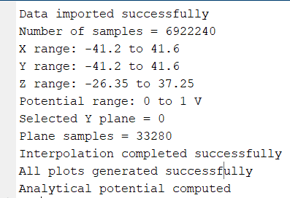
Figure 11: Exporting Potential Data to MATLAB

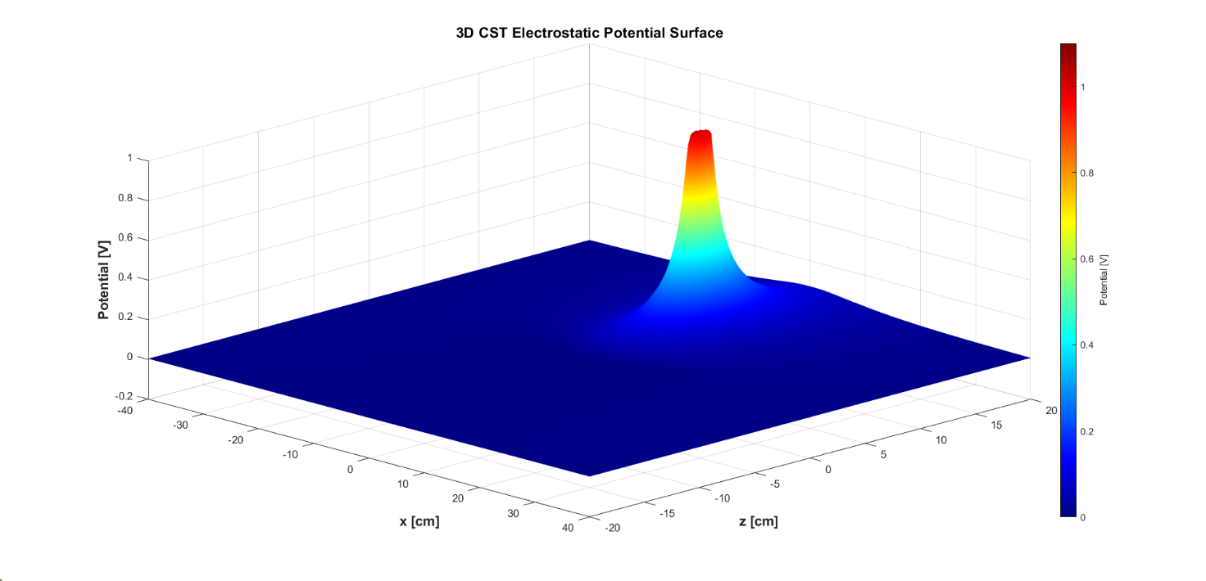
Figure 12: CST Potential Surfaces
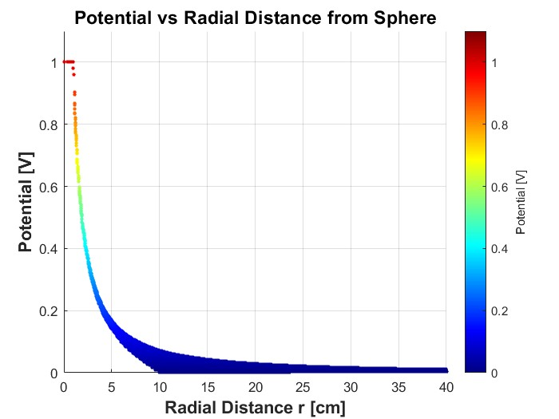
Figure 13: Potential Across Radial Distance From the Sphere

The same workflow is applied on the CST-exported electric flux density data corresponding to the induced surface charge distribution on the grounded conducting plane. The exported dataset was very large because a fine spatial sampling resolution was used during the simulation in order to capture the detailed electric field behavior near the charged sphere and the conducting surface.

The exported data contained the spatial coordinates together with the electric flux density vector components. For the analytical comparison, the normal electric flux density component on the grounded plane was selected because it represents the induced surface charge behavior on the conductor surface.

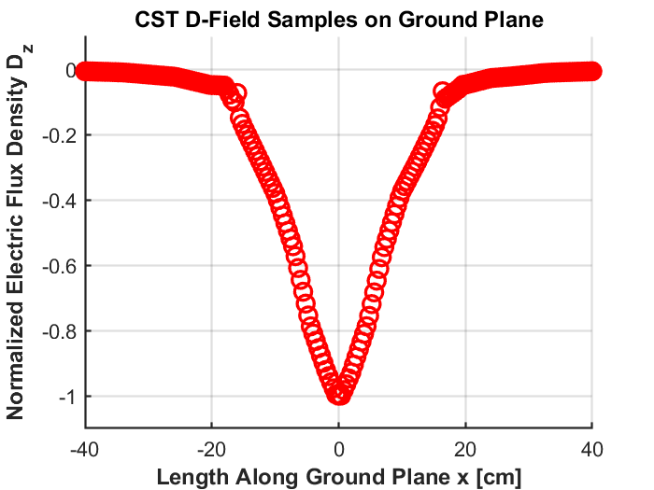
Figure 14: CST Displacement Field Samples
To simplify MATLAB post-processing and reduce computational complexity, only the centerline samples located along the grounded plane were extracted from the full volumetric dataset. The extracted samples were then imported into MATLAB for visualization and direct comparison with the theoretical image-method results.

Theory versus Reality
The final stage of this work focused on comparing the analytical image-method solution with the numerical CST electrostatic simulation results. Both the electrostatic potential distribution and the electric flux density distribution were evaluated and compared in MATLAB using the exported CST datasets.
The comparisons demonstrated that the CST simulation successfully reproduced the main physical behavior predicted by electrostatic theory. The numerical results showed the expected potential decay, induced conductor interaction, and field concentration beneath the charged sphere. Overall, strong agreement was observed between the theoretical image-method solution and the CST simulation results.

Mismatch Reasons

Although the overall agreement between theory and simulation was good, small differences appeared between the analytical and CST results. These deviations are expected because the analytical model is based on ideal assumptions, while CST performs a numerical approximation of the physical problem.
The theoretical image-method solution assumes:
- an infinite grounded conducting plane,
- an ideal mathematical point charge,
- continuous space without numerical discretization.
In contrast, the CST model used:
- a finite conducting plane,
- a finite-radius PEC sphere instead of an ideal point charge,
- a discretized tetrahedral numerical mesh.
Additional differences were introduced by:
- mesh resolution limitations,
- interpolation during MATLAB reconstruction,
- finite export sampling resolution,
- and numerical smoothing near strong field regions.

The strongest mismatch appeared near the charged sphere because the analytical solution contains a singular field behavior, while the CST simulation smooths the field locally due to the finite sphere geometry and mesh discretization.

Potential Comparison
The electrostatic potential distributions obtained from CST and from the analytical image-method equations were compared using contour plots, surface visualizations, and centerline field profiles.
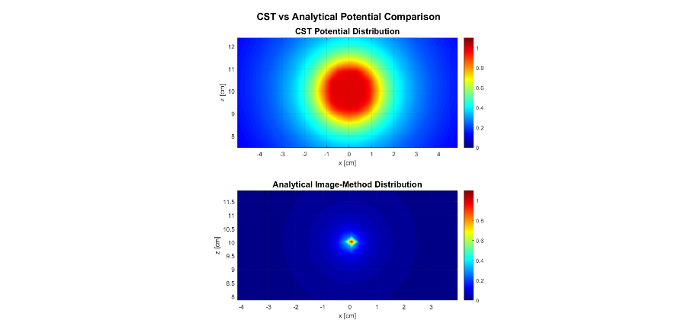
Figure 15: CST vs Analytical Potential Contour
The CST potential distribution reproduced the same general behavior predicted analytically. The highest potential appeared near the charged sphere, while the grounded conducting plane maintained approximately zero potential. The field distribution also showed the expected image-method symmetry and gradual decay away from the charge location.
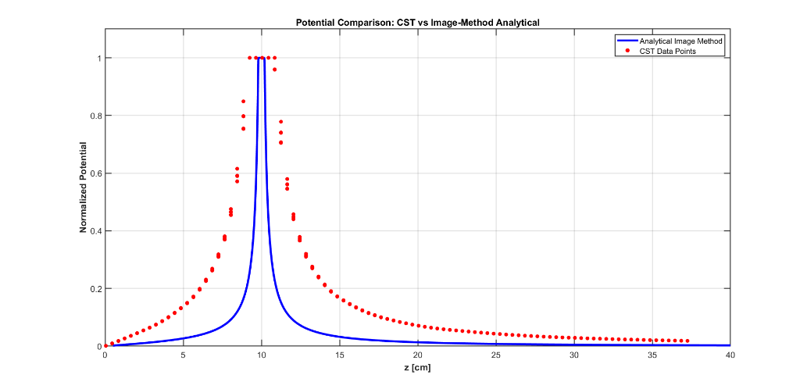
Figure 16: CST vs Analytical across z direction
The centerline comparison demonstrated that the CST numerical solution followed the same theoretical trend across the observation region. Although small deviations appeared near the charge location, the overall field shape and decay behavior showed strong consistency with the analytical solution.
The comparison confirmed that the CST electrostatic solver successfully reproduced the expected electrostatic potential behavior associated with the classical method-of-images problem.

Displacement Comparison
The electric flux density comparison focused on the normal field component along the grounded conducting plane because it directly represents the induced surface charge behavior on the conductor surface.
The CST extracted field samples were compared with the analytical image-method expression implemented in MATLAB. The comparison showed that both the theoretical and numerical solutions produced the same overall field trend, with the strongest field concentration appearing directly beneath the charged sphere and decreasing gradually away from the center.
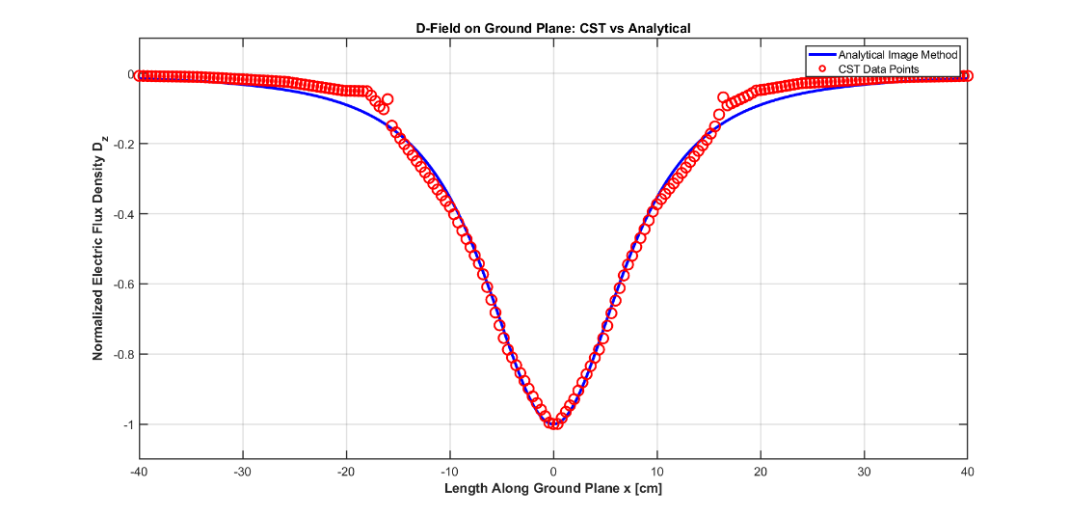
Figure 17: Displacement on Ground Plane Analytically vs CST
The numerical CST samples closely followed the analytical curve in the central region of the conductor surface, confirming correct electrostatic behavior and successful implementation of the grounded boundary condition.
Small differences between the curves were mainly caused by finite geometry effects, numerical mesh discretization, and the approximation of the ideal point charge using a finite PEC sphere. Despite these differences, the comparison demonstrated good agreement between the theoretical image-method solution and the CST electrostatic simulation.

