1. Articulate the goals of the project.   
   1. Describe the application you have chosen, its major components, and what functionality will be necessary based on the scenario.

I chose the event tracking application, the purpose of my app is to be able to post and track local wargame meetups. This will range from tournaments, store openplays to looking for games.Describe the users of the application and the assumptions being made regarding their needs and preferences.

* 1. As you think about potential users, consider the following questions to guide your response:  
     1. How many different types of users can you identify?
        1. Tournament Organizers, Players, Friendly Local Game Store Owners ( referred to as FLGS henceforth), Game Designers
     2. What different goals might individual users have?
        1. Advertisement, finding players, spending an evening.
     3. What will users need to achieve their goals in this app?
        1. Location, event times, game name, knowledge of matching up.

1. Discuss the screens and features that will be necessary to produce a user-centered UI design for the app.   
   1. Include a high-level description of every necessary screen and feature that will be in your app.
      1. Profile page and information input.
      2. Browse Events
      3. Create an event screen.
      4. Edit Event
      5. Request Store

Future Features

* + 1. Pick Up Game Matching
    2. Rating Systems
    3. Instant Message

Explain how a user might move from one screen to another.

New Attending User:   
 Would login and create a profile, including their distance they’d travel and games they’d like to play. They’d then go to the search events app. See what events are available in their area and when, which would include a filter to adjust distance, games, date and number of players. They’d select an event and could not attend/purchase a ticket.   
The individual event card would also have an option to share so that players could post about their event on social media or an embedded link.

Event Creator:

The event would click the create event button and start by choosing a location, time, game, title and input a description of the event and what is occurring and if there are any associated costs to be paid at the door. They could also set a max number of attendees (optional) events could be private or public. Private events can only be found by the share event feature.

You may choose to support your ideas with a simple diagram or illustrations to better represent the different components.

* 1. Justify your decisions by referencing the Android Design and Quality Guidelines linked in the Supporting Materials section.  
     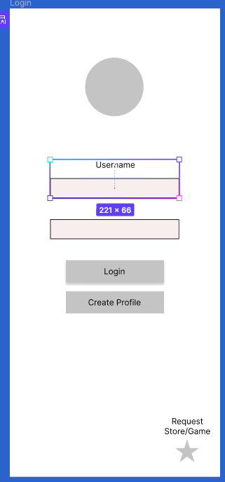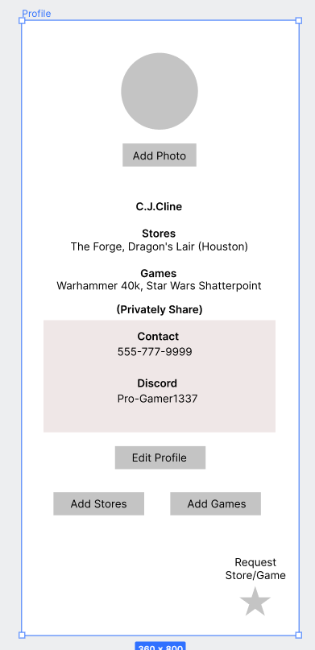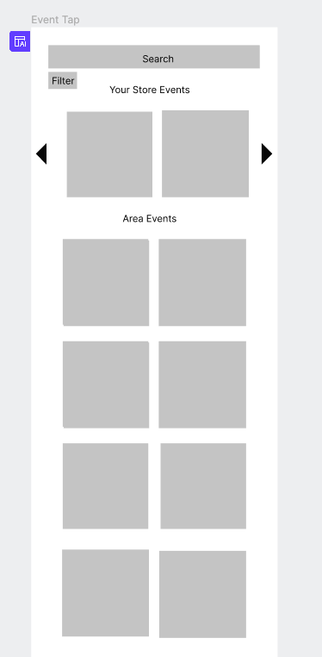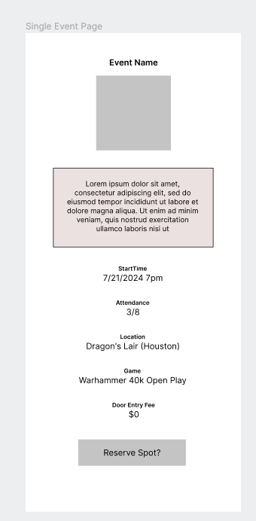

I focused primarily on hierarchy in my design philosophy using mostly the center pillar so the thirds rule while applying wasn’t really a focus. Headings and buttons received bold fonts to emphasis to gather focus. Headings were made smaller than the information, as to create visual interest and focus the eyes more intently on the intended output data.

1. Discuss how the functional app requirements will be represented in the code design and connected to the UI.   
   1. Explain the calls that show the flow of data between code and screens.

These designs were the first pass of the UI for this project, what is unfortunately left off from them will be a hideable nav bar along the bottom. Whose purpose is to navigate between, the profile, favorited events, event search and creating a new event. This is how you’ll move between screens. (this will also include the add a store/game button for the early stages)

* 1. List the major UI components on each screen.  
      Login Page - include, username/password and logins and create profile buttons as well as the suggested store/game to be reviewed to expand the database.

Single Event Page - This page includes two different buttons depending if you are the owner of the page. Reserve a spot which will up the attendance by one or edit, which will change the page into an edit mode where you can swap photos, update descriptions and times etc.

Profile Page - This will be a page that will include your default search parameters games, stores etc. You can turn this off on the search page. This current demo also includes a future plan to add in a looking for games feature where there is unlisted information you update when you match by game. (this might become a direct message feature instead)  
 You can update by either clicking the buttons for quick ads or doing a complete update with the edit button.

Event search page, this includes cards with event names and times over a photo that will be able to be clicked on to go to there single page the top includes a search bar and a filter option to remove or add additional filters to help with your search.

* 1. Determine what data each component will either display or accept as input and where the data might come from.   
      Data comes from the user, to be added to the database. - Events, Profiles, Store/Game Requests.

Data updated from the backend and super users, specific games and stores that can be selected from. ( this will be a needed feature in the future for the Looking for games feature, securing that a store that is added into it as a local store where tables are free )