# IT 230 Coding Activity Submission Template

Submit your work on the coding activities for Modules One, Two, Three, Four, and Six in this document. In addition to this document, you should submit a ZIP file containing all your Visual Studio project files and source code that can be run in Visual Studio on a different computer.

For each coding activity, complete the following steps:

* Download and rename this document to meet the file naming conventions requested in the assignment instructions.
* Fill in the required information below by replacing the bracketed text with the relevant information.
* Submit this document and your ZIP file for grading and feedback. Your ZIP file should follow the same naming conventions.

Document your work in the coding activity by completing each of the following items:

1. Provide a screenshot of the output that resulted from running your program successfully in Visual Studio. See the coding assignment instructions for an example of what should be included in the screenshot. Your screenshot must include the following elements:
   1. Your last name as the first printed text on the screen
   2. Verification that the program is fully functioning and data results are accurate for the given problem

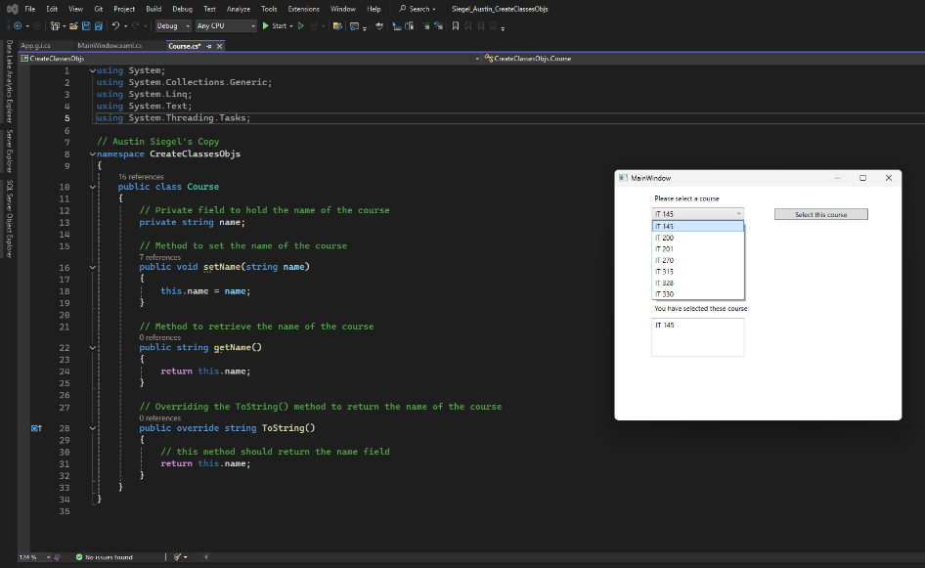

Screenshot 1: Selecting IT-145 from the dropdown window and adding it to the registered courses box.

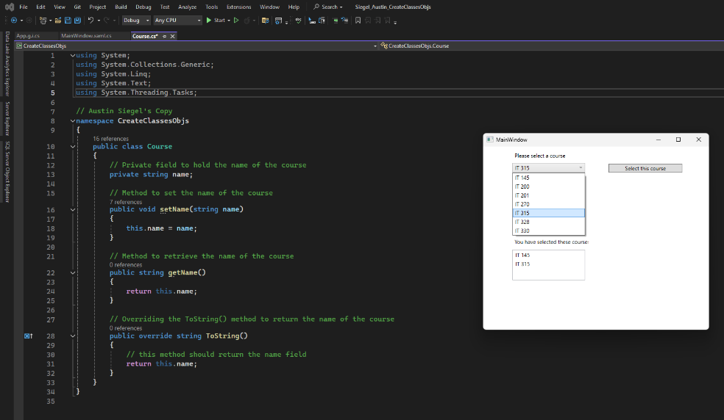

Screenshot 2: Selecting IT-315 from the dropdown window and adding it to the registered courses box.

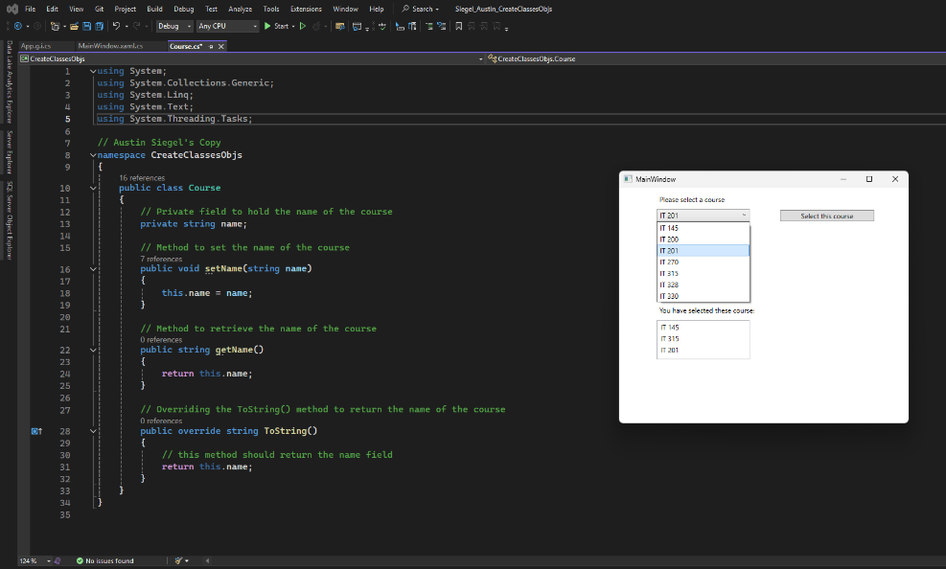

Screenshot 3: Selecting IT-201 from the dropdown window and adding it to the registered courses box.

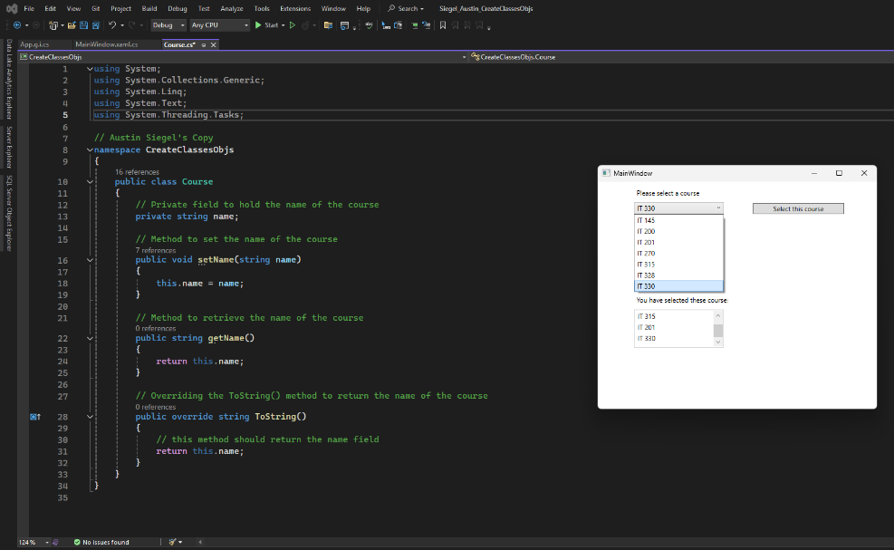

Screenshot 4: Selecting IT-330 from the dropdown window and adding it to the registered courses box. The scroll option in the registration box becomes visible.

1. Copy and paste the source code text you wrote for this assignment from the *.cs file into the space below. Only providing the *.cs files or a screenshot does not meet the requirements for this part of the assignment. Code should be logically organized. It should also follow proper syntax and conventions noted in the Coding Activity Guidelines and Rubric.

using System;

using System.Collections.Generic;

using System.Linq;

using System.Text;

using System.Threading.Tasks;

// Austin Siegel's Copy

namespace CreateClassesObjs

{

public class Course

{

// Private field to hold the name of the course

private string name;

// Method to set the name of the course

public void setName(string name)

{

this.name = name;

}

// Method to retrieve the name of the course

public string getName()

{

return this.name;

}

// Overriding the ToString() method to return the name of the course

public override string ToString()

{

// this method should return the name field

return this.name;

}

}

}

1. Show that you understand the task by explaining the design of your program in the space below. Include the process and steps you took to write your code. Explain how you arrived at the solution to the problem and completed the activity.

This project required that a course.cs file be created to let the use select courses from a list and add them to a new list of registered courses. The program uses a xaml file to show the list of potential courses and a box where the user’s selected courses are added. The Course class was made public to ensure that other methods and classes could access the necessary methods. Within the Course class exists the private string variable and three methods. Private string is used to hold a name for each course on the list (IT-315, IT-330, etc.). This variable is private to limit access to the variable to only those methods who require it.

The setName method is used to assign a value to the name variable. To avoid errors and accidental reassignment, this.name is used to tell the program to assign the name variable with the value passed through the method. The second method getName is used to retrieve the value that was just assigned to the name variable. The final method ToString is used to convert the value of the variable to a string so it can be printed to the console (the xaml file in this case).

1. Reflect on your learning experience and what you learned from completing the activity.

The biggest lesson I learned while completing this activity was the importance of setting up the proper getter and setter methods. Having this infrastructure set up beforehand makes it much easier to follow the logic of the program. This includes assigning the correct private or public values to each method. Having the methods properly names prevent unnecessary access to methods by other parts of the program that might create redundant work. This can also avoid additional syntax or logical errors by making sure private variables do not get overwritten when getting assigned a new value when the method is called again.