**7-2 Final Project Part II**

Austin Siegel

Southern New Hampshire University

IT-230 Software Development with C#.NET

Professor John Watson

6/17/2025

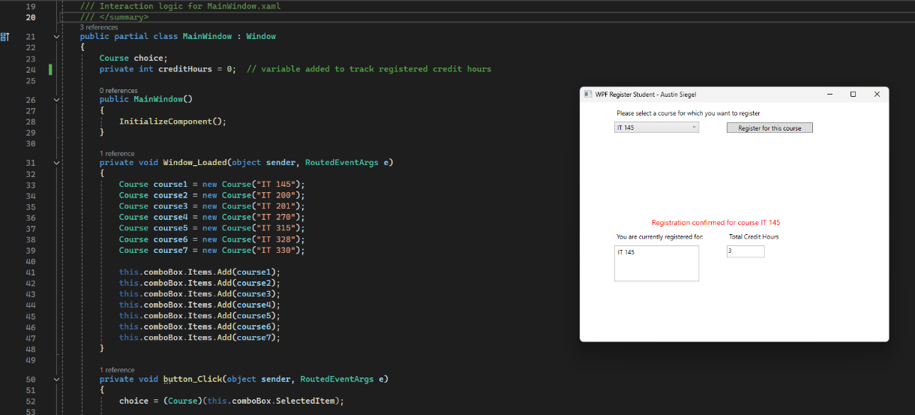

**Screenshot 1:** The program prompts the user to select a course from the dropdown menu. Once selected, the user clicks the ‘Register for this course’ button. The course is then added to the list of registered courses at the bottom of the window. A notification pops up telling the user they have been registered. The number of credit hours is also added to the right. The credit hours increase from 0 to 3.

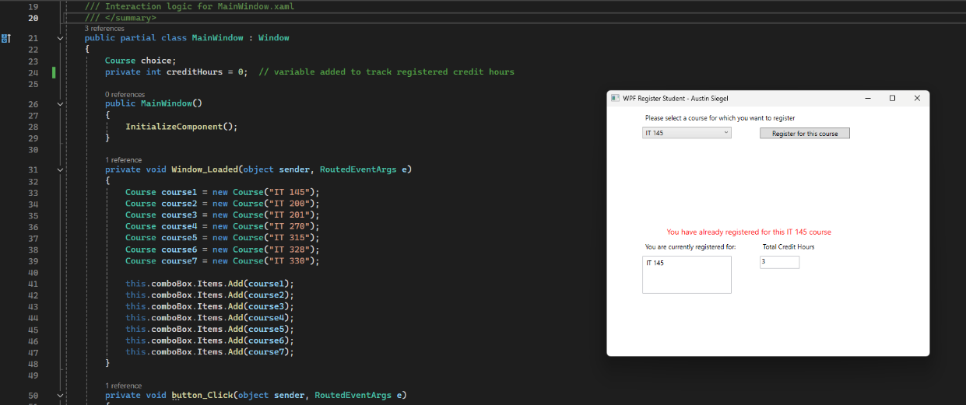

Screenshot 2: The program does not let the user register for the same course twice and notifies the user they are already registered for it. The number of credit hours remains at three since the course was not added to the list a second time.

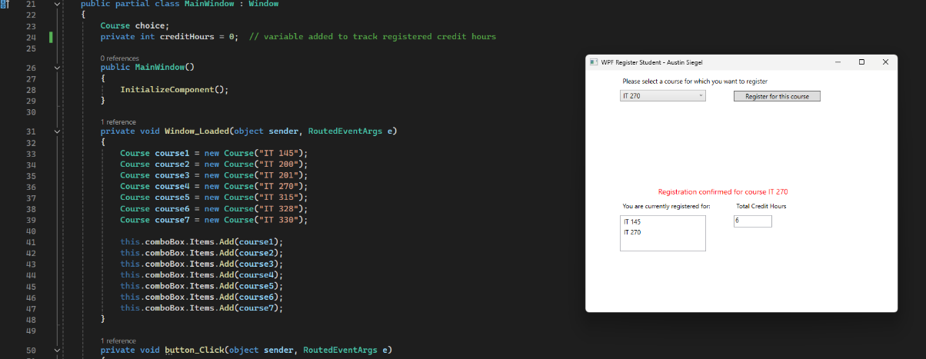

Screenshot 3: The user selects their second course from the dropdown menu. The course is added to the list of registered courses after the user clicks the ‘Register for this course’ button. A notification pops up telling the user they have been registered. The number of credit hours increases from 3 to 6.

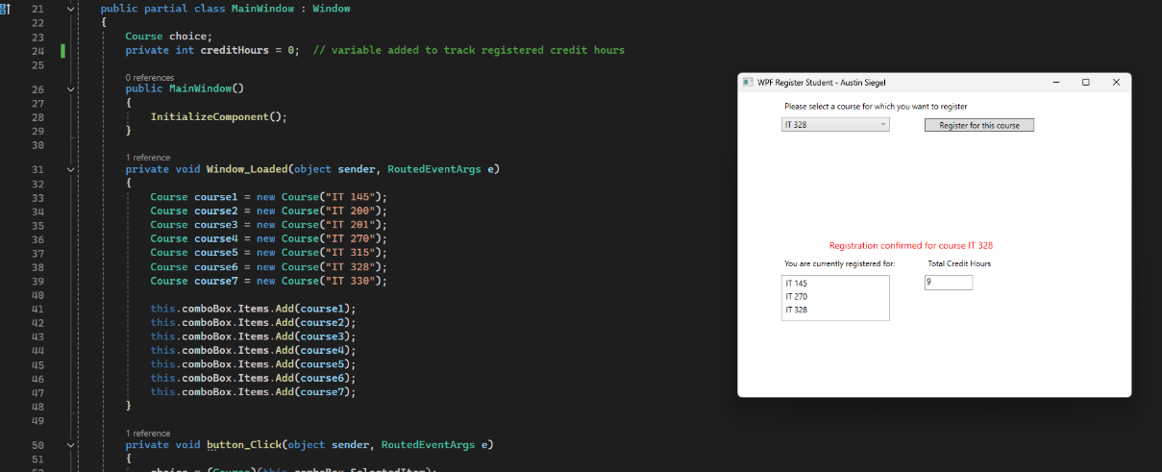

Screenshot 4: The user selects their third course from the dropdown menu. The course is added to the list of registered courses after the user clicks the ‘Register for this course’ button. A notification pops up telling the user they have been registered. The number of credit hours increases from 6 to 9.

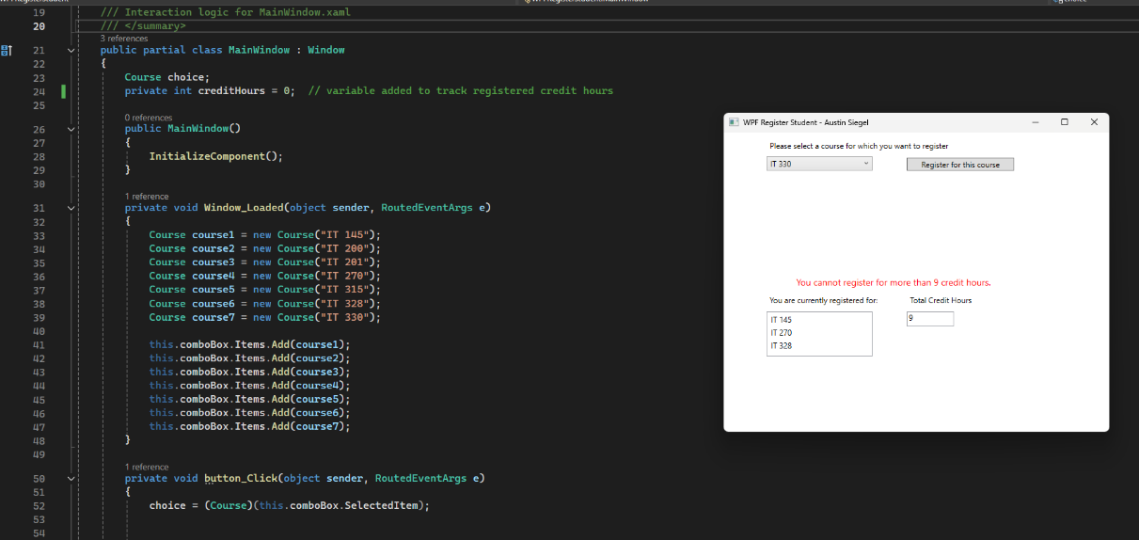

Screenshot 5: The program prevents the user from registering for a fourth course since the number of credit hours cannot exceed 9. A notification pops up telling the user they cannot exceed this limit. The user can terminate this window at any time.

**Code from MainWindow.xaml.cs**

using System;

using System.Collections.Generic;

using System.Linq;

using System.Text;

using System.Threading.Tasks;

using System.Windows;

using System.Windows.Controls;

using System.Windows.Data;

using System.Windows.Documents;

using System.Windows.Input;

using System.Windows.Media;

using System.Windows.Media.Imaging;

using System.Windows.Navigation;

using System.Windows.Shapes;

namespace WPFRegisterStudent

{

/// <summary>

/// Interaction logic for MainWindow.xaml

/// </summary>

public partial class MainWindow : Window

{

Course choice;

private int creditHours = 0; // variable added to track registered credit hours

public MainWindow()

{

InitializeComponent();

}

private void Window_Loaded(object sender, RoutedEventArgs e)

{

Course course1 = new Course("IT 145");

Course course2 = new Course("IT 200");

Course course3 = new Course("IT 201");

Course course4 = new Course("IT 270");

Course course5 = new Course("IT 315");

Course course6 = new Course("IT 328");

Course course7 = new Course("IT 330");

this.comboBox.Items.Add(course1);

this.comboBox.Items.Add(course2);

this.comboBox.Items.Add(course3);

this.comboBox.Items.Add(course4);

this.comboBox.Items.Add(course5);

this.comboBox.Items.Add(course6);

this.comboBox.Items.Add(course7);

}

private void button_Click(object sender, RoutedEventArgs e)

{

choice = (Course)(this.comboBox.SelectedItem);

if (this.listBox.Items.Contains(choice) && choice.IsRegisteredAlready())

{

this.textBlock1.Text = "You have already registered for this " + choice.ToString() + " course"; // Add string to custom text block and print it to window.

}

else if (creditHours < 9) // Total credit hours cannot exceed 9 credit hours

{

this.listBox.Items.Add(choice); // Add each select to the output box of course.

choice.SetToRegistered();

creditHours += 3; // Each course has 3 credit hours each and is updated.

this.textBox.Text = Convert.ToString(creditHours); // TextBox is the credit hour text box displayed.

this.textBlock1.Text = "Registration confirmed for course " + choice.ToString(); // Print string when each eligible course is added.

}

else

this.textBlock1.Text = "You cannot register for more than 9 credit hours.";

}

private void comboBox_SelectionChanged(object sender, SelectionChangedEventArgs e)

{

//comboBox is the method for the dropbox list of courses to choose from.

//It does not need to be defined below to execute this project.

}

private void listBox_SelectionChanged(object sender, SelectionChangedEventArgs e)

{

//listBox is the method where the courses will output to.

//It does not need to be defined below to execute this project.

}

private void textBox_TextChanged(object sender, TextChangedEventArgs e)

{

//This textBox method is the creditHours text box.

//It does not need to be defined below to execute this project.

}

}

}