Flood preparedness in the Liège–Limburg–Aachen border region post-July 2021 floods
30 October 2026

Takeaways
- Exposure is underestimated. In July 2021, 37,005 residents were in the water, 88 % in Germany. In Liège, fewer than 4 in 10 had a dry public building within 500 m. These are minimum figures: no 2021 satellite map covers Verviers, Pepinster or Belgian Limburg.
- Risk is assessed in pieces. Hazard maps, flood observations, population, shelter and warning data sit in separate systems and differ from country to country.
- Recommendations. Share one risk picture across the border, pair every warning with where to go, and spend on the right lever, place by place, in the 2027 plan review.

Introduction
In July 2021, two months of rainfall fell in a few days. The Meuse and the Vesdre in Belgium and the Ahr in Germany burst their banks; 224 people died in Germany and Belgium [13], and losses reached €46 bn, of which only €11 bn was insured [9]. Five years on, the crisis coordinator for the Liège–Limburg–Aachen border area faces a question that cannot yet be answered with confidence: would we be better prepared if the same event returned tomorrow? Information alone is not enough: EFAS warned national authorities on 10 July 2021, about four days ahead, yet up to half of those warned did not know what to do [1, 12].

What science tells us
Exposure was high and concentrated. The first satellite maps show 37,005 residents in the water: 32,562 in Germany, 2,449 in the Netherlands and 1,994 in Belgium [1, 5].
Official hazard maps miss small rivers. Rivers under about 150 km² are not modelled: the JRC 1-in-100-year map missed 12 % of the people reached in Venlo–Roermond but 91 % in Eschweiler [1, 5, 6]. Of the 224 deaths, 58 % occurred outside mapped hazard zones [13].
Plans run ahead of works. Wallonia adopted a Vesdre basin scheme [11] and enlarged the Eupen dam reserve [10], yet only one Walloon reservoir dam has an emergency plan [7]; Germany has paid out €5.84 bn of its €30 bn fund [2]; the Netherlands has done 50 of 80 actions [8]. The public record does not show how much exposure has fallen.
Most people reached had no shelter close by. In Liège only 37 % of the people the water reached had a dry public building within 500 m; told in time where to go, 78 % could walk to one within 1 km. Their capacity is not recorded, and 45 schools and 2 hospitals or care homes lie inside Liège's 1-in-100-year zone [1, 5].
Implications. Whether the region is better prepared cannot be answered with today's information, and that uncertainty is itself a risk, until hazard, exposure and the capacity to respond are assessed together and the gaps are closed.
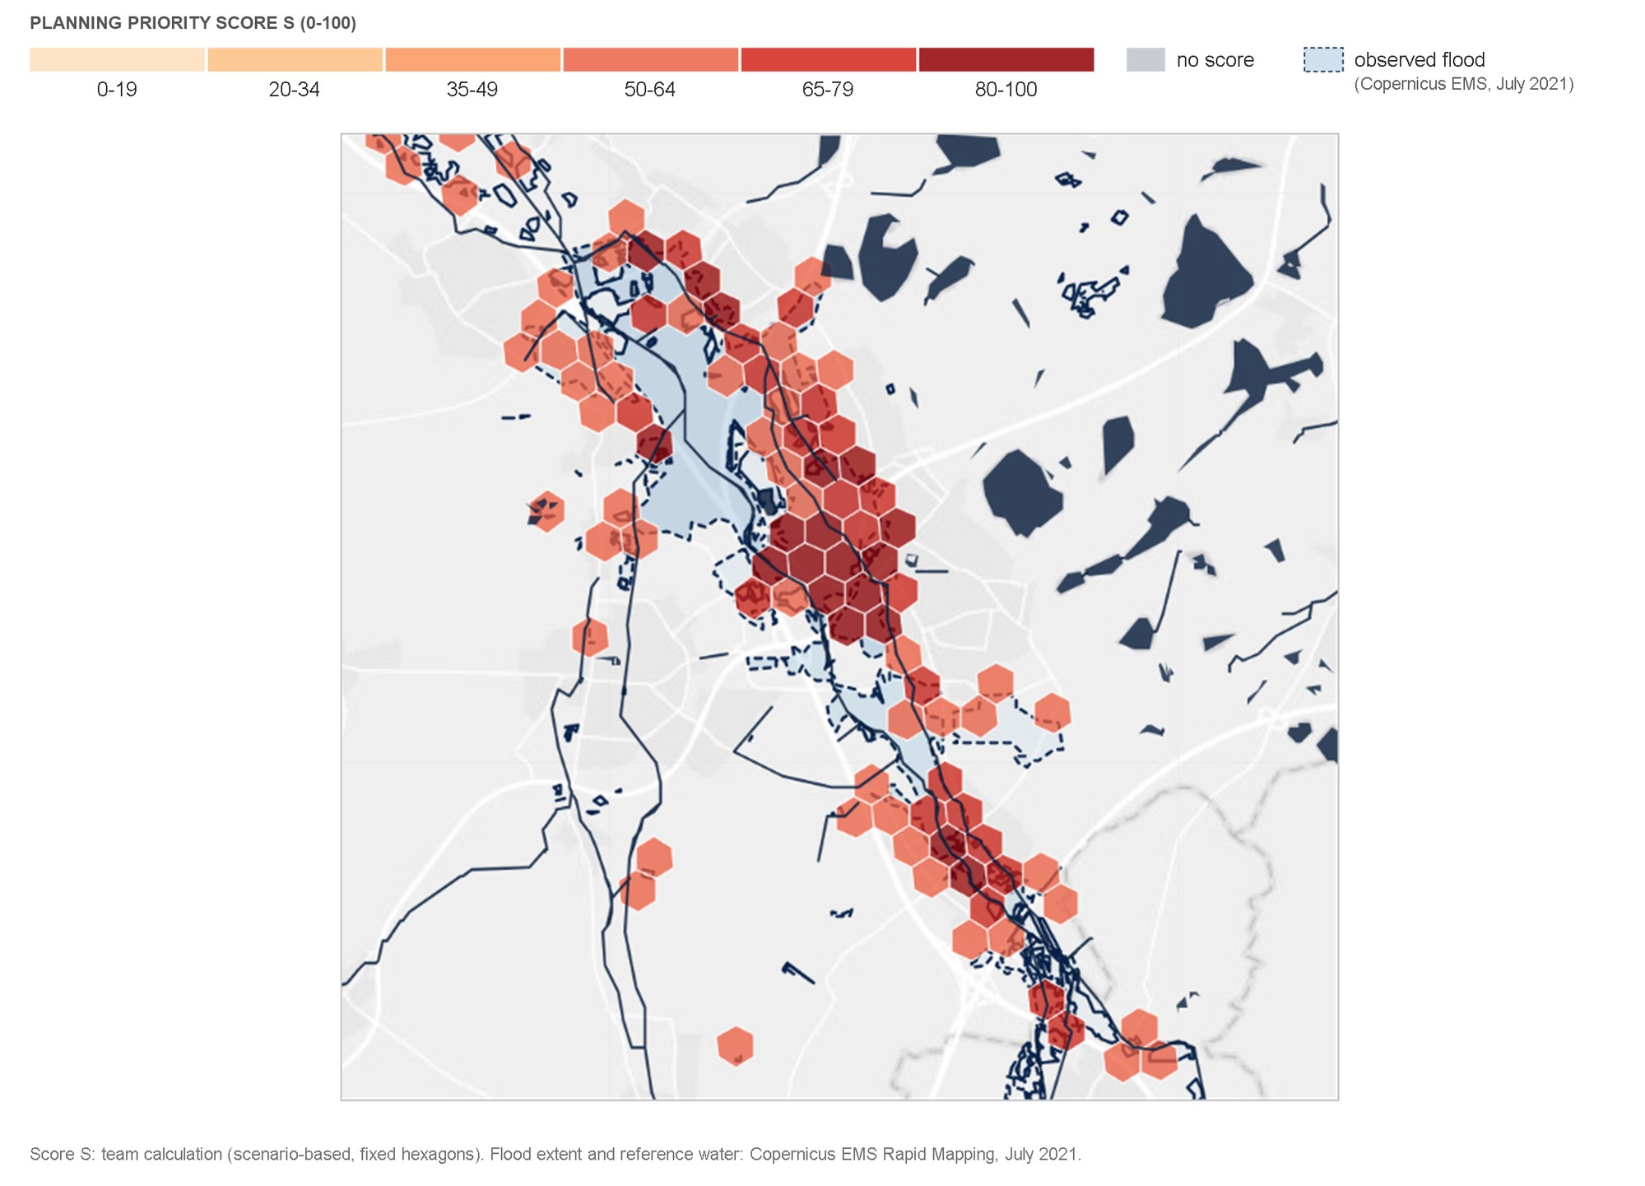
Figure 1: Planning priority score by hexagon (team calculation, scenario-based), with the flood observed in July 2021 [1].

Policy implications
1. Combine data into shared risk metrics. Each country publishes hazard, flood, population, shelter and warning data in its own formats and languages. Agree common data standards and derive simple metrics per area (exposure, shelter gap, uncertainty) with a transparent, adjustable method; start where both are highest, such as Liège. Who, by when: The crisis coordinators of Liège, Dutch Limburg and the Aachen region, through EMRIC (the Euregio Meuse-Rhine crisis cooperation), from now on. Instrument, cost: Existing Copernicus and JRC data; staff time.
2. Link warnings to local tangible actions and coordinate across borders before the next event. Each warning should come with concrete local instructions: which areas are affected and where to go. Evacuation must actively assist those least able to act: the elderly were over-represented among the 224 people who died, and many died inside their own homes [13]. In Dutch Limburg and Ahrweiler about 1 in 4 residents is over 65, against 22 % in the EU [4]. Activation mechanisms differ between countries; align them so that a warning on one side of the border triggers a compatible response on the other. Who, by when: The crisis coordinators with the mayors, before the next rain. Instrument, cost: Cell Broadcast (BE-Alert, NL-Alert, DE-Alert); staff time.
3. Spend on the right lever, place by place, in the 2027 plan review. Map the small rivers the European map leaves out and plan for the 1-in-100-year scenario, not only the 2021 footprint. On big rivers where defences hold: warning and meeting points, not a bigger dyke. On small, steep rivers: flash warning, local protection and managed retreat. With most 2021 flood losses uninsured [9], public money must not pay for the wrong wall. Who, by when: The flood-risk planners of Belgium, the Netherlands and Germany, through the International Meuse Commission, for the 2027 plan review. Instrument, cost: Floods Directive Art. 8(2) and the Art. 14 review [3]; no new body.

References
[1] Copernicus EMS, (2021), EFAS and Rapid Mapping, July 2021, https://mapping.emergency.copernicus.eu/.
[2] Deutscher Bundestag, (2026), Drucksache 21/4443, Hochwasserschutz und Verwendung der Wiederaufbauhilfe 2021, https://dserver.bundestag.de/btd/21/044/2104443.pdf.
[3] European Union, (2007), Floods Directive 2007/60/EC, Art. 8 and 14, https://eur-lex.europa.eu/eli/dir/2007/60/oj.
[4] Eurostat, (2025), Population by age group, NUTS 3 regions (demo_r_pjangrp3), https://ec.europa.eu/eurostat/databrowser/view/demo_r_pjangrp3/default/table.
[5] JRC, (2023), GHS-POP R2023A (E2020); GHS-OBAT R2024A, https://data.jrc.ec.europa.eu/.
[6] JRC, (2024), River flood hazard maps for Europe v3.1.1, https://jeodpp.jrc.ec.europa.eu/ftp/jrc-opendata/CEMS-EFAS/flood_hazard/.
[7] La DH, (2025), Un seul barrage-réservoir wallon doté de son plan d'urgence et d'intervention, https://www.dhnet.be/regions/liege/2025/12/09/un-seul-barrage-reservoir-wallon-dote-de-son-plan-durgence-et-dintervention-la-deputee-valerie-dejardin-a-interpelle-le-ministre-desquesnes-CN34L6GWWRE5LA2C6YVPJP3224/.
[8] Ministerie van Infrastructuur en Waterstaat, (2026), Voortgangsrapportage Beleidstafel wateroverlast en hoogwater, https://klimaatadaptatienederland.nl/publish/pages/236290/voortgangsrapportage-beleidstafel-wateroverlast-en-hoogwater-april-2026.pdf.
[9] Munich Re, (2022), Natural disaster losses in 2021, https://www.munichre.com/en/company/media-relations/media-information-and-corporate-news/media-information/2022/natural-disaster-losses-2021.html.
[10] RTBF, (2022), Barrage d'Eupen : des pratiques nouvelles pour éviter les catastrophes, https://www.rtbf.be/article/barrage-d-eupen-des-pratiques-nouvelles-pour-eviter-les-catastrophes-11021028.
[11] Service public de Wallonie, (2023), Schéma stratégique multidisciplinaire du bassin versant de la Vesdre, https://territoire.wallonie.be/fr/page/inondations#schema-strategique-vesdre.
[12] Thieken, A. H., et al., (2023), Performance of the flood warning system in Germany in July 2021, NHESS 23, 973–990, doi:10.5194/nhess-23-973-2023.
[13] Thieken, A. H., et al., (2026), Understanding flood fatalities: reevaluating flood risk management, Earth's Future 14(9), doi:10.1029/2026EF008695.
Authors: Team 9

