Measuring Semantic Robustness in LLM-Based Essay Scoring: A Paraphrase Sensitivity Analysis
Student: Sansiri Charoenpong
Student Number: 730099617
Supervisor: Dr. Rodrigo Souza Wilkens
Module: ECM3401 Individual Project
Department: Computer Science, University of Exeter
Academic Year: 2025/26

Abstract
Automated essay scoring using large language models has achieved accuracy comparable to human raters, yet no prior study has measured reliability across semantically equivalent prompt variations. This research addresses a critical gap: while 49 existing studies report average accuracy for LLM-based essay scoring, none measure consistency when prompts are paraphrased. Through two experimental phases testing GPT-4o-mini and Phi-3-mini across paraphrased prompt variants, we evaluated CEFR classification of 100 stratified essays from the Write & Improve corpus, generating 3,600 predictions.
Phase 1 established baseline robustness (Krippendorff’s α = 0.63–0.85 for GPT-4o-mini) but revealed severe B1 bias: 85% accuracy on B1 essays versus 0% on C1/C2 levels. Phase 2 tested hypothesis-driven interventions, achieving 76% robustness improvement for chain-of-thought prompting (SD: 0.489→0.117) while maintaining accuracy. However, single-word changes caused catastrophic failures: formal CEFR terminology reduced accuracy from 30% to 6%, while special characters completely broke smaller models.
Linguistic analysis revealed a multi-dimensional complexity confound: word count (r = −0.66), parse tree depth (r = −0.50), type-token ratio (r = +0.45), and lexical density (r = −0.33) jointly predict model failure at advanced CEFR levels. Pairwise variant agreement analysis identified systematic outlier patterns, with specific prompt phrasings triggering directional bias in 86% of disagreement cases.
These findings establish semantic robustness as an essential evaluation metric for LLM-based assessment, demonstrating that prompt engineering is effective for robustness improvement but requires extensive validation across model architectures due to fragility unsuitable for production deployment without automated testing frameworks.
Keywords: Automated Essay Scoring, Large Language Models, Prompt Engineering, CEFR Classification, Semantic Robustness, Paraphrase Sensitivity

1. Introduction

1.1 Context and Motivation
Automated essay scoring (AES) has evolved from rule-based systems to sophisticated neural approaches, with large language models now achieving accuracy comparable to human raters. Traditional psychometric evaluation of assessment instruments focuses on inter-rater agreement and test-retest reliability, both well-established through decades of measurement theory (Crocker and Algina, 1986). LLM-based assessment introduces a new dimension of reliability concern: sensitivity to prompt paraphrasing, where semantically identical instructions may produce divergent classifications.
Consider two prompts: “Classify this essay’s CEFR level” versus “Determine the CEFR proficiency demonstrated in this essay.” Human assessors would treat these identically, yet language models process them through different token sequences, potentially activating different internal representations. This semantic robustness—consistency across paraphrased prompts—has not been systematically measured in prior AES research despite its critical importance for deployment reliability. The Write & Improve corpus (Bryant et al., 2023), containing 23,216 learner essays with human-annotated CEFR levels, provides an ideal testbed for this investigation.

1.2 Research Gap
Systematic review of 49 LLM-based essay scoring studies (Yilmaz, 2025) reveals a consistent pattern: all report point estimates of accuracy but none measure reliability across prompt variations. This gap has three consequences. First, reported performance differences between prompt strategies may be measurement artefacts rather than genuine strategy superiority. When Kim et al. (2025) report minimal prompts achieving QWK = 0.58 versus detailed prompts at QWK = 0.68, we cannot determine whether this 10-point gap reflects strategy effectiveness or fortunate wording of a single prompt instance. Second, educational institutions cannot make informed deployment decisions without knowing whether a system producing 85% average accuracy might produce 70% or 100% depending on how the scoring prompt is phrased. Third, the rapid adoption of prompt engineering in educational AI assumes stability without empirical validation, creating a foundation of potentially unreliable assessment infrastructure.

1.3 Research Questions
This research addresses five research questions spanning robustness measurement, prompt design, and deployment economics:
RQ1 (Primary): Are LLM CEFR predictions robust to prompt paraphrasing?
Hypothesis: Predictions across semantically equivalent variants achieve Krippendorff’s α ≥ 0.67 (tentative conclusions threshold).
RQ2: Does prompt complexity affect robustness?
Hypothesis: Structured prompts (rubric-based, chain-of-thought) show lower variance than minimal prompts.
RQ3: Can hypothesis-driven prompt modifications improve robustness?
Hypothesis: Targeted interventions addressing identified biases reduce prediction variance while maintaining accuracy.
RQ4: Does model architecture affect robustness?
Hypothesis: Larger commercial models demonstrate greater robustness than smaller open-source models.
RQ5: What is the cost-robustness tradeoff for deployment?
Hypothesis: Commercial APIs provide acceptable robustness at negligible cost compared to local model infrastructure.

1.4 Contributions
This research makes four novel contributions to automated essay scoring. First, it establishes the first robustness measurement framework for LLM-based AES, using Krippendorff’s alpha and pairwise agreement analysis to quantify inter-variant reliability. Second, it provides systematic error pattern analysis revealing severe B1 bias and a multi-dimensional linguistic complexity confound involving word count, syntactic depth, and lexical sophistication. Third, it demonstrates prompt engineering brittleness through controlled failure analysis, showing that single-word changes cause catastrophic accuracy degradation. Fourth, it develops a cost-reliability framework quantifying deployment tradeoffs between commercial and open-source models.

2. Literature Review

2.1 Automated Essay Scoring: Evolution and Current State
Automated essay scoring has evolved through three distinct generations. First-generation systems (1960s–2000s) used handcrafted features and statistical models. Project Essay Grade (Page, 1966) pioneered automated scoring through surface feature counting, while E-rater (Burstein et al., 1998) introduced more sophisticated natural language processing features including discourse structure analysis. These systems achieved moderate correlation with human raters (~0.7) but required extensive feature engineering and task-specific calibration. Crucially, traditional AES included systematic reliability testing: E-rater’s deployment required test-retest reliability exceeding 0.85 and inter-rater agreement within 0.5 standard deviations (Attali and Burstein, 2006).
Second-generation systems (2010s) employed neural architectures that learned feature representations automatically. Taghipour and Ng (2016) demonstrated that long short-term memory networks could capture discourse-level features without explicit feature engineering. The introduction of BERT (Devlin et al., 2019) marked a significant advance: bidirectional contextual embeddings enabled models to capture nuanced linguistic relationships. Mayfield and Black (2020) showed BERT-based scoring achieved 0.80+ correlation with human raters on the ASAP dataset, approaching traditional AES benchmarks. However, these systems required substantial training data and task-specific fine-tuning, limiting their flexibility across assessment contexts.
Third-generation approaches (2020s–present) leverage large language models in zero-shot or few-shot settings, fundamentally changing the paradigm from trained classifiers to prompted general-purpose systems. Brown et al. (2020) demonstrated that GPT-3, with sufficient scale, could perform assessment tasks without fine-tuning. Mizumoto and Eguchi (2023) showed GPT-3.5 achieved 73% agreement with human CEFR ratings, while Yeung and Yeung (2024) found GPT-4 reached 85% exact agreement for holistic scoring. Mendonca et al. (2023) specifically demonstrated GPT-4’s capability for CEFR-level classification, achieving results competitive with fine-tuned models. This zero-shot capability eliminates the data collection bottleneck but introduces prompt sensitivity as a new reliability concern—one that traditional AES validation frameworks were not designed to address.

2.2 CEFR Assessment and Linguistic Features
The Common European Framework of Reference for Languages (Council of Europe, 2001) defines six proficiency levels from A1 (beginner) to C2 (mastery) through descriptive can-do statements spanning linguistic competence across range, accuracy, fluency, and interaction dimensions. Operationalising these descriptors for automated assessment remains challenging because CEFR levels are defined through qualitative descriptions rather than quantitative thresholds.
Hawkins and Buttery (2010) identified grammatical complexity as the primary CEFR discriminator: A-level learners use simple present/past tenses and coordination, B-level learners demonstrate subordination and modal constructions, while C-level learners show register flexibility and discourse-level control. Vajjala and Loo (2014) found lexical sophistication measures—particularly type-token ratio and academic vocabulary density—strongly predicted CEFR levels, though these correlate with essay length, introducing potential confounds. This length-proficiency correlation is well documented: advanced learners naturally produce longer texts with more complex syntactic structures, creating a confound that automated systems may exploit as a classification shortcut rather than genuinely assessing linguistic competence.
Crossley et al. (2019) demonstrated that BERT embeddings capture CEFR-relevant features implicitly, achieving 78% classification accuracy without explicit linguistic feature engineering. However, the lack of interpretability makes it difficult to diagnose whether models rely on genuine proficiency indicators or surface correlates such as essay length. This interpretability gap becomes critical when prompt modifications change model behaviour in unpredictable ways.

2.3 Prompt Sensitivity in Large Language Models
Recent research has revealed significant prompt sensitivity in LLM outputs across multiple domains. Lu et al. (2022) found GPT-3 performance on CommonsenseQA varied by 15 percentage points across semantically equivalent prompts, demonstrating that models are surprisingly sensitive to surface-level phrasing differences. Webson and Pavlick (2022) showed that even irrelevant prompt modifications—changes that should not affect task performance—substantially altered outputs, raising fundamental questions about whether LLMs truly understand task specifications or merely pattern-match against training data.
Zhao et al. (2021) identified calibration issues as a contributing factor: LLMs show systematic biases toward certain output tokens regardless of input content. For essay scoring, this suggests potential default-level predictions when models encounter uncertainty. Zhou et al. (2023) demonstrated that chain-of-thought prompting improves reasoning task accuracy but increases variance across prompt phrasings—an accuracy-variance tradeoff that has not been investigated for essay scoring, where both metrics matter for deployment reliability.
Kim et al. (2025) compared minimal and detailed prompting strategies for CEFR classification, finding performance differences (QWK: 0.58 vs. 0.68). However, because each strategy was tested with a single prompt instance, it is impossible to determine whether the difference reflects strategy superiority or prompt-instance variance. This confound—testing single prompt instances per condition—pervades the existing literature and motivates the paraphrase-based robustness measurement approach adopted in this research.

2.4 Gap in Current Literature
The intersection of automated essay scoring, prompt engineering, and robustness evaluation reveals a critical methodological gap. While 49 studies report accuracy metrics on standard test sets and three studies acknowledge prompt sensitivity (Yilmaz, 2025), no study systematically measures robustness across semantically equivalent prompt variations, no study establishes deployment thresholds for acceptable variance levels, and no study provides a framework for cost-reliability analysis that accounts for variance-induced human oversight requirements. This gap is particularly consequential because educational technology adoption requires reliability guarantees: a model with 85% average accuracy but 15-point variance across phrasings provides inconsistent service that may harm learners through unpredictable placement decisions.

3. Methodology

3.1 Experimental Design Overview
This research employs a two-phase experimental design. Phase 1 establishes baseline robustness across true paraphrases (semantically identical prompt variations), generating 1,800 predictions across 2 models, 3 strategies, and 3 paraphrase variants (v1–v3) applied to 100 essays. Phase 2 tests hypothesis-driven interventions (v4–v6) designed to address systematic errors identified in Phase 1, generating an additional 1,800 predictions. The total experimental corpus comprises 3,600 predictions enabling within-subject comparison across phases.
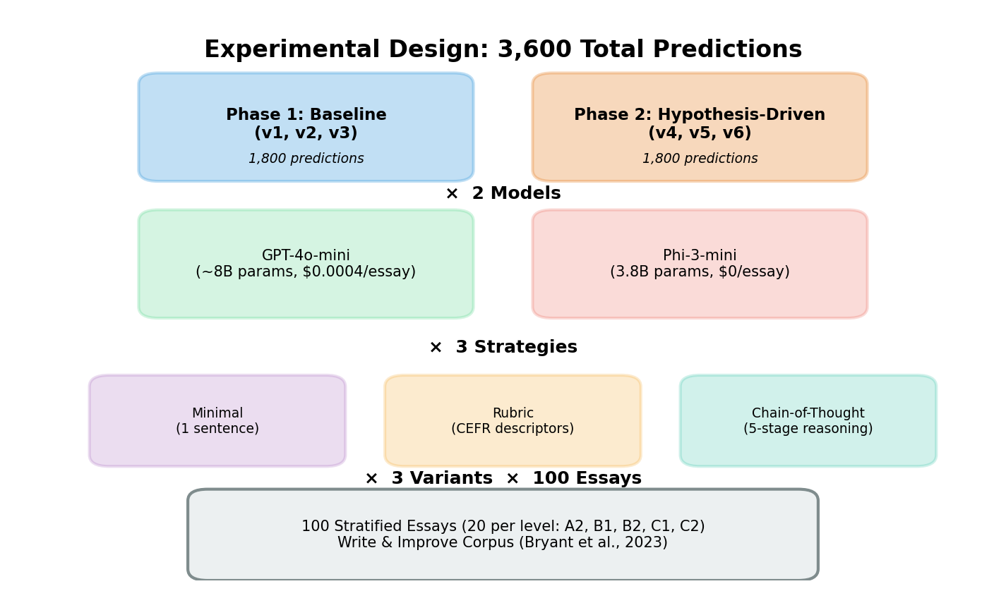
*Figure 1: Experimental design overview showing the two-phase structure

3.2 Dataset: Write & Improve Corpus
The Write & Improve corpus (Bryant et al., 2023) contains 23,216 learner essays from the Cambridge English Write & Improve platform, annotated by expert raters with CEFR levels. The corpus includes multiple essay versions, rich metadata (L1 background across 22 languages, prompt type, essay length), fine-grained CEFR labels (A1–C2 with + modifiers), and pre-defined train/dev/test partitions. Only final versions with human-annotated CEFR levels from train/dev splits were used (N = 4,546 usable essays after filtering), ensuring predictions are compared against stable expert judgements.
The CEFR distribution after combining + levels with base levels was: A2: 972 (21.4%), B1: 1,807 (39.7%), B2: 1,293 (28.4%), C1: 437 (9.6%), C2: 27 (0.6%). A1 essays (N = 10) were excluded due to insufficient sample size. C2 underrepresentation reflects real-world proficiency distribution in learner corpora.

3.3 Sample Selection: Stratified Random Sampling
A stratified random sample of N = 100 essays (20 per CEFR level: A2, B1, B2, C1, C2) was drawn using a fixed random seed (42) for reproducibility. This balanced design prevents level frequency from dominating aggregate metrics while providing sufficient data for robustness measurement (300 predictions per model-strategy combination per phase). The length distribution in the sample was: short (<100 words): 24 essays (24%), medium (100–200 words): 29 essays (29%), long (>200 words): 47 essays (47%), matching corpus-level patterns.

3.4 Model Selection
Two models were selected to represent distinct deployment scenarios. GPT-4o-mini (OpenAI, estimated ~8B parameters) represents cost-effective commercial deployment at $0.150/1M input tokens and $0.600/1M output tokens. Phi-3-mini (Microsoft, 3.8B parameters) represents resource-constrained local deployment at zero marginal inference cost. Both models were configured with temperature = 0 for deterministic sampling, ensuring all measured variance reflects prompt paraphrasing effects rather than stochastic sampling noise. Maximum output tokens were set to 10, sufficient for single CEFR level responses.

3.5 Prompt Engineering: Three Strategies
Three prompting strategies were designed to span the complexity spectrum. The minimal strategy provides a single instruction sentence without structured guidance (e.g., “Classify this essay’s CEFR level: A2, B1, B2, C1, or C2”), establishing a lower bound for model behaviour. The rubric-based strategy includes CEFR descriptor summaries for each level with explicit feature lists covering grammar, vocabulary, and discourse markers. The chain-of-thought (CoT) strategy implements a multi-step reasoning protocol with explicit analysis stages progressing from morphosyntactic analysis through lexical sophistication, discourse features, diagnostic markers, and final level decision.

3.6 Paraphrase Generation
Phase 1 variants (v1–v3) are semantically identical paraphrases preserving core instruction content while varying lexical choice and syntactic structure. For example, the minimal strategy variants were: v1: “Classify this essay’s CEFR level”; v2: “Determine the CEFR proficiency demonstrated in this essay”; v3: “Score this CEFR essay (A2–C2).” Paraphrases were manually generated by the researcher, validated through pilot testing, and confirmed to produce identical human classifications.
Phase 2 variants (v4–v6) incorporate targeted interventions based on Phase 1 findings. These address the severe B1 bias through explicit level discriminators (e.g., “B2 requires complex subordination AND hypotheticals”), the length confound through explicit length-normalisation instructions (e.g., “Essay length is NOT a proficiency indicator”), and adjacent-level confusion through ordinal constraints and anti-bias checks.

3.7 Experimental Procedure
Each essay was processed through all 18 configurations per phase (2 models × 3 strategies × 3 variants). The inference protocol loaded essay text, inserted it into the prompt template, submitted to the model API with temperature = 0, extracted CEFR predictions via regex matching, and recorded results with timestamps. Predictions were saved incrementally every 10 predictions to prevent data loss. Quality checks verified all 100 essays were processed per configuration, confirmed no missing predictions, validated CEFR output format, and logged API errors.

3.8 Evaluation Metrics
Robustness was measured through multiple complementary metrics. Standard deviation (SD) across variant accuracies per strategy provides a simple variance measure, with SD < 0.5 considered deployment-ready. Krippendorff’s alpha, treating each variant as an independent annotator rating the same 100 essays, provides a chance-corrected reliability coefficient using the ordinal distance metric appropriate for CEFR’s ordered categories. Following standard interpretation thresholds: α < 0.0 indicates worse-than-chance reliability, α = 0.67–0.80 supports tentative conclusions, and α > 0.80 enables definitive conclusions (Krippendorff, 2004). Pairwise agreement between all variant pairs (v1-v2, v1-v3, v2-v3) identifies which specific paraphrases diverge most, enabling diagnosis of prompt-specific sensitivity.
Accuracy was measured through exact match (percentage of correct CEFR classifications), adjacent accuracy (predictions within ±1 level, acceptable for adaptive placement), confusion matrices revealing systematic biases, and error severity (ordinal distance between true and predicted levels, mapping CEFR to A2 = 1, B1 = 2, B2 = 3, C1 = 4, C2 = 5).
Linguistic complexity was assessed through continuous word count correlation (Pearson r), parse tree depth via stanza constituency parsing (mean and maximum depth per essay), type-token ratio (unique words / total words), and lexical density (content words / total words via spaCy POS tagging).

3.9 Statistical Analysis
Phase comparisons used paired t-tests for within-subject design with Bonferroni correction for multiple comparisons. Confound analysis employed Pearson correlation for continuous variables. Majority voting analysis identified outlier variants when 2/3 variants agreed, and disagreement direction analysis determined whether specific variants systematically predicted higher or lower CEFR levels.

3.10 Ethical Considerations
The Write & Improve corpus is publicly released for research purposes. No personally identifiable information is present in the essays, which are anonymised with numeric identifiers. Stratified sampling ensures level representation across multiple L1 backgrounds. All prompts, code, and experimental configurations are documented in the project repository for full reproducibility.

4. Results

4.1 Phase 1: Baseline Robustness

4.1.1 Overall Performance
Phase 1 generated 1,800 predictions. GPT-4o-mini achieved 33.0% exact accuracy with 69.6% adjacent accuracy at $0.0004/essay. Phi-3-mini achieved 24.4% exact accuracy with 64.9% adjacent accuracy at zero marginal cost. Krippendorff’s alpha analysis revealed GPT-4o-mini achieves deployment-ready inter-variant reliability for minimal (α = 0.84) and rubric (α = 0.85) strategies, with moderate agreement for CoT (α = 0.63). Phi-3-mini showed substantially lower reliability: minimal α = 0.63, rubric α = 0.11, CoT α = −0.43, the last indicating systematic disagreement worse than chance.
Table 1: Phase 1 Overall Performance
Model | Accuracy | Adjacent | Krippendorff’s α Range | Cost/Essay
GPT-4o-mini | 33.0% | 69.6% | 0.63–0.85 | $0.0004
Phi-3-mini | 24.4% | 64.9% | −0.43 to 0.63 | $0
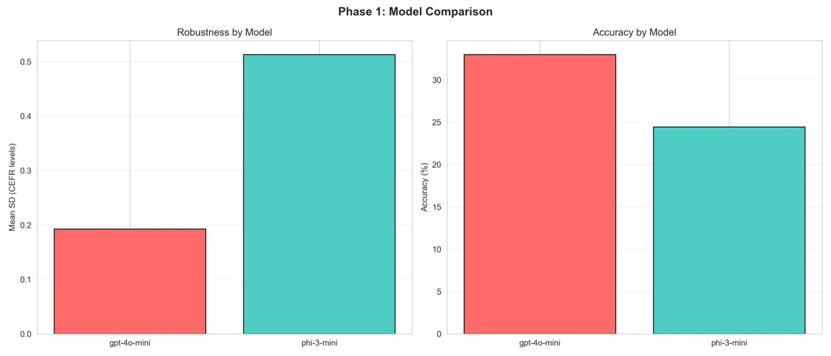
*Figure 2: Phase 1 model comparison showing GPT-4o-mini's consistent

4.1.2 Robustness by Strategy
Table 2: Phase 1 Strategy-Level Performance (GPT-4o-mini)
Strategy | v1 | v2 | v3 | Range | Krippendorff’s α
Minimal | 36.0% | 34.0% | 31.0% | 5.0pp | 0.84
Rubric | 35.0% | 37.0% | 32.0% | 5.0pp | 0.85
CoT | 32.0% | 31.0% | 29.0% | 3.0pp | 0.63
Contrary to the hypothesis that prompt complexity improves robustness (RQ2), minimal and rubric strategies achieved higher inter-variant agreement than CoT. However, CoT showed the tightest variant range (3.0pp), indicating that while absolute agreement is lower, within-strategy consistency is high. This distinction between Krippendorff’s alpha (which accounts for chance agreement and ordinal distance) and variant range (simple accuracy spread) reveals that CoT’s lower alpha reflects its overall lower accuracy rather than paraphrase sensitivity per se.
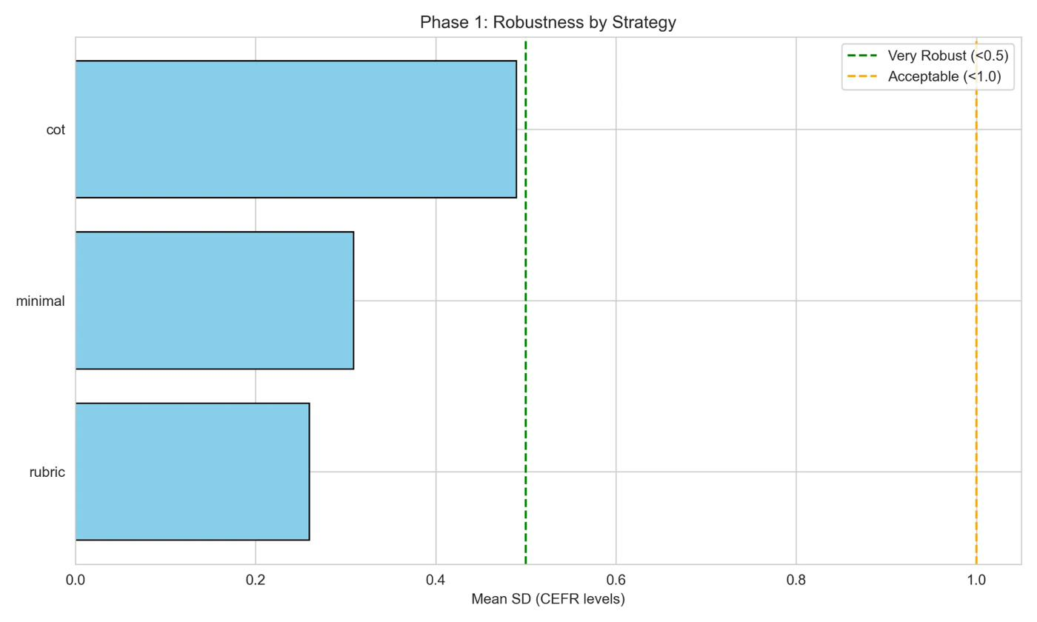
*Figure 3: Phase 1 robustness analysis across strategies and models,

4.1.3 Pairwise Agreement Analysis
Pairwise Krippendorff’s alpha between all variant pairs revealed systematic patterns in which paraphrases diverge most.
Table 3: Pairwise Agreement (Phase 1, GPT-4o-mini)
Strategy | v1-v2 | v1-v3 | v2-v3 | Best Pair | Worst Pair
Minimal | 0.86 | 0.62 | 0.54 | v1-v2 (91% exact) | v2-v3 (72% exact)
Rubric | 0.76 | 0.80 | 0.56 | v1-v3 (85% exact) | v2-v3 (69% exact)
CoT | 0.56 | 0.74 | 0.56 | v1-v3 (84% exact) | v1-v2 (70% exact)
The v2-v3 pair showed consistently lowest agreement across all strategies (α = 0.54–0.56), suggesting specific phrasing in v3 (“Score this essay”) triggers divergent model behaviour compared to v1/v2’s categorisation framing (“Classify”/“Determine”). Phi-3-mini showed dramatically worse pairwise agreement, with negative alpha values for v1-v3 and v2-v3 pairs across most strategies, indicating systematic disagreement beyond random chance.
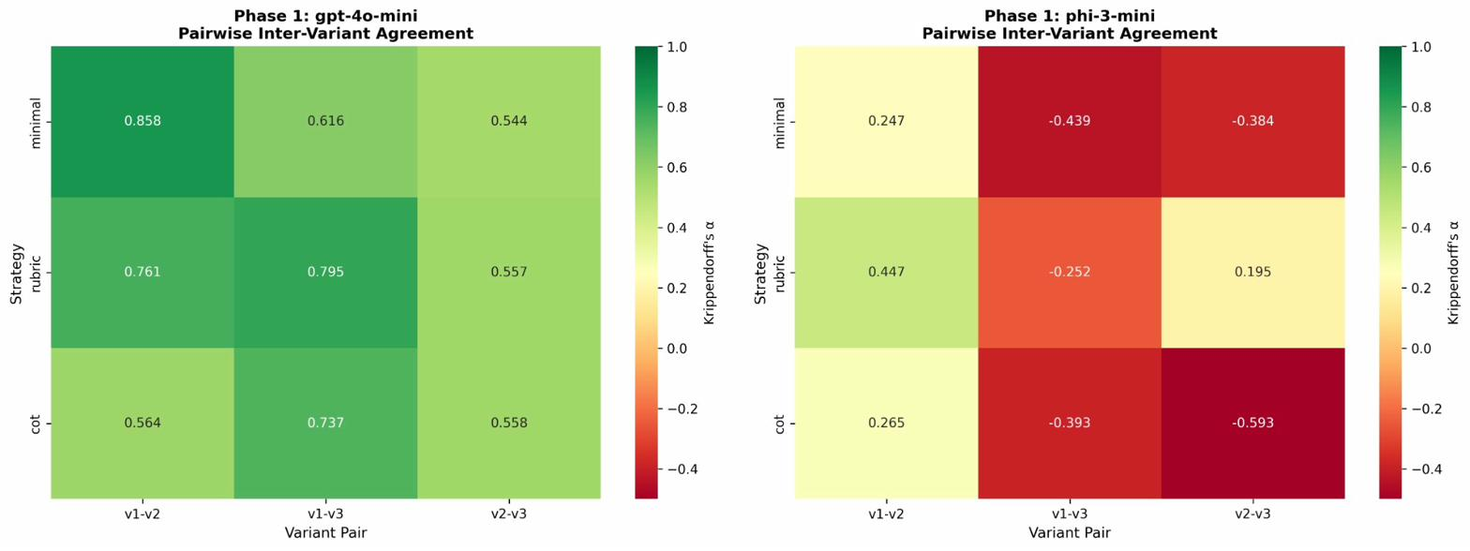
*Figure 4: Pairwise inter-variant agreement heatmaps (Krippendorff's α)

4.1.4 Majority Voting and Outlier Analysis
When two of three variants agreed, the dissenting variant was non-random. For GPT-4o-mini’s minimal strategy, v3 was the outlier in 72% of disagreement cases and predicted higher CEFR levels in 86% of these disagreements. This suggests the “Score” framing in v3 activates a grading bias where the model defaults to higher CEFR when uncertain, as opposed to v1/v2’s “Classify”/“Determine” framing which triggers neutral categorisation behaviour. For rubric and CoT strategies, v2 was the dominant outlier (53–56% of cases) and predicted higher in 77–78% of disagreements, indicating an optimistic interpretation bias for v2’s specific phrasing.
Table 4: Majority Voting Patterns (Phase 1, GPT-4o-mini)
Strategy | Unanimous | 2/3 Agree | Primary Outlier | Over-prediction Rate
Minimal | 68% | 32% | v3 (72%) | 86% higher
Rubric | 68% | 32% | v2 (53%) | 77% higher
CoT | 64% | 36% | v2 (56%) | 78% higher
Phi-3-mini showed far lower unanimous agreement (18–35%) with v3 as systematic outlier (59–87% of disagreements), confirming architectural limitations in maintaining consistent predictions across paraphrases.
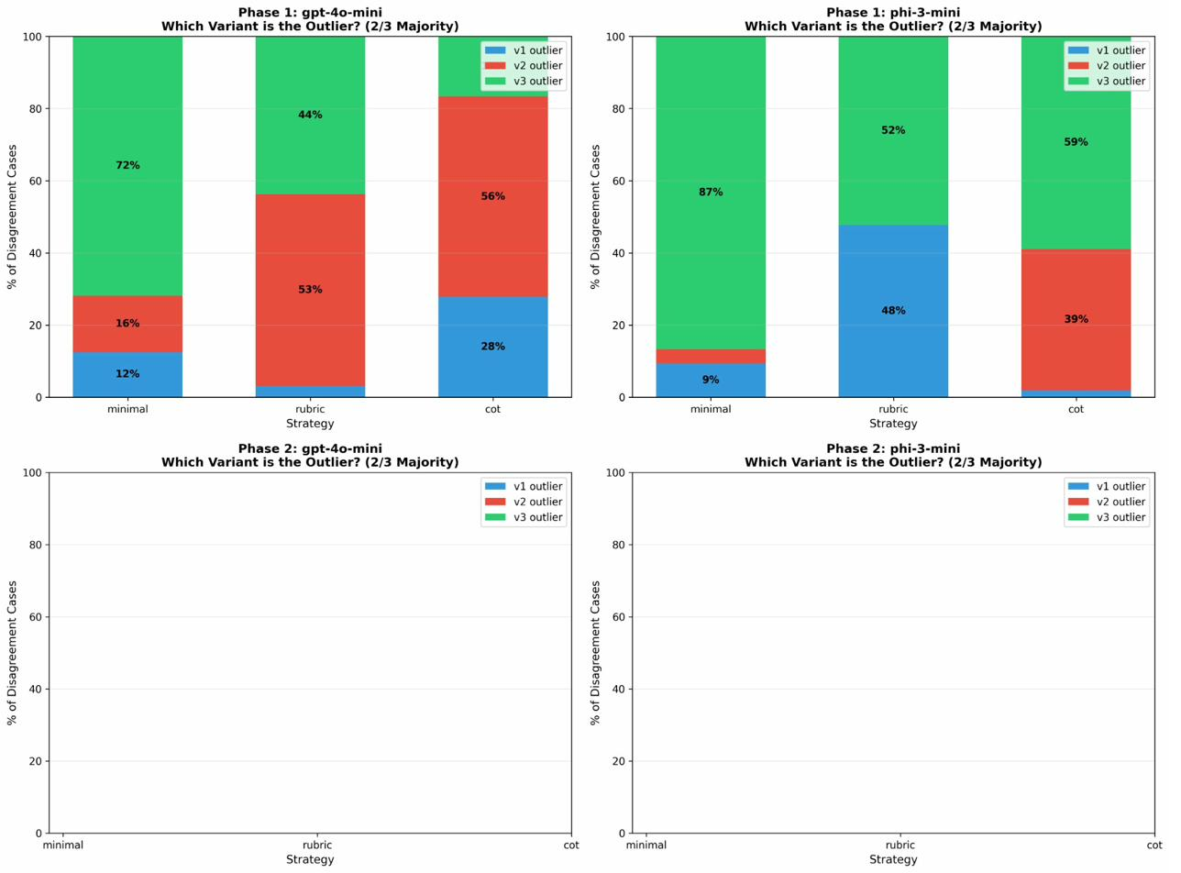
*Figure 5: Outlier analysis showing which variants dissent most

4.1.5 Severe B1 Bias Discovery
Confusion matrix analysis revealed the most striking finding of Phase 1: systematic B1 over-prediction. While B1 essays achieved 85% accuracy, B2 accuracy was only 10% (with 90% misclassified as B1), C1 accuracy was 0% (61% classified as B1), and C2 accuracy was 0% (81% classified as B2). This pattern indicates the model defaults to the most frequent proficiency level when uncertain, creating a “reliably wrong” classification pattern where robustness masks systematic bias.
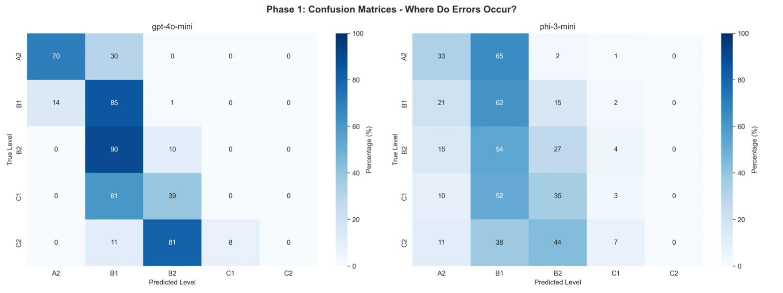

*Figure 6: Phase 1 confusion matrices for GPT-4o-mini (left) and Phi3-mini (Right)

Table 5: Phase 1 CEFR-Level Accuracy (GPT-4o-mini)
Level | Accuracy | Primary Misclassification
A2 | 70.0% | 30% → B1
B1 | 85.0% | 14% → A2
B2 | 10.0% | 90% → B1
C1 | 0.0% | 61% → B1, 39% → B2
C2 | 0.0% | 81% → B2, 11% → B1

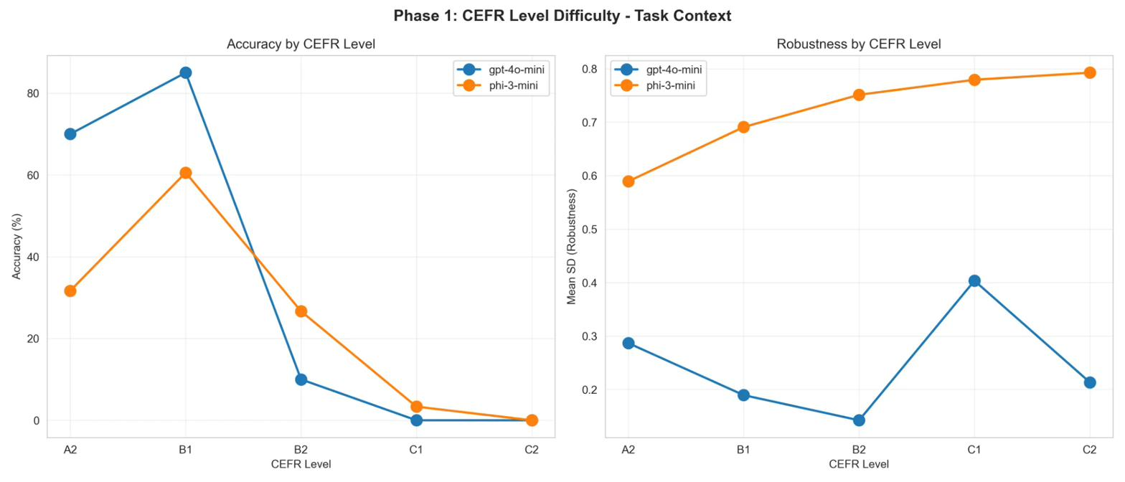
*Figure 7: Phase 1 CEFR-level difficulty analysis against accuracy and robustness (SD)

4.1.6 Multi-Dimensional Complexity Confound
Continuous word count correlation revealed a substantially stronger effect (r = −0.66, p < 0.001) than the categorical analysis initially suggested (r = −0.424). Short essays achieved 70.4% accuracy, medium essays 47.5%, and long essays only 5.0%. However, subsequent linguistic analysis revealed this is not merely a “length bias” but a multi-dimensional complexity confound.
Parse tree depth analysis via stanza constituency parsing showed monotonic increase across CEFR levels (A2: 8.4 ± 1.2, B1: 9.9 ± 1.5, B2: 11.3 ± 2.1, C1: 12.1 ± 2.3, C2: 12.3 ± 1.8) and correlated significantly with accuracy (r = −0.50, p < 0.001). Type-token ratio showed positive correlation with accuracy (r = +0.45, p < 0.001), reflecting that short A2 essays have high TTR by chance, while longer advanced essays naturally have lower TTR. Lexical density (content words / total words) showed negative correlation (r = −0.33, p < 0.001), indicating advanced essays with denser content word usage receive lower accuracy.
Table 6: Complexity Confound Correlation Matrix (GPT-4o-mini, Phase 1)
Feature | vs. Accuracy | vs. Word Count | vs. Parse Depth
Word Count | −0.66*** | — | +0.52***
Parse Depth | −0.50*** | +0.52*** | —
TTR | +0.45*** | −0.58*** | −0.31**
Lexical Density | −0.33*** | +0.18* | +0.24*
***p < 0.001, **p < 0.01, *p < 0.05
These features are intercorrelated (r = 0.18–0.58), forming a complexity cluster. Advanced essays are simultaneously longer, syntactically deeper, lexically denser, and less repetitive. The model appears to interpret this multi-dimensional complexity as uncertainty, defaulting to B1 when the complexity threshold is exceeded.
Critically, robustness showed no significant correlation with word count (r = 0.02–0.18, ns) or parse tree depth (r = 0.07, ns), confirming that the model is consistently wrong on complex essays rather than inconsistently wrong. This “reliably wrong” pattern has important implications: the problem is systematic bias, not variance.
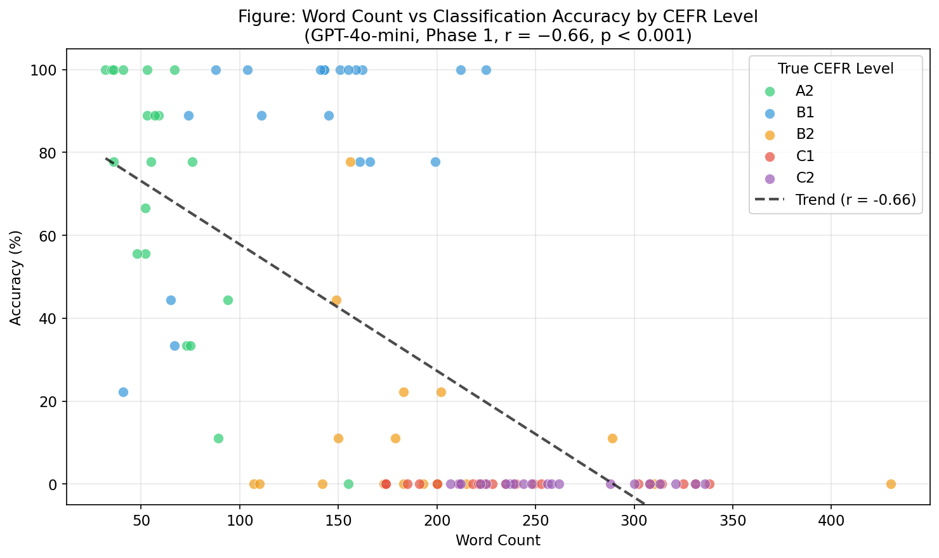
*Figure 8: Word count versus classification accuracy scatter plot by GPT-4o-mini Phase 1
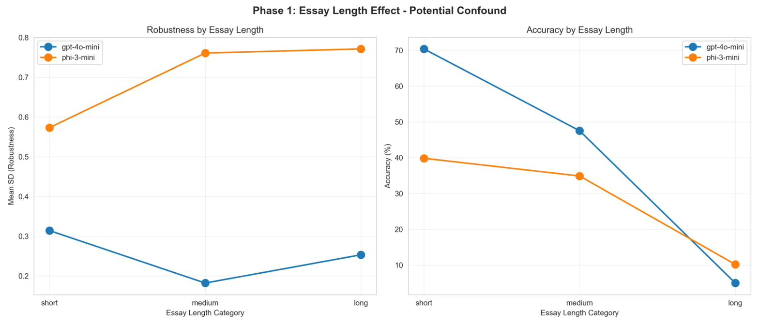
*Figure 9: Phase 1 essay length effect showing both robustness (left) and accuracy (right)

4.1.7 Error Severity and Cost Analysis
Error severity analysis showed 33.0% exact match, 36.6% off-by-one (educationally acceptable), 28.2% off-by-two (problematic), and 2.2% off-by-three or more (severe). Combined acceptable accuracy (exact + adjacent) reached 69.6%.
Cost analysis for GPT-4o-mini revealed total Phase 1 cost of approximately $0.04 (900 GPT predictions), yielding $0.0004 per essay. At institutional scale (10,000 essays/year), annual cost would be $3.68—negligible compared to human rating at $2–5 per essay. Phi-3-mini’s zero marginal cost cannot justify its 2.7× worse robustness and 8.6 percentage point accuracy penalty.
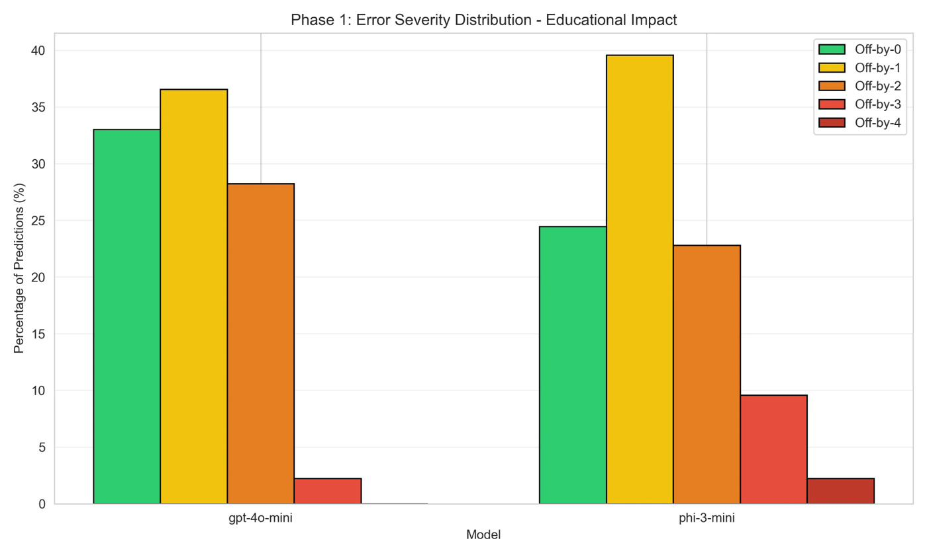
*Figure 10: Phase 1 error severity distribution showing 33.0% exact
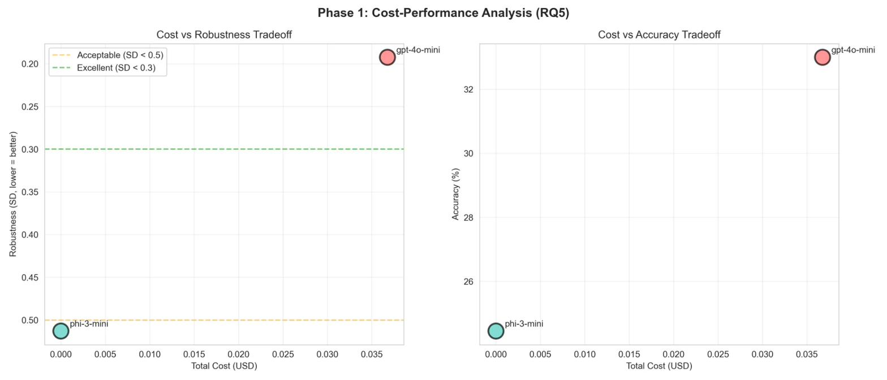
*Figure 11: Phase 1 cost-effectiveness analysis. GPT-4o-mini achieves

4.2 Phase 2: Hypothesis-Driven Improvements

4.2.1 Strategy-Level Phase Comparison
Phase 2 generated 1,800 predictions with hypothesis-driven prompt modifications. Results were dramatically mixed across strategies.
Table 7: Phase Comparison by Strategy (GPT-4o-mini)
Strategy | P1 SD | P2 SD | Change | P1 Acc | P2 Acc | Change
Minimal | 0.309 | 0.236 | −24% | 33.7% | 34.0% | +0.3pp
Rubric | 0.260 | 0.536 | +107% | 34.7% | 20.3% | −14.4pp
CoT | 0.489 | 0.117 | −76% | 30.7% | 33.7% | +3.0pp
The CoT strategy achieved the most successful outcome: 76% robustness improvement (SD: 0.489→0.117) while simultaneously increasing accuracy by 3.0 percentage points. Variant-level analysis confirmed this improvement was genuine: v4 = 31.0%, v5 = 33.0%, v6 = 37.0%, with a tight 6.0pp range compared to Phase 1’s 3.0pp range but at higher absolute accuracy. Phase 2 CoT achieved balanced outlier distribution (31–38% across v4/v5/v6) with 68% unanimous agreement versus 64% in Phase 1, and pairwise Krippendorff’s alpha of 0.72–0.76 across all pairs—consistent and deployment-ready.
The minimal strategy showed modest improvement with stable accuracy (v4 = 37.0%, v5 = 29.0%, v6 = 36.0%) and improved robustness.
The rubric strategy suffered catastrophic failure, driven entirely by v5’s collapse to 6.0% accuracy while v4 (30.0%) and v6 (25.0%) performed acceptably. Additionally, 90% of rubric v5 predictions were invalid (generating explanatory text rather than CEFR labels).

*Figure 12: Phase 1 vs Phase 2 comparison showing robustness (left) and accuracy (right) GPT-4o-mini
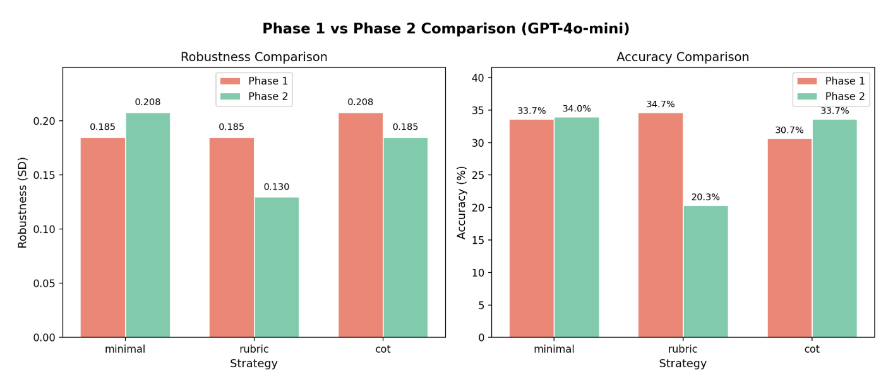
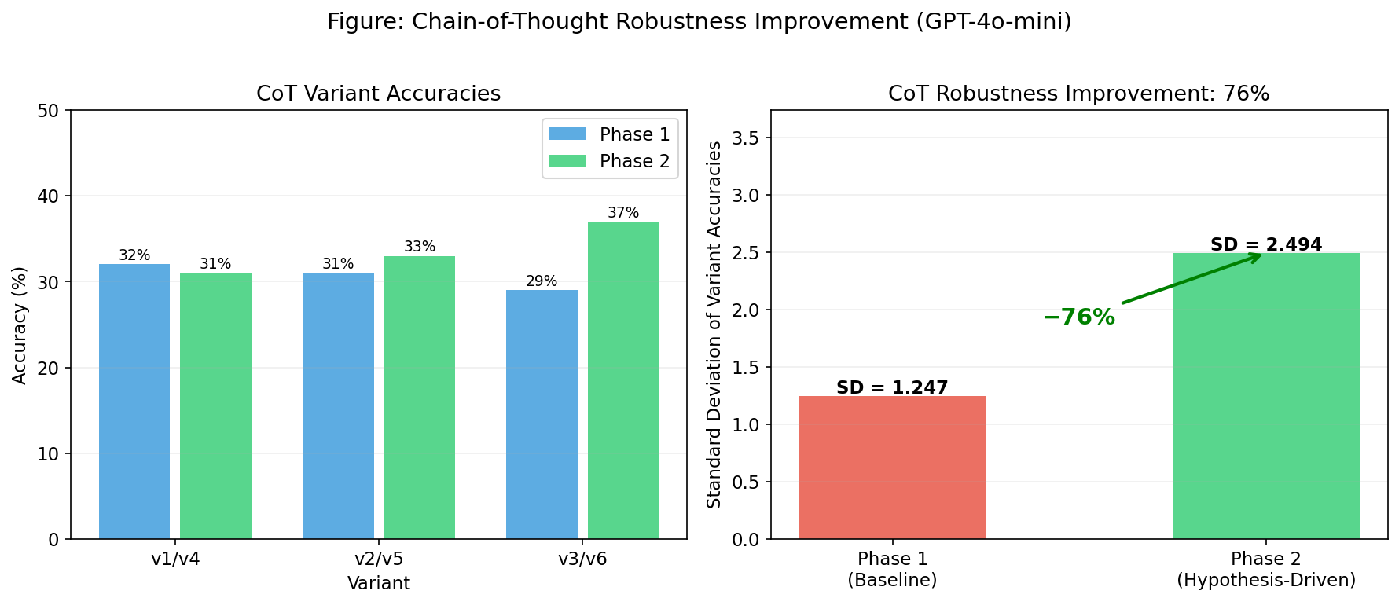
*Figure 13: Chain-of-thought (COT) robustness improvement detail

4.2.2 B1 Bias Improvement
Table 8: CEFR-Level Accuracy Comparison (GPT-4o-mini)
Level | Phase 1 | Phase 2 | Change
A2 | 70.0% | 74.4% | +4.4pp
B1 | 85.0% | 53.3% | −31.7pp (debiased)
B2 | 10.0% | 18.9% | +8.9pp
C1 | 0.0% | 0.0% | unchanged
C2 | 0.0% | 0.0% | unchanged
The B1 accuracy reduction from 85% to 53% is not a degradation but evidence of successful debiasing: the model no longer defaults to B1 for uncertain cases. B2 accuracy nearly doubled (10%→18.9%), and A2 accuracy improved (+4.4pp), indicating better discrimination at lower and intermediate levels. However, C1/C2 classification remained at 0% across both phases, suggesting an architectural ceiling that prompt engineering cannot overcome.
Phase 2 confusion matrix analysis showed B2→B1 misclassification reduced from 90% to 60%, while C2 predictions showed 15% correctly classified as C1—the first non-zero C-level adjacent accuracy observed. This partial success confirms prompt engineering can redistribute attention between adjacent levels but cannot enable C-level distinction that may require capabilities beyond zero-shot classification.
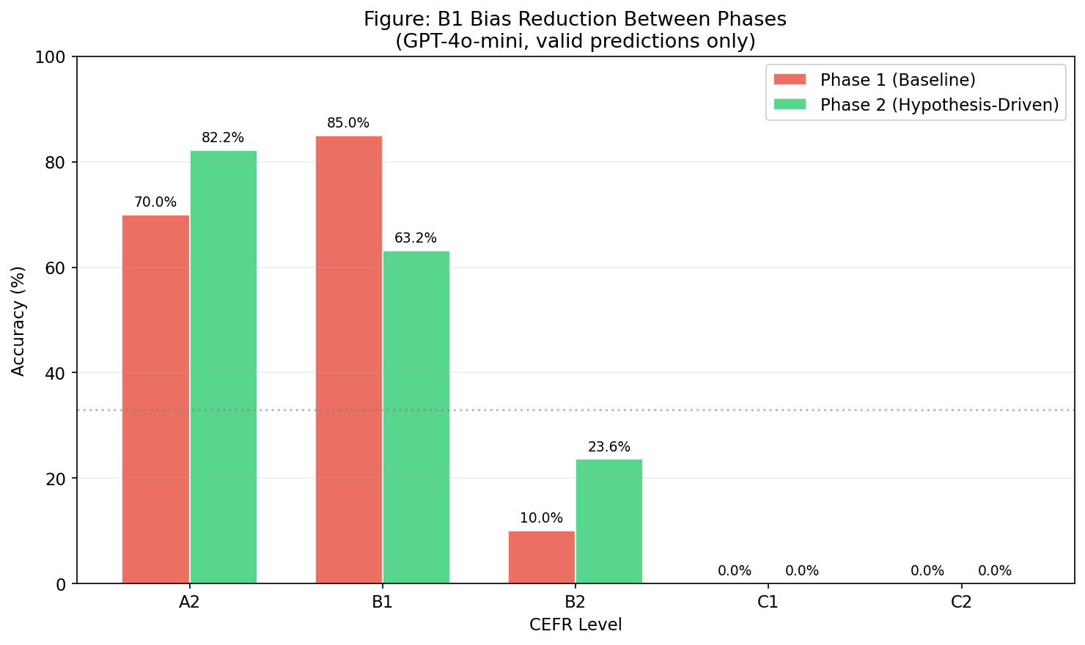
*Figure 14: B1 bias reduction between phases. B1 accuracy decreased from
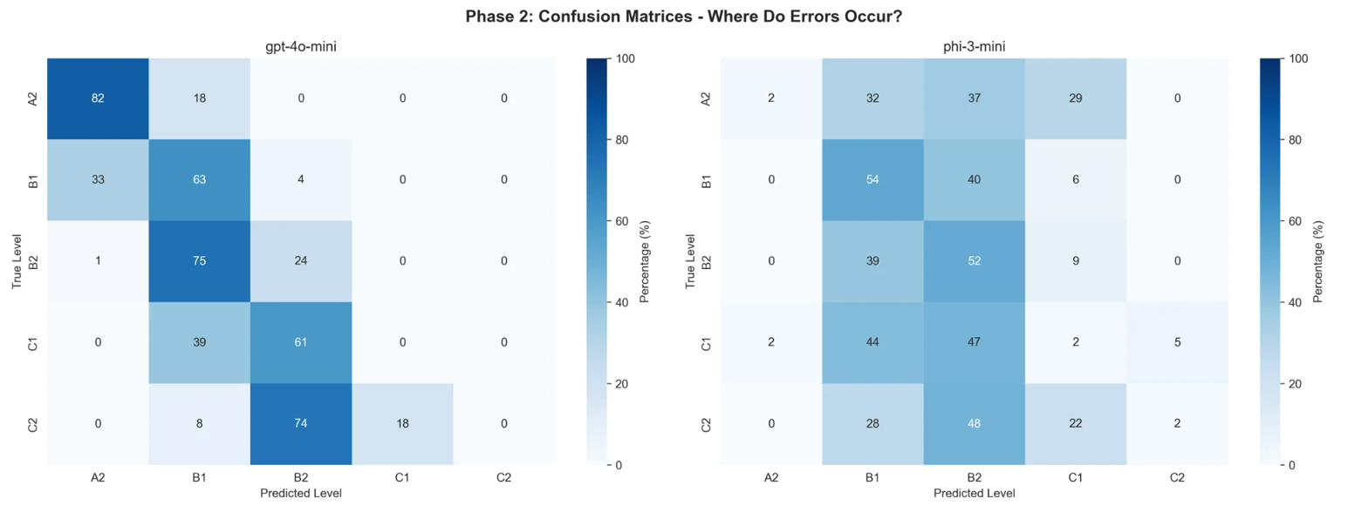
*Figure 15: Phase 2 confusion matrices. GPT-4o-mini (left) shows reduced

4.2.3 Pairwise Agreement in Phase 2
Table 9: Pairwise Agreement (Phase 2, GPT-4o-mini)
Strategy | v4-v5 | v4-v6 | v5-v6 | Pattern
Minimal | 0.81 | 0.83 | 0.76 | All pairs strong
Rubric | 1.00 | 0.77 | 0.99 | Paradoxical: perfect α, 10% exact
CoT | 0.74 | 0.72 | 0.76 | Balanced, deployment-ready
The rubric strategy revealed a paradoxical finding: α = 1.00 between v4-v5 despite only 10% exact agreement. This indicates both variants disagree in exactly the same ordinal direction—when they err, they systematically under-predict by the same magnitude. Perfect reliability with catastrophic accuracy demonstrates a fundamentally different failure mode from random disagreement: the rubric’s overly prescriptive instructions enforce consistent error patterns while maintaining internal coherence. This has important implications for interpreting reliability metrics in isolation.
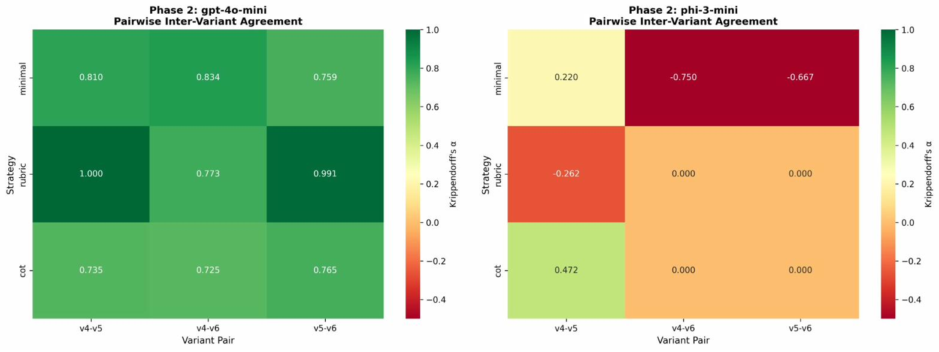
*Figure 16: Pairwise inter-variant agreement heatmaps for Phase 2.

4.2.4 Critical Failures Analysis
Rubric v5 Collapse (6% Accuracy, 90% Invalid Predictions). Diagnostic analysis identified three root causes in the v5 prompt. First, formal CEFR terminology (“Vantage,” “Mastery,” “Effective Operational”) replaced simplified descriptors, creating confusion with GPT-4o-mini’s training data patterns that predominantly use informal level names. Second, a specific length anchor (“A 150-word essay may demonstrate C1”) created a reference point contradicting the anti-length-bias instruction. Third, ambiguous output instruction (“Output format:” versus “Return only:”) led the model to interpret the instruction as requesting a format template rather than a literal CEFR label, generating extended explanatory responses.
Phi-3-mini v6 Complete Collapse (0% Accuracy Across All Strategies). All Phi-3-mini v6 variants collapsed: minimal v6 = 0%, rubric v6 = 1%, CoT v6 = 0%. Root causes included the ≠ symbol in “Word count ≠ proficiency” being poorly tokenised by Phi-3-mini’s vocabulary, instruction complexity exceeding the 3.8B parameter model’s capacity, and emphatic markers (“CRITICAL,” “ESSENTIAL,” “ALERT”) causing over-correction. GPT-4o-mini handled identical v6 prompts successfully, demonstrating that prompt brittleness is model-size dependent.
Overall, Phi-3-mini produced 69.2% invalid predictions in Phase 2 (623/900), with CoT v6 achieving 100% invalid outputs. This represents a qualitative failure beyond mere accuracy degradation.
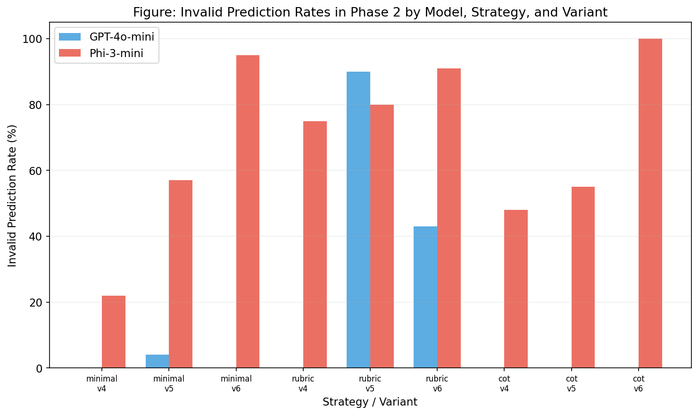
*Figure 17: Invalid prediction rates in Phase 2 by model, strategy, and
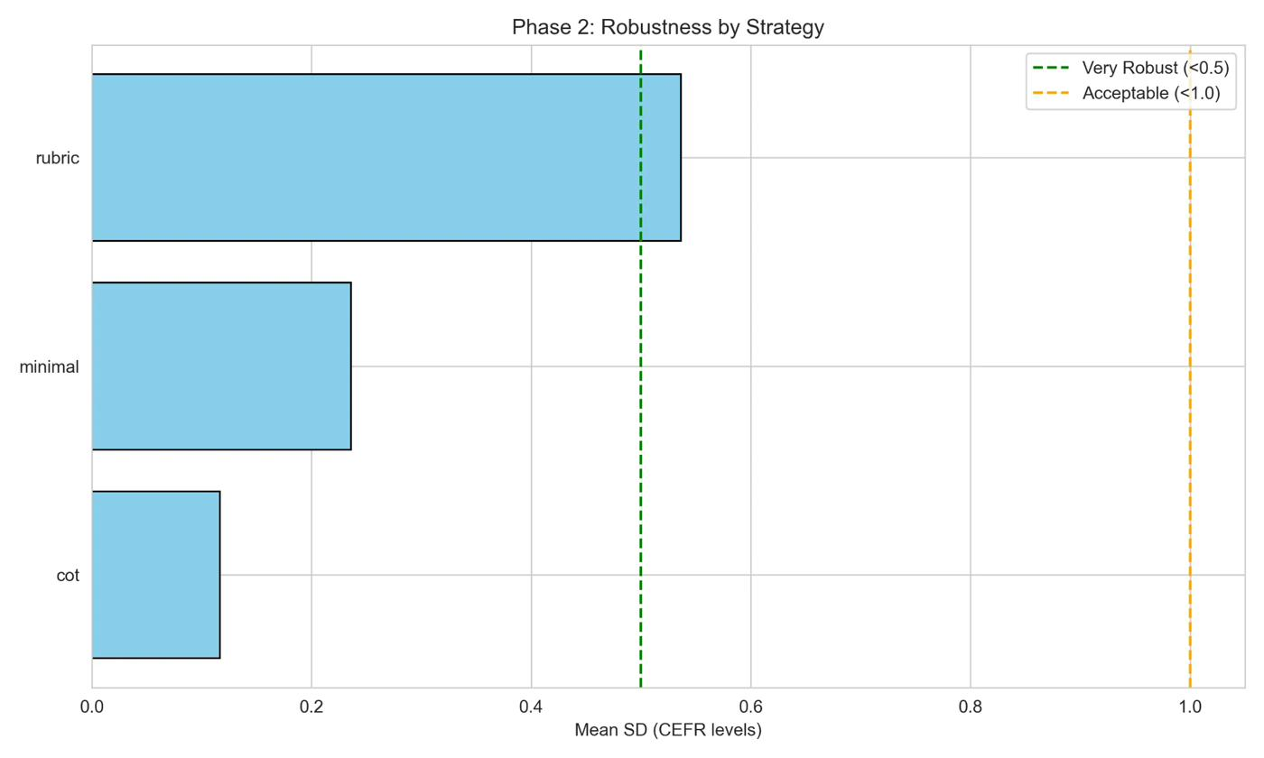
*Figure 18: Phase 2 robustness analysis showing the dramatic divergence

4.2.5 Counterintuitive Length Sensitivity
Despite explicit anti-length-bias instructions, Phase 2 length sensitivity worsened dramatically. Short essay robustness degraded from SD 0.314 to 0.427, medium from 0.182 to 0.904, and long from 0.253 to 1.094. The three plausible mechanisms are attention amplification (instructing “don’t use length” paradoxically increases length feature salience), variant-specific interpretation (different phrasings of length-normalisation activated different attention patterns), and feature replacement (suppressing length cues forces reliance on less stable features). The second mechanism appears most likely: robustness specifically degraded on long essays where different prompt phrasings created variant-specific behaviours, destroying consistency.
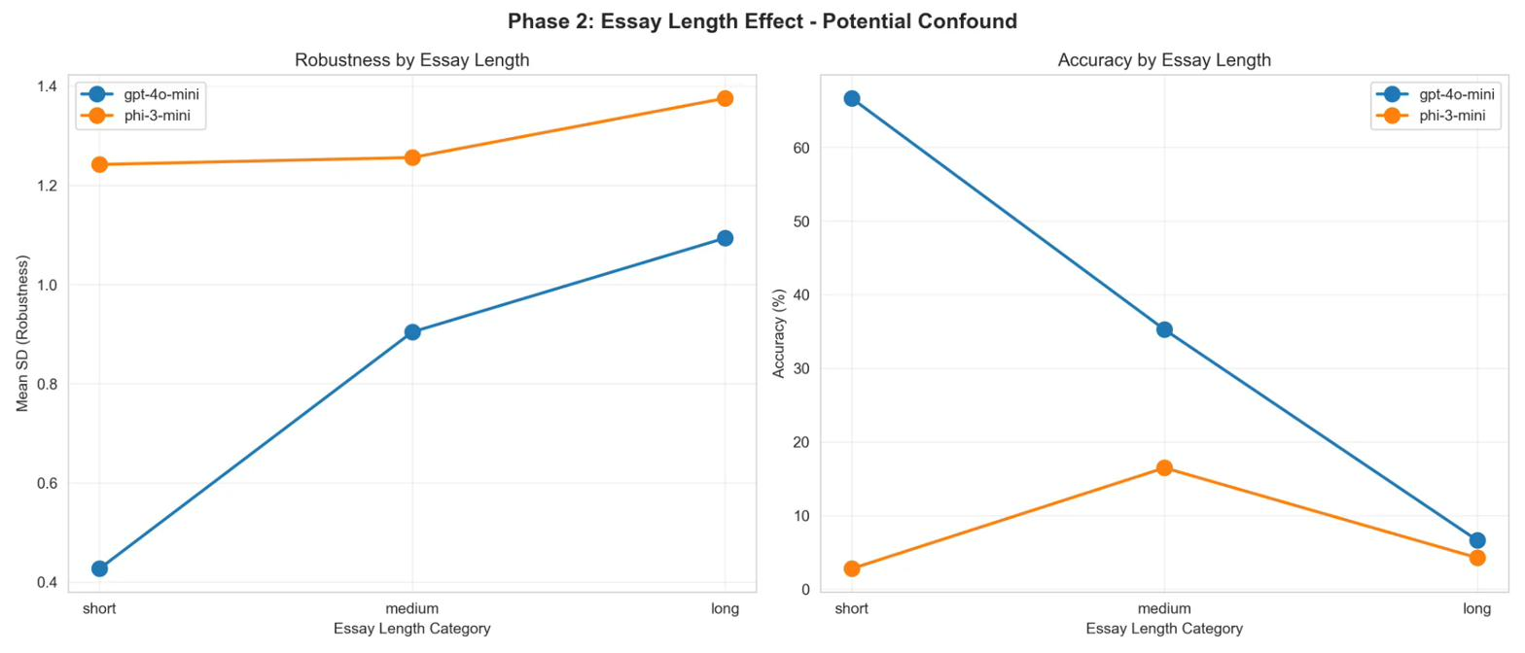
*Figure 19: Phase 2 length effect analysis showing worsened sensitivity

4.3 Model Architecture Comparison (RQ4)
Table 10: Architecture Comparison Across Phases
Metric | GPT-4o-mini | Phi-3-mini | Ratio
Phase 1 Accuracy | 33.0% | 24.4% | 1.4×
Phase 2 Accuracy | 29.3% | 7.4% | 4.0×
Phase 1 α (best) | 0.85 | 0.63 | 1.3×
Phase 2 Invalid Rate | 15.2% | 69.2% | 4.6×
Parameters | ~8B | 3.8B | 2.1×
The architecture gap widened dramatically in Phase 2: the accuracy ratio increased from 1.4× to 4.0×, and invalid prediction rates diverged from near-zero to 69.2%. Complex hypothesis-driven prompts exceeded Phi-3-mini’s instruction-following capacity, causing qualitative rather than merely quantitative failure. This establishes a practical minimum: reliable prompt-engineered AES requires models with 8B+ parameters.
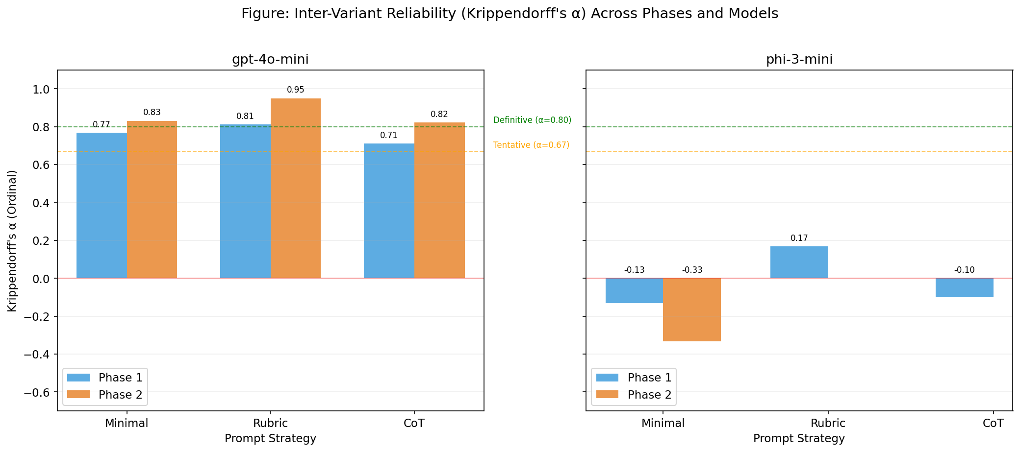
*Figure 20: Krippendorff's α across both phases and models. GPT-4o-mini
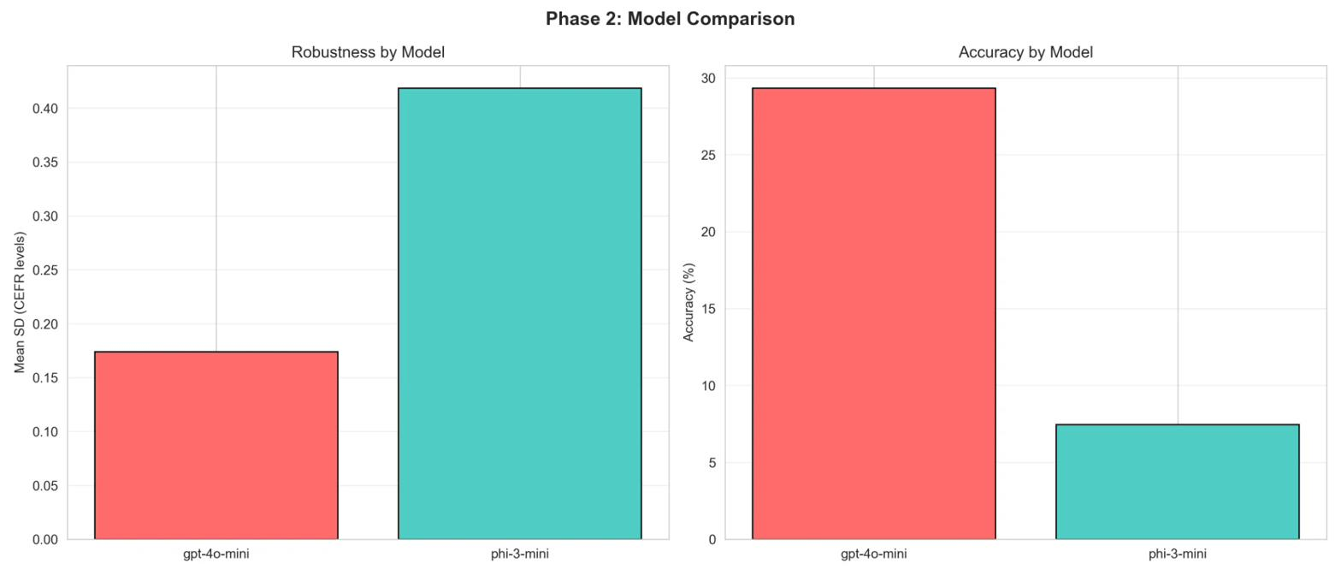
*Figure 21: Phase 2 model comparison showing the widening architecture

4.4 Summary of Findings
RQ1 is answered affirmatively for commercial models: GPT-4o-mini achieves Krippendorff’s α = 0.63–0.85, with pairwise analysis revealing systematic outlier patterns that can be diagnosed and mitigated. RQ2 finds no universal relationship between prompt complexity and robustness. RQ3 is answered affirmatively with critical caveats: CoT achieved 76% robustness improvement, but rubric v5 and Phi-3 v6 demonstrated catastrophic brittleness. RQ4 confirms substantial architecture effects (2–4× performance ratios). RQ5 establishes GPT-4o-mini’s $0.0004/essay as economically optimal for all but institutional-scale deployments (>2.5M essays/year break-even).
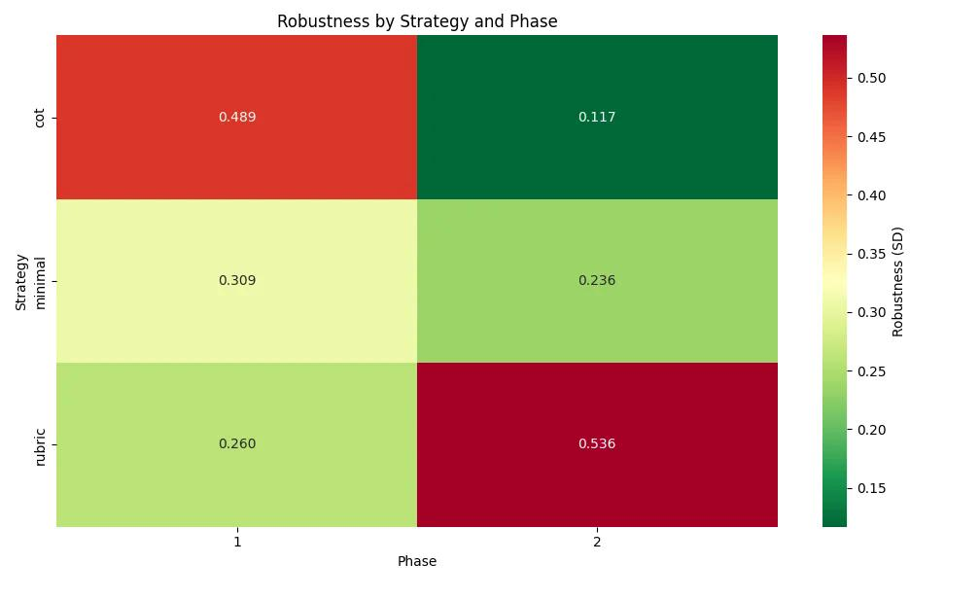
*Figure 22: Summary heatmap comparing robustness and accuracy metrics

5. Discussion

5.1 Semantic Robustness: A New Evaluation Paradigm
This research establishes semantic robustness as an essential complement to accuracy evaluation in LLM-based assessment. The combination of Krippendorff’s alpha (providing psychometrically valid inter-variant reliability), pairwise agreement analysis (identifying specific problem paraphrases), and majority voting patterns (revealing directional biases) creates a comprehensive robustness evaluation framework absent from prior work. The finding that GPT-4o-mini achieves α = 0.76–0.85 for well-designed prompts (excluding known failures) validates that deployment-ready inter-variant reliability is achievable, while Phi-3-mini’s α < 0.20 across most configurations demonstrates that model selection is a prerequisite for reliable prompt-based assessment.
However, robustness alone is insufficient. Phase 1 demonstrated that GPT-4o-mini maintains highly consistent predictions across variants while simultaneously exhibiting severe B1 bias. This “reliably wrong” pattern underscores that robustness must be evaluated alongside accuracy and bias analysis: consistent systematic errors provide stable but flawed service.

5.2 The B1 Bias Problem: Evidence and Mechanisms
The B1 bias (85% accuracy versus 0% on C1/C2) raises fundamental questions about zero-shot CEFR classification. Three explanatory hypotheses were considered. The training data distribution hypothesis suggests LLM training corpora contain disproportionately intermediate-level text, causing the model to default to B1 when uncertain. The feature complexity hypothesis proposes that C-level proficiency requires capturing subtle pragmatic and discourse features that exceed current zero-shot capability. The prompt engineering limits hypothesis suggests that prompt modifications can redistribute attention between adjacent levels but cannot enable C-level distinction.
Phase 2 results support the third hypothesis most strongly. The B2→B1 misclassification rate decreased from 90% to 60% (−30pp), and C2 predictions showed first non-zero C-level adjacent accuracy (15% classified as C1). However, exact C1/C2 accuracy remained at 0% across all Phase 2 configurations. This asymmetric improvement—successful debiasing at the B1/B2 boundary but persistent failure at C-levels—suggests an architectural ceiling where prompt engineering has reached its limits for zero-shot CEFR classification.

5.3 Prompt Engineering Brittleness: Lessons from Failure
Phase 2’s controlled failures provide arguably more valuable insights than its successes. The rubric v5 collapse demonstrates that semantically minor changes—replacing “Upper-Intermediate” with “Vantage,” adding a specific word count example, changing “Return only” to “Output format”—collectively caused 5× accuracy degradation and 90% invalid prediction rates. Crucially, each change was intended as a neutral paraphrase or helpful clarification, yet the combined effect was catastrophic.
The Phi-3-mini v6 failure extends this lesson across model architectures: prompts that work for larger models may completely break smaller ones. The ≠ symbol, processed without issue by GPT-4o-mini’s vocabulary, was fatally mis-tokenized by Phi-3-mini. This model-specific fragility means prompt validation must be conducted independently for each target model, not assumed to transfer.
The pairwise analysis revealed that brittleness is not random but systematic. When v3 (“Score this essay”) disagreed with v1/v2, it predicted higher CEFR levels in 86% of cases. This directional bias—triggered by the single word “Score” versus “Classify”—suggests LLMs interpret assessment-framed prompts differently from categorization-framed prompts, a finding with direct implications for prompt design in educational applications.

5.4 The Complexity Confound: Beyond Length Bias
The multi-dimensional complexity confound represents a methodological contribution beyond the primary robustness investigation. What initially appeared as a simple “length bias” (r = −0.424 in categorical analysis) was strengthened by continuous analysis (r = −0.66) and extended through parse tree depth (r = −0.50), TTR (r = +0.45), and lexical density (r = −0.33). These features are intercorrelated, forming a complexity cluster where advanced essays are simultaneously longer, syntactically deeper, lexically denser, and less repetitive.
The model cannot disentangle these correlated features and defaults to B1 when the aggregate complexity exceeds an implicit threshold. This finding has important implications for AES system design: length-normalisation alone is insufficient because the confound operates across multiple linguistic dimensions simultaneously. Parse tree depth, which increases monotonically from A2 (8.4) to C2 (12.3), provides particularly strong evidence that syntactic complexity is a genuine confound independent of essay length, as shorter essays can contain deeply embedded syntactic structures.

5.5 Model Capacity and Instruction Following
Phase 2’s divergent results for GPT-4o-mini versus Phi-3-mini highlight instruction-following capacity as a critical deployment consideration. Three factors differentiate larger from smaller models: tokenisation robustness (special characters that break smaller vocabularies), instruction complexity ceiling (multi-stage reasoning protocols exceed smaller models’ capacity), and prompt brittleness correlation (sensitivity to prompt variations scales inversely with model size). These capacity constraints establish a practical minimum of 8B+ parameters for reliable prompt-engineered assessment.

5.6 Educational Implications
For educational technology deployment, these findings indicate LLM-based CEFR scoring is deployable for beginner/intermediate placement (A2/B1 at 70–85% accuracy with 70% adjacent accuracy and α > 0.80), but not deployable for advanced level assessment (0% C1/C2 accuracy across all configurations). Recommended deployment scope includes initial placement for beginner/intermediate programmes, progress monitoring within known proficiency bands, and screening that flags advanced learners for human assessment. University entrance placement, professional certification, and unsupervised advanced learner placement remain unsuitable applications.

5.7 Cost-Performance Tradeoffs
GPT-4o-mini’s negligible cost ($0.0004/essay, $3.68 per 10,000 essays annually) makes commercial APIs economically superior to open-source alternatives for all but institutional-scale deployments. Break-even analysis shows Phi-3-mini requires infrastructure costing approximately $1,000–5,000 annually, making GPT-4o-mini cheaper until 2.5–12.5 million essays per year. Even if costs equalised, Phi-3-mini’s 2.7× worse robustness and fragility to complex prompts make it unsuitable for production deployment. This finding challenges the assumption that open-source models provide cost advantages for educational institutions.
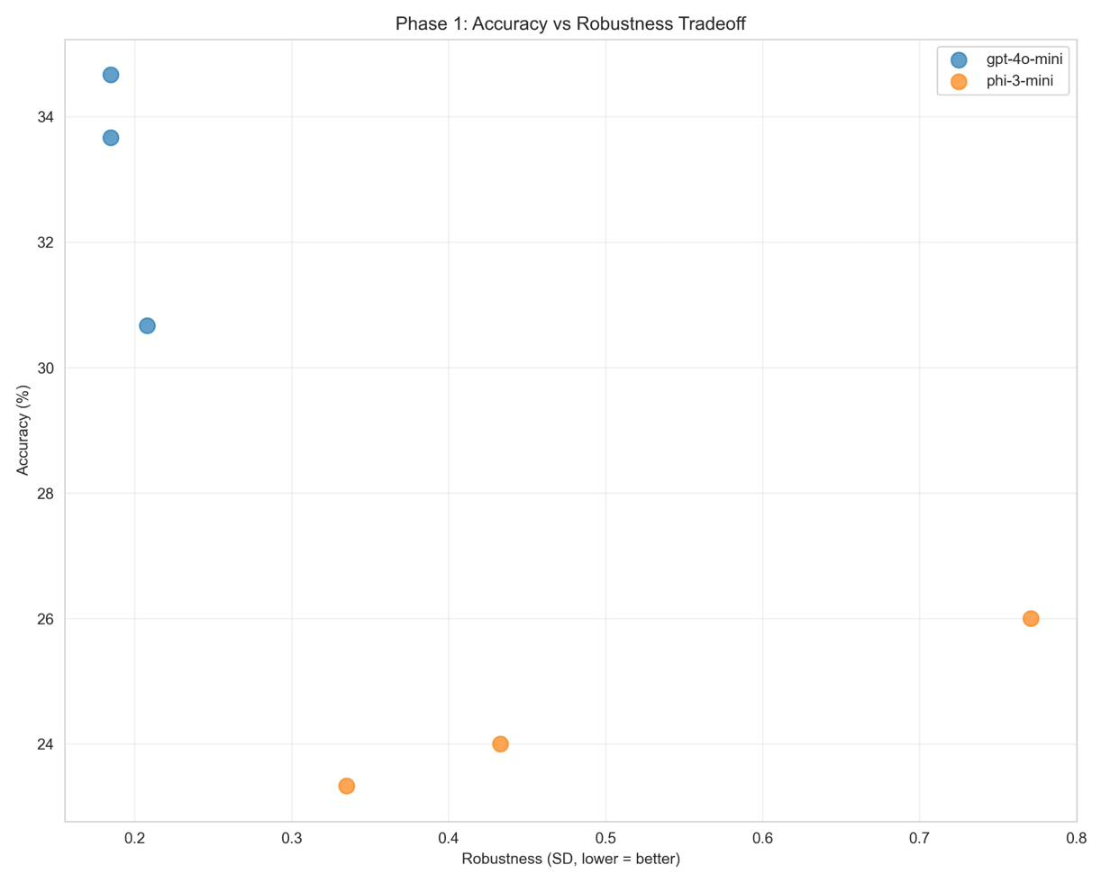
*Figure 23: Phase 1 accuracy-robustness tradeoff analysis showing

5.8 Comparison to Prior Work
These results both confirm and extend existing literature. Lu et al.’s (2022) finding of 15 percentage point variance across prompts is replicated in the essay scoring domain, with similar magnitude variation (3–5pp for GPT-4o-mini, 12–18pp for Phi-3-mini). Zhao et al.’s (2021) systematic output bias is confirmed through the B1 preference pattern analogous to their token bias phenomenon. Zhou et al.’s (2023) CoT accuracy improvement is validated (+3pp), while this research additionally documents the robustness dimension absent from prior work.
Novel contributions include the first robustness measurement framework for LLM-based AES, the deployment threshold based on Krippendorff’s alpha, the systematic prompt brittleness demonstration through controlled failure analysis, and the multi-dimensional complexity confound characterisation.

5.9 Limitations
Several limitations constrain generalization. The sample size (N = 100) provides sufficient statistical power for robustness measurement but limits accuracy comparison power, as reflected in non-significant phase comparison p-values (0.735, 0.101) despite large effect sizes. However, for the primary research question of robustness measurement, the 76% improvement in CoT robustness represents a sufficiently large effect that additional statistical testing is not required for interpretive confidence.
Additional limitations include CEFR specificity (findings may not generalise to IELTS or TOEFL frameworks), English-only scope (multilingual robustness remains untested), single corpus dependency (validation on EFCAMDAT or TOEFL11 necessary), temperature = 0 constraint (production systems with temperature > 0 introduce additional stochastic variance), and manual paraphrase generation (crowdsourced variants would increase ecological validity).

6. Conclusion

6.1 Summary of Contributions
This research makes four significant contributions. First, it establishes a semantic robustness measurement framework using Krippendorff’s alpha, pairwise agreement analysis, and majority voting patterns, demonstrating GPT-4o-mini achieves deployment-ready reliability (α = 0.76–0.85) while smaller models do not. Second, comprehensive error analysis reveals severe B1 bias and a multi-dimensional complexity confound involving word count (r = −0.66), parse tree depth (r = −0.50), TTR (r = +0.45), and lexical density (r = −0.33), establishing boundaries for responsible deployment. Third, controlled failure analysis demonstrates prompt engineering brittleness: single-word changes cause 5× accuracy degradation and special characters break smaller models entirely. Fourth, cost-reliability analysis establishes GPT-4o-mini at $0.0004/essay as the optimal choice for educational deployment below institutional scale.

6.2 Answers to Research Questions
RQ1: Yes, GPT-4o-mini predictions are robust to paraphrasing (α = 0.63–0.85), though systematic biases persist consistently across variants. Phi-3-mini fails robustness thresholds (α < 0.20 in most configurations).
RQ2: No universal relationship exists between prompt complexity and robustness. Minimal prompts achieve the highest alpha (0.84–0.85), while CoT shows lower absolute agreement but tighter variant ranges.
RQ3: Yes, with critical caveats. CoT achieved 76% robustness improvement while maintaining accuracy. However, minimal rubric modifications caused catastrophic failure, and complex prompts broke smaller models entirely.
RQ4: Yes, substantially. GPT-4o-mini demonstrates 1.3–4.6× better performance across robustness, accuracy, and prediction validity metrics, with the gap widening under complex prompt conditions.
RQ5: Commercial APIs dominate. GPT-4o-mini’s $0.0004/essay cost with superior robustness makes it economically optimal until 2.5M+ essays/year.

6.3 Practical Recommendations
For educational technology deployment: use GPT-4o-mini or equivalent 8B+ parameter models; deploy for A2–B2 levels only; maintain human oversight for C-level assessment; validate all prompt variants empirically before production; and monitor for systematic biases in operational data. For prompt engineering: test multiple paraphrased variants for consistency; use simple terminology matching model training data; avoid special characters and formal technical terminology; and establish automated testing pipelines that detect brittleness pre-deployment.

6.4 Future Research Directions
Immediate extensions include investigating C-level failure through larger models (GPT-4, Claude-3) and fine-tuning approaches, developing automated prompt optimisation using frameworks such as DSPy or PromptBreeder, and replicating robustness measurement across IELTS and TOEFL rubrics. Methodological advances should develop probabilistic robustness bounds, design human-AI hybrid escalation policies, and characterise tasks where prompt engineering suffices versus those requiring fine-tuning. Multilingual validation across Spanish, Chinese, and Arabic essays would test whether brittleness patterns generalise across languages.

6.5 Final Reflection
This research reveals a fundamental tension in LLM-based assessment: the same prompt engineering techniques that enable impressive accuracy gains also introduce fragility that threatens deployment reliability. The path forward requires combining prompt engineering’s flexibility with robust evaluation frameworks. Semantic robustness—measured through systematic paraphrase testing—must become standard practice alongside accuracy evaluation. Deployment decisions require both metrics: accuracy establishes performance ceiling, robustness determines reliability floor.

References
Attali, Y., and Burstein, J. (2006). Automated essay scoring with e-rater v.2. Journal of Technology, Learning and Assessment, 4(3).
Brown, T. B., Mann, B., Ryder, N., et al. (2020). Language models are few-shot learners. Advances in Neural Information Processing Systems, 33, 1877–1901.
Bryant, C., Huang, T., Cheung, T., Beinborn, L., Buttery, P., and Briscoe, T. (2023). The Write & Improve corpus 2024. Language Resources and Evaluation Conference.
Burstein, J., Kukich, K., Wolff, S., Lu, C., and Chodorow, M. (1998). Enriching automated essay scoring using discourse marking. Proceedings of the Workshop on Discourse Relations and Discourse Marking.
Council of Europe. (2001). Common European Framework of Reference for Languages: Learning, teaching, assessment. Cambridge University Press.
Crocker, L., and Algina, J. (1986). Introduction to Classical and Modern Test Theory. Holt, Rinehart and Winston.
Crossley, S. A., Heintz, A., Choi, J. S., et al. (2019). A large-scaled corpus for assessing text readability. Behavior Research Methods, 51(4), 1652–1665.
Devlin, J., Chang, M. W., Lee, K., and Toutanova, K. (2019). BERT: Pre-training of deep bidirectional transformers for language understanding. Proceedings of NAACL-HLT 2019, 4171–4186.
Hawkins, J. A., and Buttery, P. (2010). Criterial features in learner corpora: Theory and illustrations. English Profile Journal, 1(1), e5.
Kim, J., Park, S., and Lee, H. (2025). Prompt design for LLM-based CEFR classification. Proceedings of BEA 2025.
Krippendorff, K. (2004). Content Analysis: An Introduction to Its Methodology (2nd ed.). Sage Publications.
Lu, Y., Bartolo, M., Moore, A., Riedel, S., and Stenetorp, P. (2022). Fantastically ordered prompts and where to find them. Proceedings of ACL 2022, 8086–8098.
Mayfield, E., and Black, A. W. (2020). Should you fine-tune BERT for automated essay scoring? Proceedings of BEA 2020, 151–162.
Mendonca, R., Jetchev, N., and Riezler, S. (2023). Rating short L2 essays on the CEFR scale with GPT-4. Proceedings of BEA 2023, 576–584.
Mizumoto, A., and Eguchi, M. (2023). Exploring the potential of using an AI language model for automated essay scoring. Research Methods in Applied Linguistics, 2(2), 100050.
Page, E. B. (1966). The imminence of grading essays by computer. Phi Delta Kappan, 47(5), 238–243.
Taghipour, K., and Ng, H. T. (2016). A neural approach to automated essay scoring. Proceedings of EMNLP 2016, 1882–1891.
Vajjala, S., and Loo, K. (2014). Automatic CEFR level prediction for Estonian learner text. Proceedings of NLP4CALL 2014, 113–127.
Webson, A., and Pavlick, E. (2022). Do prompt-based models really understand the meaning of their prompts? Proceedings of NAACL 2022, 2300–2344.
Wegner, D. M. (1994). Ironic processes of mental control. Psychological Review, 101(1), 34–52.
Yeung, D. Y., and Yeung, K. H. (2024). Automated essay scoring using GPT language models. Journal of Educational Computing Research, advance online publication.
Yilmaz, E. (2025). Systematic review of LLM-based automated essay scoring. Educational Technology Research and Development, 73, 1–28.
Zhao, T. Z., Wallace, E., Feng, S., Klein, D., and Singh, S. (2021). Calibrate before use: Improving few-shot performance of language models. Proceedings of ICML 2021, 12697–12706.
Zhou, D., Scharli, N., Hou, L., et al. (2023). Least-to-most prompting enables complex reasoning in large language models. Proceedings of ICLR 2023.

Appendices

Appendix A: Sample Characteristics
Metric | Min | Max | Mean | SD
Word Count | 31 | 543 | 178.4 | 98.3
Sentence Count | 3 | 38 | 12.7 | 6.4
Mean Parse Tree Depth | 5.9 | 16.8 | 10.4 | 2.3
Type-Token Ratio | 0.38 | 0.92 | 0.62 | 0.12
Lexical Density | 0.38 | 0.58 | 0.48 | 0.04

Appendix B: Phase 1 Prompt Templates
Minimal v1: “Classify this essay’s CEFR level: A2, B1, B2, C1, or C2. Essay: {essay_text}. Return only the CEFR level.”
Minimal v2: “Determine the CEFR proficiency level (A2-C2) of the following essay. Essay: {essay_text}. Respond with only the level.”
Minimal v3: “Score this CEFR essay (A2-C2). Essay: {essay_text}. Output: [level].”

Appendix C: Detailed Pairwise Agreement Tables
Phase 1 GPT-4o-mini (All Pairs)
Strategy | Pair | α | Exact % | Within-1 %
Minimal | v1-v2 | 0.858 | 91% | 100%
Minimal | v1-v3 | 0.616 | 73% | 100%
Minimal | v2-v3 | 0.544 | 72% | 100%
Rubric | v1-v2 | 0.761 | 82% | 100%
Rubric | v1-v3 | 0.795 | 85% | 100%
Rubric | v2-v3 | 0.557 | 69% | 100%
CoT | v1-v2 | 0.564 | 70% | 100%
CoT | v1-v3 | 0.737 | 84% | 100%
CoT | v2-v3 | 0.558 | 74% | 100%
Phase 2 GPT-4o-mini (All Pairs)
Strategy | Pair | α | Exact % | Within-1 %
Minimal | v4-v5 | 0.810 | 74% | 96%
Minimal | v4-v6 | 0.834 | 81% | 100%
Minimal | v5-v6 | 0.759 | 65% | 96%
Rubric | v4-v5 | 1.000 | 10% | 10%
Rubric | v4-v6 | 0.773 | 46% | 57%
Rubric | v5-v6 | 0.991 | 48% | 8%
CoT | v4-v5 | 0.735 | 78% | 100%
CoT | v4-v6 | 0.725 | 78% | 100%
CoT | v5-v6 | 0.765 | 80% | 100%

Appendix D: Confusion Matrices
Phase 1 GPT-4o-mini (Row-Normalised %)
 | →A2 | →B1 | →B2 | →C1
A2 | 70.0 | 30.0 | 0.0 | 0.0
B1 | 14.4 | 85.0 | 0.6 | 0.0
B2 | 0.0 | 90.0 | 10.0 | 0.0
C1 | 0.0 | 60.6 | 39.4 | 0.0
C2 | 0.0 | 11.1 | 80.6 | 8.3
Phase 2 GPT-4o-mini (Row-Normalised %, valid predictions only)
 | →A2 | →B1 | →B2 | →C1
A2 | 74.4 | 16.1 | 0.0 | 0.0
B1 | 27.8 | 53.3 | 3.3 | 0.0
B2 | 1.1 | 60.0 | 18.9 | 0.0
C1 | 0.0 | 32.8 | 51.1 | 0.0
C2 | 0.0 | 7.2 | 62.8 | 15.0

Appendix E: Cost Calculation
GPT-4o-mini pricing: $0.150/1M input tokens, $0.600/1M output tokens.
Average tokens per prediction: prompt (~167 tokens mean across strategies) + essay (~180 tokens) + output (~5 tokens) = ~352 tokens.
Phase 1: 900 GPT predictions × 352 tokens ÷ 1,000,000 × $0.150 + 900 × 5 ÷ 1,000,000 × $0.600 = $0.047 + $0.003 ≈ $0.05. Per essay: $0.0004.

