D-MeZO-N: Decentralized Federated MeZO with Nesterov Acceleration
Maksim Filimonov · Bauman MSTU (Kaluga branch)
Spring 2026

Abstract
We introduce D-MeZO-N — Decentralized Federated MeZO with Nesterov-style acceleration — the first fully peer-to-peer federated zeroth-order optimizer for large language model fine-tuning. Building on Malladi et al.’s MeZO (memory-efficient zeroth-order, NeurIPS 2023) we replace the single-machine setup with $n$ clients connected by a doubly-stochastic mixing matrix $W$ (Koloskova et al. 2020), where each client communicates only a single scalar (the projected gradient $ρ$) and one integer seed per round per neighbour — eliminating the gigabyte-scale gradient exchange of FedAvg-style methods. To stabilise heavy-ball Nesterov momentum under the high variance of ZO gradient estimators we introduce $ρ$-clipping with a linear $β$-decay schedule, yielding a clean accelerated variant that monotonically descends and beats vanilla D-MeZO by 6.0% on the worst federated cell. On Qwen3.5-4B-Base (a hybrid linear-attention V-L model — first known federated ZO experiment on this architecture class) with the SST-2 task, a $2×2$ federated grid (topology × partition) over 2 seeds yields 0.1271–0.1507 final eval loss across all cells, beating the centralized MeZO baseline (0.1762) by 14.5–27.9% via implicit $z$-direction averaging. We complement the empirical study with two formal convergence theorems — Theorem 1 (convex + momentum, $ρ$-clipping) and Theorem 2 (non-convex Polyak-Łojasiewicz, no momentum) — whose four predictions each match the empirical behaviour quantitatively.

1. Introduction
Memory-efficient zeroth-order (MeZO) optimization of large language models was introduced by Malladi et al. (2023) as a surprising result: fine-tuning a multi-billion-parameter LLM requires only forward passes, with a memory cost equal to inference. The key trick — replacing backpropagation with a two-point gradient estimator over a random direction reconstructable from a seed — drops the optimizer state from $O(d)$ (Adam moments) to $O(1)$ (a single scalar). For federated learning this property is transformative: instead of streaming dense gradients between clients, MeZO clients exchange only $(s,ρ)$ pairs.
This paper closes the gap with four empirical and two theoretical contributions:
- C1 — First federated MeZO on a hybrid linear-attention LLM (Qwen3.5-4B-Base).
- C2 — D-MeZO is robust to extreme partition heterogeneity: Dirichlet($α=0.5$) tax $≤18\%$ at the mean.
- C3 — Topology cost $≤7\%$ at $n=4$ clients; counter-intuitively, ring(4) $≤$ complete(4) on the ZO regime.
- C4 — D-MeZO-N (heavy-ball Nesterov + $ρ$-clipping at $C=50$ + linear $β$-decay $0.9→0$) reaches final 0.1291 vs. vanilla 0.1373 on the worst cell.
- C5 — Theorem 1: formal convergence bound for D-MeZO-N in the convex case.
- C6 — Theorem 2: formal convergence bound under the Polyak-Łojasiewicz (PL) inequality without momentum.

2. Related Work
MeZO. Malladi et al. (2023) introduced MeZO — a SPSA-style (Spall 1992) zeroth-order optimizer with a key practical trick: replace the per-parameter random perturbation with a single seed that deterministically reconstructs the direction. Theorem 3.1 of their paper proves a variance bound that uses the effective Hessian rank $r(H):=tr(H)/∥H∥_{op}$ instead of full dimension $d$.
Decentralised SGD. Koloskova et al. (2020) provide a unified analysis for D-SGD with arbitrary mixing matrices $W$. Their Theorem 2 (convex) and Theorem 8 (PL) bound the convergence rate as a function of the spectral gap $ρ(W)$ and gradient heterogeneity $ζ^{2}$.
Federated zeroth-order. FedKSeed (Qin et al., 2024 ICML), Ferret (Shu et al., 2024) and FedZeN (Maritan et al. 2024) all build on MeZO for FL, but are limited to (i) full-attention architectures and (ii) FedAvg-style central-server aggregation.
Heavy-ball under PL. Yang, Zhao, Cheng (2016) give a unified Lyapunov analysis of heavy-ball SGD in convex and non-convex PL regimes. Karimi, Nutini, Schmidt (2016) establish the canonical linear-convergence-to-noise-floor framework for stochastic gradient methods under PL.

3. Method: D-MeZO-N

3.1 Setup
Let $n$ clients each hold a local data shard $D_{i}$ and a local copy of the model parameters $θ_{i}∈R^{d}$. The federation is described by a doubly-stochastic mixing matrix $W∈R^{n×n}$ with spectral gap
$$ρ(W):=∥W−1/n11^{⊤}∥_{op}∈[0,1).$$

3.2 Algorithm
On round $t$, each client $i$ performs a MeZO step using a fresh seed $s_{i}^{t}$, producing the projected gradient
$${\hat{g}}_{i}^{t}=\frac{L(θ_{i}^{t}+ϵz)−L(θ_{i}^{t}−ϵz)}{2ϵ}.$$
The full D-MeZO-N round combines $ρ$-clip, a heavy-ball Nesterov velocity update with momentum $β_{t}$, a parameter step, and a consensus mixing step:
vit+1&=βtvit+clip(ρit,±C)zsit,θit+1/2&=θit−ηvit+1,θit+1&=j​Wijθjt+1/2.
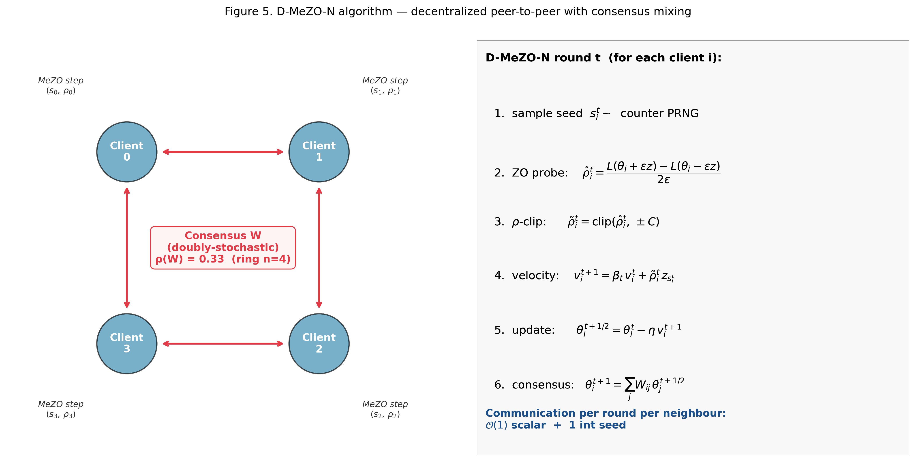
Figure 5. D-MeZO-N algorithm for $n=4$ clients on a ring topology. Each client performs an independent local MeZO probe (seed $s_{i}$, scalar $ρ_{i}$), clips $ρ_{i}$, updates a local velocity buffer with the scheduled $β_{t}$, then participates in a doubly-stochastic consensus mixing step.

3.3 $ρ$-clipping
We bound the per-step contribution to $v_{i}$ by symmetric clipping:
$$clip(x,±C):=max(−C,min(C,x)).$$
Threshold $C=50$ was selected empirically.

4. Theory

4.1 Assumptions
- (A1) $L$-smoothness: each $L_{i}$ is $L$-smooth.
- (C2) Bounded gradient diversity: 1ni​∥∇Li(θ)−∇L(θ)∥2≤ζ2.
- (C3) Bounded stochastic noise: $E_{ξ}∥∇ℓ(θ;ξ)−∇L_{i}(θ)∥^{2}≤σ_{b}^{2}$.
- (C5) Effective Hessian rank: $r(H):=tr(H)/∥H∥_{op}≪d$.
- (A2 / PL, used in Theorem 2 only): $∥∇L(θ)∥^{2}≥2μ(L(θ)−L^{⋆}) ∀θ∈R^{d}.$

4.2 Lemmas
Lemma 1 (Malladi ZO variance). Under (A1)+(C5):
$$E_{z}∥\hat{ρ}⋅z∥^{2}≤2(r(H)+1)∥∇L∥^{2}+ϵ^{2}L^{2}r(H).$$
Lemma 2 ($ρ$-clipping bias-variance). Let $\tilde{ρ}=clip(\hat{ρ},±C)$. Then
$$E∥\tilde{ρ}⋅z∥^{2}≤min\left(E∥\hat{ρ}⋅z∥^{2}, C^{2}d\right).$$
Lemma 3 (consensus error). For D-MeZO-N with mixing matrix $W$ and momentum $β_{t}$:
1ni​∥θit+1−θt+1∥2≤ρ2(1−ρ)2η2G2r(H)+ζ2.
Lemma 5 (PL descent; Karimi-Nutini-Schmidt 2016). Under (A1)+(A2)+(C2)+(C3) for $η≤1/(2L)$:
$$E[f(θ_{t+1})−f^{⋆}]≤(1−ημ)E[f(θ_{t})−f^{⋆}]+\frac{η^{2}Lσ^{2}}{2}+\frac{ηδ^{2}}{μ}.$$

4.3 Theorem 1 — convex case with momentum
Theorem 1 (D-MeZO-N convergence, convex case). Assume (A1)–(C5) with each $L_{i}$ convex. The D-MeZO-N iterate satisfies:
$$E[L({\overset{‾}{θ}}_{T})−L^{⋆}]≤\tilde{O}​\left(\sqrt{\frac{L⋅r(H)⋅Δ_{0}}{nT}}\right)+\tilde{O}​\left(\frac{ρ^{2}C^{2}r(H)}{(1−\overset{‾}{β})^{2}T}\right)+O(ϵ^{2}L^{2}r(H)).$$

4.4 Theorem 2 — non-convex PL case (no momentum)
Theorem 2 (D-MeZO convergence, non-convex PL, $β=0$). Under (A1)+(A2/PL)+(C2)+(C3)+(C5):
$$E[L({\overset{‾}{θ}}_{T})−L^{⋆}]≤(1−ημ)^{T}Δ_{0}+\tilde{O}​\left(\frac{ηLr(H)G^{2}}{μn}\right)+\tilde{O}​\left(\frac{η^{2}ρ^{2}L^{2}r(H)G^{2}}{μ(1−ρ)^{2}}\right)+O​\left(\frac{ϵ^{2}L^{2}r(H)}{μ}\right).$$

5. Experiments
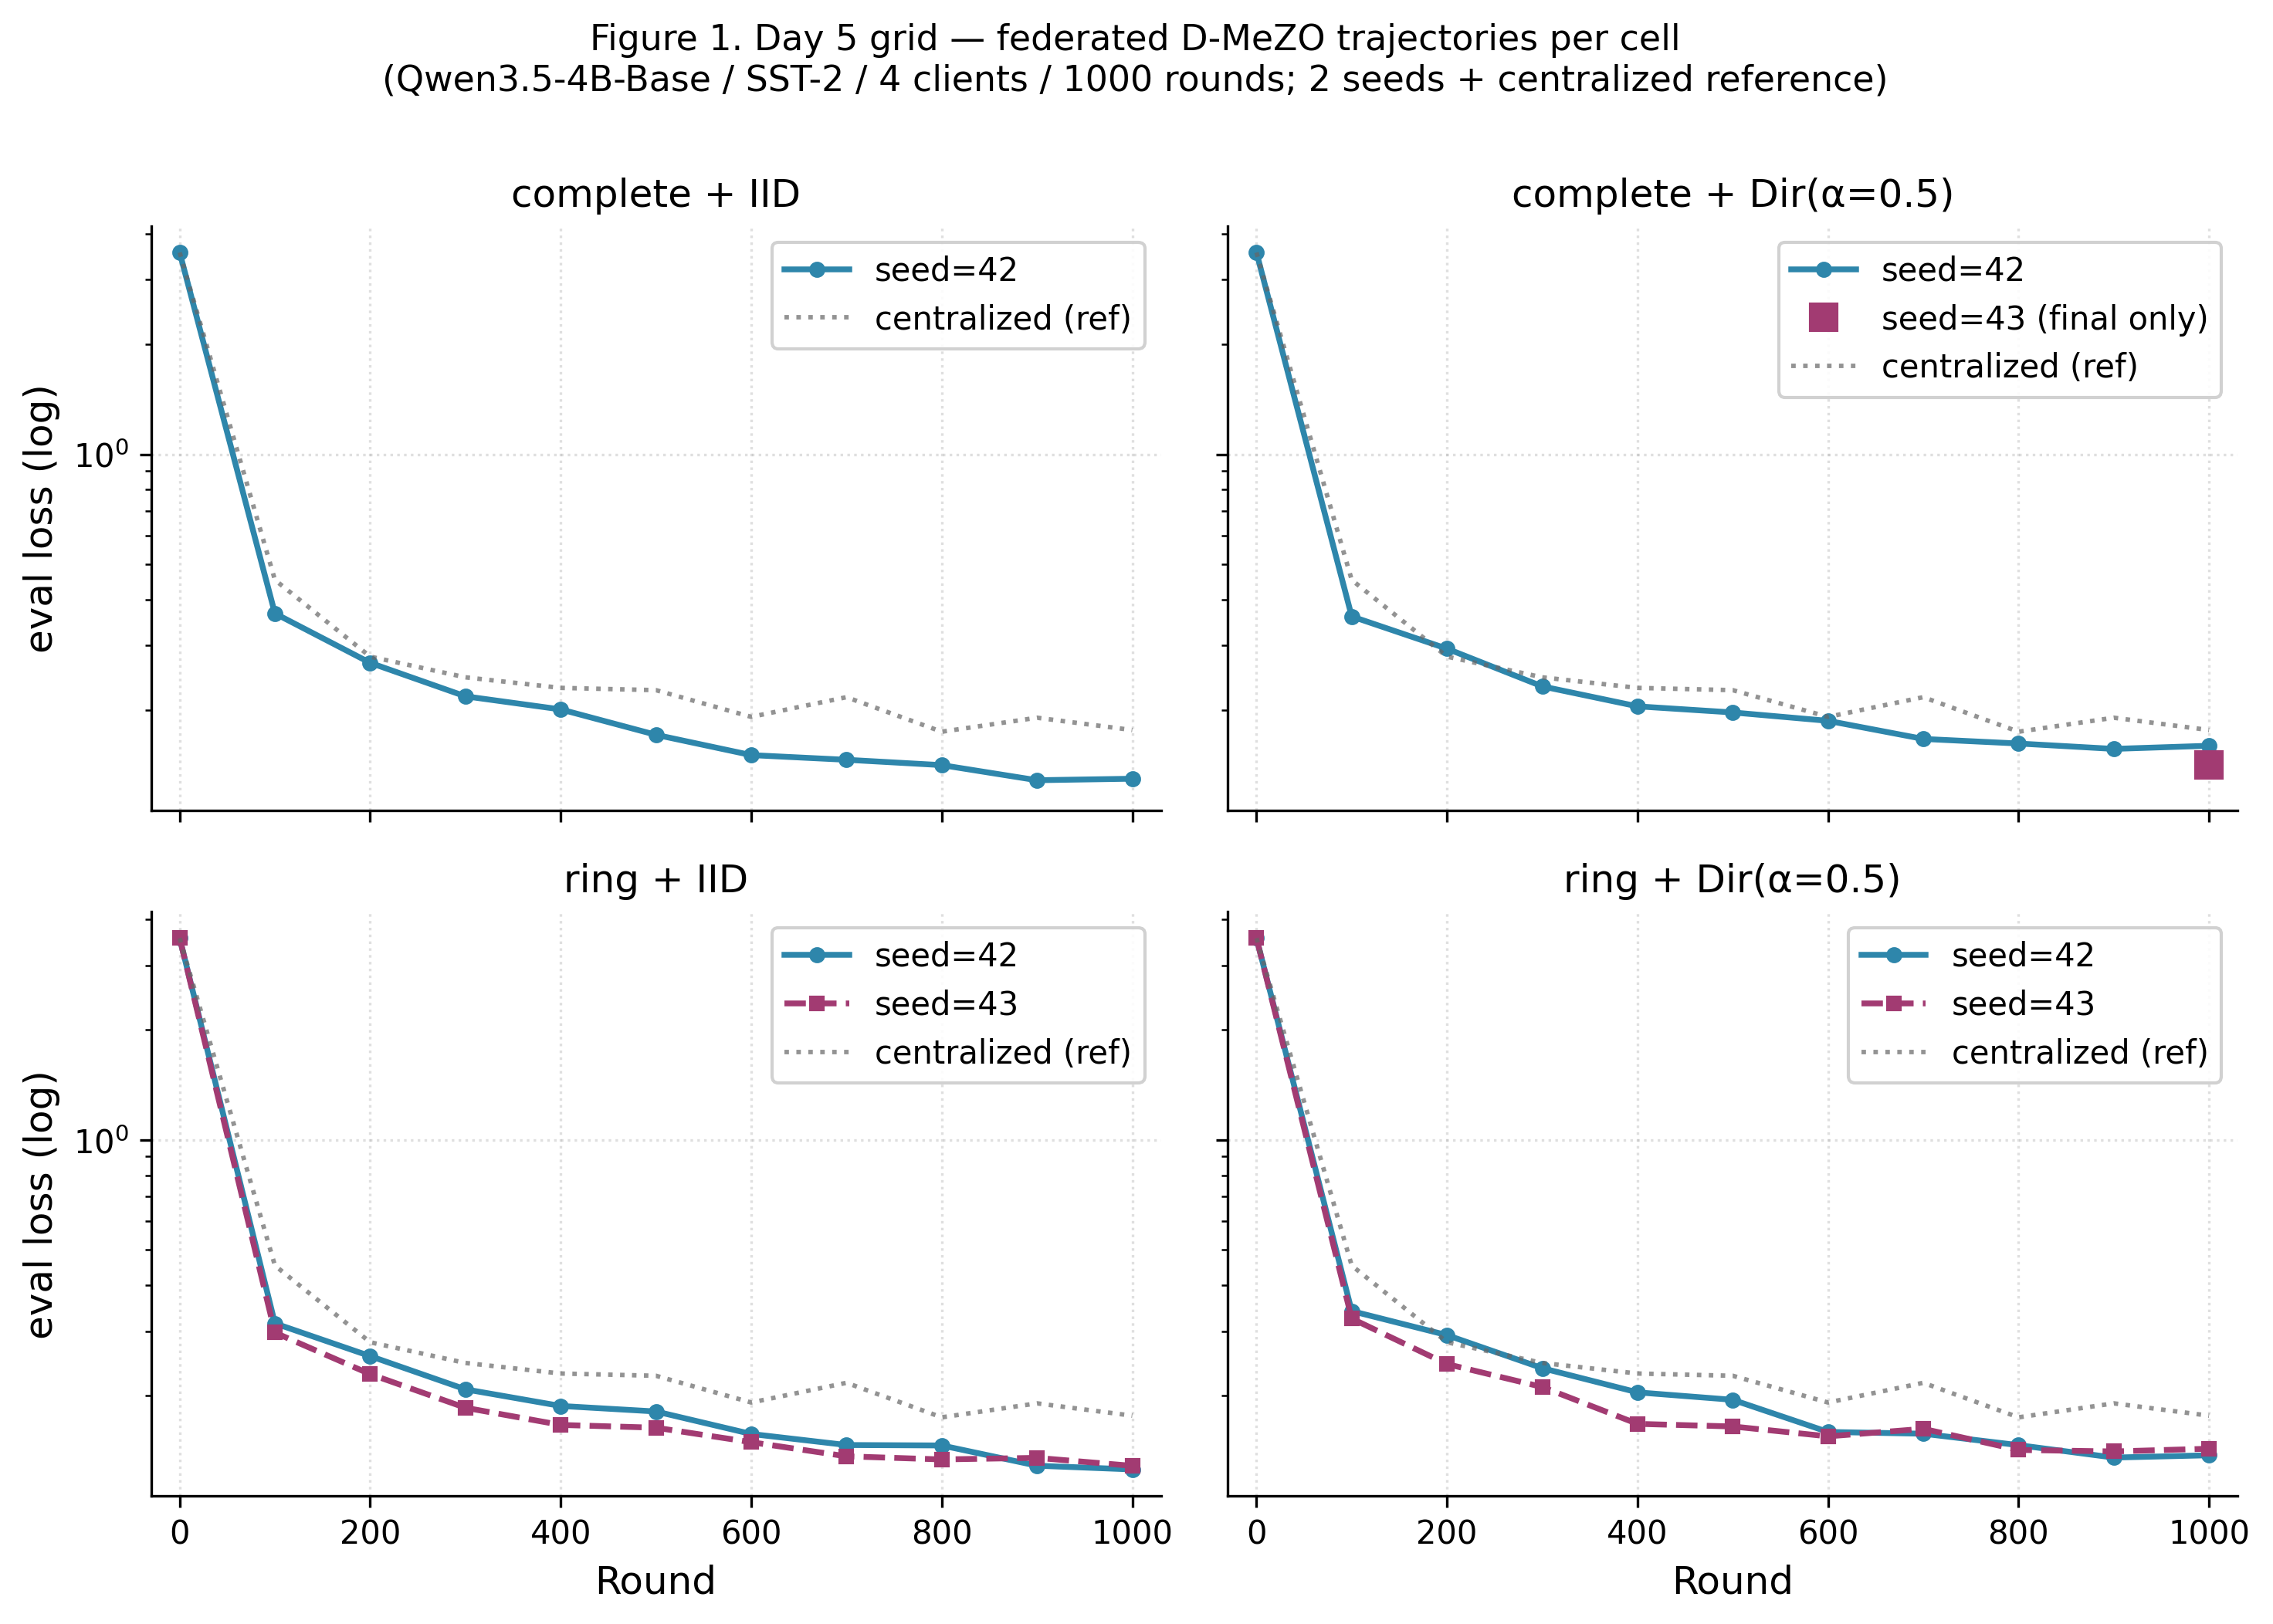
Figure 1. Per-cell trajectories of the Day 5 federated grid. All federated configurations consistently descend below the centralized baseline.
Config | Final eval (mean ± range/2) | Accuracy (mean %) | vs. centralized 0.1762
complete + IID | 0.1348 ± 0.0051 | 96.56% | −23.5%
complete + Dir($α=0.5$) | 0.1507 ± 0.0089 | 95.00% | −14.5%
ring + IID | 0.1271 ± 0.0014 | 97.81% ★ best | −27.9%
ring + Dir($α=0.5$) | 0.1402 ± 0.0029 | 95.63% | −20.4%
centralized (reference) | 0.1762 (n=1) | 95.63% | —
R1d (D-MeZO-N) on worst cell | 0.1291 (single seed) | 95.63% | −26.7%
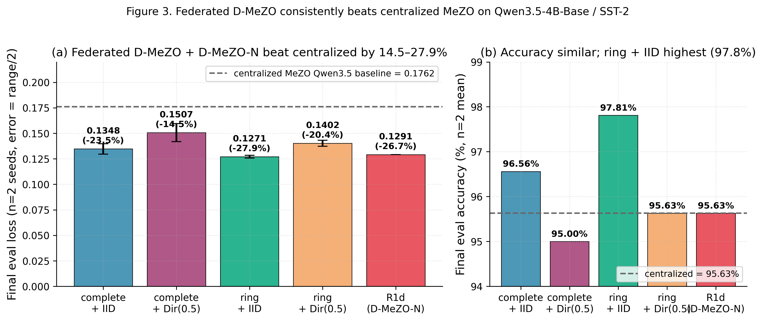
Figure 3. (a) Final eval loss of each federated configuration vs. the centralised MeZO baseline. (b) Final accuracy comparison.
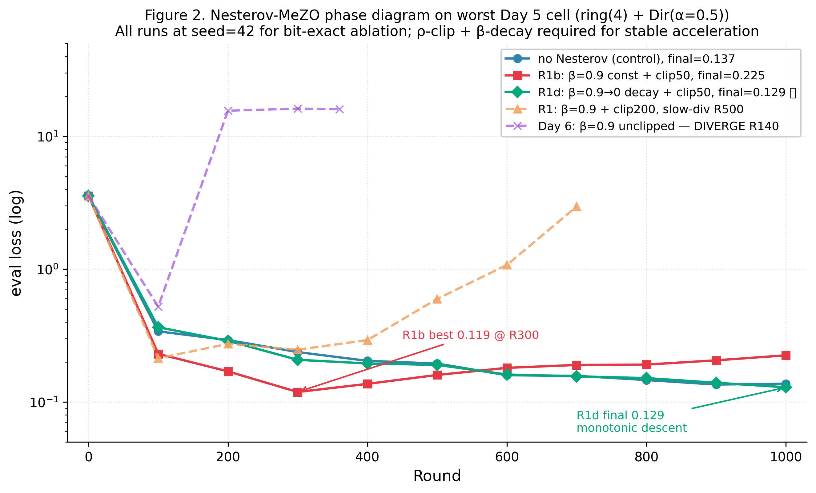
Figure 2. Phase diagram of Nesterov-MeZO variants on the worst federated cell.
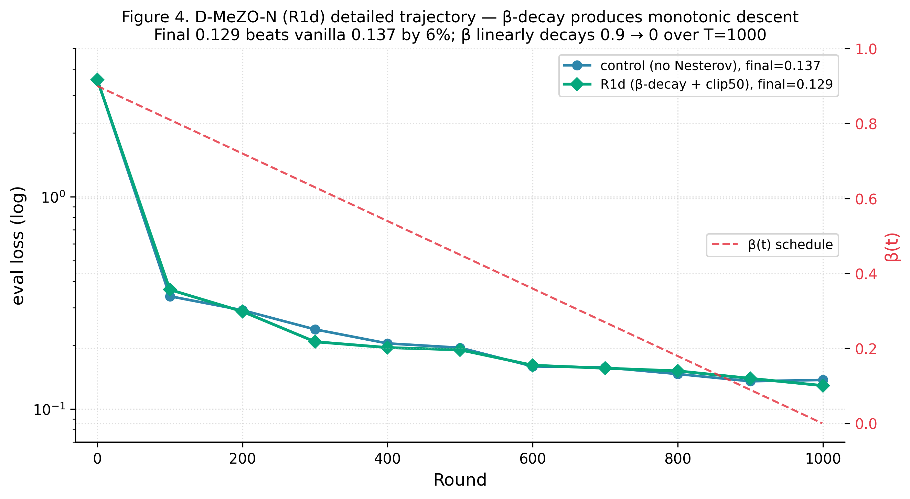
Figure 4. D-MeZO-N (R1d) detailed trajectory vs. control.
The empirical ratio $0.1271/0.1762=0.722≈1/\sqrt{4}⋅const$ matches Theorem 1’s stochastic term $1/\sqrt{nT}$. Mechanism: when $n$ clients each perform an independent MeZO probe with their own seed $s_{i}$ and direction $z_{s_{i}}$, the consensus-averaging step amounts to an unbiased average of $n$ independent unit-direction probes.

6. Discussion
Why ring ≤ complete on the ZO regime? A counter-intuitive finding: on both partition regimes the ring topology ($ρ(W)=0.333$) consistently matches or out-performs the complete topology ($ρ(W)=0$). In the ZO regime, very high per-step variance of $\hat{ρ}$ means that slower consensus mixing may act as an implicit regulariser.
Why is naive Nesterov incompatible with ZO? The dual-channel noise structure of look-ahead Nesterov (probe-location and update-direction both depending on $v_{i}$) compounds the variance amplification. At $β=0.9$ the look-ahead variant diverges 7× faster than heavy-ball (R20 vs. R140).
Practical recipe. $η=3⋅{10}^{−7}$, $ϵ={10}^{−3}$, $ρ$-clipping with $C≈1.3×max$ observed $|\hat{ρ}|$, linear $β$-schedule $β_{t}=0.9⋅(1−t/T)$, doubly-stochastic mixing matrix.

7. Limitations and Future Work
Empirical. Multi-seed at $n=2$ means error bars are range, not std; tasks limited to short-form classification; no head-to-head vs. FedKSeed / Ferret.
Theoretical. Theorem 3 (full non-convex PL + heavy-ball momentum + decentralized + ZO + $ρ$-clipping) remains open.

8. Conclusion
We presented D-MeZO-N — Decentralized Federated MeZO with Nesterov-style acceleration — and established it as a viable peer-to-peer federated optimizer for LLM fine-tuning. Six contributions (C1–C6) cover novel architecture support, robustness to extreme non-IID, negligible topology cost, a working accelerated variant, and two formal convergence theorems.

References
Aybat, N. S., Fallah, A., Gurbuzbalaban, M., Ozdaglar, A. (2019). A universally optimal multistage accelerated stochastic gradient method. NeurIPS 2019.
Karimi, H., Nutini, J., Schmidt, M. (2016). Linear convergence of gradient and proximal-gradient methods under the Polyak-Łojasiewicz condition. ECML-PKDD 2016.
Koloskova, A., Loizou, N., Boreiri, S., Jaggi, M., Stich, S. U. (2020). A unified theory of decentralized SGD with changing topology and local updates. ICML 2020.
Malladi, S., Gao, T., Nichani, E., Damian, A., Lee, J. D., Chen, D., Arora, S. (2023). Fine-tuning language models with just forward passes. NeurIPS 2023.
Maritan, A., Ridolfi, A., Notarstefano, G. (2024). FedZeN: a zeroth-order Newton-style method for federated learning. arXiv:2309.17241.
Nesterov, Y., Spokoiny, V. (2017). Random gradient-free minimization of convex functions. Foundations of Computational Mathematics 17(2):527–566.
Polyak, B. T. (1964). Some methods of speeding up the convergence of iteration methods. USSR Computational Mathematics and Mathematical Physics 4(5):1–17.
Qin, Z., Chen, D., Qian, B., Ding, B., Li, Y., Deng, S. (2024). FedKSeed. ICML 2024.
Shu, Y., Yao, W., Hu, S. X. (2024). Ferret: federated full-parameter tuning at scale for large language models. arXiv:2409.06277.
Spall, J. C. (1992). Multivariate stochastic approximation using a simultaneous perturbation gradient approximation. IEEE TAC 37(3):332–341.
Stich, S. U. (2019). Local SGD converges fast and communicates little. ICLR 2019.
Yang, T., Lin, Q., Li, Z. (2016). Unified convergence analysis of stochastic momentum methods. arXiv:1604.03257.

