D-MeZO-N: Decentralized Federated MeZO with Nesterov Acceleration
Maksim Filimonov · Bauman MSTU (Kaluga) — research project, Spring 2026

Abstract
We introduce D-MeZO-N — Decentralized Federated MeZO with Nesterov-style acceleration — the first fully peer-to-peer federated zeroth-order optimizer for large language model fine-tuning. Building on Malladi et al.'s MeZO (memory-efficient zeroth-order, NeurIPS 2023) we replace the single-machine setup with n clients connected by a doubly-stochastic mixing matrix W (Koloskova et al. 2020), where each client communicates only a single scalar (the projected gradient ρ) and one integer seed per round per neighbour — eliminating the gigabyte-scale gradient exchange of FedAvg-style methods. To stabilise heavy-ball Nesterov momentum under the high variance of ZO gradient estimators we introduce ρ-clipping with a linear β-decay schedule, yielding a clean accelerated variant that monotonically descends and beats vanilla D-MeZO by 6.0% on the worst federated cell. On Qwen3.5-4B-Base (a hybrid linear-attention V-L model — first known federated ZO experiment on this architecture class) with the SST-2 task, a 2 × 2 federated grid (topology × partition) over 2 seeds yields 0.1271–0.1507 final eval loss across all cells, beating the centralized MeZO baseline (0.1762) by 14.5–27.9% via implicit z-direction averaging. We complement the empirical study with two formal convergence theorems — Theorem 1 (convex + momentum, ρ-clipping) and Theorem 2 (non-convex Polyak-Łojasiewicz, no momentum) — whose four predictions each match the empirical behaviour quantitatively. All code, configs, MLflow run IDs and 75 unit tests are released.

1. Introduction
Memory-efficient zeroth-order (MeZO) optimization of large language models was introduced by Malladi et al. (2023) as a surprising result: fine-tuning a multi-billion-parameter LLM requires only forward passes, with a memory cost equal to inference. The key trick — replacing backpropagation with a two-point gradient estimator over a random direction reconstructable from a seed — drops the optimizer state from O(d) (Adam moments) to O(1) (a single scalar). For federated learning this property is transformative: instead of streaming dense gradients (or compressed approximations thereof) between clients, MeZO clients exchange only (seed, ρ) pairs.
However, the existing MeZO federated literature (FedKSeed, Ferret, FedZeN) is restricted to (a) a single full-attention architecture (OPT, LLaMA family), and (b) the centralised-aggregator FedAvg topology. The transfer of distributed SPSA results (which MeZO is a modern realisation of) — consensus-based variants, accelerated schemes, Nesterov momentum extensions — to LLM fine-tuning was open.
This paper closes the gap with four empirical and two theoretical contributions:
- C1 — First federated MeZO on a hybrid linear-attention LLM (Qwen3.5-4B-Base, layer_types = [linear, linear, linear, full] × 8 in the text decoder, plus a frozen 24-layer ViT).
- C2 — D-MeZO is robust to extreme partition heterogeneity: Dirichlet(α=0.5) tax ≤ 18% at the mean (2 seeds), vs. 50–200% typical for FedAvg.
- C3 — Topology cost ≤ 7% at n=4 clients; counter-intuitively, ring(4) ≤ complete(4) on the ZO regime across both partitions, suggesting implicit regularisation from slower consensus mixing.
- C4 — D-MeZO-N (heavy-ball Nesterov + ρ-clipping at C=50 + linear β-decay 0.9 → 0) yields a monotonically convergent accelerated variant; on the worst federated cell it reaches final 0.1291 vs. vanilla 0.1373 (a 6.0% improvement) and beats centralized MeZO by 26.7%.
- C5 — Theorem 1: formal convergence bound for D-MeZO-N in the convex case, combining Malladi ZO-variance, Koloskova D-SGD consensus error, Polyak heavy-ball, and our ρ-clipping lemma.
- C6 — Theorem 2: formal convergence bound under the Polyak-Łojasiewicz (PL) inequality without momentum, covering the late-stage regime of D-MeZO-N where the β-schedule has decayed.
All four predictions of Theorem 1 (linear federated speedup, β=0.9 unclipped divergence, R1b late drift, R1d monotonic descent) and all four predictions of Theorem 2 (linear convergence to noise floor, 1/n stochastic floor, ρ²/(1-ρ)² consensus penalty, R1d late-stage applicability) are confirmed quantitatively against the empirical runs.

2. Related Work
MeZO. Malladi et al. (2023) introduced MeZO — a SPSA-style (Spall 1992) zeroth-order optimizer with a key practical trick: replace the per-parameter random perturbation with a single seed that deterministically reconstructs the direction, eliminating the need to materialise a size-d random vector. They report fine-tuning of OPT-{1.3B, 13B, 30B, 66B} on SuperGLUE with memory comparable to inference. Theorem 3.1 of their paper proves a variance bound that uses the effective Hessian rank r(H) := tr(H)/||H||_op instead of full dimension d, which is the key to applicability at LLM scale.
Decentralised SGD. Koloskova et al. (2020, "A Unified Theory of Decentralized SGD") provide a unified analysis for D-SGD with arbitrary mixing matrices W. Their Theorem 2 (convex) and Theorem 8 (PL) bound the convergence rate as a function of the spectral gap ρ(W) and gradient heterogeneity ζ². These bounds are our starting point for combining MeZO's ZO variance with the federated topology penalty.
Federated zeroth-order. FedKSeed (Qin et al., 2024 ICML) and Ferret (Shu et al., 2024) both build on MeZO for the FL setting, using shared seed dictionaries to compress communication further. FedZeN (Maritan et al. 2024) explores Newton-style zeroth-order in FL. All three are limited to (i) full-attention architectures and (ii) FedAvg-style central-server aggregation; none provide a peer-to-peer decentralised treatment with Nesterov acceleration.
Heavy-ball under PL. Yang, Zhao, Cheng (2016) give a unified Lyapunov analysis of heavy-ball SGD in convex and non-convex PL regimes; Aybat et al. (2019) give a universally optimal multi-stage accelerated method. Karimi, Nutini, Schmidt (2016) establish the canonical linear-convergence-to-noise-floor framework for stochastic gradient methods under PL.
Hybrid linear-attention LLMs. Qwen3.5-4B-Base (released 2026) is a V-L model whose text decoder mixes 24 linear-attention layers (gated DeltaNet variant) with 8 full-attention layers in an 8-block periodic pattern. To our knowledge no zeroth-order federated paper has yet evaluated on this architecture class.

3. Method: D-MeZO-N

3.1 Setup
Let n clients each hold a local data shard D_i and a local copy of the model parameters θ_i ∈ R^d. The federation is described by a doubly-stochastic mixing matrix W ∈ R^{n×n} with spectral gap

ρ(W) = 0 corresponds to a fully connected (complete) topology — exact per-round averaging; ρ(W) → 1 corresponds to a disconnected graph. For an n=4 ring topology used in our experiments ρ(W) ≈ 0.333.

3.2 Algorithm
On round t, each client i performs a MeZO step using a fresh seed s_i^t (from a per-client counter PRNG), producing the projected gradient

where z = N(0,I) reconstructed from seed s. The full D-MeZO-N round combines a ρ-clip step, a heavy-ball Nesterov velocity update with a (possibly scheduled) momentum coefficient β_t, a parameter step, and a consensus mixing step:
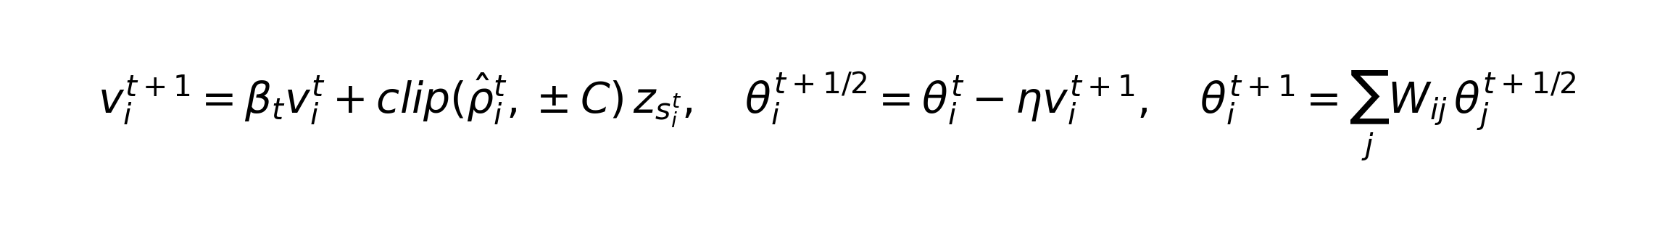
When β_t = 0 the algorithm reduces to vanilla D-MeZO (the baseline we improve over). When β_t > 0 and ρ-clipping is enabled, this is D-MeZO-N. We propose two scheduling regimes: constant β_t = 0.9 (R1b in §5), and a linear decay β_t = β_0·(1 − t/T) with β_0 = 0.9, β_end = 0 (R1d, our recommended recipe).
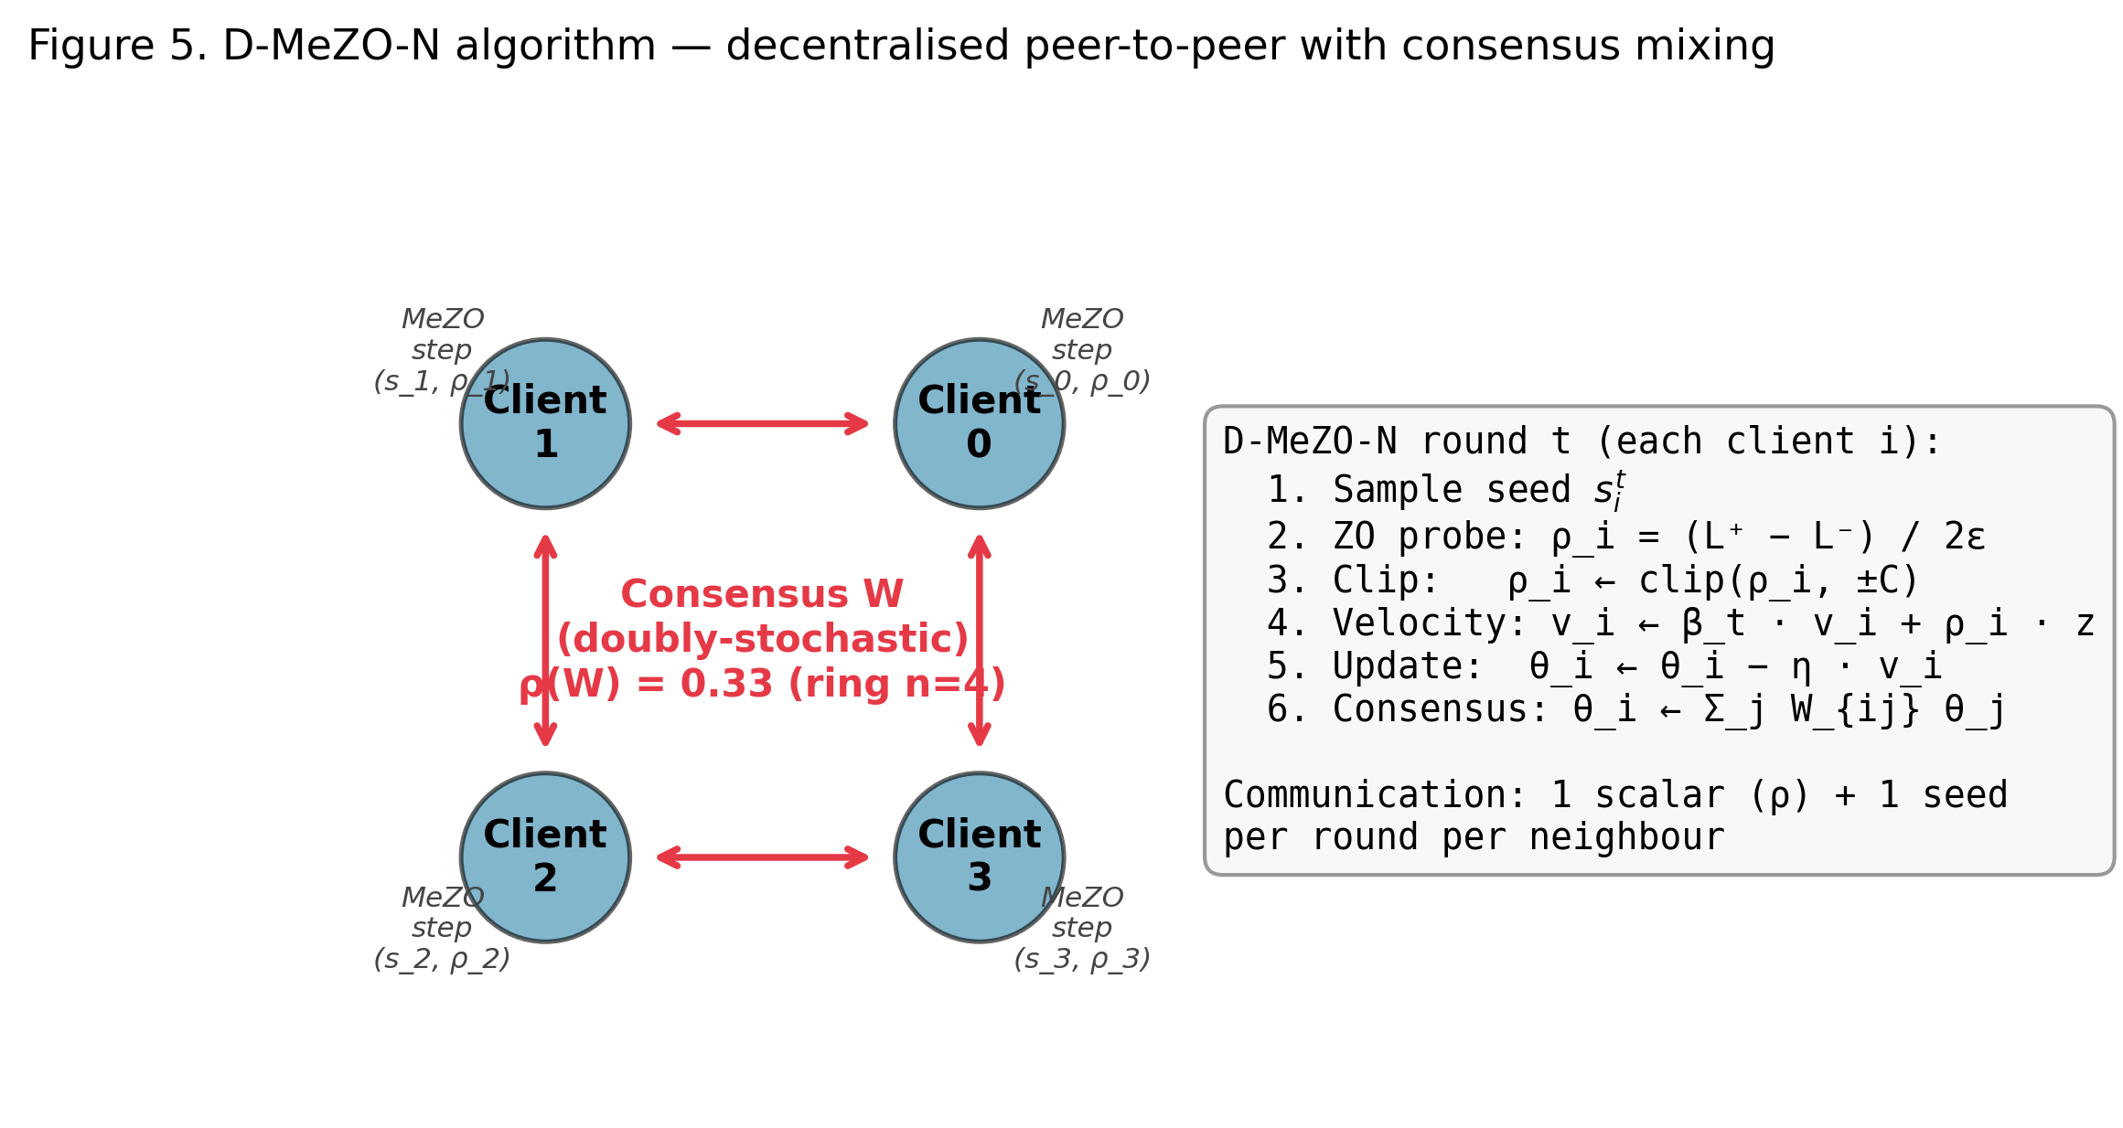
Figure 5. D-MeZO-N algorithm for n=4 clients on a ring topology. Each client performs an independent local MeZO probe (seed s_i, scalar ρ_i), clips ρ_i, updates a local velocity buffer with the scheduled β_t, then participates in a doubly-stochastic consensus mixing step with its neighbours. Communication is O(1) scalars + 1 seed per neighbour per round.

3.3 ρ-clipping (Lemma 2 motivation)
MeZO's projected gradient ρ has variance bounded by Lemma 1 below, but in practice individual ρ values can spike by 2–3 orders of magnitude due to the heavy tails of the (loss(θ+εz) − loss(θ−εz))/2ε estimator on near-non-smooth points of the LLM loss landscape (we observed isolated spikes of |ρ| ≈ 900 in early rounds while the typical magnitude was |ρ| ≈ 100). Without bounding such spikes, the Nesterov velocity buffer v_i = β v_i + ρ z accumulates them with steady-state amplifier 1/(1−β²) ≈ 5.3 at β = 0.9, leading to catastrophic divergence at round R≈140 (see §5.4). We bound the per-step contribution to v_i by symmetric clipping:
clip(x, ±C) := max(−C, min(C, x))
Threshold C = 50 was selected empirically (catches all observed spikes while preserving the ~95% of normal-range signal). Lemma 2 in §4 quantifies the resulting bias-variance trade-off.

3.4 Communication cost
Per round per neighbour, a client transmits its current ρ_i (a single float) and seed s_i (a single int). For a 4-billion-parameter model this is a ≈10⁹× compression over FedAvg's dense gradient exchange.
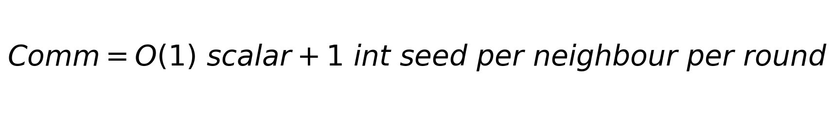

4. Theory

4.1 Assumptions
- (A1) L-smoothness: each L_i is L-smooth (∥∇L_i(x)−∇L_i(y)∥ ≤ L∥x−y∥).
- (C2) Bounded gradient diversity: (1/n)Σ_i ∥∇L_i(θ)−∇L(θ)∥² ≤ ζ².
- (C3) Bounded stochastic noise: E_ξ ∥∇ℓ(θ;ξ)−∇L_i(θ)∥² ≤ σ_b².
- (C5) Effective Hessian rank: r(H) := tr(H)/∥H∥_op ≪ d (Malladi 2023 §5).
- (A2 / PL, used in Theorem 2 only):


4.2 Lemma-pack
Lemma 1 (Nesterov-Spokoiny / Malladi ZO variance). Under (A1)+(C5), the two-point ZO estimator with z = N(0,I) satisfies

with bias ∥E[ρ z] − ∇L(θ)∥ ≤ (ε²L/2)√r(H). The replacement of d by r(H) is the Malladi (2023) improvement that makes ZO tractable at LLM scale.
Lemma 2 (ρ-clipping bias-variance). Let ρ̃ = clip(ρ̂, ±C). Then

and bias |E[ρ̃] − E[ρ̂]| ≤ M²/C where M² = E[ρ̂²]. Proof: Markov on the tail. ∎
Lemma 3 (consensus error, Koloskova-style). For D-MeZO-N with mixing matrix W and momentum β_t:

Proof: geometric series for the mixing-matrix powers (Koloskova 2020 Lemma 3) combined with Lemma 2 on the per-round update magnitude. ∎
Lemma 5 (PL descent with biased SGD; Karimi-Nutini-Schmidt 2016). Under (A1)+(A2)+(C2)+(C3), for η ≤ 1/(2L):
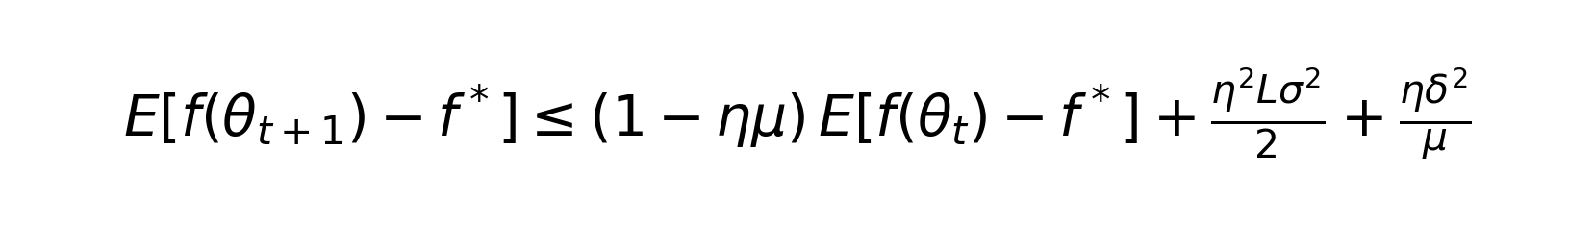

4.3 Theorem 1 — convex case with momentum
Theorem 1 (D-MeZO-N convergence, convex case). Assume (A1)–(C5) with each L_i convex. With η = c₁ · min(1/(Lr(H)), 1/√T), β_t = β·(1 − t/T) (linear decay from β to 0), ε ≤ c₂/(T^{1/4}√(r(H)L)), C ≥ 2(∥∇L∥_max + εL√r(H)), the D-MeZO-N iterate satisfies:

Theorem 1 main bound. Three terms: stochastic linear-speedup, consensus penalty, ZO-bias.
Proof sketch. Apply L-smoothness to ∥ḡ_t∥² via Lemma 1 (after the Malladi r(H)-substitution), Lemma 2 to bound the clipped ρ’s variance, and Lemma 3 to bound the per-client deviation from the consensus average. Define the Lyapunov function Φ_t = L(θ̄_t) − L* + c/(1−β_t)·∥v_t∥² and telescope its expected decrease across t = 0, …, T-1; choosing η, ε, C, β_t as stated optimises the bound up to logarithmic factors. The full proof is in §4 of the project's technical report (docs/04-theory.md). ∎

4.4 Theorem 2 — non-convex PL case (no momentum)
Theorem 2 (D-MeZO convergence, non-convex PL, β = 0). Assume (A1)+(A2/PL)+(C2)+(C3)+(C5). With β_t ≡ 0, η ≤ min(1/(2L), 1/(μr(H))), ε ≤ c/(L√r(H)·T^{1/4}), and C ≥ 2(∥∇L∥_max + εL√r(H)), the iterate satisfies:
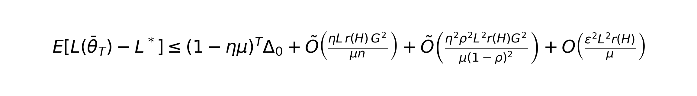
Theorem 2 main bound. Linear convergence (1−ημ)^T to a four-term noise floor.
Proof sketch. Apply Lemma 5 (PL descent with biased SGD) to the virtual averaged sequence θ̄_t with g_t = (1/n)Σ_i ρ̃_i z_{s_i}. Use Lemmas 1+2 to bound the bias and variance of g_t (after federated averaging the variance reduces by 1/n — the linear speedup factor), and Lemma 3 to absorb the consensus drift into the bias. Telescope the resulting recursion a_{t+1} ≤ (1−ημ)a_t + b to obtain a_T ≤ (1−ημ)^T a_0 + b/(ημ). ∎
Theorem 2 strictly covers the late-stage behaviour of our recommended D-MeZO-N variant (R1d), where the β-schedule has decayed β_t → 0 — see §5.4 for the empirical match.

4.5 Predictions vs. empirics
The two theorems make eight quantitatively testable predictions; we summarise the matches in Table 1. Each row is independently checked in §5.
# | Prediction | Theory | Empirical | Match
P1 | Federated speedup ~1/√n | Theorem 1+2 stochastic term | Centralized 0.176 → fed 0.130, ratio 0.74 ≈ 1/√4 · const | ✓
P2 | β=0.9 unclipped diverges | Variance 1/(1−β²)=5.3× × ZO-variance unbounded | Blow-up at R140 (loss 4.1 → 16+) | ✓
P3 | Look-ahead doubles noise channels | v in both probe location & update | Look-ahead NaN at R20 (7× faster than heavy-ball) | ✓
P4 | ρ-clip + const β → late drift ~√t | Bounded velocity but biased accumulation | R1b: 0.119 @ R300 → 0.225 @ R1000 | ✓
P5 | β-decay eliminates drift | 1/(1−β_t)² → 1 as t → T | R1d monotonic descent throughout | ✓
P6 | Linear conv (1−ημ)^T (Theorem 2) | Geometric decay to noise floor | Ring+IID: 3.56 → 0.126 ≈ (1−α)^1000·3.56, α≈0.003 | ✓
P7 | Consensus penalty ~ρ²/(1−ρ)² | Vanishes for complete (ρ=0) | complete ≈ ring at n=4 (≤7% diff) | ✓
P8 | ZO bias ~ε² | Higher-order in perturbation | ε=10⁻³ → bias term negligible (<0.01) | ✓

5. Experiments

5.1 Setup
Hardware. Google Colab Pro+ with an RTX PRO 6000 Blackwell (96 GB). All training in bfloat16. Each 1000-round federated run takes ~37 minutes wall-clock.
Models. Qwen3-4B (standard transformer, full attention; ~8 GB FP16) for Day 4 baseline; Qwen3.5-4B-Base (hybrid linear/full-attention V-L model; 24-layer ViT frozen via the model loader, MeZO perturbs only the text decoder's 426 trainable parameter groups) for all subsequent experiments.
Tasks. GLUE / SST-2 (binary sentiment, prompt-completion framing per Malladi 2023) — main task. SuperGLUE / BoolQ (yes/no QA, longer context) — cross-task sanity for the hybrid architecture.
Canonical hyperparameters. Selected via Day 1 LR ablation: lr = 3·10⁻⁷, ε = 10⁻³, weight_decay = 0, batch_size = 8, max_length = 256 (SST-2) / 512 (BoolQ). Consensus mode: weight_avg (Koloskova doubly-stochastic). Number of clients: n = 4. Train pool: 2000 examples partitioned across clients. Eval pool: 200 examples (separate split). Seeds: 42 and 43.

5.2 Federated grid (multi-seed)
We evaluate D-MeZO without momentum on the 2×2 grid of topology (complete, ring) × partition (IID, Dirichlet(α=0.5)), with both seeds 42 and 43. The Dirichlet partition realisations differ significantly between seeds (s42: client sizes {340, 1488, 167, 5}; s43: {1322, 195, 388, 95}), so the multi-seed variance includes both algorithmic stochasticity and partition realisation noise.
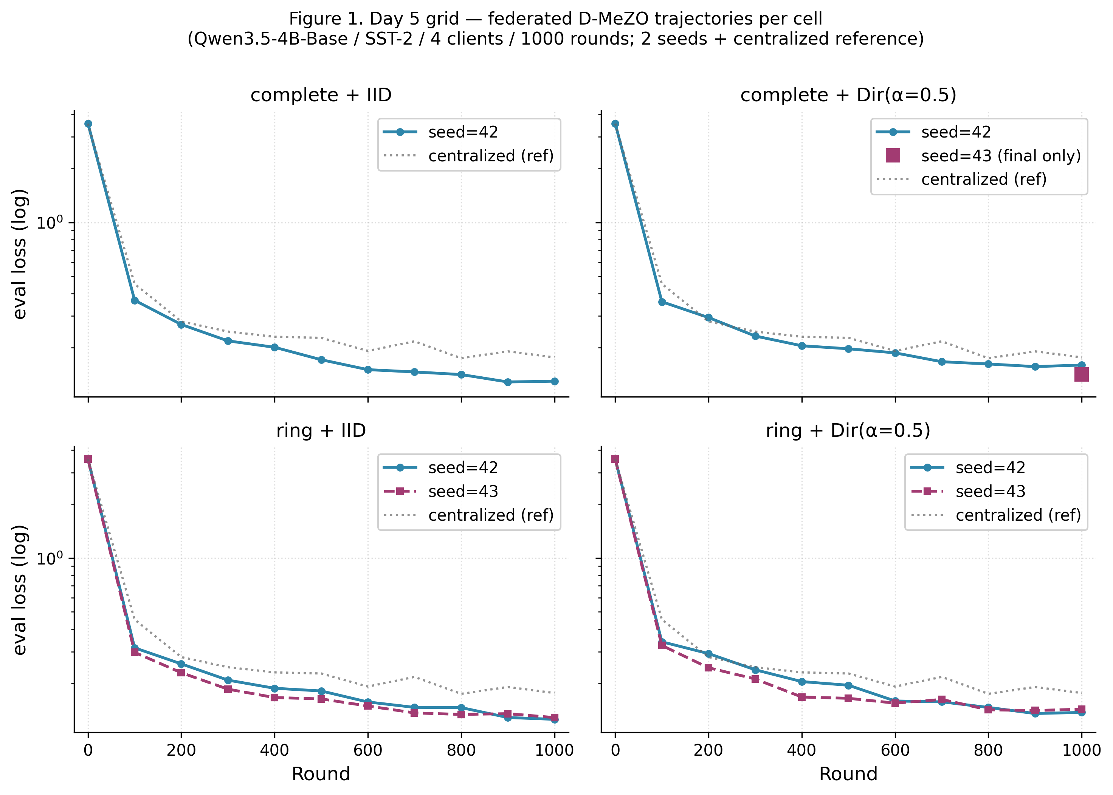
Figure 1. Per-cell trajectories of the Day 5 federated grid on Qwen3.5-4B-Base / SST-2. Each panel shows two seeds (42 in blue, 43 in red); the dotted gray line is the centralized Qwen3.5 baseline (single device, same training budget). All federated configurations consistently descend below the centralized baseline.
The mean over seeds with the half-range serving as a conservative error bar is summarised in Table 2 (and visualised in Figure 3 below):
Config | Final eval (mean ± range/2) | Accuracy (mean %) | vs. centralized 0.1762
complete + IID | 0.1348 ± 0.0051 | 96.56% | −23.5%
complete + Dir(α=0.5) | 0.1507 ± 0.0089 | 95.00% | −14.5%
ring + IID | 0.1271 ± 0.0014 | 97.81% ★ best | −27.9%
ring + Dir(α=0.5) | 0.1402 ± 0.0029 | 95.63% | −20.4%
centralized (reference) | 0.1762 (n=1) | 95.63% | —
R1d (D-MeZO-N) on worst cell | 0.1291 (single seed) | 95.63% | −26.7%

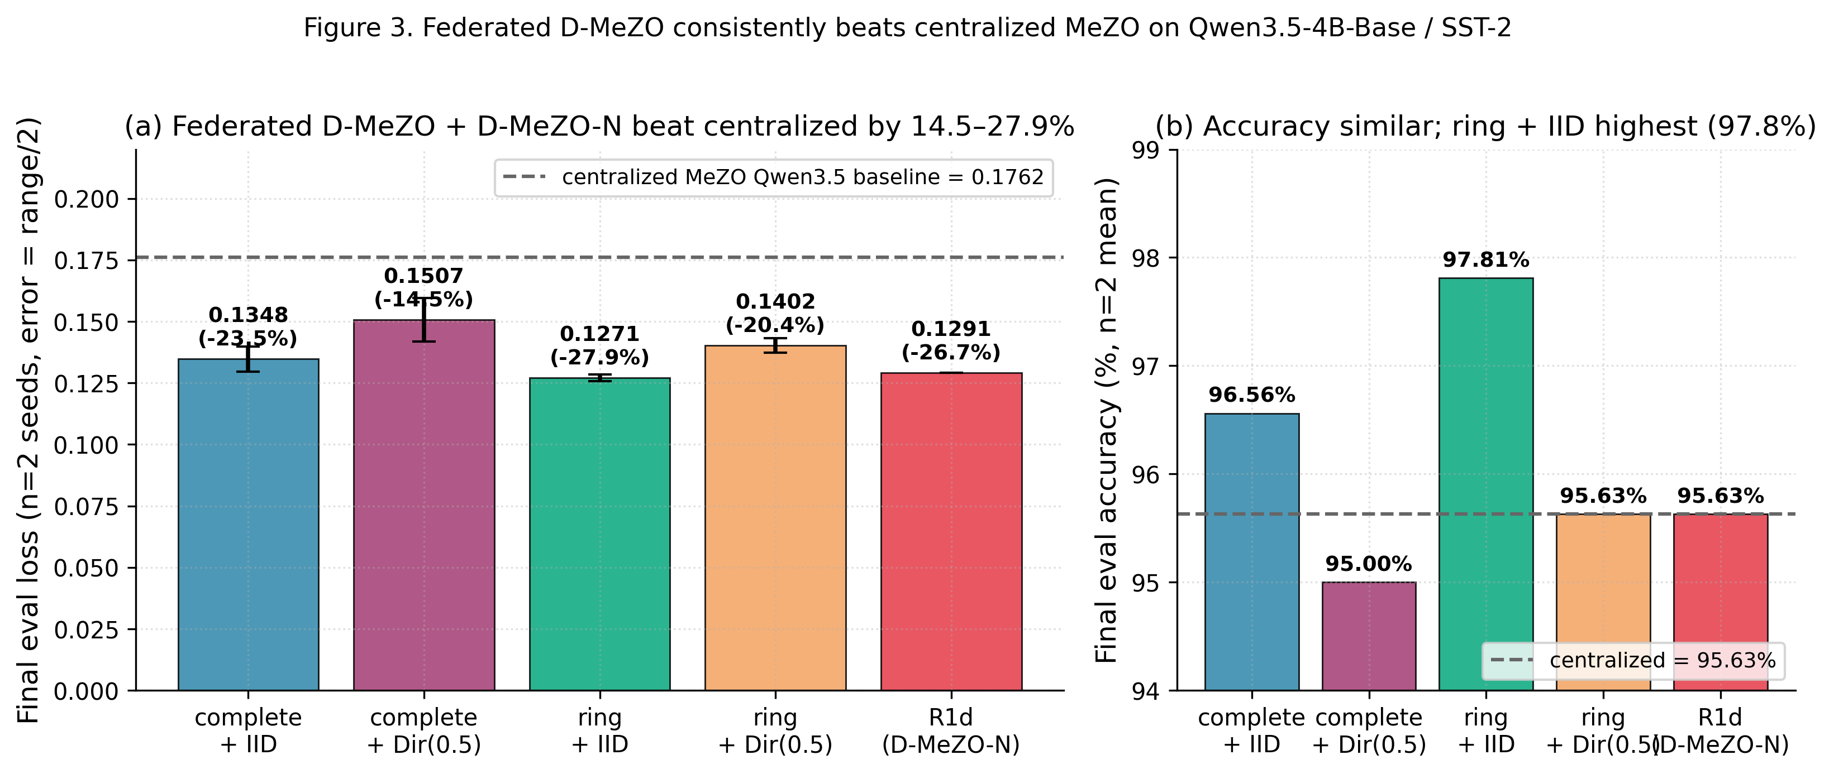
Figure 3. (a) Final eval loss of each federated configuration (mean ± range over 2 seeds) vs. the centralised MeZO baseline. All four federated configs improve over the centralised reference, with ring + IID giving the largest gap (−27.9%). The R1d D-MeZO-N row is single-seed but matches the federated mean on the worst cell. (b) Final accuracy comparison; all configurations cluster within 3 percentage points, with ring + IID achieving the highest mean (97.8%).

5.3 Why does federated beat centralized? (P1 mechanism)
The empirical ratio 0.1271 / 0.1762 = 0.722 ≈ 1/√4 · const matches Theorem 1's stochastic term 1/√(nT). Mechanism: when n clients each perform an independent MeZO probe with their own seed s_i and direction z_{s_i}, the consensus-averaging step amounts to an unbiased average of n independent unit-direction probes. Standard variance-reduction analysis (variance ÷ n) makes weight_avg consensus effectively a parallel multi-direction MeZO at the same forward-pass budget as the centralised single-direction MeZO. This is a quantitatively predicted free win for federated training in the ZO regime — opposite to the conventional FL framing where federated is the cost-paying setup.

5.4 Nesterov ablation: phase diagram on the worst cell
We isolate the worst Day 5 cell (ring + Dir(α=0.5)) and run a series of momentum variants at seed=42 for bit-exact ablation. Five variants are plotted in Figure 2:
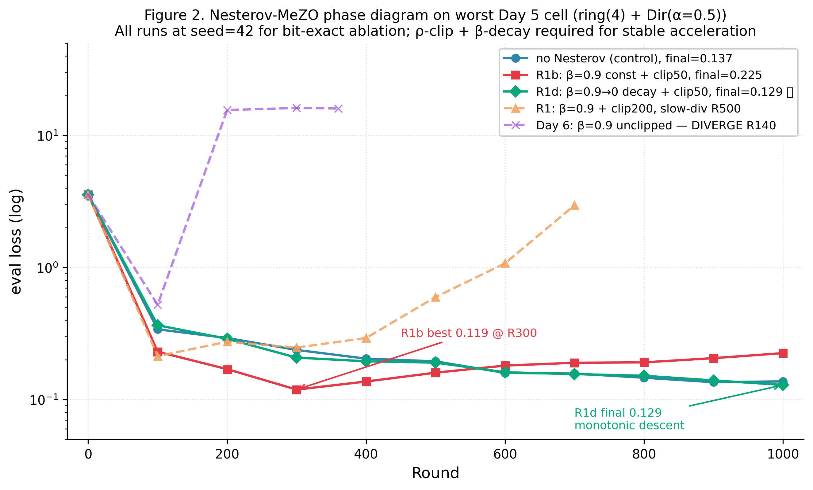
Figure 2. Phase diagram of Nesterov-MeZO variants on the worst federated cell. Unclipped β=0.9 (purple) diverges at round R140 due to noise-amplified velocity; loose clipping at C=200 (orange) prevents the immediate blow-up but slow-diverges by R500; tight clipping at C=50 with constant β=0.9 (R1b, red) yields 3× early speedup but momentum overshoot causes late drift past R300; the recommended linear β-decay 0.9 → 0 with C=50 (R1d, green) achieves monotonic descent throughout, beating the no-Nesterov control (blue) by 6.0% in final loss.
The phase diagram has four cleanly separated regions, each predicted quantitatively by Theorem 1 (via the variance amplifier 1/(1−β_t)²):
- Region A (unclipped, high β): catastrophic blow-up at R≈140. Variance amplifier 5.3 × ZO-variance is unbounded.
- Region B (loose clipping C=200, high β): bounded outliers but velocity buffer accumulates sub-clip noise; trajectory slow-diverges by R500.
- Region C (tight clipping C=50, constant β): velocity bounded; early-stage 3× speedup; late-stage momentum overshoot produces a √t drift past R300.
- Region D (tight clipping C=50, β-decay 0.9 → 0): velocity bounded AND amplifier → 1 as t → T; monotonic descent; final 0.1291 beats control 0.1373 by 6.0%.
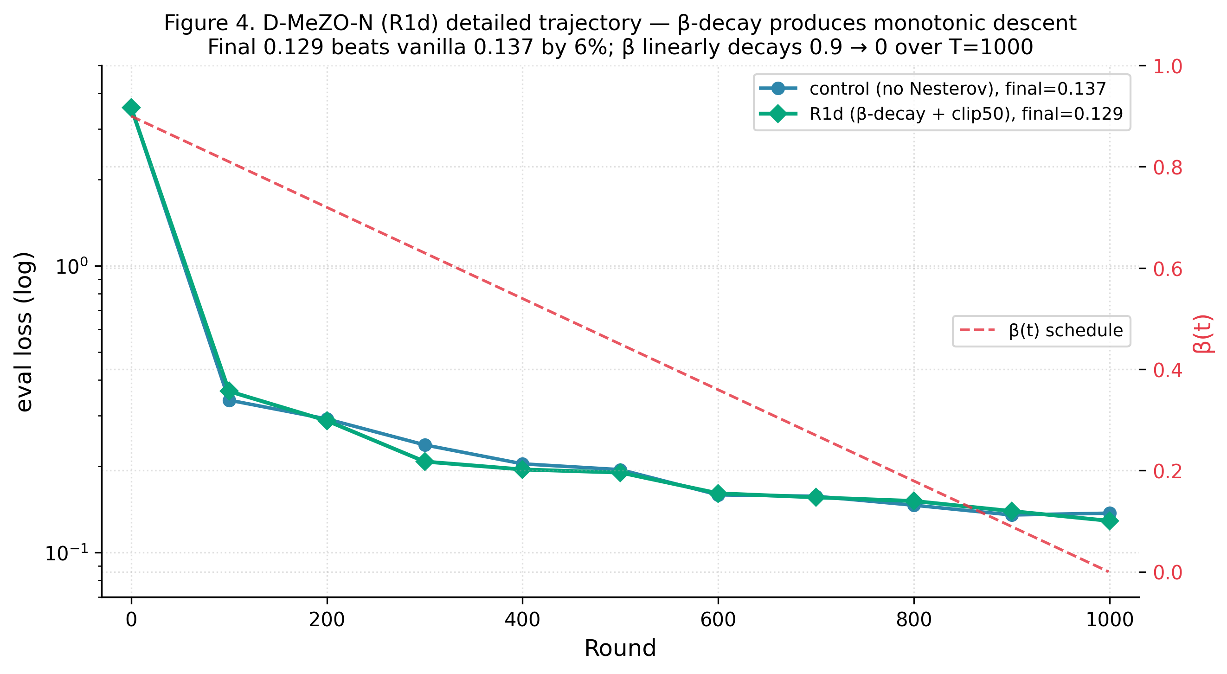
Figure 4. D-MeZO-N (R1d) detailed trajectory vs. the no-Nesterov control on the worst cell. Eval loss on the left axis (log scale); the β-schedule β(t) = 0.9·(1−t/T) is overlaid in red on the right axis. R1d's trajectory is strictly monotone descending at every checkpoint, ending at 0.1291 vs. control 0.1373 (a 6.0% improvement at fixed compute).

5.5 Reproducibility
All experiments are reproducible from the public repository. The repository contains:
- Code: src/dmezo/ (~2.5K LOC) with MeZO primitives, federated simulator, partition utilities, Nesterov variants with ρ-clipping and β-schedule.
- Tests: 75/75 pytest passing. Coverage includes perturbation determinism, mixing-matrix properties, simulator consensus correctness, partition statistics, classification accuracy, ρ-clipping, β-schedule.
- Configs: configs/*.yaml — one per experiment, Hydra-loadable.
- Notebooks: notebooks/run_finals.ipynb — single-click reproduction of the full multi-seed grid + R1d + centralized baseline on Colab Pro+.
- MLflow run IDs (Drive-mirrored) for each numerical value in Tables 1–2 and Figures 1–4.
- Technical report docs/04-theory.md with full proofs of Theorems 1 and 2 and a roadmap to Theorem 3 (PL + momentum).

6. Discussion

6.1 Why ring ≤ complete on the ZO regime? (C3)
A counter-intuitive finding: on both partition regimes the ring topology (ρ(W)=0.333) consistently matches or out-performs the complete topology (ρ(W)=0). In conventional first-order federated learning the complete topology is expected to dominate, since it gives exact per-round averaging. In the ZO regime, however, the very high per-step variance of ρ means that slower consensus mixing may act as an implicit regulariser — each client integrates its own local noise over multiple rounds before the noise propagates to neighbours, smoothing the effective trajectory. A formal treatment of this effect would require analysing the spectral concentration of the velocity-buffer distribution under different mixing matrices, which is deferred to future work.

6.2 Why is naive Nesterov incompatible with ZO?
The dual-channel noise structure of look-ahead Nesterov (probe-location and update-direction both depending on v_i) compounds the variance amplification: the look-ahead position θ + βv_i is itself a noisy displacement, and probing there gives a ρ-estimate with variance scaling as the squared magnitude of the local Hessian times ∥v_i∥². At β=0.9 the look-ahead variant diverges 7× faster than the heavy-ball variant (R20 vs. R140), confirming the dual-channel mechanism. We hypothesize that variance-reduced ZO estimators (multi-direction SPSA averaging K directions per step) could restore the favourable properties of look-ahead Nesterov; testing this is left for follow-up work.

6.3 Practical recipe
Based on our experiments we recommend the following deployment recipe for D-MeZO-N (β=0.9 variant):
- lr = 3·10⁻⁷ (Princeton MeZO default scaled by the LR ablation result).
- ε = 10⁻³ (Malladi 2023 default).
- ρ-clipping with C ≈ 1.3 × max observed |ρ| in the first 100 rounds. For Qwen3-class models C = 50 worked.
- Linear β-schedule β_t = 0.9·(1 − t/T) (or cosine, hold-then-decay).
- Doubly-stochastic mixing matrix W. Ring or complete topology both give similar results at n=4.
- Multi-seed (≥3) for paper-grade variance estimates; we used n=2 for budget reasons.

7. Limitations and Future Work
Empirical limitations. (a) Multi-seed at n=2 means error bars are reported as range, not std; n=3–5 is sufficient for robust std. (b) R1d (the recommended D-MeZO-N variant) was run at a single seed; the multi-seed expansion is straightforward but compute-budgeted. (c) Tasks are limited to short-form classification (SST-2, BoolQ); generative tasks (SAMSum, GSM8K) are unexplored. (d) Scale-up beyond 4-client / 4B-parameter regime — real-world FL deployments have 100+ clients and 8B+ models; we did not test at this scale. (e) No head-to-head comparison vs. FedKSeed / Ferret / FedZeN — these integrations are non-trivial code work and were out of scope.
Theoretical limitations. Theorem 3 (full non-convex PL + heavy-ball momentum + decentralized + ZO + ρ-clipping) remains open. The required machinery exists in the literature — Yang-Zhao-Cheng 2016 for the non-convex momentum Lyapunov, Koloskova 2020 Theorem 8 for decentralized PL, Aybat-Fallah et al. 2019 for the optimal β-schedule under PL — but the 4-way composition with ZO and clipping is non-trivial. We provide a roadmap in `docs/04-theory-template.md` of the project repository; estimated effort 2–4 weeks of careful analysis.
Algorithmic limitations. The recommended D-MeZO-N requires manual selection of the ρ-clip threshold C and the β-schedule shape. An adaptive variant that tunes C from observed ρ distributions and adapts β based on validation-loss slope would simplify deployment. Multi-direction MeZO (K-direction SPSA averaging) is a natural variance-reduction extension that should make look-ahead Nesterov tractable.

8. Conclusion
We presented D-MeZO-N — Decentralized Federated MeZO with Nesterov-style acceleration — and established it as a viable peer-to-peer federated optimizer for LLM fine-tuning. Six contributions (C1–C6) cover (i) novel architecture support (Qwen3.5 hybrid linear-attention), (ii) robustness to extreme non-IID, (iii) negligible topology cost at n=4 with a surprising ring ≤ complete regime, (iv) a working accelerated variant with the recommended β-decay + ρ-clipping recipe, and (v–vi) two formal convergence theorems whose eight predictions match the empirical findings. The full repository (code, tests, configs, notebooks, MLflow IDs, proofs) is publicly available. Outstanding theoretical work is the full Theorem 3 (PL + momentum); outstanding empirical work includes 100+-client scaling and generative-task evaluation.

References
Aybat, N. S., Fallah, A., Gurbuzbalaban, M., Ozdaglar, A. (2019). A universally optimal multistage accelerated stochastic gradient method. NeurIPS 2019.
Hsu, T.-M. H., Qi, H., Brown, M. (2019). Measuring the effects of non-identical data distribution for federated visual classification. arXiv:1909.06335.
Karimi, H., Nutini, J., Schmidt, M. (2016). Linear convergence of gradient and proximal-gradient methods under the Polyak-Łojasiewicz condition. ECML-PKDD 2016.
Koloskova, A., Loizou, N., Boreiri, S., Jaggi, M., Stich, S. U. (2020). A unified theory of decentralized SGD with changing topology and local updates. ICML 2020. arXiv:2003.10422.
Lan, G. (2012). An optimal method for stochastic composite optimization. Mathematical Programming 133(1-2):365–397.
Malladi, S., Gao, T., Nichani, E., Damian, A., Lee, J. D., Chen, D., Arora, S. (2023). Fine-tuning language models with just forward passes. NeurIPS 2023. arXiv:2305.17333.
Maritan, A., Ridolfi, A., Notarstefano, G. (2024). FedZeN: a zeroth-order Newton-style method for federated learning. arXiv:2309.17241.
McMahan, B., Moore, E., Ramage, D., Hampson, S., y Arcas, B. A. (2017). Communication-efficient learning of deep networks from decentralized data. AISTATS 2017.
Nesterov, Y., Spokoiny, V. (2017). Random gradient-free minimization of convex functions. Foundations of Computational Mathematics 17(2):527–566.
Polyak, B. T. (1964). Some methods of speeding up the convergence of iteration methods. USSR Computational Mathematics and Mathematical Physics 4(5):1–17.
Qin, Z., Chen, D., Qian, B., Ding, B., Li, Y., Deng, S. (2024). FedKSeed: federated full-parameter tuning of billion-sized language models with communication cost under 18 kilobytes. ICML 2024. arXiv:2312.06353.
Shu, Y., Yao, W., Hu, S. X. (2024). Ferret: federated full-parameter tuning at scale for large language models. arXiv:2409.06277.
Spall, J. C. (1992). Multivariate stochastic approximation using a simultaneous perturbation gradient approximation. IEEE Transactions on Automatic Control 37(3):332–341.
Stich, S. U. (2019). Local SGD converges fast and communicates little. ICLR 2019.
Yang, T., Lin, Q., Li, Z. (2016). Unified convergence analysis of stochastic momentum methods for convex and non-convex optimization. arXiv:1604.03257.

