FPT UNIVERSITY - DEPARTMENT OF INFORMATION TECHNOLOGY
COURSE: DBI202 - DATABASE SYSTEMS
LAB 3: CONCEPTUAL MODELING (ERD) & RELATIONAL MODEL MAPPING
Business Analysis, Entity-Relationship Diagram & Logical Relational Schema
Student Name: | Student ID: | Class:
Huỳnh Hoàng Siêu | QE210005 | SE20D

1. Business Requirements Analysis
Based on the university management system specifications, the following structural entities, attributes, and relationships are identified:
Entity and Attribute Inventory:
1. DEPARTMENT: dept_code (PK), dept_name, office_number, office_phone, manage_start_date.
2. INSTRUCTOR: instructor_id (PK), name, birthdate, startdate, sex.
• Multivalued Attribute: Qualifications (specialized_training, institute, grad_year).
3. SUBJECT: subject_code (PK), name, total_credit, credits_theory, practice_credits.
• Recursive Relationship: Prerequisite subjects.
4. CLASS: class_code (PK), coursework_program.
5. STUDENT: student_number (PK), ssn (Candidate Key / Unique), name, birth_date, sex,
current_address, current_phone, permanent_address, permanent_phone.
6. SECTION (Weak Entity): Dependent on CLASS. Discriminator: section_number, semester, training_year.
7. GRADE_REPORT (Associative Relationship): Connects STUDENT and SECTION. Contains theory and practice grades.

Cardinalities and Business Constraints:
• Department – Instructor (Management): 1:1. Exactly one instructor manages a department.
• Department – Instructor (Employment): 1:N. A department employs multiple instructors.
• Department – Subject: 1:N. A department offers multiple subjects.
• Instructor – Subject: M:N. An instructor teaches multiple subjects across departments; a subject can be taught by multiple instructors.
• Subject – Subject: M:N recursive prerequisite relationship.
• Department – Class: 1:N. A department manages multiple academic classes.
• Instructor – Class (Supervisor): 1:N. Each class has one academic supervisor from its managing department.
• Class – Student: 1:N. Each student belongs to exactly one class.
• Class – Section: 1:N identifying relationship. Section is a weak entity.
• Section – Subject: N:1. Each section is dedicated to one subject.
• Section – Instructor: N:1. Each section is taught by an assigned instructor.
• Student – Section (Grade Report): M:N associative evaluation.
2. Entity-Relationship Diagram (ERD)
The complete conceptual ERD illustrating all entities, weak entities, relationships, attributes, and cardinalities is embedded below:

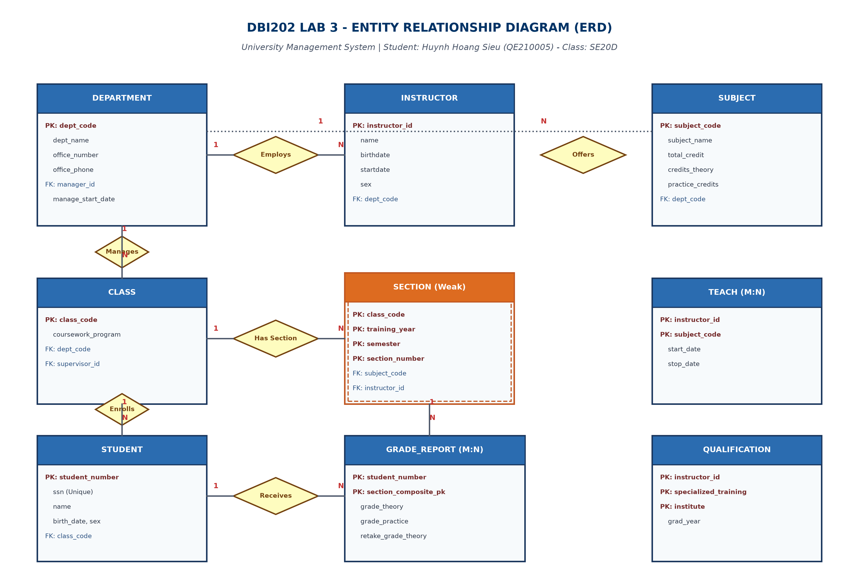
Figure 3.1: Complete Entity-Relationship Diagram for University Management
3. Systematic ERD-to-Relational Mapping (7 Rules)
Applying the formal 7-step mapping transformation rules from Chapter 4 of the DBI202 curriculum:
1. Strong Entities Mapping: DEPARTMENT, INSTRUCTOR, SUBJECT, CLASS, STUDENT mapped into independent tables with primary keys.
2. Weak Entity Mapping: SECTION is identified by CLASS. Its primary key is the composite key (class_code, training_year, semester, section_number).
3. 1:1 Relationship Mapping: Department manager relationship mapped by placing manager_instructor_id and manage_start_date into DEPARTMENT.
4. 1:N Relationship Mapping: Foreign keys placed on the 'Many' (N) side tables:
• INSTRUCTOR receives dept_code.
• SUBJECT receives dept_code.
• CLASS receives dept_code and supervisor_instructor_id.
• STUDENT receives class_code.
• SECTION receives subject_code and instructor_id.
5. M:N Relationship Mapping: Junction tables created with composite primary keys:
• TEACH (Instructor – Subject): PK (instructor_id, subject_code), start_teaching_date, stop_teaching_date.
• PREREQUISITE_SUBJECT: PK (subject_code, prereq_subject_code).
• GRADE_REPORT: PK (student_number, class_code, training_year, semester, section_number).
6. Multivalued Attribute Mapping: INSTRUCTOR_QUALIFICATION table created with PK (instructor_id, specialized_training, institute), grad_year.
7. Derived Attributes Exclusion: TotalScore and Pass/Fail status are dynamically derived from theory and practice grades and omitted.
4. Final Relational Model Schema
The complete relational database schema with Primary Keys (Bold & Underlined) and Foreign Keys is presented below:
Relational Model Specification:
1. DEPARTMENT(
dept_code (PK), dept_name, office_number, office_phone,
manager_instructor_id (FK → INSTRUCTOR),
manage_start_date
)
2. INSTRUCTOR(
instructor_id (PK), name, birthdate, startdate, sex,
dept_code (FK → DEPARTMENT)
)
3. INSTRUCTOR_QUALIFICATION(
instructor_id (PK, FK → INSTRUCTOR),
specialized_training (PK),
institute (PK),
grad_year
)
4. SUBJECT(
subject_code (PK), name, total_credit, credits_theory, practice_credits,
dept_code (FK → DEPARTMENT)
)
5. PREREQUISITE_SUBJECT(
subject_code (PK, FK → SUBJECT),
prereq_subject_code (PK, FK → SUBJECT)
)
6. INSTRUCTOR_SUBJECT [TEACH](
instructor_id (PK, FK → INSTRUCTOR),
subject_code (PK, FK → SUBJECT),
start_teaching_date,
stop_teaching_date
)
7. CLASS(
class_code (PK), coursework_program,
dept_code (FK → DEPARTMENT),
supervisor_instructor_id (FK → INSTRUCTOR)
)
8. STUDENT(
student_number (PK), ssn (Unique),
name, birth_date, sex,
current_address, current_phone,
permanent_address, permanent_phone,
class_code (FK → CLASS)
)
9. SECTION [Weak Entity](
class_code (PK, FK → CLASS),
training_year (PK),
semester (PK),
section_number (PK),
subject_code (FK → SUBJECT),
instructor_id (FK → INSTRUCTOR)
)
10. GRADE_REPORT(
student_number (PK, FK → STUDENT),
class_code (PK, FK → SECTION),
training_year (PK, FK → SECTION),
semester (PK, FK → SECTION),
section_number (PK, FK → SECTION),
grade_theory, grade_practice, retake_grade_theory
)

Business Integrity Constraints & Referential Actions:
1. Unique Key Constraint: STUDENT(ssn) is guaranteed UNIQUE across all students.
2. Supervisor Department Alignment: CLASS.supervisor_instructor_id must reference an INSTRUCTOR belonging to CLASS.dept_code.
3. Grade Range & Evaluation Rule: grade_theory and grade_practice must be in range [0.0, 10.0]. TotalScore = 0.5 × grade_theory + 0.5 × grade_practice. Pass condition: grade_theory > 4.0 AND TotalScore > 5.0.
4. Referential Integrity Actions: Deleting a Department or Class cascades deletion to weak entity Sections and student enrollments (ON DELETE CASCADE), whereas instructor deletion is restricted (ON DELETE NO ACTION / SET NULL) to preserve historical teaching logs.

