**Practical 13**

**Aim:-** List Department in sorted order of location.

**Introduction:-** We introduce a new key word ORDER BY which sort the result table in the order according to the selected column.

**Query:-**

SQL> select Department.*, Dept_locations.Dlocation from Department, Dept_locations where department.Dnumber = Dept_locations.Dnumber order by Dept_locations.Dlocation;

**Result:-**

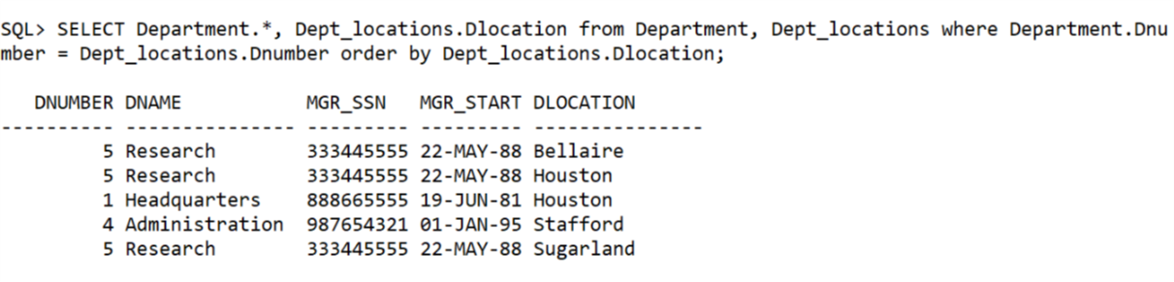

**Learning:-**

By listing the Table names after the FROM clause we perform the catersian product among the two relation. We select the tuples which have the required condition applied at WHERE clause.

**Practical 14**

**Aim:-** Find list of all employees who have worked for any project for more than 20 hours

**Introduction:-** We use theta join in this query and select the tuples that have the hours greater than 20 hours.

**Query:-**

select employee.Fname, employee.Lname,works_on.hours from employee, works_on where employee.ssn=works_on.essn and works_on.hours>20;

**Result:**

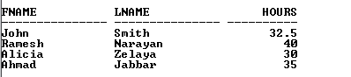

**Learning:-**

By listing the Table names after the FROM clause we perform the Theta join among the two relation, but since the SSN and ESSN are different names, we have to use WHERE clause. We select the tuples which have the required condition applied at WHERE clause.

**Practical 15**

**Aim:-** Raise salary of employees who work for department 4 by 20%

**Introduction:-** This query will use the update key word to update the data in table. The UPDATE statement is used to modify the existing records in a table.

**Query:-**

Update employee set salary = 1.2*salary where Dno = 4;

**Result:**

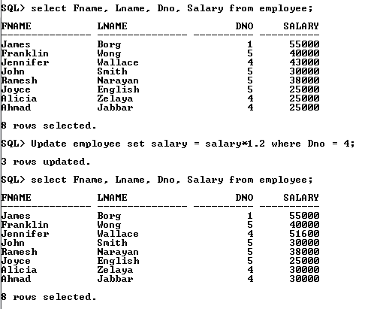

**Learning:-**

To update an exact cell, we have to point it out at WHERE clause with the primary key in the expression.

**Practical 16**

**Aim:-** Count the total number of employees.

**Introduction:-** The COUNT() function returns the number of rows that matches a specified criteria. The COUNT(column_name) function returns the number of values (NULL values will not be counted) of the specified column:

SELECT COUNT(column_name) FROM table_name;

**Query:-**

Update employee set salary = 1.2*salary where Dno = 4;

**Result:**

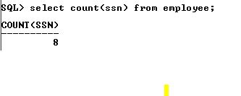

**Learning:-**

Count is put after SELECT clause and return a table with one row and one column. By grouping the counted column, we got a table with number of row is equal to number of unique values in the column.

**Practical 17**

**Aim:-** Count the total number of emoloyees in department 4

**Introduction:-** The COUNT() function returns the number of rows that matches a specified criteria. The COUNT(column_name) function returns the number of values (NULL values will not be counted) of the specified column:

SELECT COUNT(column_name) FROM table_name;

**Query:-**

Select Count(ssn) From Employee where Dno = 4;

**Result:**

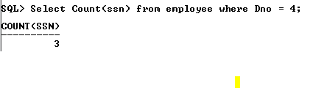

**Learning:-**

Count is put after SELECT clause and return a table with one row and one column. By grouping the counted column, we got a table with number of row is equal to number of unique values in the column.

**Practical 18**

**Aim:-** Calculate Avg, min and Max salary and rename column as avg_sal, min_sal and max_sal.

**Introduction:-**

The SQL AVG(), MIN() and MAX() Functions:

The AVG() function returns the average value of a numeric column.

The MIN() function returns the smallest value of the selected column.

The MAX() function returns the largest value of the selected column.

**Query:-**

Select avg(salary) as avg_sal, min(salarly) as min_sal, max(salary) as max_sal from employee;

**Result:**



**Learning:-**

Same as COUNT() function, Avg(), Min() and Max() are once listed after SELECT clause will form respective column in the result table.

**Practical 19**

**Aim:-** Try to insert duplicate data in primary key column of employee and dept tables.

**Introduction:-**

We will insert a duplicated primary key and see what error will be asserted.

**Query:-**

Insert into employee(Fname, Lname, Ssn, Dno) Values(‘Elliot’, ‘Andreson’, 888665555,4);

**Result:**



**Learning:-**

Since the primary key is unique and not null, any value that attempts to insert will be rejected by the database system.

**Practical 20**

**Aim:-** Display employee name, dept number, and name of all employees.

**Introduction:-**

We again use the theta join in this query to select the columns that is not in a same tables but dependent on the same primary key.

**Query:-**

select Employee.Fname, Employee.Lname, Department.Dno, Department.Dname from employee, Department where Employee.Dno = Department.Dnumber;

**Result:**

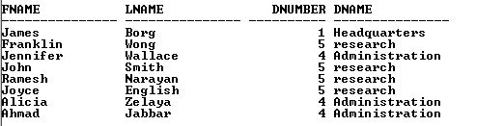

**Learning:-**

We can select the Deparment name and The Employee name which are in different tables but share the same Dnumber (Deparment number).

**Practical 21**

**Aim:-** Try to insert data in foreign key column which does not exist in primary key column.

**Introduction:-**

We are going to see the violated in the foreign key and the primary key in other table that the foreign key references to.

**Query:-**

Insert into Works_on values(888665555,5,10);

**Result:**

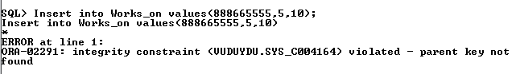

**Learning:-**

The foreign key must be inserted with the properly existing primary key from the table it references, otherwise the database system will alert error.

**Practical 23**

**Aim:-** Find minimum and maximum salary in dept 5

**Introduction:-**

We use max() and min() function in this query for the table Employee. And apply for column Salary.

**Query:-**

select max(salary), min(salary) from Employee where dno = 5;

**Result:**

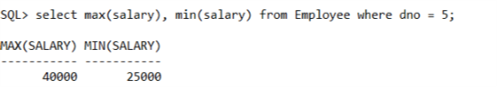

**Learning:-**

We can change the name of the Max(salary) and Min(Salary) to any name by using AS key word after the function in the query.

**Practical 24**

**Aim:-** Calculate average salary for all employees in dept having more than 5 employees.

**Introduction:-**

We are going to use COUNT function and GROUP BY key word to solve this query problem.

Because we desire the result of particular groups in a single column , here is Dno.

**Query:-**

select count(dno) as Count_Emp, avg(salary) as avg_sal from employee group by dno having count(dno)>2;

**Result:**

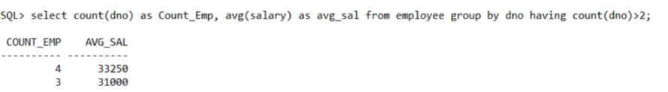

**Learning:-**

Group by will group the tuples which have the same values in a column. We can then calculate the values of the tuples in a same group and display the result in different rows.

**Practical 25**

**Aim:-** Find total salary received by all employees.

**Introduction:-**

We are going to use SUM() function in this query to find the total salary in the employee table.

**Query:-**

Select sum(salary) from employee;

**Result:**

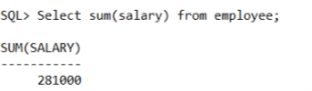

**Learning:-**   
The SUM() function returns the total sum of a numeric column.

**Practical 27**

**Aim:-** Find all projects whose number of hours worked for by an employee is less than 10.

**Introduction:-**

Simply select the work hours which are smaller than 10 from the WORKS_ON table.

**Query:-**

select * from works_on where hours<10;

**Result:**

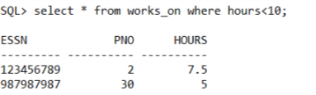

**Learning:-**

Select clause will display all the selected column in a table. * means select every columns.

**Practical 29**

**Aim:-** Find total no of hours worked on each project.

**Introduction:-**

We are going to calculate the total hours worked on each project by using SUM() function. And group the hours by the Project Number.

**Query:-**

select pno,sum(hours) from works_on group by pno;

**Result:**



**Learning:-**

Group by will group the tuples which have the same values in a column. We can then calculate the values of the tuples in a same group and display the result in different rows.