**Practical No. XIII**

**Aim:-** List Department in sorted order of location.

**Introduction:-** say something about this query.

**Query:-**

SQL> select Department.*, Dept_locations.Dlocation from Department, Dept_locations where department.Dnumber = Dept_locations.Dnumber order by Dept_locations.Dlocation;

**Result:-**

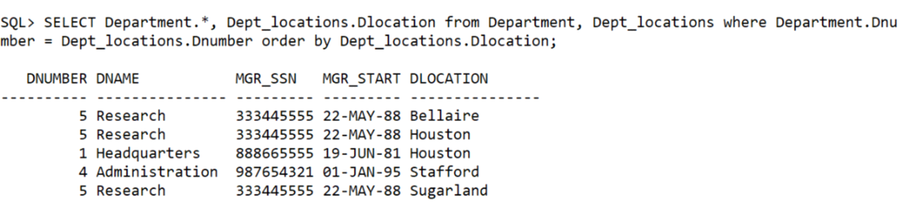

**Learning:-**

By listing the Table names after the FROM clause we perform the catersian product among the two relation. We select the tuples which have the required condition applied at WHERE clause.

14. Find list of all employees who have worked for any project for more than 20 hours

select employee.Fname, employee.Lname,works_on.hours from employee, works_on where employee.ssn=works_on.essn and works_on.hours>20;

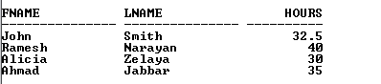

15. Raise salary of employees who work for department 4 by 20%

Update employee set salary = 1.2*salary where Dno = 4;

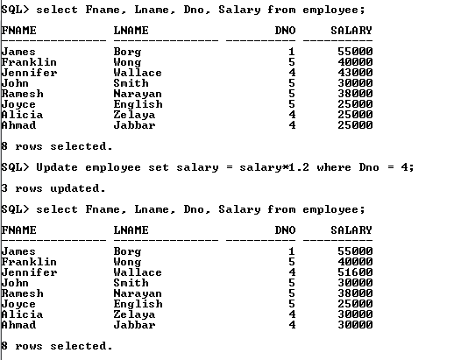

16. Count the total number of employees.

Select count(ssn) from employee;

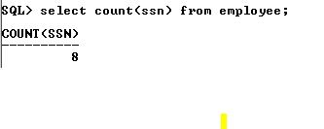

17. Count the total number of emoloyees in department 4

Select Count(ssn) From Employee where Dno = 4;

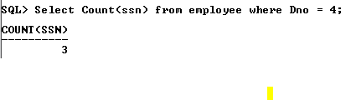

18. Calculate Avg, min and Max salary and rename column as avg_sal, min_sal and max_sal.

Select avg(salary) as avg_sal, min(salarly) as min_sal, max(salary) as max_sal from employee;



19. Try to insert duplicate data in primary key column of employee and dept tables.



20. Display employee name, dept number, and name of all employees.

select Employee.Fname, Employee.Lname, Department.Dno, Department.Dname from employee, Department where Employee.Dno = Department.Dnumber;

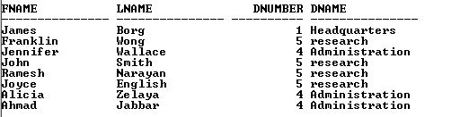

21. Try to insert data in foreign key column which does not exist in primary key column.

Insert into Works_on values(888665555,5,10);

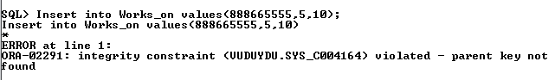

22. Print location and total employees in each department

23. Find minimum and maximum salary in dept 5

select max(salary), min(salary) from Employee where dno = 5;

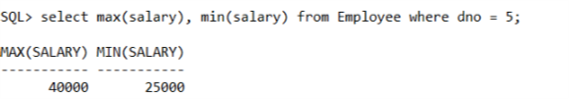

24. Calculate average salary for all employees in dept having more than 5 employees.

select count(dno) as Count_Emp, avg(salary) as avg_sal from employee group by dno having count(dno)>2;

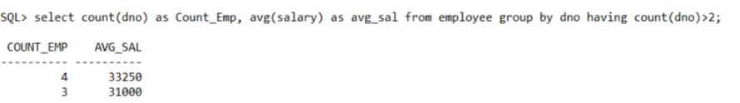

25. Find total salary received by all employees.

Select sum(salary) from employee;

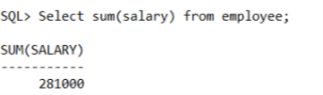

26. Find min and max salary, rename title as min_salary, max_salary (same as 18)

27. Find all projects whose number of hours worked for by an employee is less than 10.

select * from works_on where hours<10;

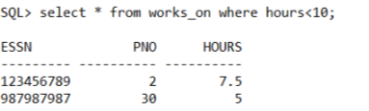

28. Add a new column description in master table.(No idea)

29. Find total no of hours worked on each project.

select pno,sum(hours) from works_on group by pno;

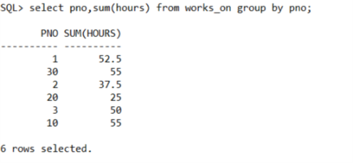

30. Implement the grant command.

The syntax for the command is:

GRANT privilege_name ON object_name TO {user_name |PUBLIC |role_name}

[WITH GRANT OPTION];

Privilege_name is the access right or privilege granted to the user. Some of the access rights are ALL, EXECUTE, and SELECT.

Object_name is the name of a database object like TABLE, VIEW, STORED, PROC, SEQUENCE.

User_name is the name of the user to whom an access right is being granted.

PUBLIC is used to grant access rights to all users.

Role_name is a set of privileges grouped together.

WITH GRANT OPTION – allows an user to grant access rights to other users.

Example:

GRANT SELECT ON Employee TO user1;

31. Implement the REVOKE command.

Syntax:

REVOKE privilege_name ON object_name FROM {user_name|PUBLIC|role_name};

Example: REVOKE SELECT ON employee FROM user1;

32. Retrieve the names of all employees in department 4 who work more than 10 hours per week on ProductX project

With productX_Ssn as (select works_on.essn from works_on, project where works_on.pno = project.pnumber and project.pname='ProductX' and works_on.hours>10)

select Employee.ssn, Employee.fname, Employee.lname from employee, productX_Ssn where employee.ssn=productX_Ssn.essn;.

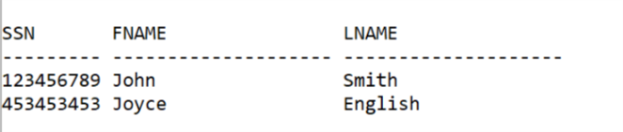

33. List then name of all employee who have a dependent with the same first name as themselves.

select fname from employee, dependent where dependent_name = fname;

No row selected.

34. Find the names of all employees who are directly supervised by “Franklin Wong”.

with supervisor as (Select ssn, fname, lname from employee where Fname='Franklin' and Lname = 'Wong') select supervisor.fname as super_name, employee.fname, employee.lname from supervisor, employee where supervisor.ssn = employee.super_ssn;

