**Practical No. XIII**

**Introduction:-** List Department in sorted order of location.

**Query:-**

SQL> select Department.*, Dept_locations.Dlocation from Department, Dept_locations where department.Dnumber = Dept_locations.Dnumber order by Dept_locations.Dlocation;

**Result:-**

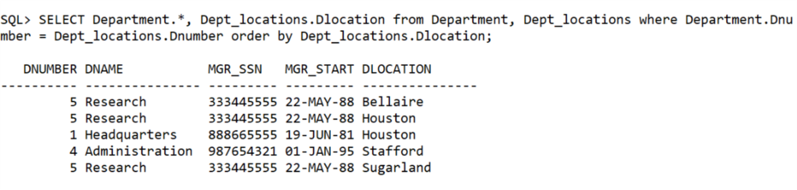

**Learning:-**

By listing the Table names after the FROM clause we perform the catersian product among the two relation. We select the tuples which have the required condition applied at WHERE clause.