EXPERIMENT 4
//------------------------------------------------------------------------------
//
//Desc: Pipe communication between child process and parent process. Child asks
//parent for the file, and parent sends back the file content.
//
//Date: 6/2/2018
//
//Author: VU DUY DU - 2k16/CO/364
//
//------------------------------------------------------------------------------

#include<sys/types.h>
#include<unistd.h>
#include<stdio.h>
#include<string.h>

#define MAXSIZE 10000

void write_to_console(const char s[]){
write(1,s,strlen(s));
}
typedef struct two_way_pipe{
int pc2p[2];//child write at pc2p[1], parent read at pc2p[0]
int pp2c[2];
}Pipe;
void initPipe(Pipe*p){
if(pipe(p->pc2p)<0){
write_to_console("Init: failed to initialize pipe pc2p\n");
return ;
}
if(pipe(p->pp2c)<0){
write_to_console("Init: failed to initialize pipe pp2c\n");
return;
}
}
void run_parent(Pipe*p){
write_to_console("P: Hello from Parent process\n");

//get file name sent from child process
char buf;//read one by one
char filename[26];
close(p->pc2p[1]);//close the other unused terminal
while(read(p->pc2p[0],&buf,1)){
filename[strlen(filename)]=buf;
filename[strlen(filename)+1]='\0';
}

OBJECTIVE:-
Write a program to implement a 2-way-pipe communication between parent and child processes.
Child sends a file name to parent and then parent sends back the file content to child.
CODE:-
close(p->pc2p[0]);
write_to_console(filename);
write_to_console(" --(received by Parent)\n");

//load the file from system
char buffer[MAXSIZE] = "File does not exit";
FILE*file = fopen(filename,"r");
if(file){
const int MAX_NUM_CHAR_PER_LINE = 100;
char line[MAX_NUM_CHAR_PER_LINE];
strcpy(buffer,"");
while(fgets(line,MAX_NUM_CHAR_PER_LINE,file)){
//write(1,line,strlen(buffer));
strcat(buffer,line);
}
write_to_console("P: Success to load the file ");
}else{
write_to_console("P:Error: Failed to load the file ");
}
write_to_console(filename);
write_to_console("\n");

//send buffer data to the client
close(p->pp2c[0]);
write(p->pp2c[1],buffer,strlen(buffer));
close(p->pp2c[1]);
}
void run_child(Pipe*p){
write_to_console("C: Hello from Child process\n");

//send file name to parent
write_to_console("C: Sending file name to parent\n");
close(p->pc2p[0]);
const char filename[]="README.txt";
write(p->pc2p[1],filename,strlen(filename));
close(p->pc2p[1]);

//get the parent file content
char buffer[MAXSIZE],buf;
int size = 0;
close(p->pp2c[1]);
while(read(p->pp2c[0],&buf,1)){
buffer[size++] = buf;
buffer[size] = '\0';
}
write_to_console("C: Received the data: \n\"");
write_to_console(buffer);
write_to_console("\"\n");

}
int main(){
printf("Hello world of IPC\n");

//create a two_way_pipe for communication
Pipe p;
initPipe(&p);

switch(fork()){//fork a new child
case -1:
write_to_console("error: failed to fork a child process\n");
break;
case 0:
//this is child process
run_child(&p);
break;
default:
//this is parent process
run_parent(&p);
break;
}
return 0;
}

OUTPUT:-
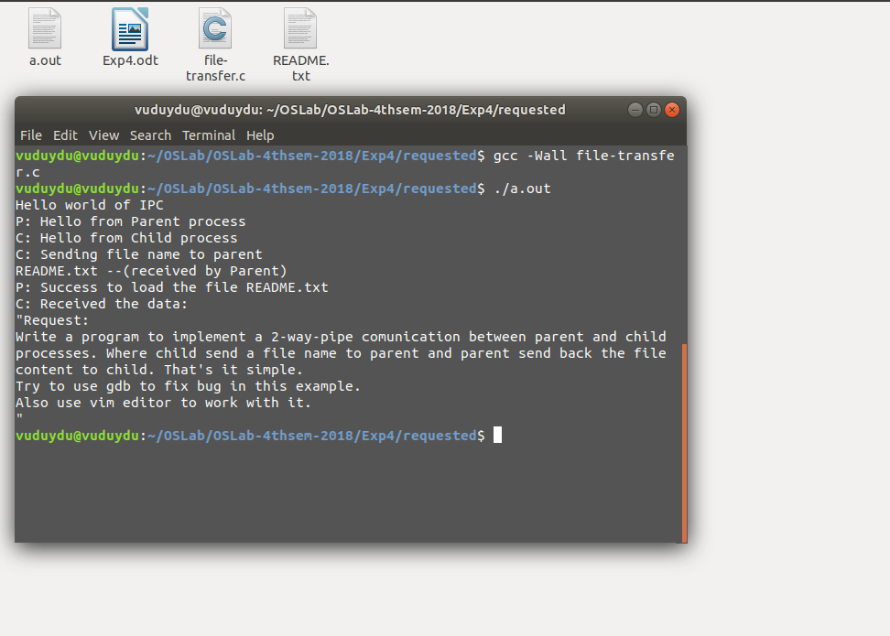

DISCUSSION:-
In this experiment, we use pipe – a method of Interprocess Communication (IPC) to send messages between parent and child processes. Each pipe has two ends, one is for reading and the other is for writing. By using the function pipe(), we create a pipe. For sending message forth and back, we have to use 2 pipes.

