EXPERIMENT 5

OBJECTIVE:-
Write a program using pipes to emulate the first come first scheduling algorithm. Find the average waiting time and turnaround time.
CODE:-

//------------------------------------------------------------------------------
//
// Date: 21/2/2018
//
// Author: VU DUY DU - 2k16/CO/364
//
//------------------------------------------------------------------------------

#include<sys/types.h>
#include<unistd.h>
#include<stdio.h>
#include<stdlib.h>
#include<sys/wait.h>
#include<string.h>
#define MAX_NUM 100
void write_to_console(const char s[]){
write(1,s,strlen(s));
}
char temp[1000];
int pc2p[2];
int pp2c[2];

int main(){
printf("Helo FCFS simulation\nEnter no of processes: ");
int n = 2;//number of processes to be scheduled
scanf("%d",&n);
int arr_time[MAX_NUM] = {0,2};
int burst_time[MAX_NUM] = {3,4};
printf("Arrive time and Burst time of: \n");
for(int i = 0; i<n; i++){
printf("process %i: ",i);
scanf("%d %d",&arr_time[i],&burst_time[i]);
}
for(int i = 0; i<n; i++)
printf("%d\t%d\n",arr_time[i],burst_time[i]);

int scheduling_time = 0;

//create 2 pipes

double awt = 0.0;
double atat = 0.0;
int processed_num = 0;
while(processed_num<n){//wait for the job to come
for(int i = 0; i<n; i++){
if(arr_time[i]<=scheduling_time)//find out one process arrives
{
pipe(pp2c);
pipe(pc2p);

switch(fork()){
case -1: printf("Error to fork a child\n");break;
case 0:
//run the child here
sprintf(temp,"\nC-%d: Enter child process, \
ready to run\nC-%d: ",getpid(),getpid());
write_to_console(temp);
//receive burst time
close(pp2c[1]);
char buffer[2];int btime = 0;
while(read(pp2c[0],&buffer[0],1)){
btime*=10;
btime+= buffer[0]-'0';
}
int time = 0;
while(time<btime){
sleep(1);
time++;
sprintf(temp,"%d ",time);
write_to_console(temp);
}
sprintf(temp,"\nC-%d: Finished, now sending back my\
running time\n\n",getpid());
write_to_console(temp);
close(pc2p[0]);
sprintf(buffer,"%d",time);
write(pc2p[1],buffer,strlen(buffer));
close(pc2p[1]);
exit(0);
break;
default:{
int w = scheduling_time - arr_time[i];
awt+=w;
sprintf(temp,"P-%d: At %d tick(s), new process %d - %d,\ waited %d\n",getpid(),scheduling_time,
arr_time[i],burst_time[i],w);
write_to_console(temp);
//send burst time to child process
close(pp2c[0]);
char buffer[2];
sprintf(buffer,"%d",burst_time[i]);
write(pp2c[1],buffer, strlen(buffer));
close(pp2c[1]);
//wait for child to process
wait(NULL);

//receive the message
close(pc2p[1]);
int returned_time = 0;
while(read(pc2p[0],&buffer[0],1)){
returned_time*=10;
returned_time+= buffer[0]-'0';
}
close(pc2p[0]);
sprintf(temp,"P-%d: Handled the running time from\ process %d: %d tick(s)\n"
,getpid(),i,returned_time);
write_to_console(temp);

scheduling_time+=returned_time;
atat += scheduling_time-arr_time[i];
}
}

processed_num++;
if(processed_num>=n) break;
}
}
//update time while waiting for process to arrive
sleep(1);//one tick
scheduling_time++;

}
printf("\n\nSummary:\nAWT: %.2f tick(s)\nATAT: %.2f tick(s)\n",
awt/(double)n,atat/(double)n);
return 0;
}

OUTPUT:-
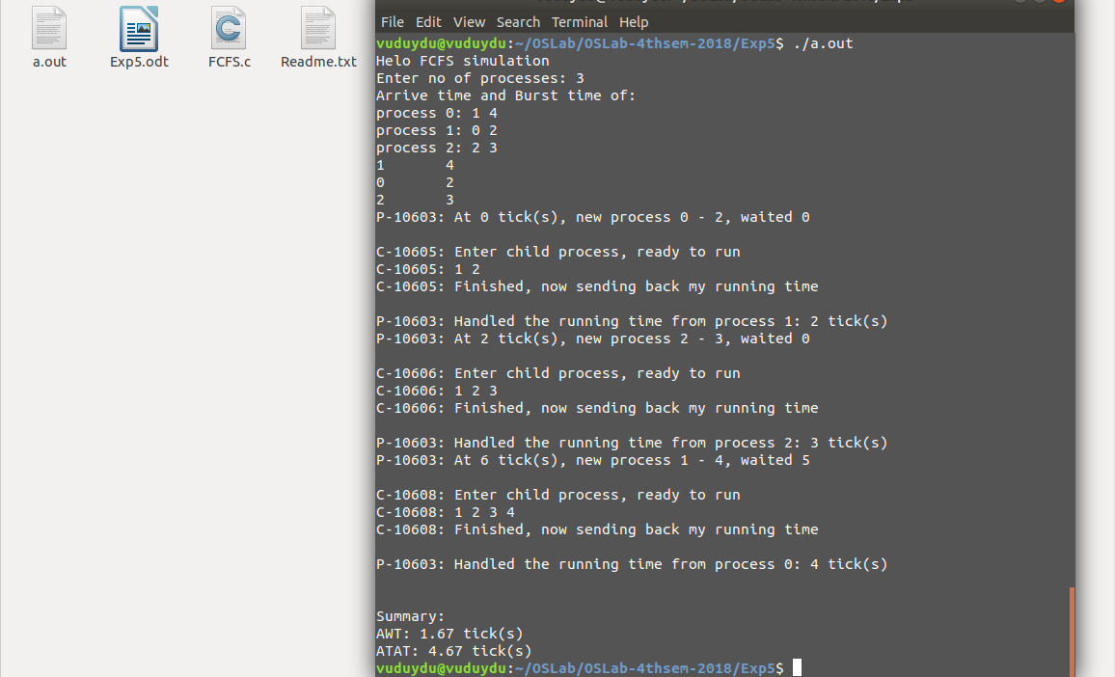

DISCUSSION:-
In this experiment, the first come first scheduling algorithm has been implemented. The parent process or the scheduler fork() a child, and send the burst_time through pipe to that child process. After executing, the child process will give back the running time to parent to handle the scheduling_time.
In scheduler, the average waiting time (AWT) and turnaround time (ATAT) are caculated.

