OPERATING SYSTEM LAB

Delhi Technological University
Student: VU DUY DU
Roll Number: 2k16/CO/364

EXPERIMENT 1

OBJECTIVE:
- Write a program for bubble sort in C on linux Operating System, Compile it
using gcc

CODE:-

#include<iostream>

//Sorting function using bubble-sort algorithm
void bubble_sort(int*arr, int n){
for(int i = 0; i<n-1; i++){
for(int j = i; j<n-1; j++){
if(arr[j]>arr[j+1]){
//swap 2 adjecient elements in the array
int temp = arr[j];
arr[j] = arr[j+1];
arr[j+1] = temp;
}
}
}
}
//main function
int main(){
//the given array
int arr[]={5,1,8,6,7,10},n = 6;

//function call
bubble_sort(arr,n);

//display the array
for(int i = 0; i<n; i++)
std::cout<<arr[i]<<" ";
return 0;
}

OUTPUT:-
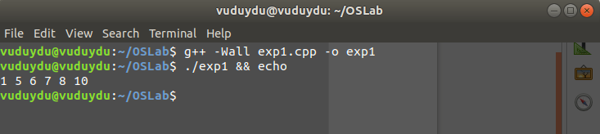

DISCUSSION:-
The above program illustrates the program compiling and running in linux environment by using GNU/GCC.
To compile the C/C++ source file we use the command line:
g++ -Wall exp1.cpp -o exp1
And to run the compiled execute file by the command line:
./exp1

