EXPERIMENT 2

OBJECTIVE:-
Write a C program to check process ids of the program and the parent of the program process
1. Use system command to check execute ps command to get all the processes under the current user system(“ps”).
2. Use getpid() and getppid() to get the program process and parent process ids. Check if the program process id and parent process id are listed in the ps command.

Extend this program to fork 5 child processes. Parent must wait for all the children to exit.

CODE 1:-
//exp2-1.c

#include<stdlib.h>
#include<stdio.h>
#include<sys/types.h>
#include<unistd.h>

int main(){
//execute the command 'ps' under Shell
system("ps");
//display the id of the current process
printf("this process id: %i\n",getpid());
//and the parent that create this process
printf("the parent process id: %i\n",getppid());
return 0;
}
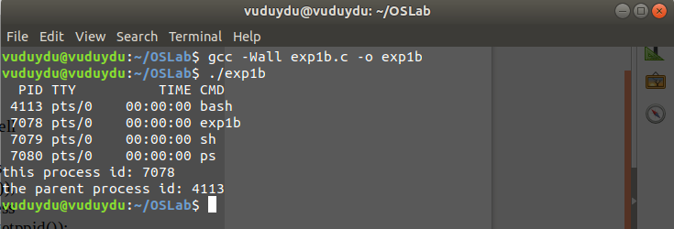
OUTPUT:-

CODE 2:-
//exp2-2.c
//-----------------------------------------------------------------
//
//this program create 5 child processes from the parent process,
//the parent process has all the ids of its children.
//
//-----------------------------------------------------------------

#include<stdlib.h>
#include<stdio.h>
#include<sys/types.h>
#include<unistd.h>

int main(){
//execute the command 'ps' under Shell
system("ps");
int count = 1;
//at this point program is forked into with the same data
int p1 = fork();
//fork return id of the child, if any, otherwise 0
//in parent process, p assingned with the id of the child
if(p1!=0){
//fork for the second time in parent process
int p2 = fork();
if(p2!=0){
//fork for the third time in parent process
int p3 = fork();
if(p3!=0){
//fork for the fouth time in parent process
int p4 = fork();
if(p4!=0){
//fork for the fifth time in parent process
int p5 = fork();
if(p5!=0){
printf("%i: %i is parent of %i, %i ,%i ,%i and %i\n",
count,getpid(),p1,p2,p3,p4,p5);
}else{
count++;
printf("%i: %i is parent of %i\n",count,getpid(),p5);
}
}else{
count++;
printf("%i: %i is parent of %i\n",count,getpid(),p4);
}
}else{
count++;
printf("%i: %i is parent of %i\n",count,getpid(),p3);
}
}else{
count++;
printf("%i: %i is parent of %i\n",count,getpid(),p2);
}
}else{//in child process, p assingned with 0
count++;
printf("%i: %i is parent of %i\n",count,getpid(),p1);
}
return 0;
}

OUTPUT:-
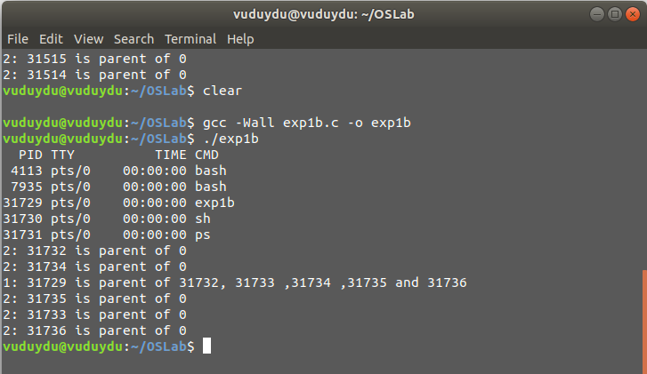
DISCUSSION:-
In this experiment, we create 2 programs to display the id of process in a program and to create 5 child processes by using fork() function.

getpid() is used to get the id of the current process.
getppid() returns the id of the parent process that create the current process.
ps is a command line that displays all the ids of the current running processes.

