EXPERIMENT 3

OBJECTIVE:-
Write two program severprogram.c and clientprogram.c and compile them separately as sever program
and client program respectively. clientprogram.c must print the n numbers, serverprogram.c
must fork a child process which should execute the clientprogram using exec command.

CODE:-
//---------------------------------------------------------
//
//Desc: A client program that do some cool thing
//
//Date: 29/1/2018
//
//Author: VU DUY DU - 2k16/CO/364
//
//---------------------------------------------------------
#include<sys/types.h>
#include<unistd.h>
#include<stdio.h>
int main(){
printf("Client: Hello world from client with process id:%i,\
which is execute from server %i\n",getpid(),getppid());
int n;
printf("Client: Enter a number: ");
scanf("%d",&n);
printf("Client: Printing n: ");
//this is a n-cycle loop that display a set of number from 0 to n-1
for(int i = 0; i<n; i++)
printf("%i ",i);
printf("\n");
return 0;
}

//---------------------------------------------------------
//
//Desc: A server program that fork a new process and then
//run a client program on that process.
//
//Date: 29/1/2018
//
//Author: VU DUY DU - 2k16/CO/364
//
//---------------------------------------------------------

#include<sys/types.h>
#include<sys/wait.h>
#include<unistd.h>
#include<stdlib.h>
#include<stdio.h>

int main(){
printf("Main process has id: %i\n",getpid());
int p = fork();
if(p==0){//we want the child to do this task only
printf("Child: I am a child process, my ID is: %i\n",getpid());
printf("Child: Now I'm gonna run a client program inside of me (clientprogram.out)\n");
//make sure client program is in the same directory with server
char* argv[2] = {"Not null",NULL};
//using execvp() from exec family to execute client program
execvp("./clientprogram",argv);
printf("Child: client's code is merge with this child code\n");
}else{//at this point p is equal to the child process id is allowed
printf("Parent: Hello child, I'm your parent %i, I have your ID: %i\n",getpid(),p);
printf("Parent: Paused to wait for all the children to terminate\n");
wait(NULL);//wait for all the children
printf("Parent: All children have terminated\n");
}
return 0;
}

OUTPUT:-
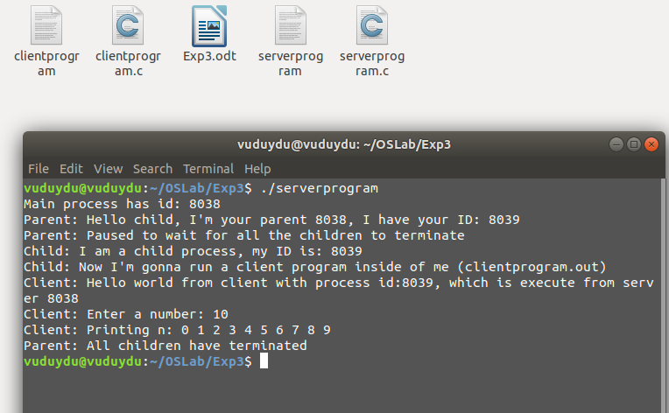

DISCUSSION:-
In this experiment, we use fork() to create a new process in a server program, and from inside of that process, we trigger to execute a client program by using exec family. (execvp()) Since scanf() requires user input, it takes some specific amount of time for client program to terminate. Hence in server program, we use wait() function from sys/wait.h to wait for the child process to complete, i.e. wait for the client to terminate.

