- 5page
- - Arial, size 12, 1.5 line spacing
Table of contents:
Problem statement
-define real world challenge in ASEAN context, explain why it matters, who is most affected (threats it bring to community)
Target Beneficiary Group
-intended audience or beneficiaries
Use of AI
-explain how AI technology is applied, why AI is suitable and innovative approach
Feasibility
-how idea can be realistically implemented
Scalability & Impact
-demo how the solution can grow beyond the initial implementation
-potential impact on community, national, regional level
Outreach Plan
-outline how team will raise AI awareness among at least 1000 community members, directly and indirectly
- expected outcomes and budget needed including experts, implementation, partners and other domains
(diagram, chart, wireframes, example)

Keyword:
AI literacy, social good, inclusive, sustainable, reach everyday-community.
Focus area of Google.org
- Access to knowledge, skills, learning
- Accelerate scientific progress
- Stronger community and safer digital world

Problem statement
-define real world challenge in ASEAN context, explain why it matters, who is most affected (threats it bring to community)
- ASEAN courts rely heavily on CCTV
- Low-end cameras dominate
- Chain-of-custody is often broken
CCTV video evidence plays a vital role in the justice system. Monitored CCTV systems are commonly used to improve safety and security in commercial environments like retail stores, offices and manufacturing sites. Whether CCTV is capturing a crime in progress or providing proof in a personal injury claim, CCTV footage can significantly influence a case’s direction. CCTV evidence must be authentic and relevant to be considered by a judge.
Video footage evidence used in court may be tampered with deepfake technology, since local communities and small businesses often use CCTV cameras with less built-in protection, and local storage such as DVR and NVR that is easily been altered by malicious individuals, or more vulnerable to physical tampering. This will affect admissibility of chain of custody. High chance of abusing deepfake technology have threaten the judicial system and decrease trust in legal system. In many local communities, CCTV systems still rely on local storage with limited tamper-proofing, so AI-based detection of deepfake or manipulated footage — especially before official storage or backup — is an important emerging need.
the law punishes misuse and platform duties, but does not provide tools to detect AI content in advance (lack of technical verification tools to assess whether the digital media has been AI-manipulated), especially for surveillance, evidence and community safety
- not law to protect other types of digital evidence, like videos sued in court or surveillance footage
- legal protections for AI-altered digital evidence, and lawmakers are behind in regulating AI for court reporting or other serious applications.
- doesn’t provide a legal framework for AI-altered surveillance footage or deepfakes in CCTV evidence.
Online Safety Act 2025 (Act 866, effective 2026)
- focus on harmful digital content
- platform responsibility and public safety priority
- to enhance and promote online safety in Malaysia by regulating harmful content and providing for duties and obligations of the applications service providers, content applications service providers and network service providers, and to provide for related matters.
- introduced to combat harmful online content and enhance online safety in Malaysia, particularly in view of recent rise in use of AI to disseminate and misinformation and deepfake without individual consent. It complement the regulatory framework for social media and internet messaging service providers set out by CMA (Communications and Multimedia Act 1998)
Penal Code Amendment Act 2025 (Sections 507B–507F)
- criminalise misuses of digital content
- include AI-generated misuse
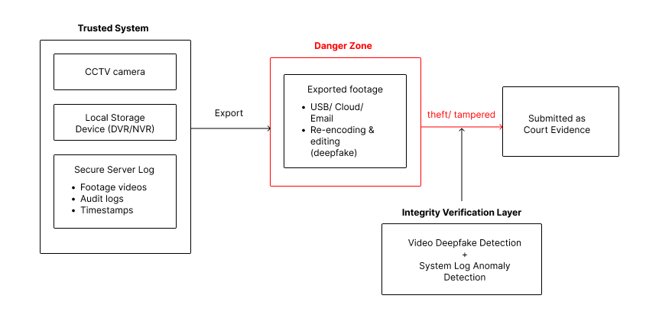

Target Beneficiary Group
-intended audience or beneficiaries
- small business and residential level community who have no access to CCTV surveillance system that have advanced security
- use local system and less protected
- designed for low-resource settings (local CCTV)
# Primary User
- operated by legal and investigation professionals (lawyers, legal aid clinics) *only intermediate, not final beneficiaries

Use of AI
-explain how AI technology is applied, why AI is suitable and innovative approach
AI-assisted forensic assessment of CCTV video integrity for legal and public-sector use
- currently in court, AI (smart court) is applied for legal action such as trial preparation and summary, translation, and recordings transcript,etc.
deepfake can be used to create evidence or provide alibis to cover crime's misbehaviour/ prove innocence/prove guilt
- the evidence could be tampered if they are not carefully controlled and easy to be manipulated by AI tools
- affect legal responsibility for keeping evidence safe, authentic and untampered. (care, custody, and control)
- heavy weightage for video and audio evidence
The CCTV server logs are trusted, but the exported video may be manipulated later
Industry security practices emphasize continuous, tamper-resistant audit logging to ensure integrity and compliance. However, once surveillance footage is exported from its original recording system, the integrity guarantees provided by server-side logs may no longer hold. This creates a critical gap between trusted logging systems and the video evidence ultimately submitted for forensic or legal review
Courts usually assume:
- CCTV system = trusted
- Evidence handling = risk zone
Your system does NOT accuse the CCTV system
It verifies:
“Is this file consistent with what the CCTV system produced?”
Our system checks whether the submitted video still carries the technical characteristics of footage produced by the original CCTV system.
CCTV servers are trusted, but once footage is exported for sharing or submission, it leaves the trusted environment and becomes vulnerable to manipulation. Our system verifies whether the submitted video is still consistent with the original server records.

- use AI as an assistive verification layer of video evidence from CCTV footage
- detect authenticity of video or tampered footage
-check server log suspicious activity if provided (server log is ground truth)
Why AI is a suitable, innovative, and responsible approach
- deepfake is AI-generated, so we need pattern recognition at scale (using machine learning algorithms to recognize pattern)
- AI can analyse thousands of frame consistently
- spot patterns that human may miss to prevent human oversight
- does not make legal or enforcement decisions, but provide decision support to reduce human error and bias
Resnet 50 for deepfake detection and isolation forest for suspicious event system log
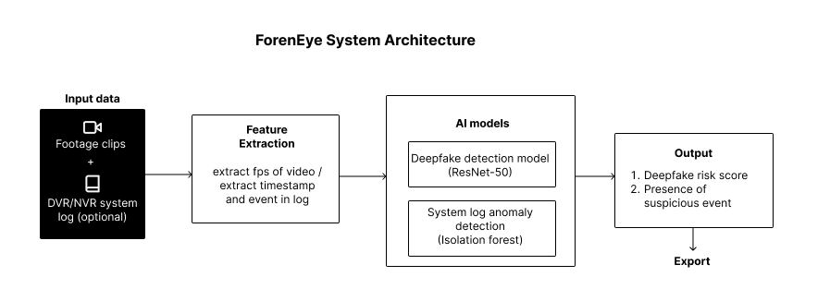

Problem statement
In the ASEAN context, courts rely heavily on CCTV footage as a primary form of evidence in criminal and civil proceedings. CCTV systems are widely deployed in commercial environments such as retail stores, offices, manufacturing sites, and residential areas to improve safety and security. Footage may capture crimes in progress, verify alibis, or support personal injury claims, and can significantly influence the direction and outcome of a case. However, for CCTV evidence to be admissible in court, it must be authentic, relevant, and maintain a proper chain of custody.

Figure 1: Project Scope
A major real-world challenge arises from the widespread use of low-end CCTV cameras across ASEAN, particularly among small businesses and local communities. These systems often rely on local storage solutions such as DVRs and NVRs with limited built-in protection and minimal tamper-resistance. As a result, footage can be physically altered or manipulated. Once video is exported from the original server environment for sharing or submission, it leaves the trusted logging system and becomes vulnerable to unauthorized modification. This creates a critical gap between trusted server logs and the final video file submitted as evidence. While CCTV servers and their audit logs are generally treated as trustworthy, the exported video itself enters a high-risk zone in terms of evidence handling.
The rise of deepfake technology and AI-based video manipulation further intensifies this threat. Deepfake tools can be used to fabricate events, create false alibis, insert or remove individuals from footage, or distort timelines, which potentially to prove innocence or guilt dishonestly. This threatens the integrity of judicial processes, undermines the admissibility of evidence, and erodes public trust in the legal system.
Although recent Malaysian legal reforms such as the Online Safety Act 2025 (Act 866, effective 2026) focus on regulating harmful digital content and strengthening platform, they primarily address online content dissemination rather than forensic verification of surveillance evidence. Similarly, the Penal Code Amendment Act 2025 (Sections 507B–507F) criminalizes misuse of digital and AI-generated content. However, these legal measures punish misuse after the fact and remains no comprehensive legal framework specifically addressing AI-altered surveillance footage or deepfake manipulation in court-submitted video evidence. Therefore, there is a pressing need for technical verification mechanisms that can assess the integrity of digital surveillance evidence before it is relied upon in court.

Target Beneficiary Groups
The primary beneficiaries of this solution are small businesses and residential-level communities in ASEAN that rely on low-cost CCTV systems with limited security protections. These groups typically use locally stored surveillance systems that are more vulnerable to tampering and lack advanced verification mechanisms. The system is designed specifically for low-resource settings where upgrading to high-end, enterprise-grade surveillance infrastructure is not feasible.
Although the ultimate beneficiaries are community members whose safety and legal rights depend on trustworthy evidence, the primary users of the system are legal and investigative professionals, such as lawyers, legal aid clinics, and investigators. These professionals operate the tool as an intermediate layer of verification before submitting or challenging CCTV footage in court. The system supports them in assessing evidence integrity but does not replace judicial decision-making.
Use of AI
The proposed solution applies AI as an assistive forensic verification layer for assessing the integrity and authenticity of CCTV video evidence intended for legal and public-sector use. While AI technologies are already being used in court systems for administrative purposes—such as trial preparation, transcription, translation, and document summarization—there is limited use of AI for verifying the authenticity of surveillance evidence itself. Given that deepfakes and AI-based manipulations are generated using advanced machine learning techniques, detecting them requires equally sophisticated pattern recognition capabilities.
The system does not accuse or discredit the CCTV infrastructure itself. Instead, it verifies whether the submitted video file remains technically consistent with the characteristics of footage originally produced by the CCTV system. Courts typically assume that CCTV systems are trusted environments, but recognize that evidence handling after export is a risk zone. Therefore, the system bridges this gap by checking whether the exported file still carries the expected technical fingerprints, encoding patterns, and consistency markers associated with the original recording system.
AI is particularly suitable and innovative for this task because it can analyze thousands of frames consistently and at scale, identifying subtle artifacts or inconsistencies that may not be detectable through manual human review. Deepfake detection using models such as ResNet-50 enables frame-level analysis of visual anomalies, while techniques such as Isolation Forest can detect suspicious patterns or anomalies in CCTV server logs when such logs are available as ground truth references. AI-driven pattern recognition reduces human oversight errors and bias, enhances reliability, and strengthens forensic assessment.
Importantly, the system functions as a decision-support tool rather than an autonomous legal authority. It does not make legal or enforcement decisions; instead, it provides technical risk assessments and integrity indicators to assist legal professionals in evaluating whether CCTV footage may have been tampered with. By integrating AI-based video analysis with log anomaly detection, the system addresses the growing gap between trusted surveillance infrastructure and vulnerable exported evidence, offering a responsible and scalable solution to protect judicial integrity in the ASEAN context.

