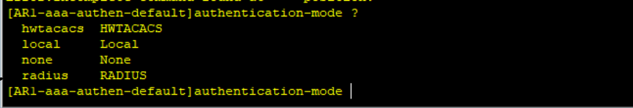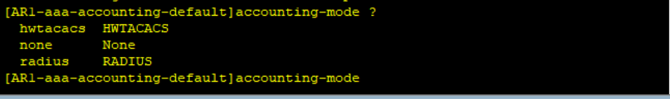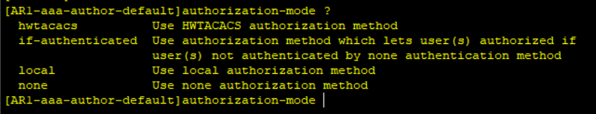
Authentication:
- None
- Local
- Remote (Radius, HWTACACS)
Authorization:
- None
- Local
- Remote (HWTACACS)
- if-authenticated
Account:
- None
- Remote (Radius, HWTACACS)

