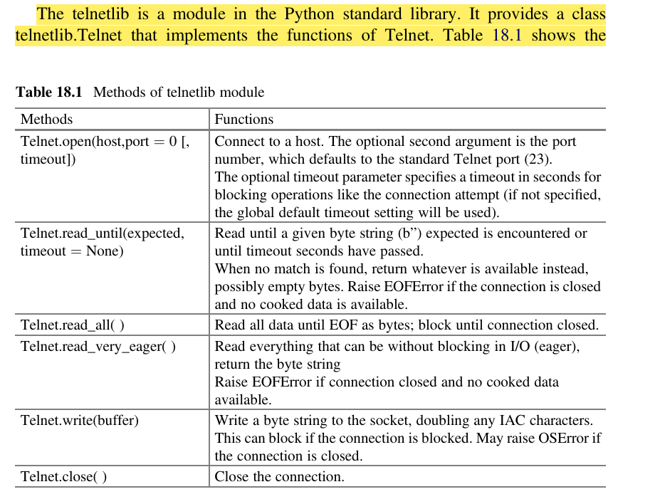
https://docs.python.org/uk/3.8/library/telnetlib.html

