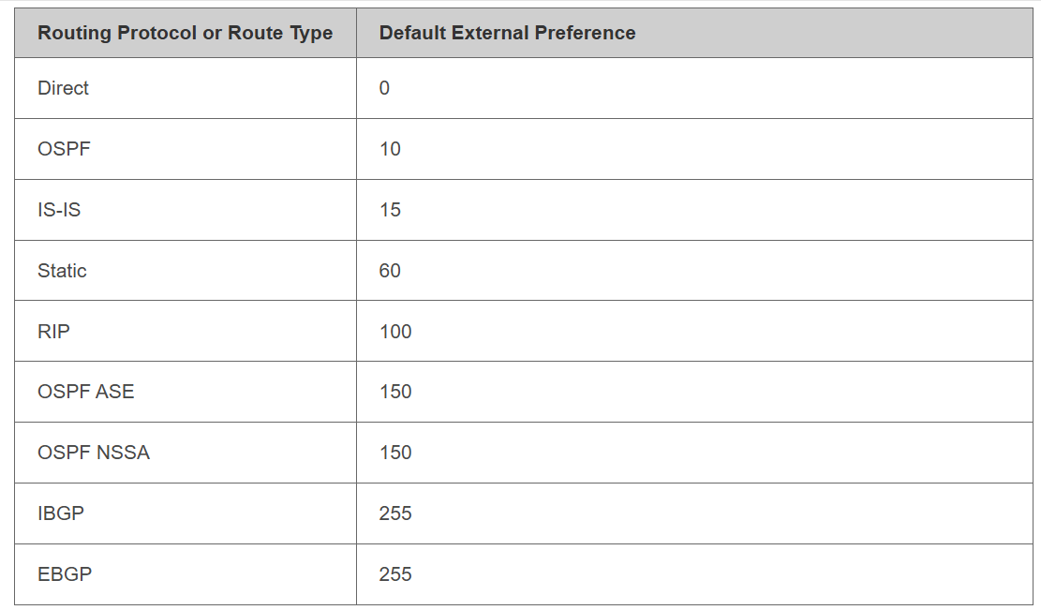
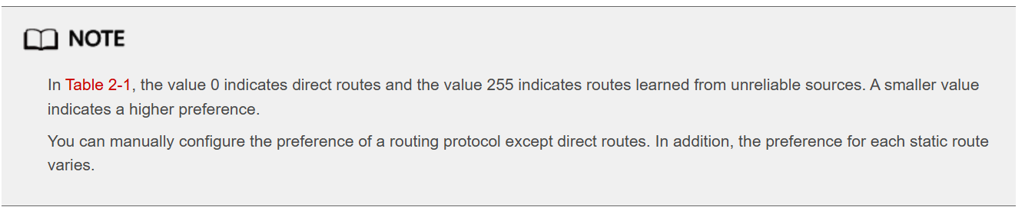
https://support.huawei.com/enterprise/en/doc/EDOC1000047418/e3a3303d/routing-protocol-preference
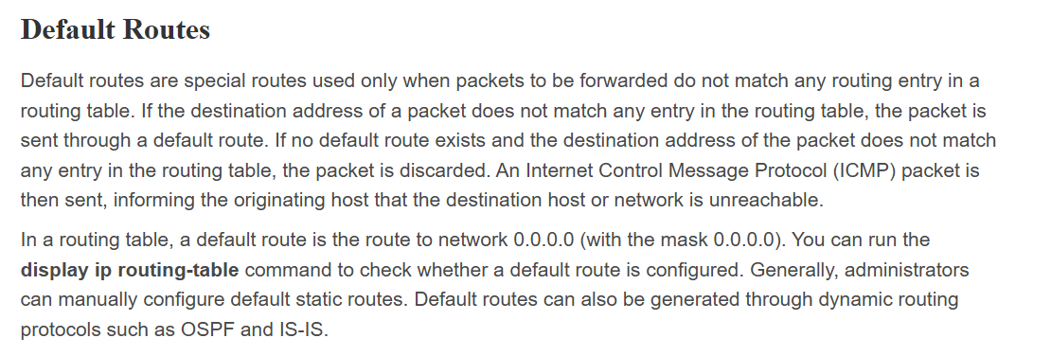
https://support.huawei.com/enterprise/en/doc/EDOC1100086956/e18497a3/ip-routing-basics

