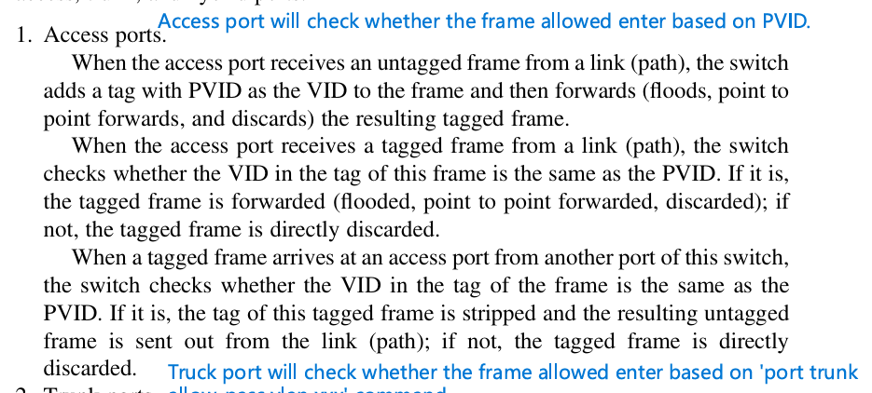

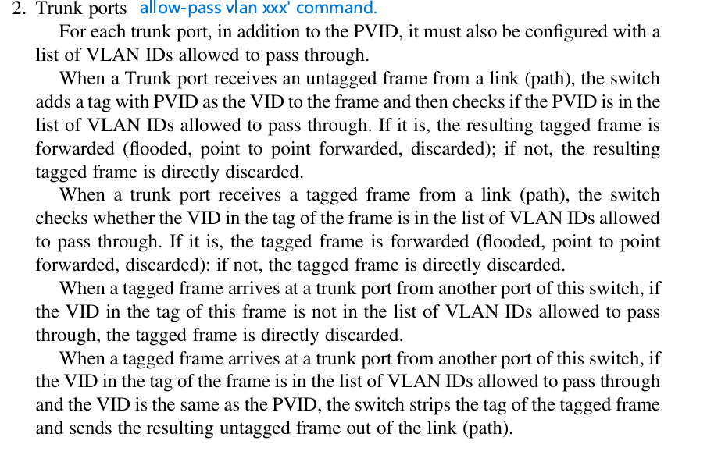
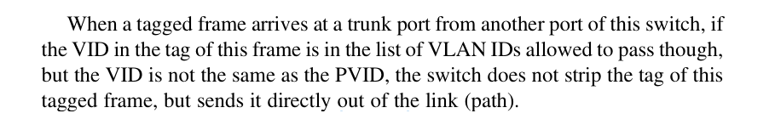
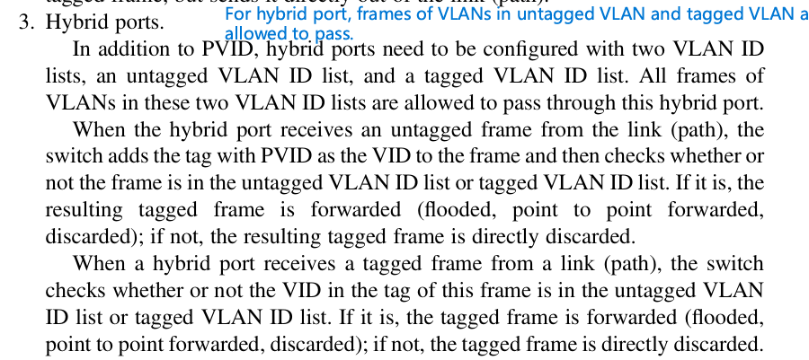
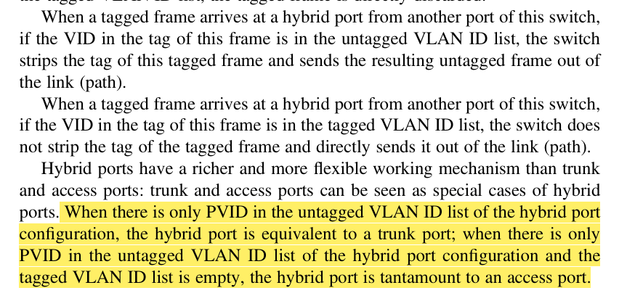

- Receive frames:
- If untagged, need to tag VID of frame = PVID
- If tagged already, no need to do anything
- Check if frame allowed to enter into port
- For access port: if VID of frame == PVID, can enter into port
- For trunk port: if VID of frame == port trunk allowed-pass VLAN XX, can enter into port
- For hybrid port: if VID of frame = tagged or untagged list, can enter into port

- Send out frames:
- Check if frame is allowed to exit out of port
- For access port: if VID of frame == PVID, can exit out of port
- For trunk port: if VID of frame == port trunk allowed-pass VLAN XX, can exit out of port
- For hybrid port: if VID of frame = tagged or untagged list, can exit out of port
- Check need to untagged the frame:
- For access port, if VID of frame == PVID, strip off the tag
- For trunk port: if VID of frame == PVID, strip off the tag. Otherwise, remain tagged.
- For hybrid port: if VID of frame = untagged, strip off the tag. Otherwise, remain tagged.

