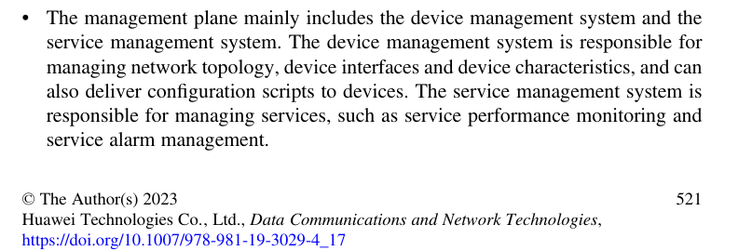
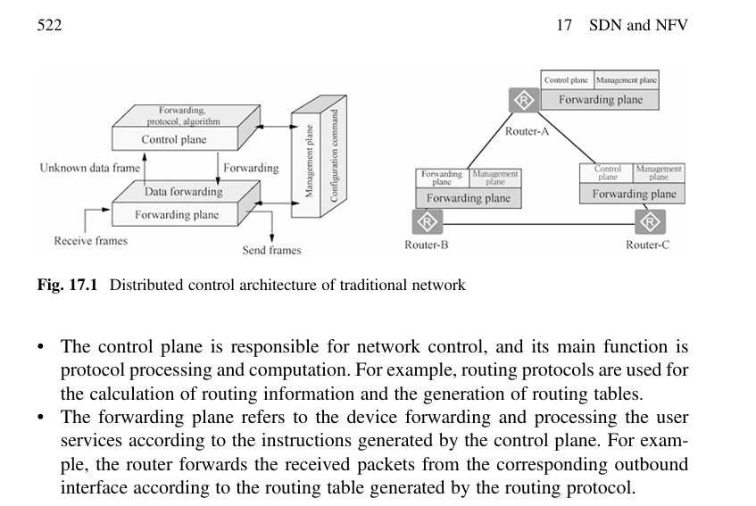
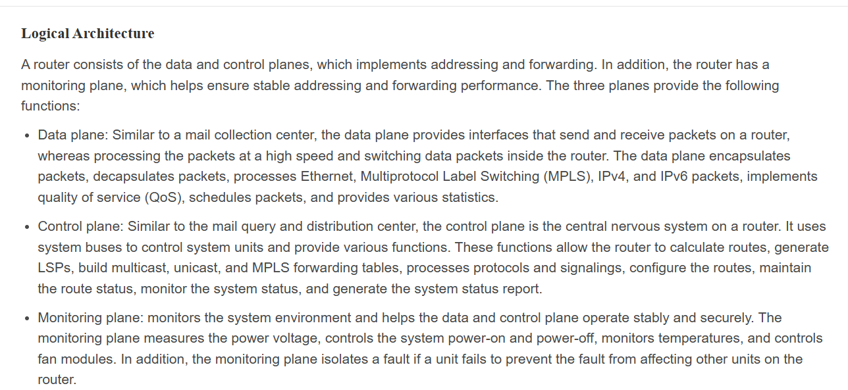
https://support.huawei.com/enterprise/en/doc/EDOC1100410976/c5c00b3b/product-signal-flow-overview

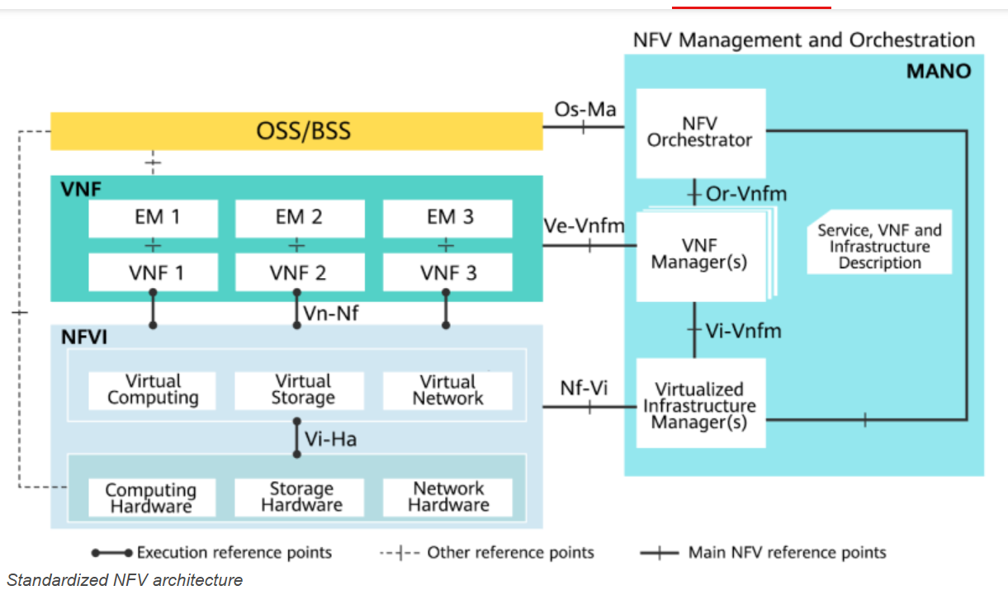

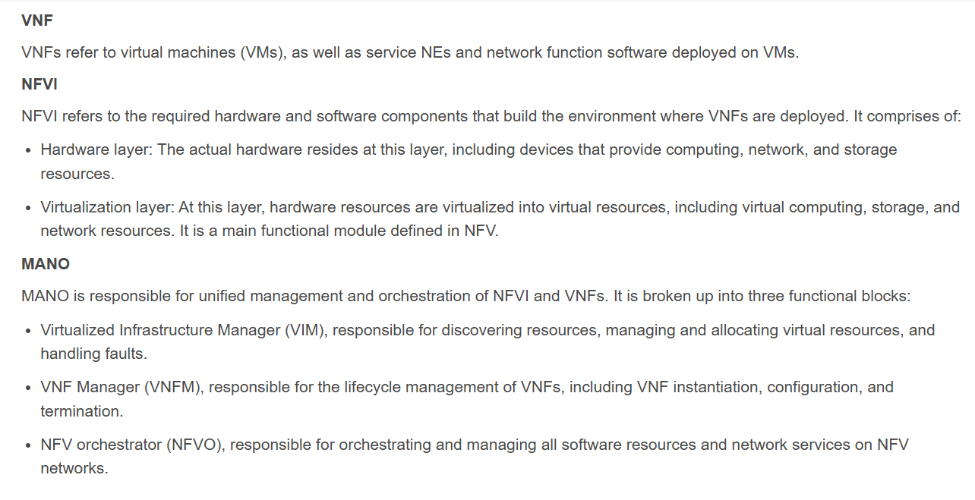
https://info.support.huawei.com/info-finder/encyclopedia/en/NFV.html

