Login to VPR
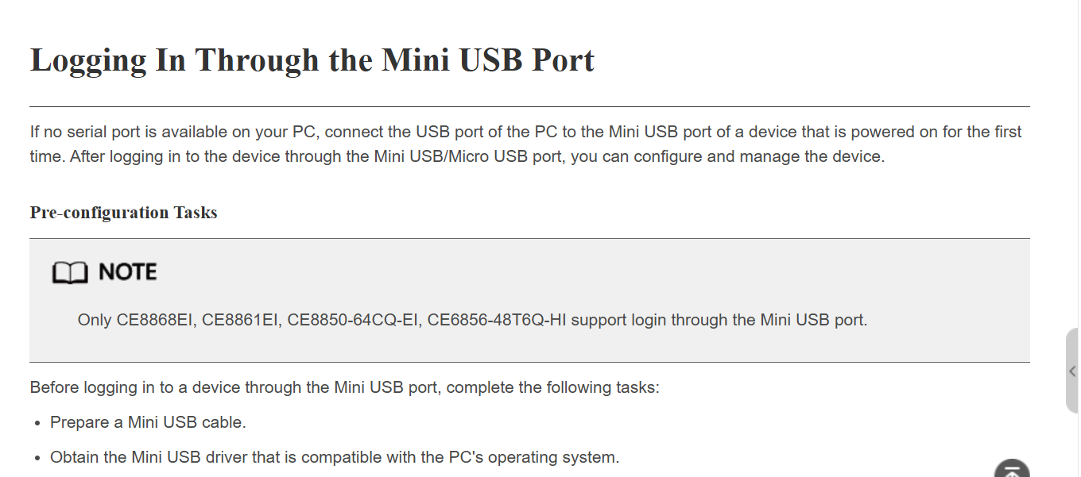
https://support.huawei.com/enterprise/en/doc/EDOC1100389628/8f6d9efc/logging-in-through-the-mini-usb-port
