Consider an undirected graph where each edge weighs 6 units. Each of the nodes is labeled consecutively from 1 to n.
You will be given a number of queries. For each query, you will be given a list of edges describing an undirected graph. After you create a representation of the graph, you must determine and report the shortest distance to each of the other nodes from a given starting position using the breadth-first search algorithm (BFS). Return an array of distances from the start node in node number order. If a node is unreachable, return for that node.
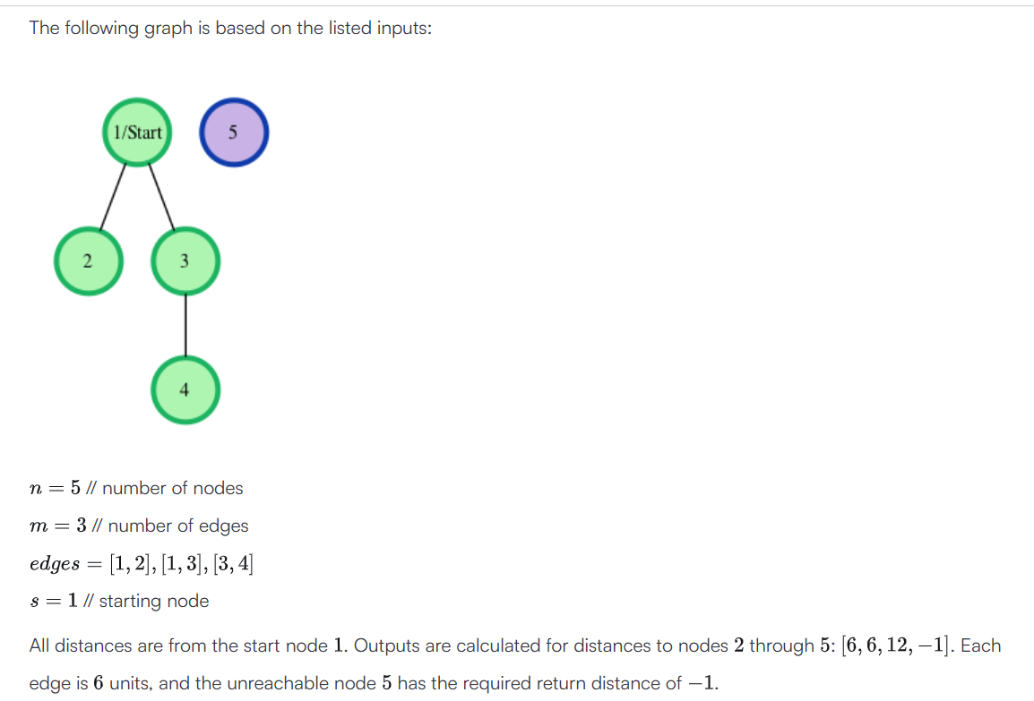
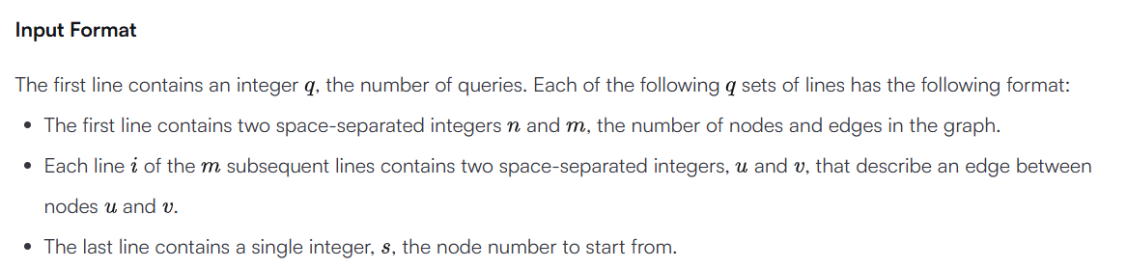

Sample Input
2
4 2
1 2
1 3
1
3 1
2 3
2

Sample Output
6 6 -1
-1 6

