Coding Challenge: Minimize Maximum Pair Sum in Array

Problem Statement
The pair sum of a pair (a, b) is equal to a + b. The maximum pair sum of a list of pairs is the maximum value among all the pair sums.
For example, if we have pairs (1, 5), (2, 3), and (4, 4), the pair sums are 1+5 = 6, 2+3 = 5, and 4+4 = 8. The maximum pair sum of this list would be max(6, 5, 8) = 8.
Given an array nums of even length n, pair up the elements of nums into n / 2 pairs such that:
- Each element of nums is in exactly one pair.
- The maximum pair sum is minimized.
Return the minimized maximum pair sum.

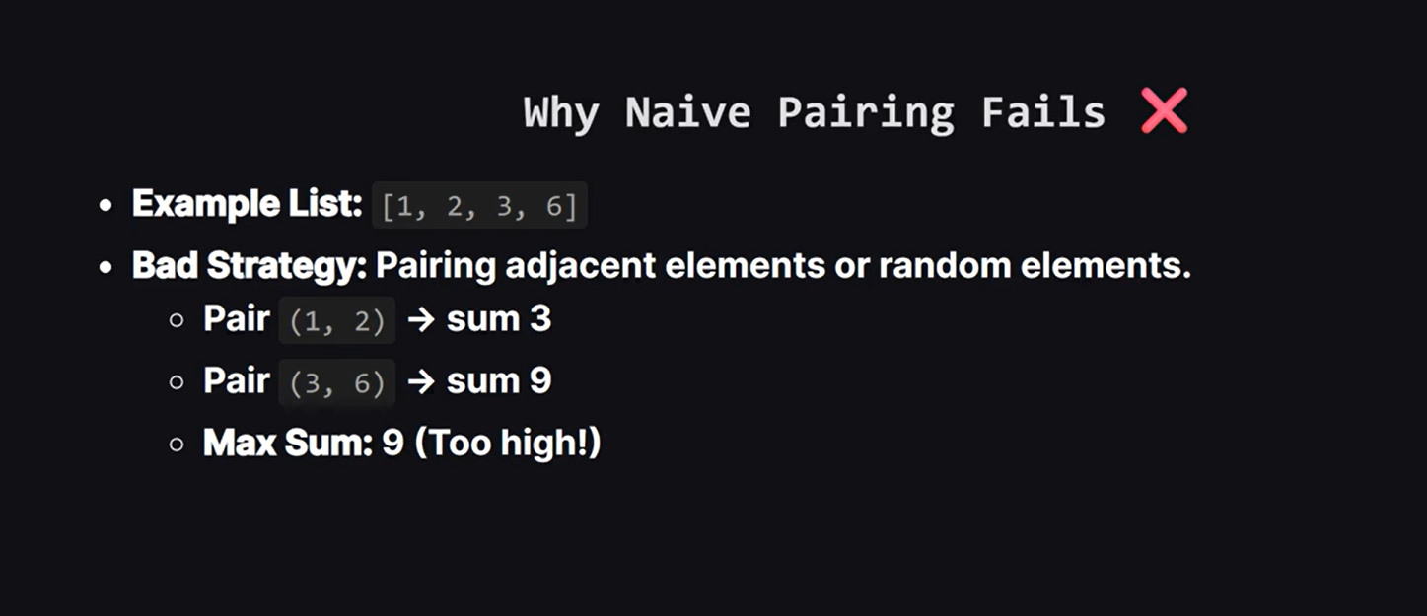
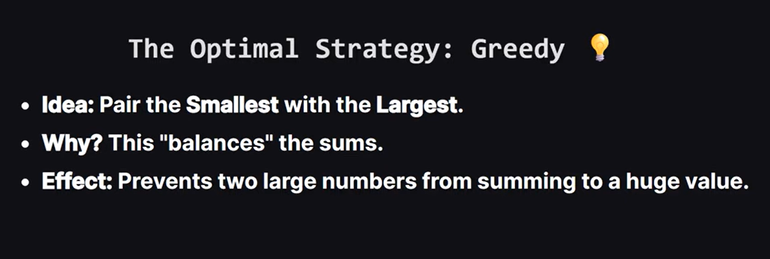

1. Advanced & Structural Patterns
- Test Case 1: Alternating High and Low Values
  - nums = [1, 100, 2, 99, 3, 98]
  - Expected Output: 101
  - Explanation: Sorting aligns them to [1, 2, 3, 98, 99, 100]. Optimal pairs are (1, 100), (2, 99), and (3, 98), all summing perfectly to 101.
- Test Case 2: Strictly Increasing Arithmetic Progression
  - nums = [2, 4, 6, 8, 10, 12]
  - Expected Output: 14
  - Explanation: Pairs are (2, 12), (4, 10), and (6, 8). Every single pair sums to exactly 14.

2. Extreme Values & Constraints
- Test Case 3: All Elements At Maximum Constraint Value (10⁵)
  - nums = [100000, 100000, 100000, 100000]
  - Expected Output: 200000
  - Explanation: Tests for integer overflow thresholds if handled improperly in languages or older types, ensuring the sum correctly reaches 2 x 10⁵.
- Test Case 4: Minimal Elements At Lowest Constraint Value (1)
  - nums = [1, 1, 1, 1]
  - Expected Output: 2
  - Explanation: Validates performance at the absolute floor of the problem constraints.

3. Duplication & Skewed Distributions
- Test Case 5: Bi-modal Distribution with Massive Duplicate Blocks
  - nums = [10, 10, 10, 90, 90, 90]
  - Expected Output: 100
  - Explanation: Every 10 is forced to pair with a 90, meaning all pair sums are uniformly 100.
- Test Case 6: Single Extreme Outlier Pair
  - nums = [5, 6, 7, 1, 2, 100]
  - Expected Output: 101
  - Explanation: Sorting gives [1, 2, 5, 6, 7, 100]. The pairs are (1, 100), (2, 7), and (5, 6). The max sum is heavily dictated by the outlier pair (1, 100) → 101.

