Depth First Search
0 -> 1, 2
1 -> 0, 2
2 -> 0, 1, 3, 4
3 -> 2
4 -> 2
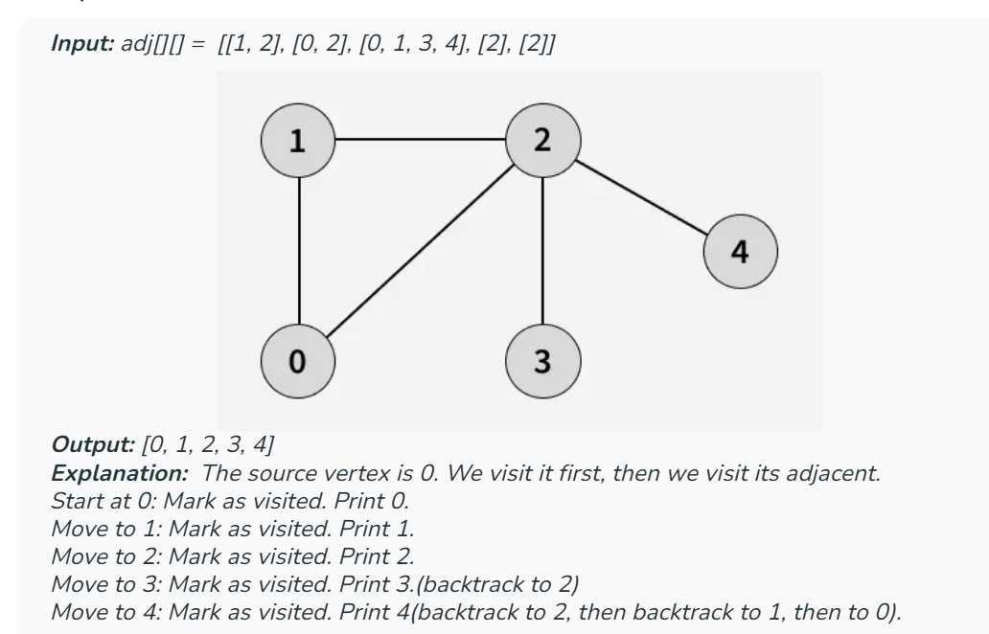
Input: adj[][] = [[1, 2], [0, 2], [0, 1, 3, 4], [2], [2]]
Output: [0, 1, 2, 3, 4]

