**UNITED INTERNATIONAL UNIVERSITY**

Department of Computer Science and Engineering (CSE)

**Course Title: Theory of Computation Trimester & Year: Fall 2022**

**Course Code: CSE 2233 Section: C**

CT-01

**Credit Hours: 3.0**

**MdMH**

Total Marks: **20** Time: **45** min

1. Write a Formal definition of the DFA including the transition table by using the state diagram given in Figure 01. The DFA has been constructed over alphabet, ∑ = {𝑎, 𝑏}.

**3**

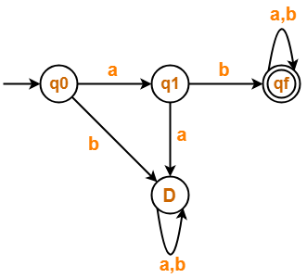

**Figure 01: State Diagram**

1. A DFA is defined over alphabet ∑ = {𝑥, 𝑦} which accepts all the strings w of the Language L where

L = {w | w starts and ends with the same symbol}. **5**

( Construct only the state diagram of the DFA )

1. Write a Formal definition of the DFA including the state diagram using the transition table given in

Table 01. The DFA has been constructed over alphabet, ∑ = {j, k, l}. **3**

Table 01: Transition table

|  |  |  |  |
| --- | --- | --- | --- |
|  | *j* | *k* | *l* |
| ➔ A | A | B | D |
| *B | A | E | D |
| C | A | D | A |
| *D | D | E | A |
| E | B | C | D |

1. A DFA is defined over alphabet ∑ = {0, 1} which accepts all the strings w of the language L where

L = {w | w contains “1010”}.

* 1. Write down four strings that will be accepted by the DFA
  2. Write down two strings that will not be accepted by the DFA
  3. Construct the state diagram of the DFA.
  4. Write down the formal definition of the DFA including the transition table.

**2 + 4 + 3**