**UNITED INTERNATIONAL UNIVERSITY**

Department of Computer Science and Engineering (CSE)

**Course Title: Theory of Computation Trimester & Year: Summer 2024**

**Course Code: CSE 2233 Section: I (Set-B)**

CT-01

**Credit Hours: 3.0**

**MdMH**

Total Marks: **10** Time: **30** min

1. Write a **Formal definition** of the DFA including the **transition table** by using the state diagram given in Figure 01. The DFA has been constructed over alphabet, **∑ = {0, 1}**.

**2**

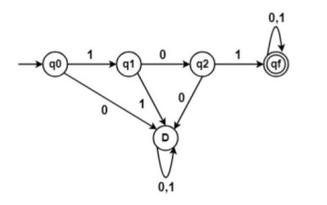

**Figure 01: State Diagram**

1. Construct a **DFA** defined over alphabet **∑ = {c, d, e}** that accepts all the strings w of the Language L where,

**5**

L = {w | w starts with **‘dc’** and contains **‘edd’** or **‘ecd’** and ends with **‘ce’**}.

1. Design a **DFA** that accepts the Language, L over alphabet **∑ = {a, b, c}** **3**

L = { w | w **starts** and **ends** with **same symbol** }.