**UNITED INTERNATIONAL UNIVERSITY**

Department of Computer Science and Engineering (CSE)

**Course Title: Theory of Computation Trimester & Year: Fall 2022**

**Course Code: CSE 2233 Section: C**

CT-02

**Credit Hours: 3.0**

**MdMH**

Total Marks: **20** Time: **50** min

1. Consider the following NFA, and show with the help of **NFA-tree** whether the string “1101010” is accepted or not.

**3**

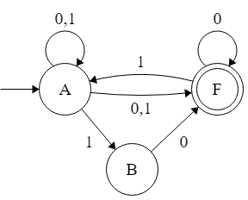

1. Convert the following **NFA** over alphabet $\sum{=\{a,b\}}$ to an equivalent **DFA**.  **7**

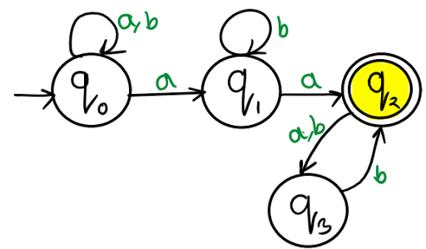

1. Consider the following DFA, and with the help of **Extended Transition Function** show that what will be the next state for the input string **011010** from the starting state **S0**

**3**

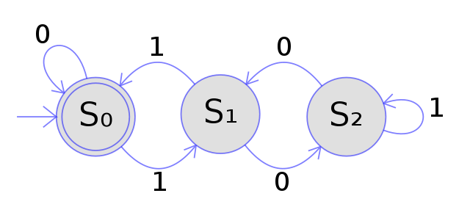

1. A **DFA** is defined over alphabet ∑ = {0, 1} which accepts all the strings w of the language L where

**L = {w | w mod 3=0 }**

(Here, w contains the set of all strings whose length always returns remainder 0 when divided by 3 )

**Construct the state diagram & transition table of the DFA.**

1. Design a **NFA** that accepts the following language : **3**

L = starts with ‘mxn’ and contains ‘mxn’ | ∑ = {m,n,x}

**4**