**UNITED INTERNATIONAL UNIVERSITY**

Department of Computer Science and Engineering (CSE)

**Course Title: Theory of Computation Trimester & Year: Summer 2024**

**Course Code: CSE 2233 Section: C, I (2)**

CT-02

**Credit Hours: 3.0**

**MdMH**

Total Marks: **10** Time: **30** min

1. Convert the following **NFA** to an equivalent **DFA**. (Remember to draw the state diagram of the DFA) **6**

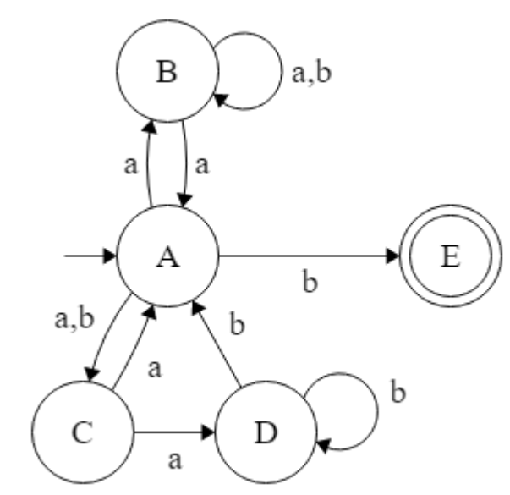

**Figure 01: State Diagram of NFA**

1. Construct an **NFA** defined over alphabet **∑ = {0, a, b}** that accepts all the strings of the following Language, L where, **4**

L = {w | w starts with **‘0ab0’ or ‘b00a’**, contains **‘b0a’** or **‘b00’** and ends with **‘b’**}.