How Machines Learn

Machine learning learn patterns from input data and use those patterns to make predictions for new input features. This guide explains that workflow through movie recommendations, spam email detection, and face recognition.

From examples to predictions
During training, a model adjusts its weights and parameters to improve its label predictions. For example, a spam model compares its predictions with correct email labels and learns from its errors. After training, we test it on examples it has not seen before. Using the trained model on a new input is called inference.
Good training performance alone is not enough: the model must also work on new examples. Predictions can be wrong when the examples are limited, unrepresentative, or very different from the new input.

Movie recommendations
Real life use:
A streaming service suggests movies a viewer might enjoy.
What it learns from:
The system can learn from watched movies, ratings, likes, and viewing patterns across many users. Movie information, such as genre, can also help. Watching something is a clue about interest, not proof that the viewer liked it.
What it learns:
It learns relationships between viewers and movies, such as which titles appeal to people with similar viewing histories.
How it uses the learning:
For a viewer, the trained system estimates interest in available movies and ranks them. If someone often enjoys science fiction, it may suggest another science fiction film or a title liked by similar viewers.
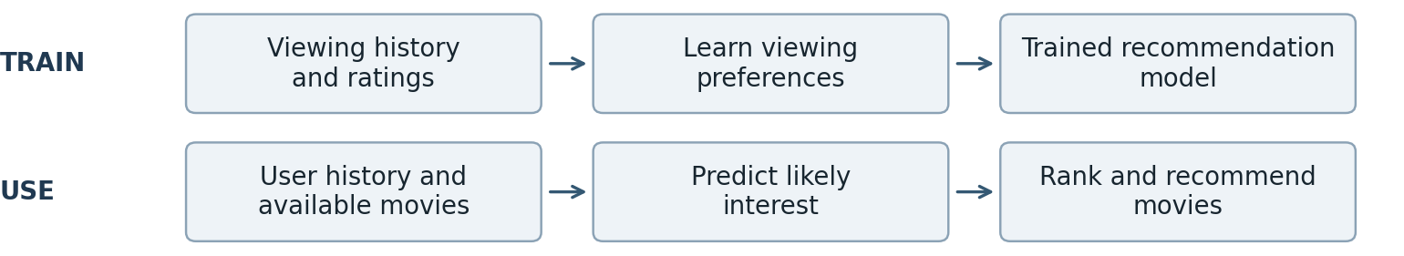
Key point:
New ratings and viewing activity can help update recommendations. A suggestion is a prediction of preference, not a guarantee.

Spam email detection
Real life use:
An email service separates unwanted messages from useful ones.
What it learns from:
Training examples are emails labelled “spam” or “not spam.” The model can use message text, sender information, and links as clues.
What it learns:
It learns combinations of clues associated with spam, such as repeated promotional language and suspicious links. One word alone does not reliably identify spam.
How it uses the learning:
When a new email arrives, the model estimates how likely it is to be spam. The service uses a chosen threshold to decide whether to move it to the spam folder. For example, a fake prize message with a suspicious link may be flagged.
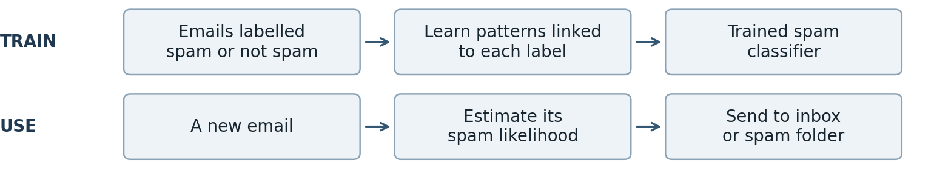

Key point:
A useful email can be flagged by mistake. User corrections can provide examples for later model updates.

Face recognition
Real life use:
A photo application groups pictures that appear to show the same person.
What it learns from:
A face model can be trained on many images with identity labels, including different expressions, angles, and lighting conditions.
What it learns:
It learns visual features that help distinguish faces. It represents each face as a set of numbers, often called an embedding.
How it uses the learning:
For a new photo, the system finds the face and creates its numerical representation. It compares this with saved face templates. A sufficiently close match suggests the same person; otherwise, it can return no match. For example, it may group two photos of the same friend despite different expressions.
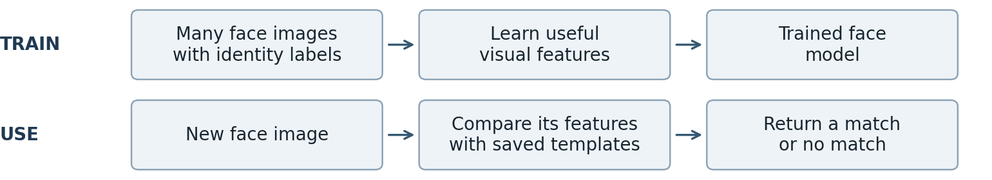

Key point:
Face detection finds where a face is; face recognition compares whose face it might be. Poor lighting or an obscured face can cause errors.

My main learning
Machine learning connects past examples to new predictions. The applications differ, but each needs useful training data and testing on unseen examples. More data helps only when it is relevant and reliable; no model is automatically correct.

