Machine Learning Model Exploration
Flower Classification Using Google Teachable Machine
Prepared by: Sifat Singh Bhatia
Task 3 | InAmigos Foundation
Date of demonstration: 6/10/26

1. Objective
To explore a beginner-friendly machine learning platform by training an image classifier to distinguish roses from sunflowers, testing it on unseen images, and recording its predictions.

2. Platform and dataset
Google Teachable Machine provides a visual interface for collecting labelled examples, training a model, and previewing predictions without advanced coding. This demonstration uses two classes: Rose and Sunflower.
Dataset source: TensorFlow Flowers image dataset. Only the rose and sunflower categories are used. Actual image counts should be entered below.
Class | Training images | Held-out test images
Rose | 641 | 20
Sunflower | 699 | 20
Total | 1340 | 40

Test images must be kept separate from training images. Complete all blank fields with your actual observations before submission.
3. Labelled training examples
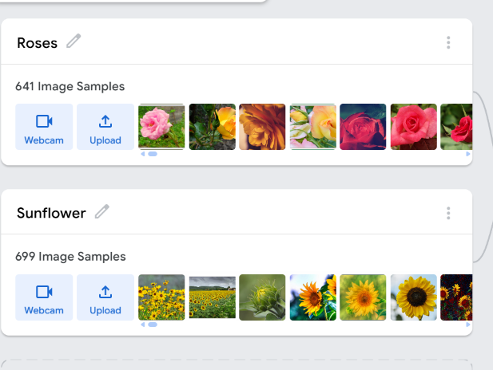

4. Training the model
In Teachable Machine, create an Image Project using the Standard image model. Name the classes Rose and Sunflower and upload the corresponding images into each class. Select Train Model to begin training.
The model learns visual patterns from labelled examples and uses those patterns to assign a class to a new image.
Training settings used: Default / Custom: Default
Epochs, batch size and learning rate (if recorded): 50 , 16 and 0.001

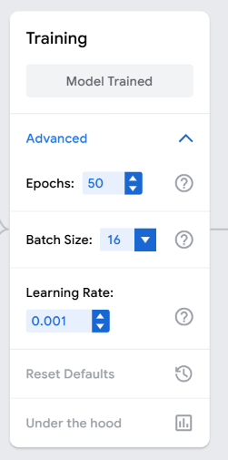

5. Testing and predictions
Upload held-out images in the preview panel. For each image, compare the known class with the class assigned the highest score. Record correct and incorrect predictions.
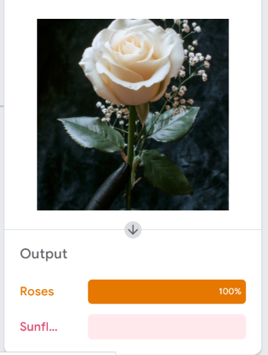

Actual class: Rose
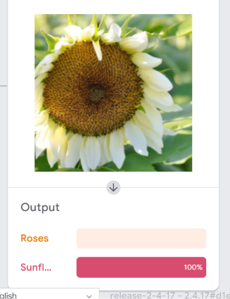
Actual class: Sunflower
The confidence displayed for one image is a model score. It does not measure accuracy across the test set.

7. Learning and conclusion
This exercise demonstrates the supervised learning workflow: prepare labelled examples, train a model, test it on unseen inputs, and inspect its predictions. Model performance depends on the examples provided and should be measured using separate test images.

8. References and saved files
Platform: https://teachablemachine.withgoogle.com/
Dataset: https://www.tensorflow.org/tutorials/load_data/images

