Understanding AI and Machine Learning
A simple learning guide
This guide explains six basic concepts and shows how they appear in everyday life. The goal is to understand what AI does, how machines learn, and how different learning methods work.
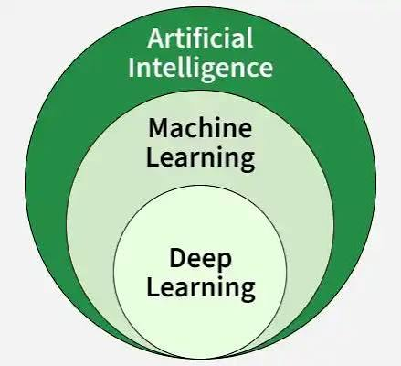

Artificial Intelligence
Artificial Intelligence (AI) is the field of making computers perform tasks that usually need human intelligence. These tasks include solving problems and making decisions. AI workflow involves understanding the structured data, follow the functions and work using these predefined functions to generate user required output. There are broadly two types of AI being used in real world being agent-AI and generative-AI
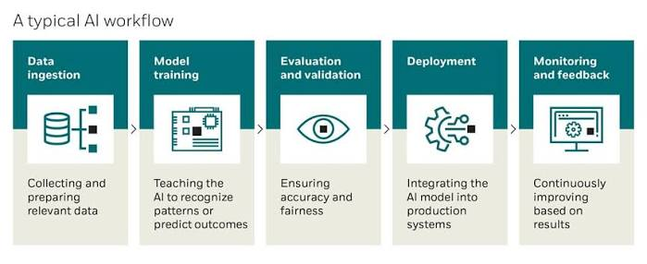
Real-life example: A voice assistant understands a spoken request such as “Set an alarm for 7 AM” and carries out the task. Other various examples include chat bots being: ChatGPT, Claude, Gemini etc.

Machine Learning
Machine Learning (ML) is a part of AI in which the main focus is on learning patterns from structured data instead of building production based LLM-applications. After learning from examples, a model uses those patterns to make predictions about new data. A model here is considered the prediction machine which is backed by the data is had learn.

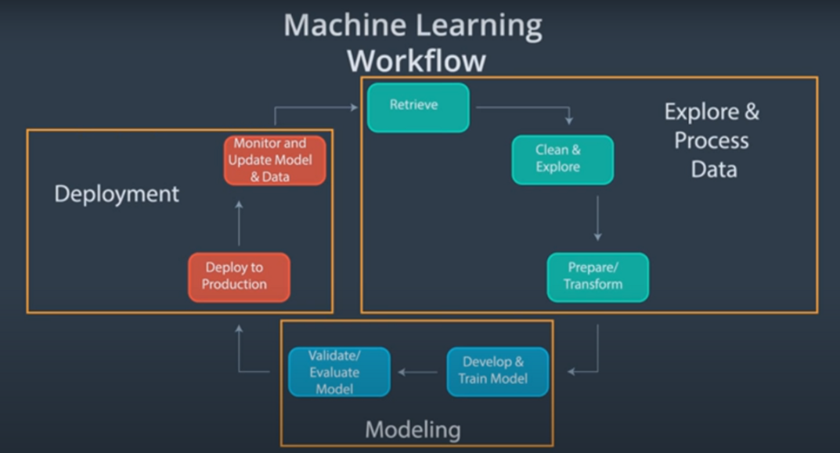
Real-life example: A shopping app learns from browsing and purchase patterns to suggest products a customer may like. Other various examples include: anomaly detection, classification, regressions etc.

Deep Learning
Deep Learning (DL) is a subset of machine learning that uses neural networks with various types of layer being input, output and hidden. A neural network is a mathematical system that learns patterns from data in form of tensors which are extracted from image pixels & speech features. Its layers work together to recognise complex information using deep layers, such as shapes and faces in images.
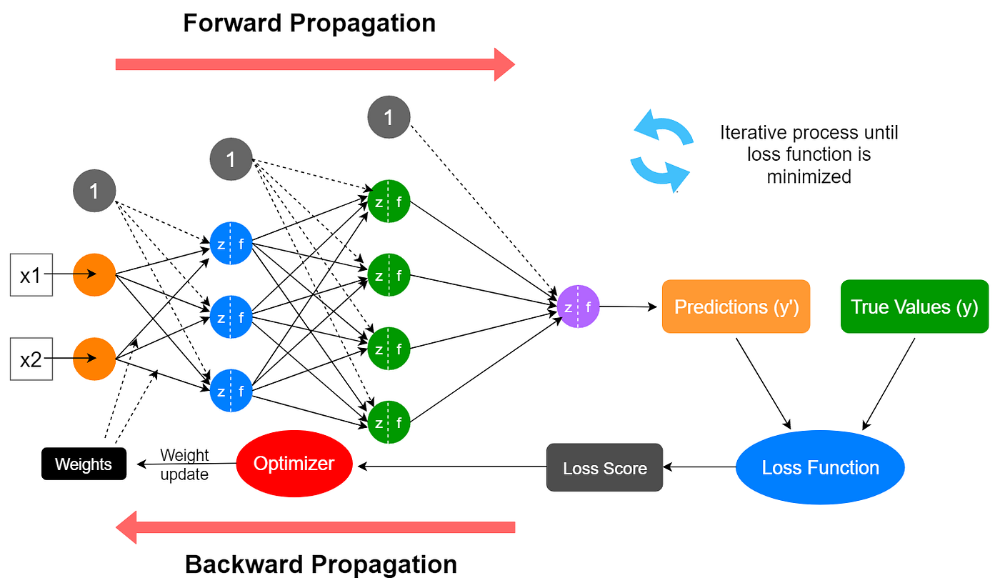
Real-life example: A phone’s face-unlock system can use deep learning to recognise the registered user’s face. Some other applications include: image classification, annotations, human sentimental analysis, object detection etc.

How these concepts connect
AI is the broad field. Machine learning is one part of AI, and deep learning is one part of machine learning. They are related concepts, not three separate subjects.
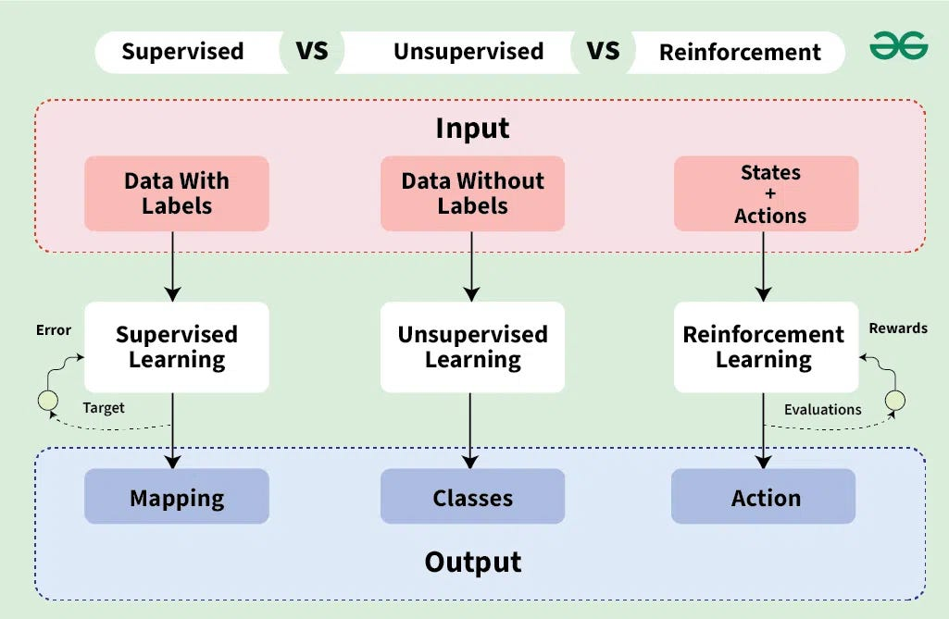

Three ways machines learn
Supervised, unsupervised and reinforcement learning differ in the information or feedback used during learning.

Supervised Learning
In supervised learning, a model learns from examples that include the correct answers, called labels. It compares its predictions with those answers and adjusts to reduce mistakes. It can then predict answers for new examples. Main differentiation input and output with (labels or classes) are given just need to identify patterns in between .
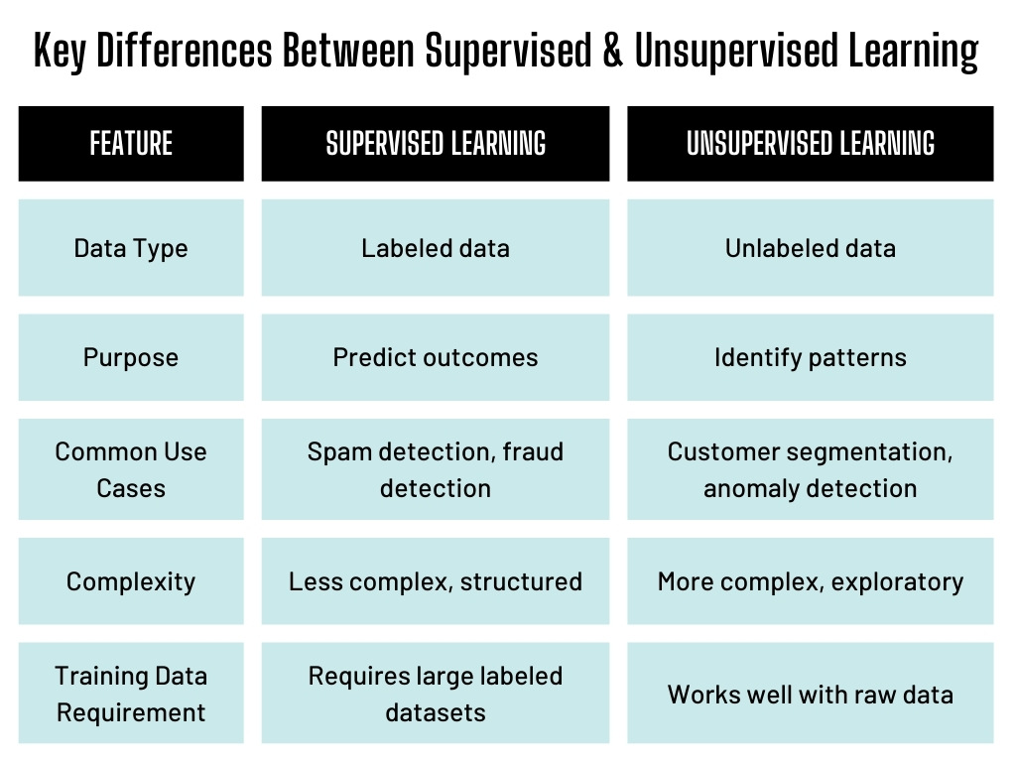
Real-life example: An email filter learns from messages labelled “spam” or “not spam”. It uses the patterns it learns to classify incoming emails.

Unsupervised Learning
In unsupervised learning, a model receives data without correct-answer labels. It looks for patterns or groups within that data. People then interpret the patterns to decide whether they are useful. Main differentiation input and output without (labels or classes) need to identify the similar classes and then recognize the pattern between them.
Real-life example: A supermarket groups customers with similar buying habits using purchase records, without being given customer groups in advance.

Reinforcement Learning
In reinforcement learning, a learner called an agent takes actions and receives rewards or penalties as feedback. Through repeated attempts, it learns which actions lead to a greater total reward over time.
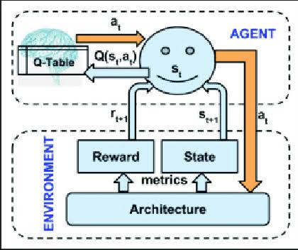
Real-life example: A robot can learn to pick up objects through repeated trials. Successful grasps earn rewards, helping it improve how it moves its gripper.

How a basic machine learning project works
First, people define a task and collect relevant data. They prepare the data and train a model to learn patterns. Next, they test it on data it has not seen before. If it performs well enough, they use it to make predictions and continue checking its results.
Remember: Supervised learning uses labelled examples, unsupervised learning finds patterns without labels, and reinforcement learning uses rewards. These systems can make mistakes; their results depend on the data, learning method and task.
Sources/References:
- Google
- ChatGPT
- Grammarly

