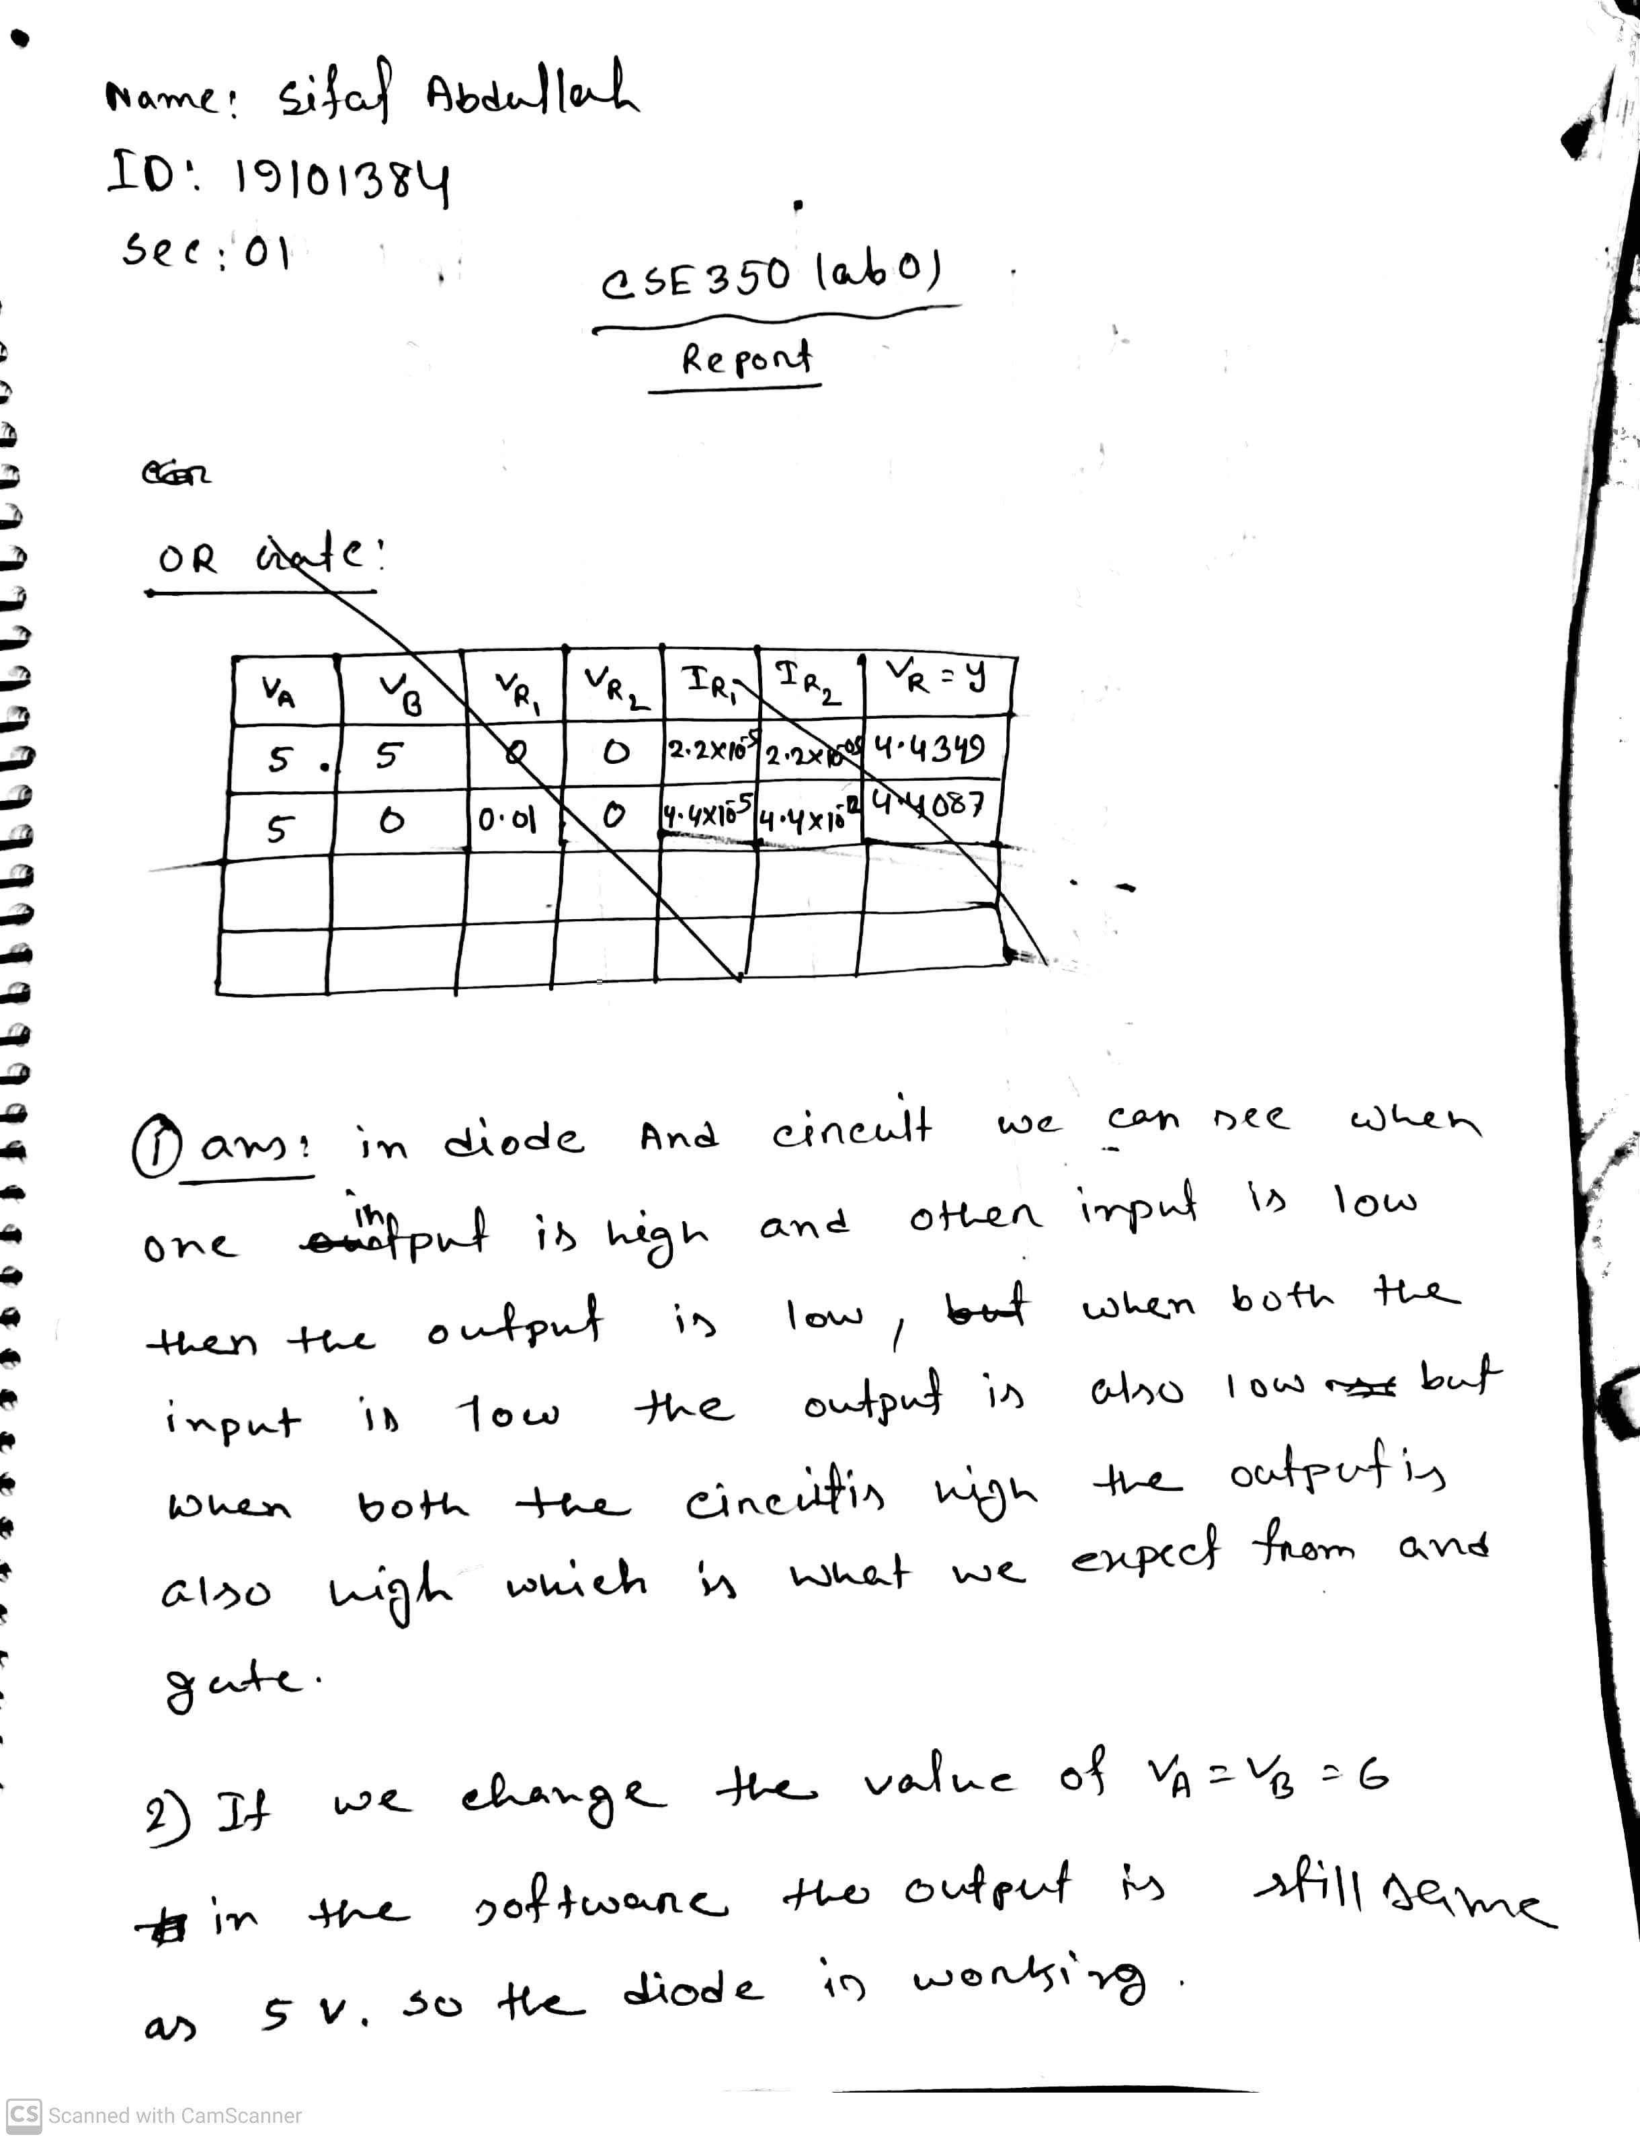

OR Gate:

**OR Gate:**

|  |  |  |  |  |  |  |
| --- | --- | --- | --- | --- | --- | --- |
| Va | Vb | Vr1 | Vr2 | Ir1 | Ir2 | Vr=Y |
| 5 | 5 | 0 | 0 | 2.21e-005 | 2.21e-005 | 4.4349 |
| 5 | 0 | 0.1 | 0 | 4.4e-005 | 4.4e-012 | 4.4087 |
| 0 | 5 | 0 | 0.1 | 4.4e-012 | 4.4e-005 | 4.4087 |
| 0 | 0 | 0 | 0 | 1.19e-02 | 1.19e-02 | 1.38e-015 |

**And Gate:**

|  |  |  |  |  |  |  |
| --- | --- | --- | --- | --- | --- | --- |
| Va | Vb | Vr1 | Vr2 | Ir1 | Ir2 | Vr=Y |
| 5 | 5 | 0 | 0 | 5e-012 | 5e-012 | 5 |
| 5 | 0 | 0 | -0.01 | 9.41e-012 | 4.4e-005 | 0.591 |
| 0 | 5 | -0.01 | 0 | 4.4e-005 | 9.41e-012 | 0.591 |
| 0 | 0 | 0 | 0 | 2.21e-005 | 2.21e-005 | 0.5651 |

**Inverter:**

|  |  |  |  |  |  |  |  |  |
| --- | --- | --- | --- | --- | --- | --- | --- | --- |
| vi | Vr1 | Vr2 | vrc | I1 | I2 | ib | ic | Y |
| 5 | 4.3 | 5.7 | -4.89 | 0.0002 | 5.7e-005 | 0.0002 | 0.002 | 0.108 |
| 0 | 0.65 | 4.35 | 0 | 4.35e-005 | 4.3e-005 | 3.196e-012 | 1.7e-011 | 5 |

