**CNN(Convolutional Neural Network) MODEL** is a category of machine learning model. Specifically, it is a type of deep learning algorithm that is well suited to analyzing visual data. A neural network architecture designed for processing visual data like images.

**Create Model after Augmentation the Images :**

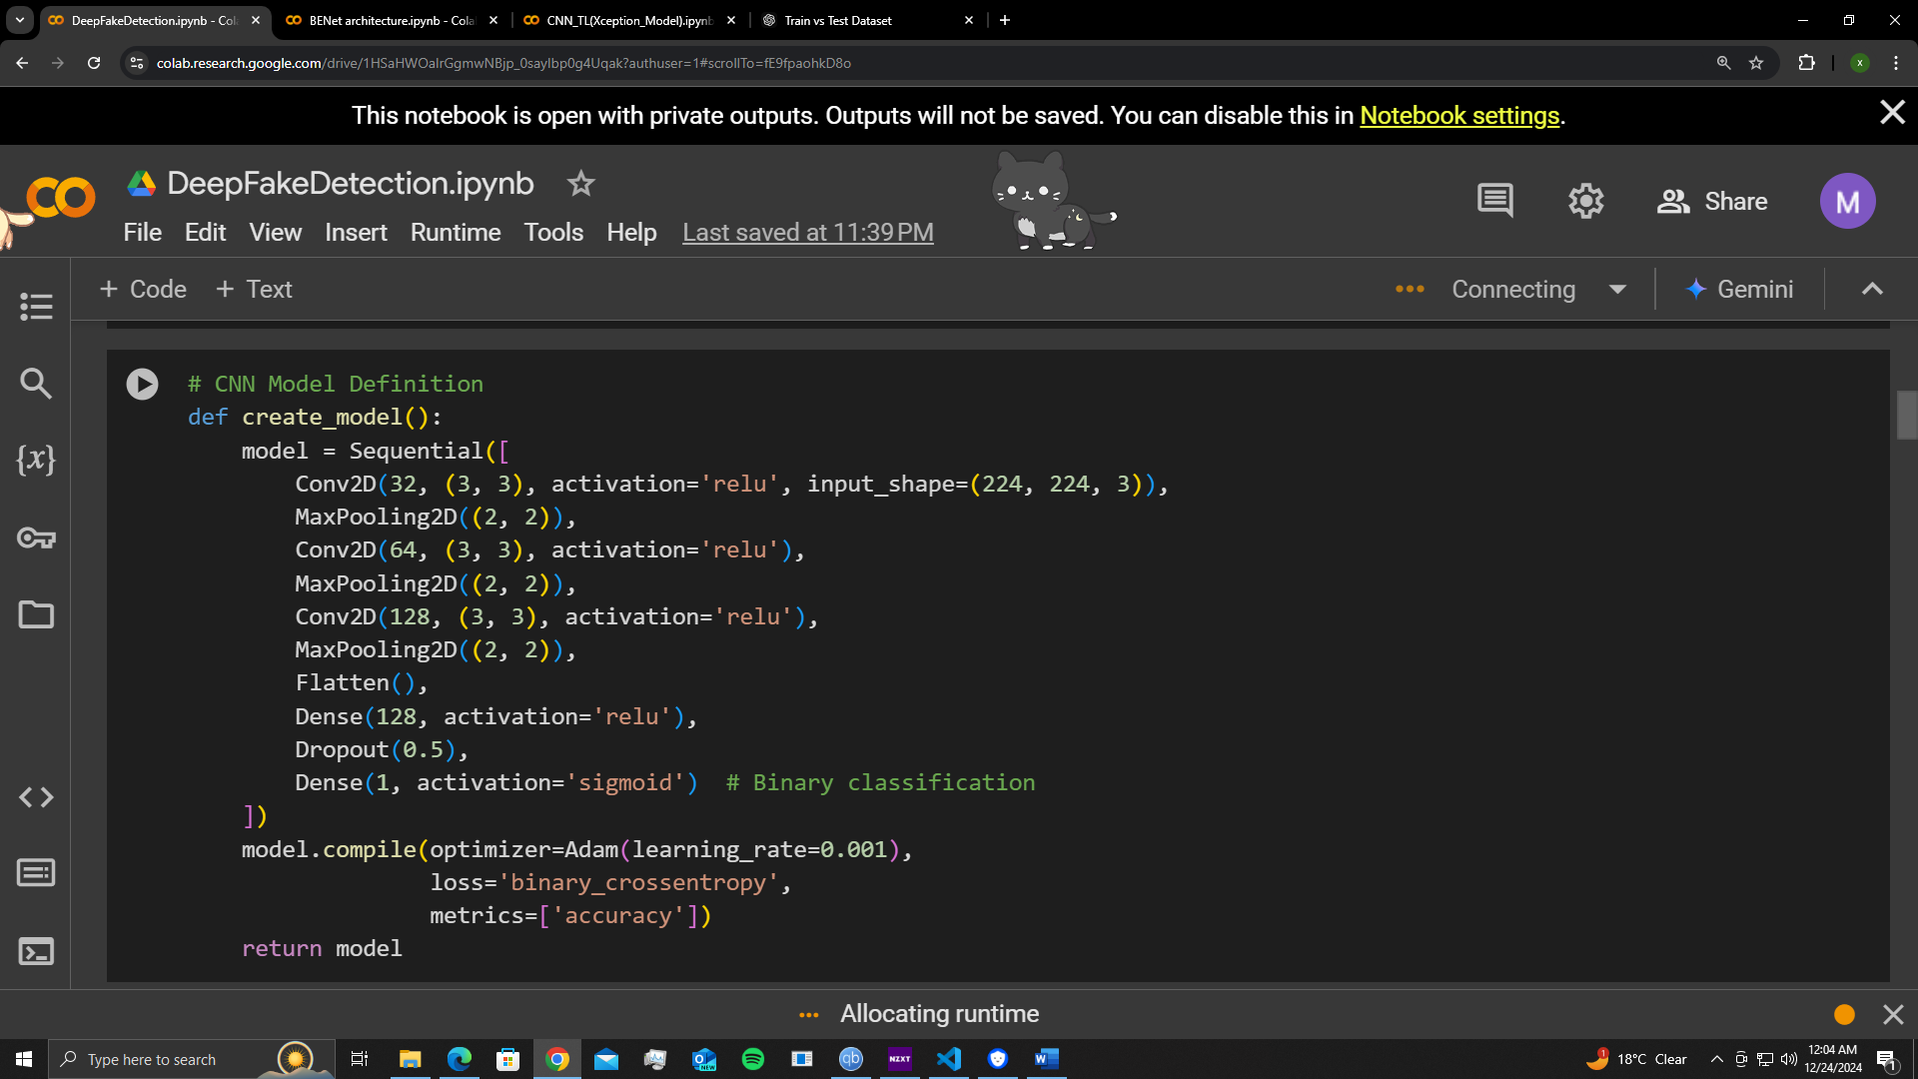

**Fit the model :**

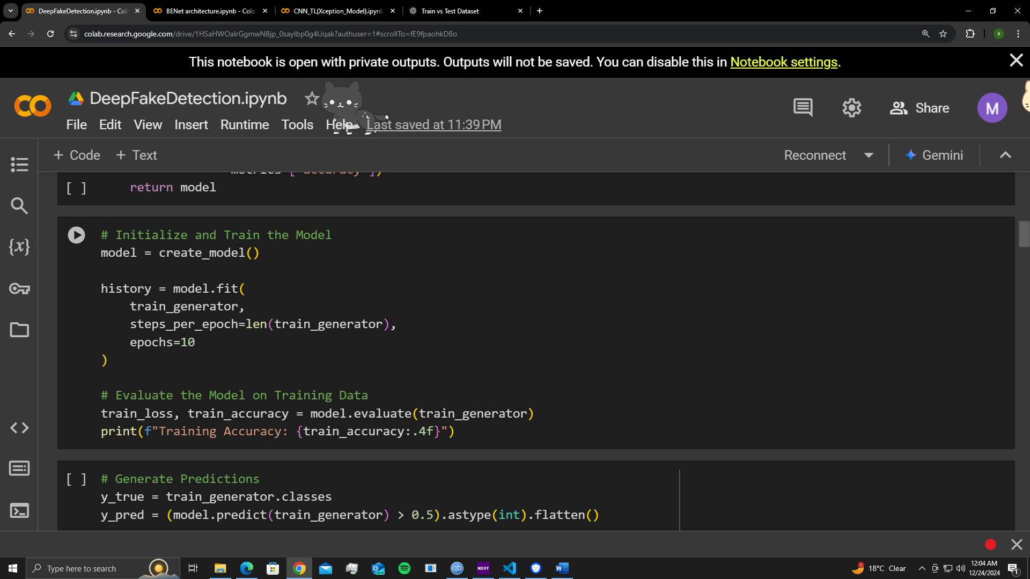

**Accuracy of the CNN Model :**

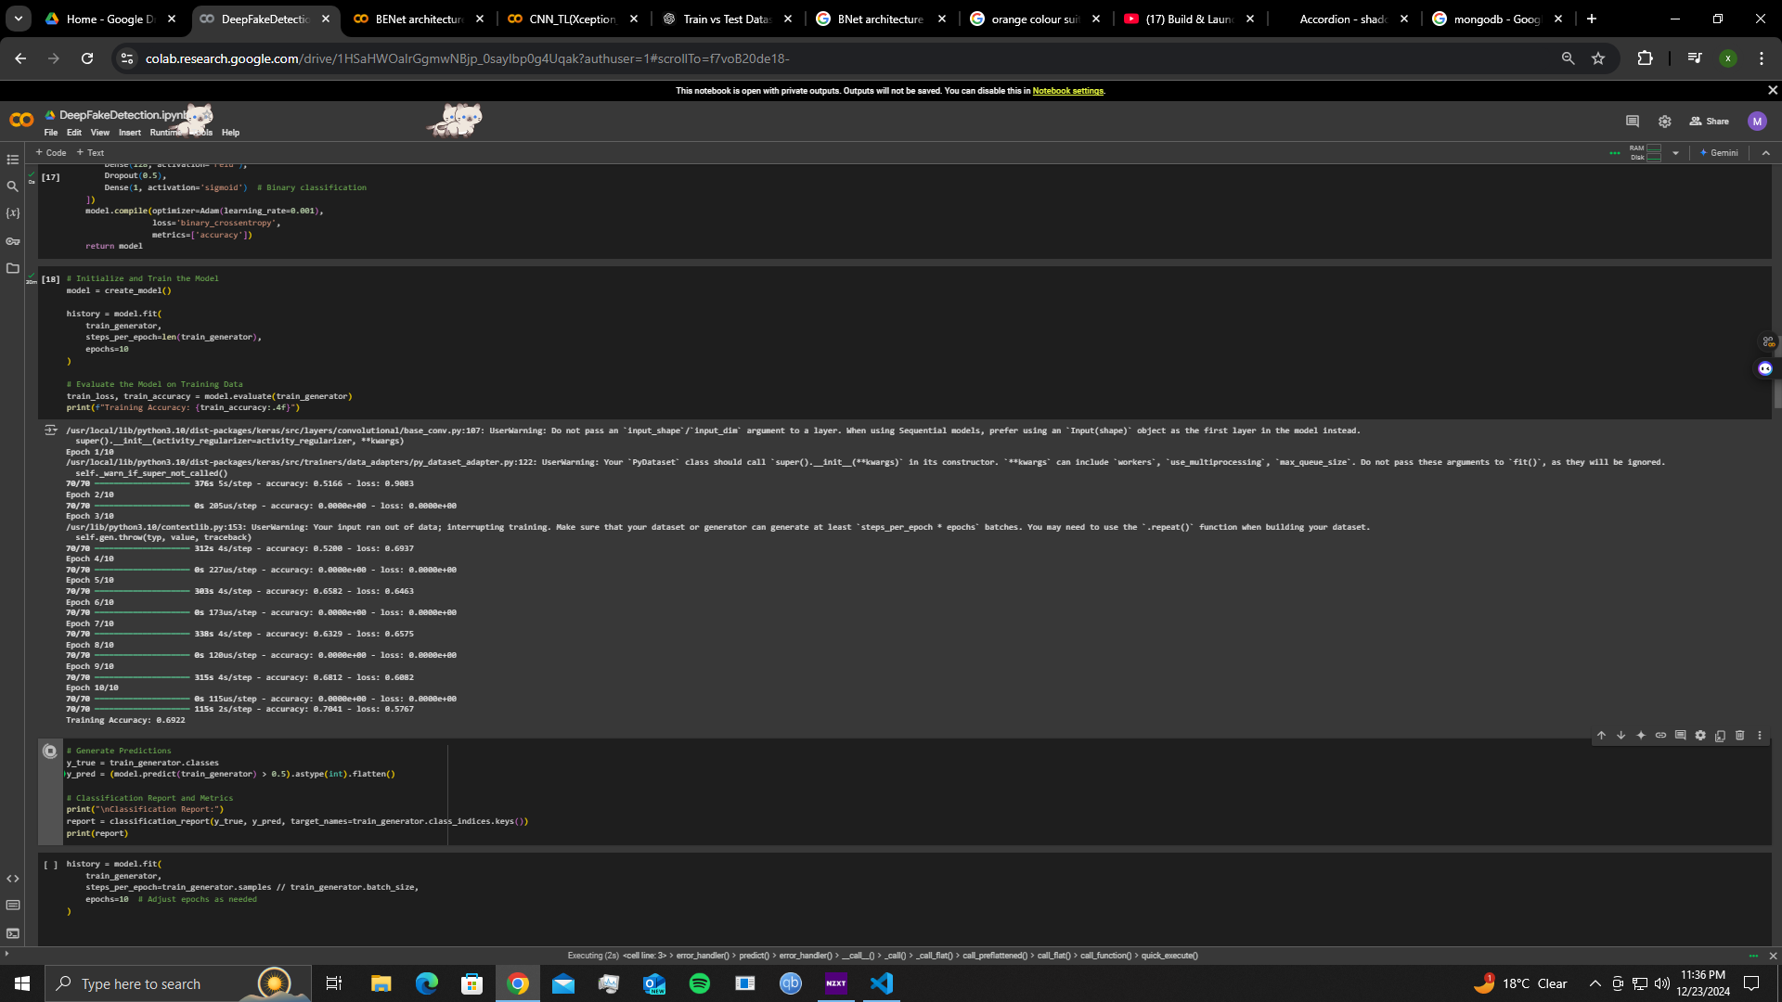

**Confusion Metrix :**

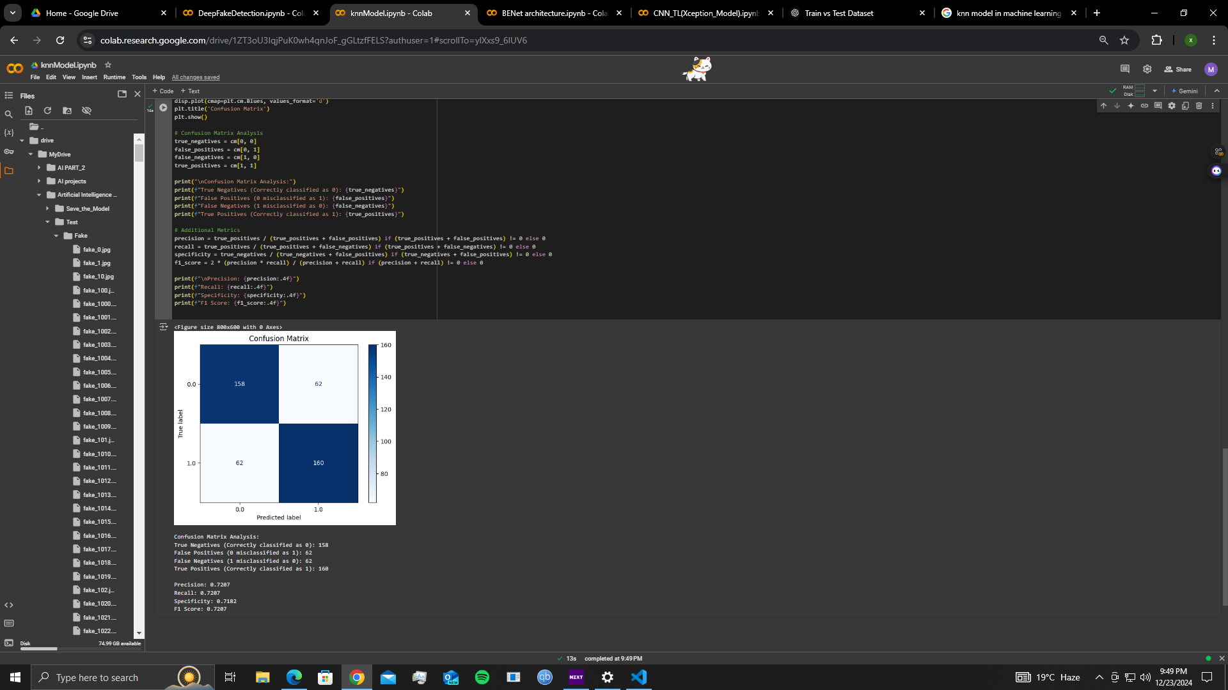

**KNN (K nearest neighbours)** is a data science model used to identify the closest approximate neighbours to the input data.

**After Fit the model accuracy :**

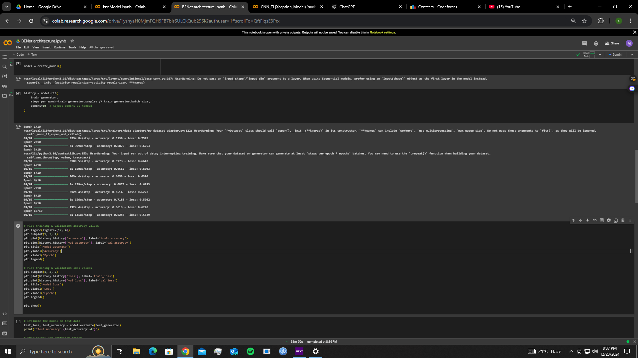

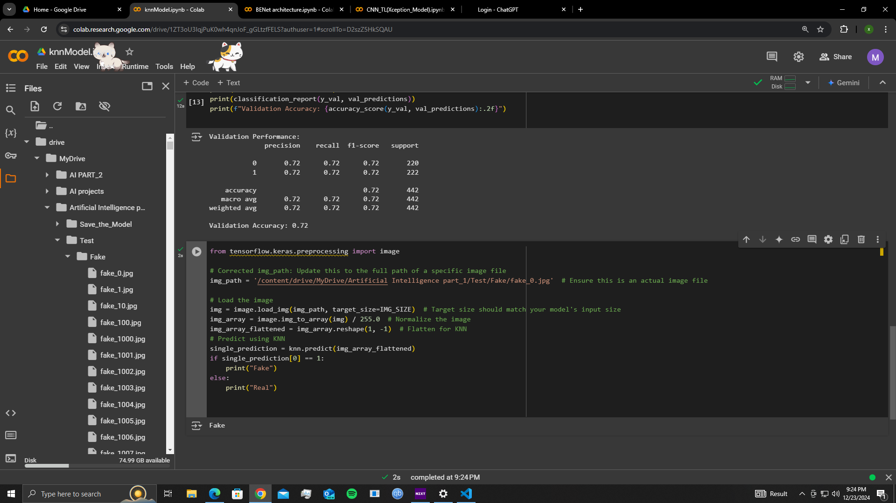

**Confusion Metrix :**



**Bar chart for confusion matrix :**

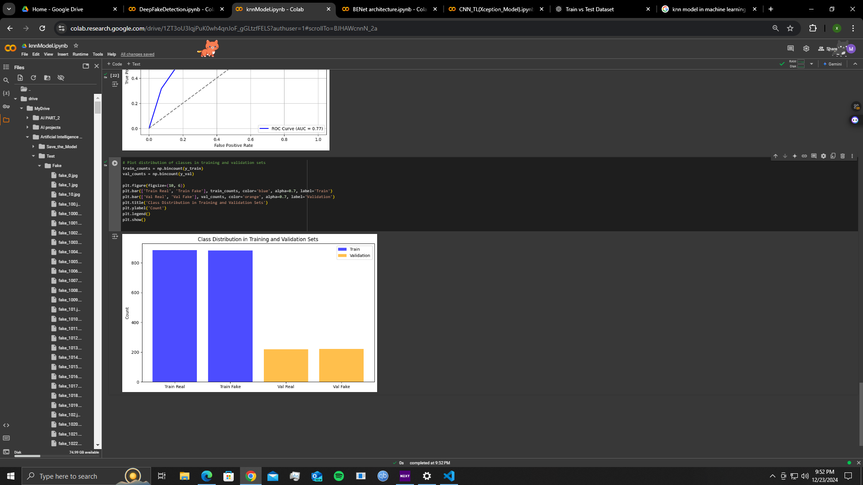

**Transfer learning Xception Model .**Xception is a convolutional neural network that is 71 layers deep.

**After Fit the model accuracy and accuracy loss :**

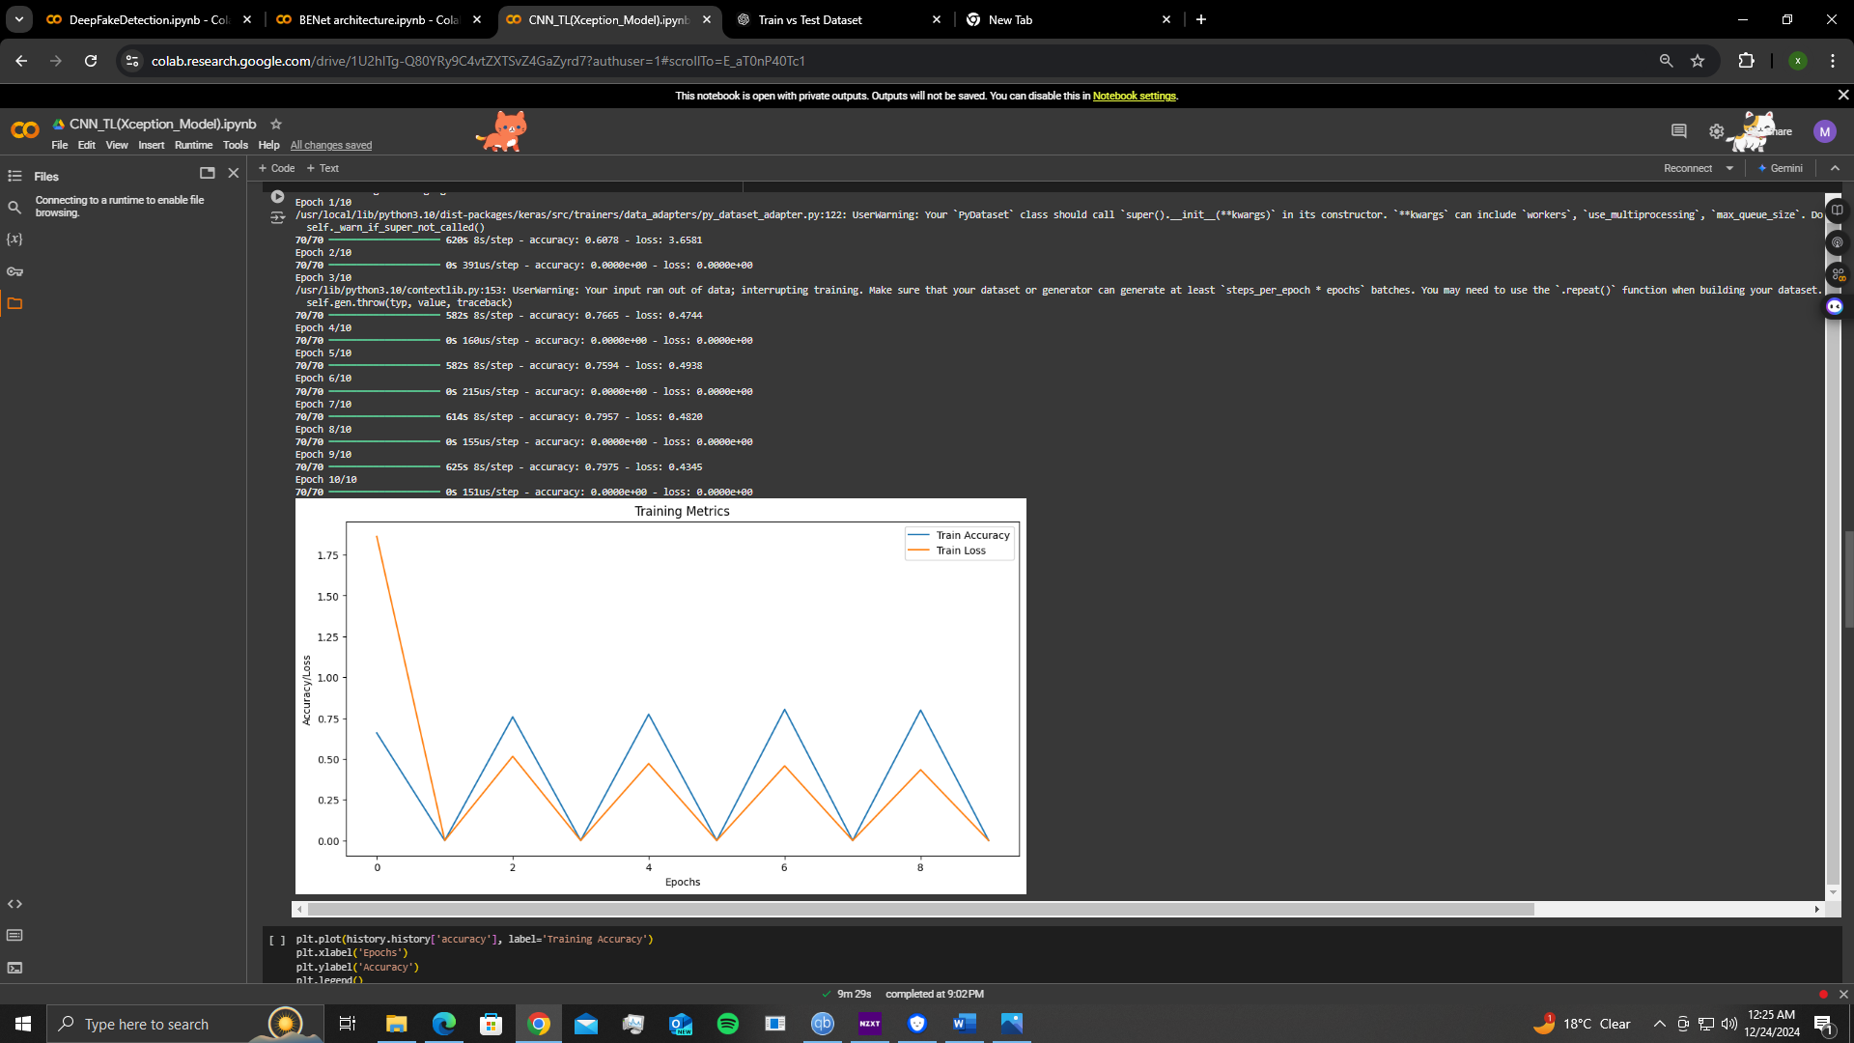

**Confusion Metrix :**

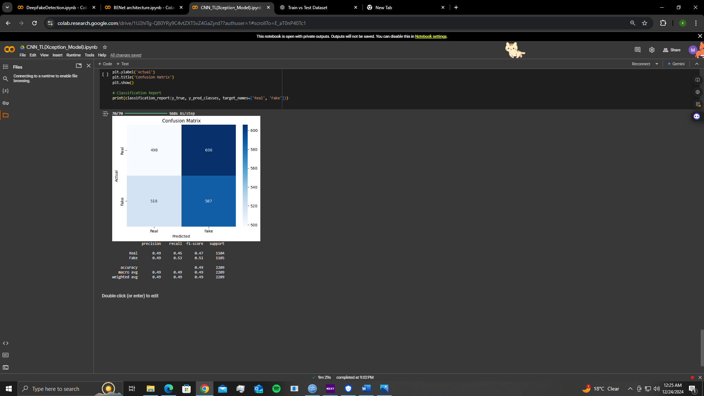

**Unseen test data :**

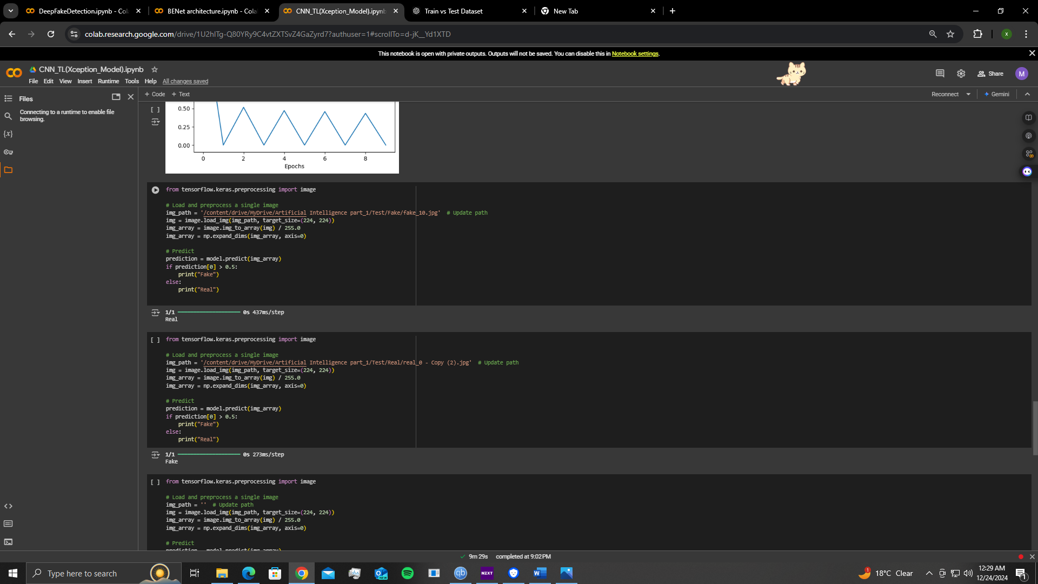

**GAN’s Model :**