

**Project Report**

**Design a full-fledged network for an organization with multiple subnets.**

Course Title: Computer Networks

Course Code: CSE405

Section: 02

Submitted to:

**Dr. Anisur Rahman (MAR)**

Associate Professor  
Department of Computer Science & Engineering

Submitted by:

Sheikh Rayana Jafa

ID 2021-3-60-146

**TITLE**

Designing a Full-fledged Network for an Organization with Multiple Subnets.

**INTRODUCTION**

Apex University, is an enterprise like East West University, owns many computers, with a complex network infrastructure. Apart from wired internet access to all the classrooms, labs, employee PCs, library and other administrative and academic wings, the university also provides wireless internet access for every campus. On top of that the university runs a complex networked systems to support several of its business process like admissions, advising, results, eTender, library, management, accounts and so on. The task is to create a complete model of a complex network by discovering the interconnectivity of the systems and subnetworks, which will reflect the University’s structure and facilities, features within the network.

**USING TOOLS**

❖ Cisco Packet Tracer

❖ PT-Router

❖ 2960 switch

❖ PC

❖ Copper Straight-Through cable

❖ Serial DCE cable

❖ DNS Server

❖ DHCP Server

❖ WEB Server

❖ Access Point-PT

❖ Wireless Devices: Laptops, Smartphones, PCs, Tablet PC

**PURPOSE OF THE NETWORK**

➢ All devices connected to the server represent the web page of the University of Apex, acting as a WEB, DHCP, and DNS server.

➢ Identified web server by installing DNS server to connect University of Apex website.

➢ Provides all necessary IP addresses to all networks with a DHCP server.

➢ Wireless Internet connection is visible.

➢ The university's entire network consists of five routers serving five campuses.

➢ Finally network connection is established between all hosts.

**PHYSICAL DIAGRAM**

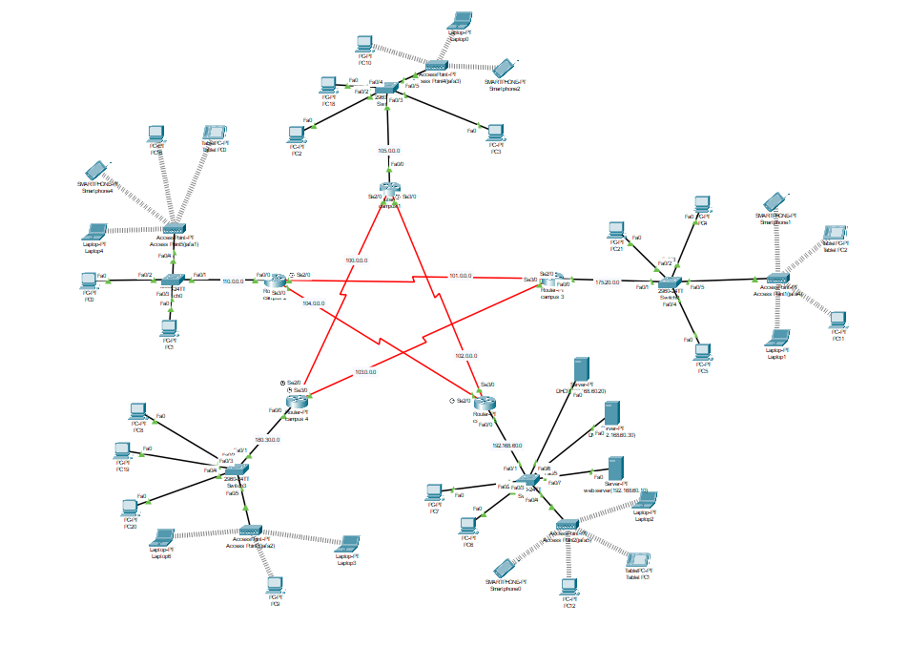

Figure 1: Network Model created in Cisco Packet Trace

**Number of Network: 10**

**DESIGN ISSUES**

Actually, there is no Design issues all the connection, servers, End devices are working perfectly. There is a problem of CiscoPacket tracer that we have to send a ICMP packet for 2/3 time or its failed but after that its works perfectly.

**LIMITATIONS**

The network is very complex. Maintaining this network can create problems. More campus networks cannot be added very easily. To add more networks, manual configuration is needed. The network can support a limited number of hosts.

**ROUTER CONFIGURATION**

**Campus 1**

enable

config t

interface fa0/0

ip address 105.255.255.254 255.0.0.0

no shut

do wr

exit

interface se2/0

ip address 100.0.0.2 255.0.0.0

clock rate 64000

no shut

do wr

exit

interface se3/0

ip address 102.0.0.1 255.0.0.0

clock rate 64000

no shut

do wr

exit

**Campus 2**

enable

config t

interface fa0/0

ip address 110.255.255.254 255.0.0.0

no shut

do wr

exit

interface se2/0

ip address 101.0.0.1 255.0.0.0

clock rate 64000

no shut

do wr

exit

interface se3/0

ip address 104.0.0.2 255.0.0.0

clock rate 64000

no shut

do wr

exit

**Campus 3**

enable

config t

interface fa0/0

ip address 175.20.255.254 255.255.0.0

no shut

do wr

exit

interface se2/0

ip address 101.0.0.2 255.0.0.0

clock rate 64000

no shut

do wr

exit

interface se3/0

ip address 103.0.0.2 255.0.0.0

clock rate 64000

no shut

do wr

exit

**Campus 4**

enable

config t

interface fa0/0

ip address 180.30.255.254 255.255.0.0

no shut

do wr

exit

interface se2/0

ip address 100.0.0.1 255.0.0.0

clock rate 64000

no shut

do wr

exit

interface se3/0

ip address 103.0.0.1 255.0.0.0

clock rate 64000

no shut

do wr

exit

**Campus 5**

enable

config t

interface fa0/0

ip address 192.168.60.254 255.255.255.0

no shut

do wr

exit

interface se2/0

ip address 104.0.0.1 255.0.0.0

clock rate 64000

no shut

do wr

exit

interface se3/0

ip address 102.0.0.2 255.0.0.0

clock rate 64000

no shut

do wr

exit

**ROUTING TABLE**

Campus 1:

router ospf 1

network 105.0.0.0 0.255.255.255 area 0

network 100.0.0.0 0.255.255.255 area 0

network 101.0.0.0 0.255.255.255 area 0

exit

Campus 2:

router ospf 1

network 110.0.0.0 0.255.255.255 area 0

network 101.0.0.0 0.255.255.255 area 0

network 104.0.0.0 0.255.255.255 area 0

exit

Campus 3

router ospf 1

network 175.20.0.0 0.0.255.255 area 0

network 101.0.0.0 0.255.255.255 area 0

network 103.0.0.0 0.255.255.255 area 0

exit

Campus 4:

router ospf 1

network 180.30.0.0 0.0.255.255 area 0

network 100.0.0.0 0.255.255.255 area 0

network 103.0.0.0 0.255.255.255 area 0

exit

Campus 5:

router ospf 1

network 192.168.60.0 0.0.0.255 area 0

network 102.0.0.0 0.255.255.255 area 0

network 104.0.0.0 0.255.255.255 area 0

exit

**SERVER CONFIGURATION**

**DHCP Server: [IP:192.168.60.20]**

DHCP can serve IP across network automatically. Only one DHCP server has been used for 5 campuses. When a device requested, DHCP server can serve unique IP address according to their Campus network. That’s why there is total 5 pool names in DHCP server configuration.

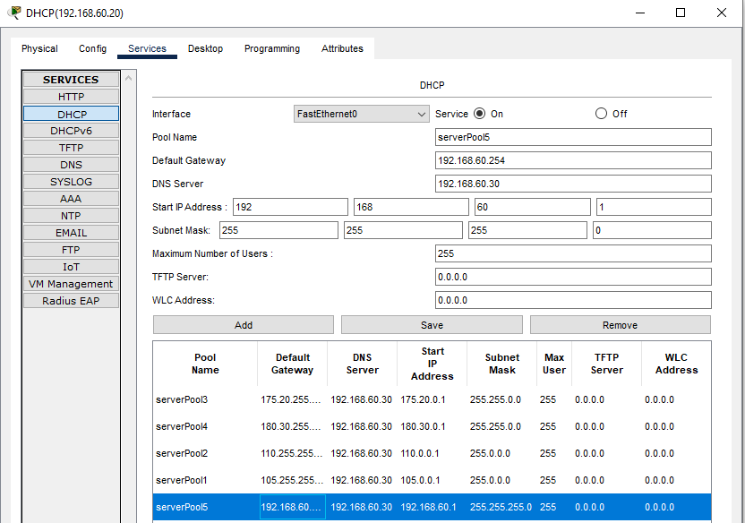

Figure: Creating Serverpool

**DNS Server: [IP:192.168.60.30]**

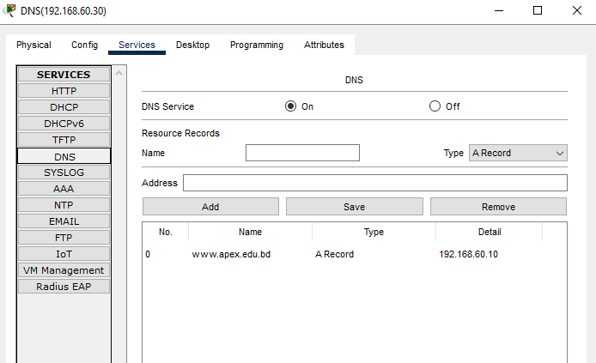

**Figure: DNS**

**Web Server: [192.168.60.10]**

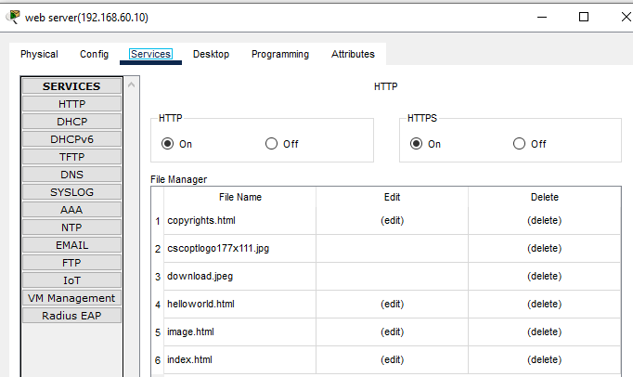

**Figure: web server**

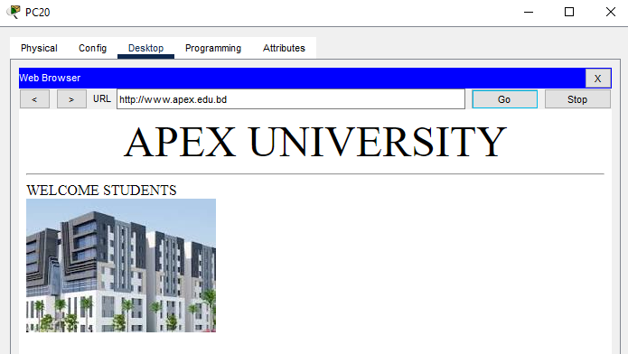

**Figure: Searching result of www.apex.edu.bd**

**CONCLUSION**

Despite encountering challenges, I successfully implemented the project plan as outlined in the project description and made every effort to complete it with precision. In this project, a comprehensive model of a complex network was designed. The network consisted of end devices, routers, switches, and wireless routers, all integrated to form a functional and cohesive system. Seamless communication between all devices across the entire network was achieved. A DHCP server was incorporated to dynamically assign IP addresses to all five campuses as needed, and a DNS server was deployed to manage website domain resolution. Through careful planning and execution, the project's objectives were successfully met, ensuring efficient and reliable network performance.