

**Mini Project 3**

**Semester:** Spring 25

**Course code:** CSE487

**Course Title:** Cyber Security, Law and Ethics

**Section:** 03

**Group: 02**

**Project Title:** Using AI in Autonomous Military Drones

**Submitted By**

|  |  |
| --- | --- |
| **Student Name** | **Student ID** |
| Md Sifat Ullah Sheikh | 2022-1-60-029 |
| Urmi Kirtonia | 2022-1-60-184 |
| Tanjila Akter | 2022-1-60-078 |
| Ronjon Kar | 2022-1-60-091 |

**Submitted To**

Dr. Md. Hasanul Ferdaus

Assistant Professor

Department of Computer Science & Engineering

**Submission Date: 24 May 2025**

**Introduction**

In today's world, AI has changed our lives a lot, and the role of AI in almost all sectors is undeniable. Like all sectors, AI has a lot of contribution in the battlefield. AI is working in the rise of Military drones. A flying machine will automatically search for and attack targets without human help. Most people think that it helps keep soldiers out of harm's way in military operations. However, several ethical questions are also being raised. What if the machine accidentally attacks an innocent person? The most important thing is, is it right to give a machine the responsibility of who lives and who dies in war? These are not just technical questions, they touch on deep ethical issues about human life, fairness, and responsibility. In such high-risk situations, even a small error in an AI system can have irreversible consequences. Moreover, decisions made by AI lack empathy, moral judgment, and human accountability. As these technologies evolve, it becomes essential to balance innovation with ethical responsibility to ensure that AI serves humanity rather than harms it.

**Stakeholder Analysis in Military AI and Defense Technologies**

A stakeholder is **[5]** any person, group, or organization that is affected by or has an interest in a project, decision, or system. In the context of military and defense technologies, different stakeholders have different concerns, goals, and impacts.

**Military and Defense Agencies**

Military and defense agencies have an interest in increasing military power so that they can ensure the safety of their soldiers. They aim to reduce the cost of increasing military power. This organization can benefit from using advanced and fast troubleshooting technology. However, if there is a mistake in the technology or if someone is harmed, they can face serious reputation problems.

**AI Developers and Technology Companies**

AI developer companies can earn huge profits from government contracts by developing new technologies. If their technology doesn't work properly and crashes at critical times, they can face ethical criticism and legal problems.

**Civilians (In a conflict zone)**

Civilians want to be safe, and they want their basic human rights protected from such attacks. They are a very vulnerable group. If they are mistakenly targeted, they have no legal way to seek justice.

**Government and Lawmakers**

These organizations work to maintain world peace and ensure that every country respect human rights. They sometimes enforce strict laws and push for the banning of certain military technologies to protect civilians.

**Media and Journalists**

They report on military operations and investigate the ethical implications of military AI to inform the public, but the lack of transparency in AI-based military operations makes it difficult to uncover the truth or hold anyone accountable.

**Application of ethical frameworks**

**1**. **ACM Code of Ethics and Professional Conduct:**

* Core Principles Involved: Contribution to society **[1]** and human well-being, avoidance of harm, honesty, and concern for the public good.
* Application: Autonomous drones, capable of lethal force, must be developed and deployed with the utmost caution. Their use should always aim to maximize societal well-being and minimize harm. AI limitations, including risks of bias, error, or unintended consequences, must be honestly disclosed to policymakers and the public to ensure responsible decision-making.

**2.** **ACM/IEEE-CS Software Engineering Code of Ethics and Professional Practice**

* Core Principles Involved: Public interest **[2]** testing and validation, privacy, professional responsibility.
* Application: Autonomous drone software must be properly tested and debugged to avoid errors or mistakes in the target. They must take responsibility for any failures, errors or misuse. The confidentiality of the information collected will be protected and strict rules regarding data will have to be followed. Ensuring public safety will always take priority over advancing military or technological goals.
* **3. Web 2.0 Code of Conduct**
* Core Principles Involved: Prevention of societal harm **[3]**, transparency, privacy, and individual control.
* Application: The deployment of autonomous drones poses privacy violations and creates fear among the public. Developers must create transparent, reliable, and explainable AI systems that can make sound decisions. Most importantly, they must not compromise democratic values, individual rights, and public safety.

**The group’s justified ethical decision**

After fully examining the impact of diversity, we strongly believe that autonomous drones should not be used without skilled personnel. While these measures may improve the speed of response among soldiers, they may also create concerns about technical policy and human nature.  
Autonomous drone systems have no moral judgment, empathy or situational decision-making ability. Only humans can take decisions about whom to attack and whom not to attack. No object can accurately determine that. When AI mistakenly identifies non-fighters as fighters and harms them, political and humanitarian problems can arise. This goes against several important points of the IEEE Software Failure and ACM code of conduct. Harming non-combatants on the battlefield is very dangerous. Autonomous weapons can create misunderstandings of combatants on the battlefield, privacy violations, and a lack of transparency. Web 2.0 creates **[4]** technologies that facilitate human freedom and attract individuals to current autonomous technologies.

Therefore, we strongly support the following:

* Fully autonomous drones should be allowed to be used.
* International rules should be created to regulate the use of autonomous weapons.
* Legislation should be passed to address the rights of developers.
* Only humans, not machines, will have the power to decide their own lives and livelihoods. This must be ensured.

### **Criticism and Defense of the Decision**

Our decision to oppose the deployment of fully autonomous military drones without human intervention is likely to face several criticisms, especially from proponents of technological advancement and military efficiency.

**Criticism 1:** Combat Delay Is Caused by Human Decision-Making.  
Critics argue that human oversight in lethal decisions can slow response time, potentially missing critical threats.

**Defense:** Time is of the essence, but one misadjusted AI strike can cost innocent lives. Human moral wars need to intervene in irreversible decisions to achieve context and accountability.  
**Criticism 2:** AI Can Saves Soldiers’ Lives.  
Supporters say AI would reduce risk by taking humans out of harm’s way on risk-filled missions **Defense:** AI can come to the rescue, but full autonomy can end up leading to misjudgment and legal transgressions. Lethal force has to be kept in human control to protect moral responsibility and to keep civilians safe.  
**Criticism 3:**Moral Limitations May Boycott into Strategic Harm.  
Some have argued that the banning of AI weapons would leave a country sitting as defenseless ducks in the face of other states advancing their technology while unencumbered.  
**Defense:** Setting an example through ethical governance and through global treaties makes it less likely that we find ourselves in a situation where we would have reckless competition in arms. Values should shape our innovation, not fear of losing a foot race.  
**Criticism 4:** AI is less Biased than Humans.  
AI is thought to be free of emotional bias and fatigue and therefore a more consistent decision maker.  
**Defense:** AI continues to be biased by training data and can’t feel empathy or understand context. To hand life-or-death decisions to machines is to take away important human judgment and responsibility.

**An Overview of our proposed mini-project Framework**

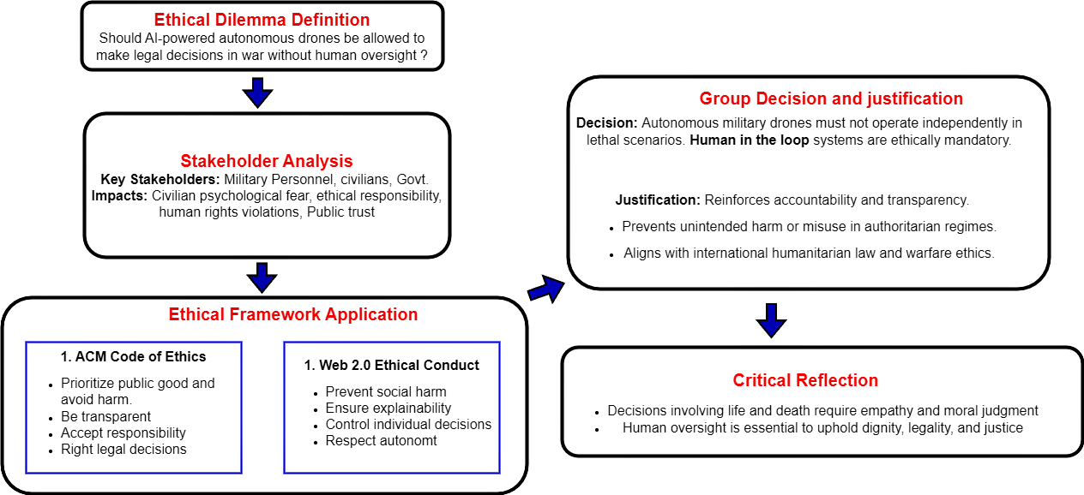**Reference: 1)** [https://www.acm. org/code-of-ethics](https://www.acm.org/code-of-ethics) **2)** <https://www.acm.org/code-of-ethics/software-engineering-code> **3)** <https://www.w3.org/TR/ethical-web-principles/> **4)** Konert, A., & Balcerzak, T. (2021). Military autonomous drones (UAVs)-from fantasy to reality. Legal and Ethical implications. Transportation research procedia, 59, 292-299. **5)** Internet Source (Google) **6)** DrawIO