Faster Calculation for CGH based on number of object points

Md Sifatul Islam,1 Author Two,2,* and Nam Kim*

1School of Information and Commu. Eng., Chungbuk National Univ., Cheongju, Chungbuk 361-763, Korea

\**namkim@chungbuk.ac.kr*

**Abstract:** For a three-dimensional display using computer-generated holograms (CGHs), fast CGH calculations are required and calculation time can be reduced by introducing wavefront recording planes (WRPs). However the conventional multiple wavefront recording planes (M-WRPs) based full-color computer-generated hologram (CGH) have color uniformity problem caused by intensity distribution and high computation time due to the big distance between object points in the depth range and the WRPs. This paper proposes methods which create WRPs based on the number of object’s point at each depth layer and reduce the calculation time and also having higher intensity reconstructed images. The proposed method is confirmed by numerical and optical reconstructions.

© 2018 Optical Society of America under the terms of the [OSA Open Access Publishing Agreement](https://doi.org/10.1364/OA_License_v1)

1. Introduction

In recent years, advancement of hardware and technologies are creating trend for 3D television, AR, VR and many more 3D display technologies. Among all holography is the most prominent technique for reconstruction of all three dimensional (3D) information of an object in space and holographic projection can also achieve true 3D scene without wearable devices. In this technique, an object’s light field is recorded as interference fringes in the form of a so-called hologram. The physical process of light propagation in holography can also be simulated on a computer, called computer generated holograms (CGHs). In 1967 Brown and Lohmann proposed the CGH [1] and it has no requirement for any recording material [2-3]. However, an object consists of huge amount of three dimensional information; thus CGH generation is computationally costly [4-5].

However full-color hologram generation is one of the main limitation and many research have been done so far [6-7]. There are various approaches for faster full-color hologram generation [8-10]. To accelerate the generation of hologram many methods have been introduced so far. To reduce computational cost of holographic calculation Zhao et al. introduced a fast calculation method for point cloud gridding (PCG) method [11-12] where sub holograms are generated for each individual depths of the object and finally accumulated the sub holograms to form a complete hologram.

Shimobaba et al. introduced wavefront recording plane (WRP) where a virtual plane, WRP, is placed close to the object point and parallel to the hologram plane [13-14]. Instead of direct calculation of the optical field from a 3D object to the hologram plane, the optical field only calculate the active area of the WRP and then propagate to the hologram plane by the Fast Fourier Transform (FFT). However, for long depth objects, due to large distance between the object points and WRP the active area size would also be large; thus computation time would still be high. Arai et al. proposed acceleration of CGH generation using tilted WRP which uses “Least Square Tilted WRP method” and “RANSAC Multi-Tilted WRP method.” to maintain the minimum distance between the WRP and curved sides of the object [15]. This proposed method reduces the calculation time but only for short depth objects. Anh-Hoang et al proposed double WRP to reduce the calculation further [16] where they introduced two WRPs at two different distances from object. The usage of GPU and lesser distance between object and the WRPs lowered the calculation time but still was not enough. Later, Hasegawa et al proposed a multiple WRP (M-WRPs) method to optimize the number of WRPs and their arrangements automatically [17]. Due to shorter depth range calculation time was faster but reconstructed image quality was same as that in the conventional M-WRPs method. Recently, Piao et al proposed a method for image quality enhancement for M-WRPs [18]. In this method WRP is set at each layer using fixed active area size. However, fixed activation area might over-estimate or under-estimate the color uniformity.

Look-up table method [19-21] are used to store pre-computed calculation and use them later for faster generation of hologram. Dong et al proposed MPEG method where frames of pictures are grouped before generating the where input 3-D video frames are grouped into a group of pictures and then are divided into 2-D arrays of image blocks. Then CGH is generated for each block by using the TR-NLUT [22-23] method and adding them altogether. In this paper, fast and efficient methods for full-color CGH is proposed for point-cloud of objects with non-uniform distribution of object points, without usage of any look-up table . The proposed methods create WRP based on the number of object points in each depth layer. Due to prioritizing depth layers with higher number of object points and shortest distance between WRPs and those depth layers faster calculation with higher reconstructed image can be achieved.

1. Conventional M-WRPs method

In conventional M-WRPs object is divided into several depth ranges and WRP is set in the middle of each depth range, as shown in Fig. 2.

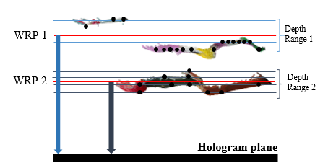

Fig. 2 Schematic diagram of conventional M-WRPs method

The light field of each pixel of the WRP is calculated by summing the contribution of each object point according to equation (1),

 (1)

Where is the distance between *jth* point and the WRP, shown by equation (2), is the number of object points, is the wavelength of the light, is the intensity of the *jth* object point, and is the coordinate of the *jth* point on the WRP object.

 (2)

The smaller the depth range is the shorter is. This would reduce the calculation time for  and would also record higher intensity of light from the object points to the WRP. Thus each depth range is divided farther into smaller depth ranges until minimum calculation time or maximum PSNR is found, as shown in Fig 3.

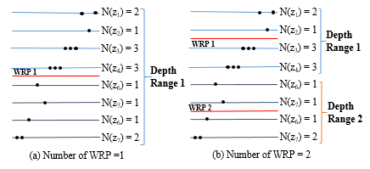

Fig. 3 Relation of WRP and depth range in conventional M-WRPs method

Next, light propagate from the WRPs to the CGH via a diffraction calculation, as shown in equation (3). The amplitude and phase information of the object points are recorded in the WRP.As a result, the diffraction calculation from the WRP to the CGH is the same as that from the object points directly to the CGH.

 (3)

 (4)

 and  are the Fourier and inverse Fourier operators, *k* is the wave number, *z* is the distance between the WRP and the hologram plane, and  is the impulse response of *P-th* WRP, shown by equation (4). As WRP is set in the middle of the depth range, even for long depth object active area and it greatly reduce the calculation time. However, both backward and forward propagation of light intensity for each WRP causes non-uniformity of diffraction pattern.

1. **Proposed Method**

In subsequent paragraphs the proposed methods are described. In both the proposed methods point cloud object is considered as sub-layers based on each depth plane and WRP is set based on the number of object points in each depth plane.

* 1. *Distributed M-WRPs method*

In this section methodology of DistributedM-WRPs (DM-WRPs) method is explained. Below all steps of DM-WRPs are presented:

Step 1: Number of object point in each depth layer is computed

Step 2: Second order of difference among all values in Step 1 is calculated.

Step 3: Object is divided into depth ranges based on the change in second order of difference obtained from Step 2.

Step 4: Within each depth range WRP is set closest to the depth layer with maximum number of object point, as shown in Fig. 4

Step 5: Until minimum calculation time or maximum PSNR is achieved depth ranges with maximum number of depth layers are further divided into smaller depth ranges and next whole process is repeated from Step 1 on onwards.

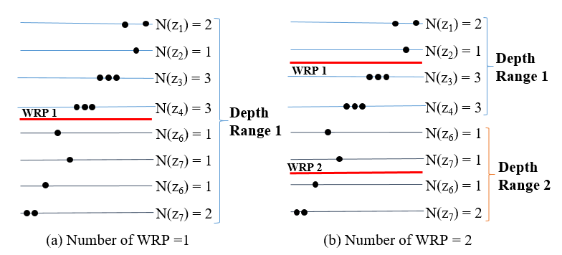

Fig. 4 Relation of WRP and depth range in DM-WRPs method

The height of the object can be expressed as:

 (5)

*D* is the average number of depth layers in a depth range. Since distance between each depth layer is equal. Hence *D* can be considered as the total distance of a single depth range. *C* is the total number of depth ranges in the object. In worst case, when maximum number of object point is in the depth layer positioned at the farthest end of a depth range, *Dk*. For all object points within the *Dk*total propagation distance to the respective WRPs can be expressed as:

 (7)

So average distance between each depth layer, *d,* can be expressed as:

 (8)

* 1. *Reduced M-WRPs method*

In this section methodology of Reduced multiple WRPs (RM-WRPs) method is explained in details. Firstly, WRP is set closer to one end of the object. Onwards each depth layer is iterated and number of object points in each layer is counted. A new WRP is set, if and only if, the next layer has more number of object points than the previous layer,**, otherwise wavefront of all object points from the current depth layer is propagated to the last WRP, as shown in Fig. 5. Where  is the number of object point in the *ith* depth layer. Change in number of object points in next depth layer are caused by change in shape of the object. Typically, change in object points in any new depth layers due to starting of a new object or curves and edges of the object.

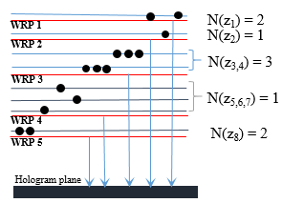

Fig. 5. Hologram generation using conventional RM-WRPs

If WRP position is too far from the starting of the new object the color intensity of the object would be less and thus finally would produce a low quality reconstruction image. Since WRPs are created for each changes in number of object points, each WRP is created for smaller depth range, sometime for each individual depth layer too. Total height of the object can be expressed as:

 (9)

Where *C* is the average number of depth range with equal number of object points in each layer, *D* is the number of depth layers with equal number of object points, and  is total number of layers that have unequal number of object points with neighboring depth layers. In best case number of object point would be different at each and every depth layer. Thus *d* would be approximately 0but for worst case number object point can be same for all depth layers. However data acquisition from depth cameras or any kind of real life data acquisition number of number of object points in a depth layer and its neighboring layers are hardly same. Thus *d* can be expressed as:

 (10)

16 images from light field dataset [12] was analyzed and maximum 30 out of 487 depth layers were having equal number of object points. Considering other datasets ****and *d* can be shown as:

 (11)

1. **Experimental Results and Discussion**

To verify the proposed methods, we have calculated CGH from RGB-D image using the conventional M-WRPs method, proposed DM-WRPs method and RM-WRPs method. The numerical simulation is conducted using Windows 10 64-bit operating system, MATLAB 2018b, and Intel(R) Core(TM) i5-7500 CPU @3.40GHz. The wavelength of Red, Green, and Blue is 633nm, 532nm, and 473nm, respectively and the sampling rate is 7.4µm.

*4.1 DM-WRPs method*

Firstly 512 X 512 image of Fig.6 were used to make 1024 X 1024 point cloud calculate the CGH. Object depth of 1.24cm and distance of object to the CGH was set at 24cm.

To further verify, point cloud created from real object using Kinect were used. The reconstructed images of light field images [22] and Kinect Image, Three_objects, are shown in Fig. 7 and Fig. 8.

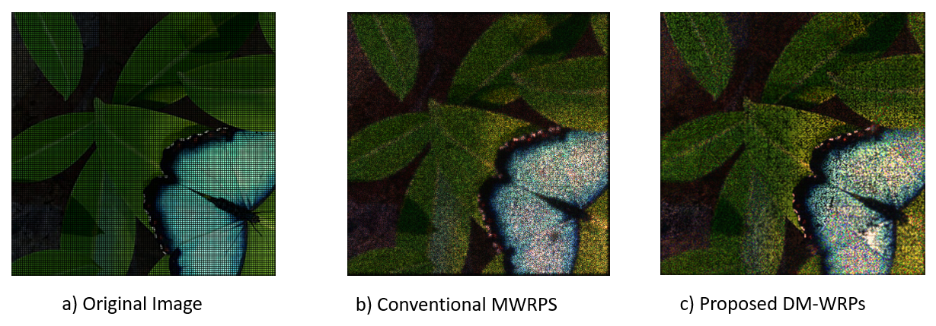

Fig. 7. a) Original Image and Reconstructed image of Papillion using b) conventional M-WRPs method c) DM-WRPs method

For both conventional M-WRPs and DM-WRPs depth ranges were created; the number of WRPs and their position determine the calculation time. Thus, Table 1, shows the calculation time difference between conventional M-WRPs and DM-WRPs for different number of WRPs. In DM-WRPs depth ranges were created dynamically based on the second-order of difference. Hence every object has minimum threshold number of WRP. Here minimum WRP for *Papillon* and *Three*_objects are 6, 4 respectively. However in conventional M-WRPs object can’t be segmented into fractional number of depth ranges.

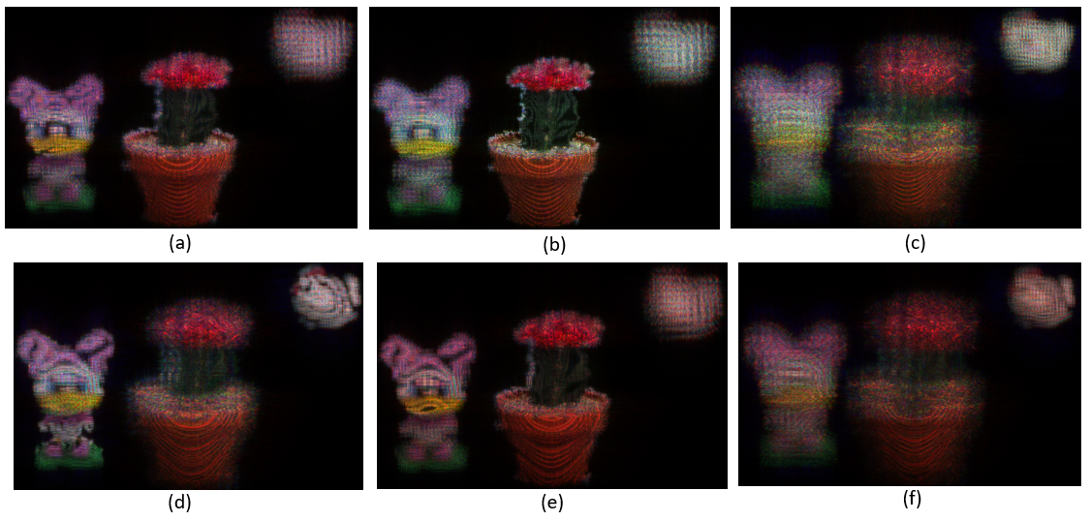

Fig. 8. Reconstruction image using Three_Objects using conventional MWRPs method and DM-WRPs method respectively, focused on a), d) Micky b), e) Cactus c), f) chicken

|  |  |  |  |
| --- | --- | --- | --- |
| Papillion | No. of WRPs | Calculation Time | |
| Conventional  M-WRPs | Proposed  DM-WRPs |
| 4 WRPs | 1574.3 | - |
| 6 WRPs | - | 640.4 |
| 8 WRPs | 1600.1 | 644.8 |
| 10 WRPs | **1551.5** | **636.3** |
| 16 WRPs | 1624.0 | 641.9 |
| 32 WRPs | 1668.2 | 659.7 |
| Three_Objects | 2 WRPs | **368.5** | - |
| 4 WRPs | 465.2 | 159.3 |
| 5 WRPs | 372.0 | **156.9** |
| 8 WRPs | 469.1 | 161.4 |
| 16 WRPs | 483.0 | 170.2 |
| 32 WRPs | 483.0 | 179.3 |

Table 1. Calculation time difference for each number of WRP using conventional M-WRPs method and DM-WRPs method

For each WRP number of calculation time using DM-WRPs method is lower than conventional WRP method. Numerical results shows that DM-WRPs method is two times faster than conventional M-WRPs method. Although DM-WRPs method makes calculation faster color uniformity problem still remains which could be resolved by RM-WRPs method in section 4.2.

*4.2 RM-WRPs method*

*Papilon* and *Three_objects* have 232 and 128 unique depth layers respectively. Since WRP is created for almost each depth layer depth perception of the reconstruction images are much higher, reconstructed images are shown in Fig. 9.

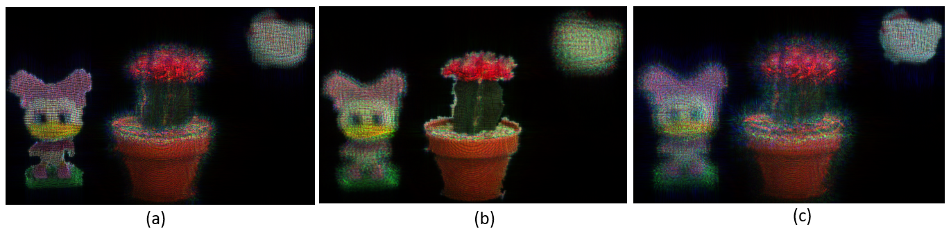

Fig. 9. a) Original Image of Three_,Reconstructed image of a) Three_objects b) Papillion using RM-WRPs method

Computation time and PSNR comparison between conventional M-WRPs method and RM-WRPs method are shown in Table 2.

|  |  |  |  |  |  |  |
| --- | --- | --- | --- | --- | --- | --- |
|  | Conventional  M-WRPS | | | Proposed  RM-WRPS | | |
| WRP | PSNR | Time | WRP | PSNR | Time |
| Papilon | 10 | 17.7485 | 1551.5 | 216 | 18.0941 | 694.6 |
| Three_object | 2 | 16.8760 | 368.5 | 122 | 17.1039 | 180.2 |

Table 2. Calculation time and PSNR comparison between conventional M-WRPs method and RM-WRPs method

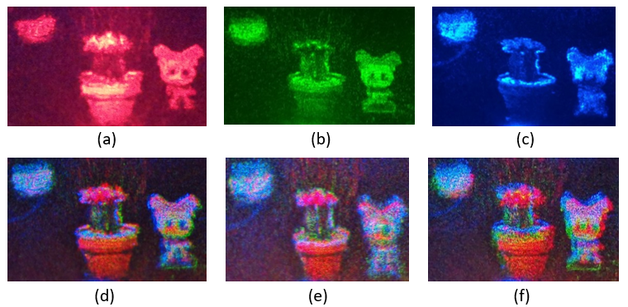

Fig. 10. Monochromatic Images: a) Red b) Green c) Blue and full color image of Three_Objects: focused on d) Toy e) Cactus f) chicken

1. **Conclusion**

In this paper, DM-WRPs and RM-WRPs method is proposed to enhance computation time and quality of reconstructed images in full-color CGH. The proposed DM-WRPs methods sets WRPs based on second order of difference among the number of object points in depth layers and in RM-WRPs method WRP is created whenever number of object point is different compared to the previous depth layer. In both the proposed method depth layer with maximum number of object point is focused and thus depth changes are perfectly recorded. In comparison of conventional M-WRPs method calculation time of CGH generation was greatly reduced by both DM-WRPs and RM-WRPs method. Although quality of reconstructed images was slightly increased but CGH generation is two times faster in both the methods and both the proposed methods also have higher depth perception.

1. Funding, acknowledgments

5.1 Funding

sdfdsfsdfsdf

5.2 Acknowledgments

Acknowledgments should be included at the end of the document. The section title should not follow the numbering scheme of the body of the paper. Please do not include any funding sources in the Acknowledgment section.

References

1. A. W. Lohmann and D. P. Paris, “Binary Fraunhofer holograms, generated by computer,” Appl. Opt. 6, 1739–1748 (1967).
2. D. Mengü, E. Ulusoy, and H. Ürey, "Holographic Image Projection with Phase Only Spatial Light Modulators via Non-Iterative CGH Computation Method," in Digital Holography & 3-D Imaging Meeting, OSA Technical Digest (Optical Society of America, 2015), paper DT2A.5.
3. Su-Juan Liu, Dan Xiao, Xiao-Wei Li, and Qiong-Hua Wang, "Computer-generated hologram generation method to increase the field of view of the reconstructed image," Appl. Opt. 57, A86-A90 (2018)
4. Ping Su, Wenbo Cao, Jianshe Ma, Bingchao Cheng, Xianting Liang, Liangcai Cao, and Guofan Jin, "Fast Computer-Generated Hologram Generation Method for Three-Dimensional Point Cloud Model," J. Display Technol. 12, 1688-1694 (2016)
5. Takashi Nishitsuji, Tomoyoshi Shimobaba, Takashi Kakue, and Tomoyoshi Ito, "Fast calculation of computer-generated hologram using run-length encoding based recurrence relation," Opt. Express 23, 9852-9857 (2015)
6. Kyoji Matsushima and Noriaki Sonobe, "Full-color digitized holography for large-scale holographic 3D imaging of physical and nonphysical objects," Appl. Opt. 57, A150-A156 (2018)
7. Yasuhiro Tsuchiyama and Kyoji Matsushima, "Full-color large-scaled computer-generated holograms using RGB color filters," Opt. Express 25, 2016-2030 (2017)
8. M. Lucente, “Interactive computation of holograms using a look-uptable,” J. Electron. Imaging 2, 28–34 (1993).
9. H. Kim, J. Hahn, and B. Lee, “Mathematical modeling of trianglemesh-modeled three-dimensional surface objects for digital holography,” Appl. Opt. 47, D117–D127 (2008).
10. H. Zhang, L. Cao, and G. Jin, “Computer-generated hologram with occlusion effect using layer-based processing,” Appl. Opt. 56, F138–F143 (2017).
11. Y. Zhao, C. X. Shi, K. C. Kwon, Y. L. Piao, M. L. Piao, and N. Kim, “Fast calculation method of computer-generated hologram using a depth camera with point cloud gridding,” Opt. Commun. 411, 166–169 (2018).
12. Yu Zhao, Ki-Chul Kwon, Munkh-Uchral Erdenebat, Md-Sifatul Islam, Seok-Hee Jeon, and Nam Kim, "Quality enhancement and GPU acceleration for a full-color holographic system using a relocated point cloud gridding method," Appl. Opt.57, 4253-4262 (2018)
13. T. Shimobaba, N. Masuda, and T. Ito, “Simple and fast calculation algorithm for computer-generated hologram with wavefront recording plane,” Opt. Lett. 34, 3133–3135 (2009).
14. N. Okada, T. Shimobaba, Y. Ichihashi, R. Oi, K. Yamamoto, T. Kakue, and T. Ito, “Fast calculation of computer-generated hologram for RGB and depth images using wavefront recording plane method,” Photo. Lett. Poland 6, 90-92 (2014)
15. D. Arai, T. Shimobaba, K. Murano, Y. Endo, R. Hirayama, D. Hiyama, T. Kakue, and Tomoyoshi Ito, "Acceleration of computer-generated holograms using tilted wavefront recording plane method," Opt. Express 23, 1740-1747 (2015)
16. A. H. Phan, M. L. Piao, S. K. Gil, N. Kim, “Generation speed and reconstructed image quality enhancement of a long-depth object using double wavefront recording planes and a GPU,” Appl. Opt 53, 4817-4824 (2014).
17. Naotaka Hasegawa, Tomoyoshi Shimobaba, Takashi Kakue, and Tomoyoshi Ito, "Acceleration of hologram generation by optimizing the arrangement of wavefront recording planes," Appl. Opt.56, A97-A103 (2017)
18. Yan-Ling Piao, Yu Zhao, Hui-Ying Wu, Anar Khuderchuluun, Erkhembaatar Dashdavaa, Jong-Rea Jeong, Nam Kim, "Image quality enhancement for digital holographic display using multiple wavefront recording planes method," Proc. SPIE 10944, Practical Holography XXXIII: Displays, Materials, and Applications, 1094416 (1 March 2019);
19. Lucente, M., “interactive computation of holograms using a look-up table,” Journal of Electronic Imaging 2(1) (091995).
20. Yoshikawa, H., Yamaguchi, T., and Kitayama, R., “Real-time generation of full color image hologram with compact distance look-up table,” in [Advances in Imaging], Advances in Imaging, DWC4, Optical Society of America (2009).
21. Zi Wang, Guoqiang Lv, Qibin Feng, Anting Wang, and Hai Ming, "Highly efficient calculation method for computer-generated holographic stereogram using a lookup table," Appl. Opt. 58, A41-A47 (2019)
22. Xiao-Bin Dong, Seung-Cheol Kim, and Eun-Soo Kim, "MPEG-based novel look-up table for rapid generation of video holograms of fast-moving three-dimensional objects," Opt. Express 22, 8047-8067 (2014)
23. S.-C. Kim, J.-H. Yoon, and E.-S. Kim, “Fast generation of three-dimensional video holograms by combined use of data compression and lookup table techniques,” Appl. Opt. **47**, 5986–5995 (2009).
24. Honauer K., Johannsen O., Kondermann D., Goldluecke B. (2017) A Dataset and Evaluation Methodology for Depth Estimation on 4D Light Fields. In: Lai SH., Lepetit V., Nishino K., Sato Y. (eds) Computer Vision – ACCV 2016. ACCV 2016. Lecture Notes in Computer Science, vol 10113. Springer, Cham