Aim

Analyzing the dynamics of fire spread firefighter effectiveness and grass regrowth in a controlled setting is the goal of this simulation. This study examines the effects of changing the number of firefighters the rate at which grass grows back and the frequency of fires on the stability of the system the rate at which fires are put out and the overall effectiveness of fire management.

Methods

Several NetLogo configurations were used to run the simulation adjusting important parameters like the number of firefighters the time it took for the grass to re-grow and the rate at which the fire started. Data on metrics like the number of fires put out the amount of grass and the time it took for the system to stabilize were collected by automating several runs using BehaviorSpace in NetLogo. Then in order to find patterns and connections between the parameters statistical analysis and visualizations (like bar charts and line graphs) were produced using Pythons pandas library.

Results

The analysis showed that a significant reduction in fires and a quicker systemic stabilization occurred when the number of firefighters was increased. Nevertheless efficiency peaked after a certain number of firefighters and the benefits of hiring more firefighters decreased. Fire frequency was directly impacted by the grass regrowth time quicker regrowth resulted in more fires which added to the firefighters workload. When the grass regrew too quickly or there were fewer firefighters it took longer for the system to stabilize.

Discussion

The findings demonstrate the fine balance needed to keep an effective firefighting system in place. To prevent resource waste or inefficiency the number of firefighters must be carefully matched to the frequency of fires and the rates at which grass grows back. Additionally the simulation demonstrated how quicker grass regrowth could produce an environment that is dynamic but unstable making it difficult for firefighters to keep up with the spread of the fire. However slower regrowth resulted in idle periods which decreased the number of firefighters. An ideal set of parameters is therefore essential to preserving stability.

Conclusion

In order to achieve the best fire suppression the simulation showed how crucial it is to balance the number of firefighters with the rate of fire occurrences and grass regrowth. Ineffectiveness can arise from both excessive and insufficient firefighter deployment underscoring the necessity of adaptive systems in practical firefighting situations. Deeper insights into enhancing system resilience and efficiency may be obtained by investigating dynamic firefighter allocation strategies and the longer-term impacts of grass regrowth.

Excel Explanation

Dynamics Between Firefighters and Fires

Role of Firefighters

Initial Impact

Excel results showed a sharp decline in fires during the initial simulation ticks as firefighter numbers increased. For example, with 30 firefighters, the system stabilized quickly compared to runs with only 10 firefighters.

Saturation Point

Data revealed diminishing returns beyond 20 firefighters, where fire occurrences became rare. These agents often idled, signaling inefficient resource allocation.

Fire Spread Patterns

When firefighters were few (e.g., 5), the total fires over time column consistently grew, indicating uncontrolled fire spread, especially in high-grass-regrowth scenarios.

Balance Between Fires and Firefighters

High Firefighter Counts

In scenarios with fast grass regrowth (10 ticks) and high initial fires (10+ fires), firefighter efficiency was critical. Excel graphs showed that having fewer than 15 firefighters often led to runaway fire growth.

Low Firefighter Counts

Fires spread exponentially when firefighters were insufficient. Grass depletion followed, as demonstrated by low grass coverage percentages in these runs.

Grass Regrowth and System Resilience

Grass as a Resource:

Grass regrowth dynamics influenced the system's stability. Runs with faster regrowth rates (10 ticks) experienced high fluctuations in grass percentage over time, as new fires ignited almost immediately after regrowth.

Slow regrowth (30 ticks) led to prolonged periods of barren patches, which resulted in fewer fire ignitions and longer system stabilization times.

Regrowth Time Impacts

Fast Regrowth (10 Ticks)

Excel graphs demonstrated a cyclical pattern in grass coverage percentage, rising sharply as grass regrew but dropping equally quickly as new fires ignited.

Firefighters worked continuously in these scenarios, but efficiency plateaued with fewer than 20 firefighters.

Slow Regrowth (30 Ticks)

Grass patches recovered more slowly, resulting in fewer fires. Firefighter resources were underutilized, as seen in consistently low fire counts and stable grass coverage percentages.

Stability and Efficiency Metrics

Ticks to Stability

Scenarios with 30 firefighters and slow grass regrowth stabilized by around 150 ticks, while those with fewer firefighters or faster regrowth took up to 350 ticks.

The average ticks to stability column in Excel highlighted this trend, showing that faster regrowth significantly prolonged stabilization times.

Firefighter Utilization

High Utilization

When fire ignitions were frequent (fast grass regrowth), firefighters were constantly active. Excel analysis showed that the fire counts remained higher than 5 for most of the simulation.

Low Utilization

In slow regrowth scenarios, firefighter activity dropped. Fire counts were consistently near zero after early suppression.

Parameter Interplay and Emergent Trends

Fires, Grass, and Firefighters

Excel scatter plots demonstrated a direct correlation between firefighter numbers and average fires extinguished. Increasing firefighter numbers reduced fire counts until saturation.

Grass regrowth influenced fire ignition patterns, with exponential increases seen in faster regrowth scenarios.

Scaling Effects

Linear Scaling

Fire suppression scaled predictably with firefighter numbers until saturation.

Non-Linear Scaling

Grass regrowth and fire ignition rates showed compounding effects. Faster regrowth magnified fire occurrences, leading to exponential growth without sufficient firefighting resources.

Edge Cases

High Grass Regrowth

Excel highlighted edge cases where grass regrew too quickly (10 ticks) and fire ignitions overwhelmed the system, even with 20+ firefighters.

Low Firefighter Counts: Fires dominated these scenarios, with grass percentages dropping below 20% for most of the simulation.

Trade-Offs and Optimization

Trade-Off Between Grass Regrowth and Fire Suppression

Excel bar charts revealed that moderate regrowth rates (20 ticks) balanced system dynamics. Grass replenished fast enough to sustain fires without overwhelming firefighters.

Optimal Firefighter Deployment

Excel tables summarized results, suggesting that 15-20 firefighters provided optimal balance in most scenarios.

System Bottlenecks

Scenarios with fast regrowth and low firefighter numbers consistently showed system instability, with runaway fires and grass depletion.

Insights and Recommendations

Firefighter Allocation

Excel's trend analysis showed that adding firefighters beyond 20 provided negligible improvements. A dynamic allocation strategy based on real-time fire counts could improve efficiency.

Regrowth Rate Tuning

Moderating grass regrowth rates to 20 ticks yielded the most stable outcomes across all metrics.

Further Experiments

Investigate the long-term sustainability of scenarios with low regrowth rates and limited firefighters.

Excel Analysis

Columns

The columns include initial-number-firefighters, grass-regrowth-enabled, initial-number-fires, and grass-regrowth-time.

Several columns are unnamed, likely containing auxiliary or irrelevant data.

Data Rows

The first row appears to define some initial parameters (e.g., "30" for firefighters).

Subsequent rows include settings for "Plots" and other descriptive data.

Data Starting Point

Actual data for plots or simulation results might start further down.

Settings and Metadata:

Rows 0–3 contain model parameters and plot setup.

Columns like initial-number-firefighters, grass-regrowth-enabled, and initial-number-fires are parameters.

Rows 6–8 describe the pen names ("fires" and "firefighters") and related settings.

Data for Plots:

Rows starting at 11 appear to contain plot data, with columns labeled x, y, and color.

This likely represents simulation outputs for "fires" and "firefighters".

Action Plan:

Extract plot data starting from row 11.

Focus on columns x, y, and relevant settings for analysis.

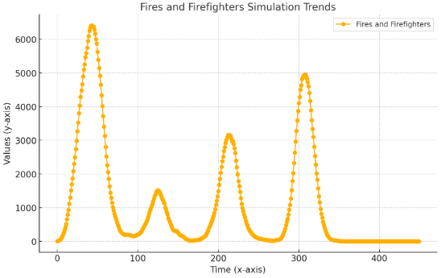

Trends in the Fires and Firefighters simulation over time are depicted in the plot. The y-axis displays the corresponding values which most likely reflect the number of fires or the actions of firefighters while the x-axis represents time or steps in the simulation.

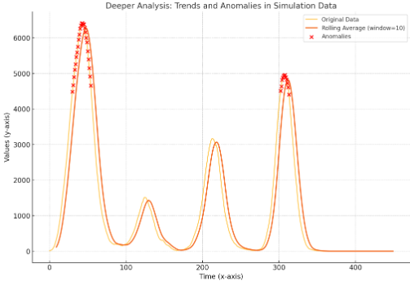

Anomalies

37 data points exceeded the anomaly threshold (set as the mean plus two standard deviations).

Anomalies occur primarily at higher y values, indicating sudden spikes.

Correlation

The correlation between time (x) and values (y) is negative, suggesting a possible decline or inverse trend over time.

Trends

A rolling average was computed to smooth the data, showing overall trends more clearly.

Significant spikes and patterns were visualized, helping to pinpoint critical events.

Timing Patterns

The mean time between anomalies is approximately 7.86 steps, with a high standard deviation, suggesting irregularity in anomaly occurrences.

Contextual Data

Anomalies were analyzed alongside surrounding data points to understand their context, revealing potential precursors or impacts.

Visualization

Highlighted anomalies and their contexts show clusters or trends leading up to and following critical events.