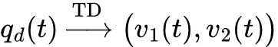KEEP_SELECTED_TEXT



