Spatio-Temporal dynamics of the intertidal seagrass meadow of Banc d’Arguin, Mauritania, in a context of high atmospheric complexity.
Simon Oiry^{1,2}
Pierre Gernez¹
Laurent Barillé¹
El-Hacen Mohamed El-Hacen^{3,4}
Jim de Fouw⁵
1. Institut des Substances et Organismes de la Mer, ISOMer, Nantes Université, UR 2160, F-44000 Nantes, France
2. Consiglio Nazionale delle Ricerche, Istituto di Scienze Marine (CNR-ISMAR), 34149 Trieste, Italy
3. BirdEyes, Centre for Global Ecological Change at the Faculties of Science & Engineering and Campus Fryslân, Wirdumerdijk, Leeuwarden, The Netherlands
4. Parc National du Banc d’Arguin, Tavregh Zeina, Nouakchott, Mauritania
5. Department of Coastal systems, NIOZ Royal Netherlands Institute for Sea Research, Texel, Netherlands
2026-10-12
Abstract
To be Written

1. Alternative Title propositions :
- Mapping intertidal seagrass dynamics under Saharan dust: atmospheric correction and Sentinel-2 time-series analysis in Banc d’Arguin
- Spatiotemporal dynamics of intertidal seagrass in Banc d’Arguin, Mauritania from Sentinel-2 imagery: overcoming atmospheric-correction challenges under Saharan dust

2. Introduction
Seagrasses are marine angiosperms that form highly productive meadows across shallow coastal waters (Orth et al., 2006). By creating three-dimensional habitat, attenuating waves, stabilising sediments and recycling nutrients, these foundation species support diverse assemblages of invertebrates, fishes, birds and marine megafauna (Waycott et al., 2009). Their ecological functions translate into services that include nursery habitat and fisheries support, shoreline protection, water-quality regulation and long-term organic-carbon storage (Barbier et al., 2011; Fourqurean et al., 2012; Nordlund et al., 2016; Unsworth et al., 2019). Yet seagrass meadows are exposed to multiple, often interacting pressures, including coastal development, eutrophication, altered sediment regimes, destructive fishing and anchoring, and climate-driven warming and extreme events (Orth et al., 2006; Waycott et al., 2009). A synthesis of 547 sites estimated a net loss of 19.1% of the surveyed meadow area since 1884, while also revealing strong regional heterogeneity and recent recovery at some locations (Dunic et al., 2021). This variability makes sustained, spatially explicit observation essential: global trends cannot substitute for local evidence, and recovery cannot be distinguished from continued degradation without repeatable measurements (Duffy et al., 2019). The Parc National du Banc d’Arguin (PNBA), Mauritania, is an exceptional case. Located at the interface between the Sahara and the eastern boundary upwelling system of the North Atlantic, this approximately 12,000-km² protected seascape contains one of the largest remaining seagrass systems in Africa (Pottier et al., 2021; Wolff et al., 1993). A recent park-wide habitat map estimated about 772 km² of seagrass, comprising approximately 353 km² of intertidal meadow dominated by Zostera noltei and 419 km² of predominantly subtidal meadow dominated by Cymodocea nodosa (Pottier et al., 2021). These meadows sustain the benthic food web, provide habitat and nursery grounds for fishes and invertebrates, and underpin a site used by more than two million migratory waterbirds along the East Atlantic Flyway (El-Hacen et al., 2020; van der Heide et al., 2012). Their extent does not imply ecological stability: between spatially comprehensive surveys conducted in 1986 and 2014, seagrass cover increased approximately twofold while macrozoobenthic community composition and estimated secondary production changed markedly (El-Hacen et al., 2020). The Banc d’Arguin meadow is therefore both a globally important conservation asset and a dynamic ecosystem whose trajectories require reliable observation (de Fouw et al., 2016; El-Hacen et al., 2020).
The environmental setting of Banc d’Arguin is governed by the juxtaposition of a hyper-arid desert margin, broad shallow tidal flats and the wind-driven Mauritanian upwelling system (Ould Dedah, 1993; Wolff et al., 1993). Freshwater input is negligible, precipitation is generally below 100 mm yr⁻¹, and persistent northerly winds help control waves, currents, sediment redistribution and exchanges between the bank and adjacent shelf (Ould Dedah, 1993; Wolff et al., 1993). Wind forcing is strongly seasonal: mean speeds reported for the intertidal system rise to about 9 m s⁻¹ in May–June and decline to about 6 m s⁻¹ in November–December (Ould Dedah, 1993). This annual cycle is embedded within the latitudinal migration of the Intertropical Convergence Zone, which reorganises both the origin and vertical pathway of mineral-dust transport over northwestern Africa (Knippertz and Todd, 2012). During winter, dust reaching coastal Mauritania is transported mainly in low-level north-easterly trade winds from Western Saharan and regional sources; during summer, transport increasingly occurs within the elevated Saharan Air Layer and draws on sources in Mauritania, Mali and farther east (Friese et al., 2017; Senghor et al., 2017). Superimposed on this seasonality are discrete dust outbreaks, including events that deliver anomalously coarse particles offshore (Friese et al., 2016). This aerosol regime creates a particular obstacle to optical monitoring of Banc d’Arguin, where low-tide habitat mapping depends on preserving the spectral consistency of exposed intertidal surfaces across acquisition dates (Song et al., 2001). Each usable acquisition captures a highly heterogeneous coastal mosaic comprising dense and sparse Zostera noltei, wet and dry sediment, tidal pools and adjacent bright desert surfaces (Pottier et al., 2021). Above this mosaic, mineral-dust abundance, particle-size distribution, source region and absorption properties vary seasonally and among individual outbreaks (Friese et al., 2016; Kaufman et al., 2002; Knippertz and Todd, 2012). These changes can alter the apparent brightness and spectral shape of otherwise unchanged intertidal targets, producing both spatial gradients within a scene and radiometric offsets among acquisition dates (Doxani et al., 2023; Song et al., 2001). The difficulty is compounded by the way Sen2Cor, the atmospheric correction algorithm routinely applied on Sentinel-2 images by the European Space Agency, estimates aerosol optical thickness (Main-Knorn et al., 2017). The processor preferentially retrieves aerosol information over reference targets with known spectral behaviour, particularly dense dark vegetation, and uses fallback information or default values where suitable reference areas are unavailable (European Space Agency, 2021; Main-Knorn et al., 2017). In the hyper-arid Banc d’Arguin landscape, dominated by bright desert surfaces and an intertidal zone that alternates among vegetation, moist sediment, bare sediment and shallow pools, the availability and representativeness of such reference targets cannot be assumed (Pottier et al., 2021; Wolff et al., 1993). An aerosol model adequate for one acquisition may consequently leave a different residual bias in another (Doxani et al., 2023). Thick, absorbing Saharan dust has already been shown to defeat conventional atmospheric correction off western Africa (Moulin et al., 2001), while comparative evaluations demonstrate that processor performance is strongly environment-dependent (Bui et al., 2022; Doxani et al., 2023; Warren et al., 2019). For this study, the central requirement is therefore not merely to retrieve plausible reflectance for a single date, but to preserve the field-measured spectral relationships among exposed intertidal targets across acquisitions made under contrasting dust conditions (Doxani et al., 2023; Song et al., 2001).
Mapping exposed intertidal Zostera noltei requires stable spectral relationships among seagrass canopies, wet and dry sediment, macroalgae and residual tidal pools. Discrimination is particularly challenging where seagrasses and co-occurring green macroalgae, which share major photosynthetic pigments, produce partly overlapping multispectral signatures (Davies et al., 2023). Nevertheless, spectral-library experiments have shown that machine-learning classifiers can distinguish soft-bottom intertidal vegetation at Sentinel-2 spectral resolution, with little improvement obtained by increasing spectral resolution beyond approximately ten bands (Davies et al., 2023). Building on this foundation, Davies et al. developed the Intertidal Classification of Europe: Categorising Reflectance of Emerged Areas of Marine vegetation with Sentinel-2 (ICE CREAMS v1.0), a multiclass neural network trained with extensive drone-derived labels to identify seagrass and other exposed intertidal habitats (Davies et al., 2024a). Independent validation across approximately 12,000 Sentinel-2 pixels yielded an overall accuracy of 0.82 for seagrass presence or absence, and subsequent applications resolved both seasonal phenology across 12 North-East Atlantic meadows and contrasting interannual trajectories at six European sites (Davies et al., 2024a, 2024b). These results establish ICE CREAMS as a scalable framework for intertidal seagrass monitoring, but transferring the classifier among dates and regions presupposes that the spectral relationships encoded by the model are preserved in the input imagery (Davies et al., 2024a, 2024b; Song et al., 2001). Under the variable aerosol loads of Banc d’Arguin, incomplete correction can alter both the magnitude and shape of target spectra (Doxani et al., 2023; Song et al., 2001). A classifier trained on one radiometric condition may then encounter another: unchanged seagrass can migrate in feature space, while atmospheric variability can be misinterpreted as habitat gain, loss or change in cover (Song et al., 2001). This problem is particularly consequential for time-series analysis, for which consistency among dates is at least as important as the accuracy of any single scene (Lyons et al., 2013; Roelfsema et al., 2014). Sentinel-2 has already demonstrated the feasibility of mapping the PNBA’s coastal habitats, with a single-date supervised classification attaining more than 80% overall accuracy (Pottier et al., 2021). However, a static inventory cannot establish the timing, persistence or spatial pattern of ecological change (Davies et al., 2024b; Lyons et al., 2013). Conversely, the pronounced differences observed between the 1986 and 2014 benthic surveys demonstrate the value of long-term comparison but do not resolve the intervening trajectory (El-Hacen et al., 2020). A radiometrically consistent satellite record could bridge these scales by tracking expansion, contraction and fragmentation at frequencies unattainable through field surveys alone (Davies et al., 2024a, 2024b). Without such a record, managers cannot confidently separate ecological change from retrieval artefacts, establish contemporary baselines, identify persistent hotspots of loss, evaluate conservation measures or target field surveillance (Duffy et al., 2019; Unsworth et al., 2019). More broadly, incomplete information on meadow status and condition remains a major barrier to seagrass conservation, and coordinated observing frameworks explicitly call for the integration of field measurements with repeated satellite mapping (Duffy et al., 2019; Unsworth et al., 2019). Resolving atmospheric-correction uncertainty is thus a prerequisite not only for classification accuracy, but also for defensible conservation assessments and policy decisions in the PNBA (Doxani et al., 2023; Song et al., 2001).
This study addresses that bottleneck by establishing a locally validated workflow for mapping the intertidal seagrass meadows of Banc d’Arguin through time. First, we use field hyperspectral measurements acquired over representative seagrass and non-seagrass targets to evaluate Sentinel-2 reflectance produced by Sen2Cor and two alternative atmospheric-correction approaches. The field spectra are matched to the Sentinel-2 spectral response, enabling us to assess both spectral fidelity and temporal consistency and to identify the correction best suited to this dust-influenced coastal environment. Second, we adapt the ICE CREAMS classification framework to the selected reflectance product, so that the habitat model operates on radiometrically coherent inputs rather than on correction-dependent spectral artefacts. Third, we apply the resulting workflow to the Sentinel-2 archive to reconstruct a time series of seagrass distribution and quantify the spatial and temporal dynamics of the intertidal meadow. The following sections describe the field campaign, satellite processing and atmospheric-correction comparison, the adapted classification workflow, and the procedures used to validate maps and derive change metrics.

3. Methods

3.1 Study area
The study was conducted in the Parc National du Banc d’Arguin (PNBA), on the north-western coast of Mauritania. The park comprises an extensive system of islands, shallow channels and broad intertidal flats at the interface between the Sahara and the eastern Atlantic (Pottier et al., 2021; Wolff et al., 1993). The present analysis focused on the exposed intertidal platform within Sentinel-2 tile 28QCH. The spatial domain was defined by the project intertidal mask in WGS 84 / UTM zone 28N (EPSG:32628), and all field positions and image products were transformed to this common projected coordinate system before spatial extraction.
Field work was undertaken during 20–30 March 2026, with hyperspectral sampling recorded from 22 to 29 March at Ebel Kheiznaya, Baie d’Aouatif, Niroumi, Arel and Zira. Figure 1 places this sampling within the regional and park-wide context. Panel b shows the intertidal analysis domain and campaign stations, while panels c and d locate the eight atmospheric-correction validation stations on the Sentinel-2B image acquired on 27 March, the same date as the matchup measurements. The two enlarged panels are necessary because the coastal sand references (AC01–AC02) and the offshore intertidal targets (AC03–AC08) were separated by approximately 22 km.
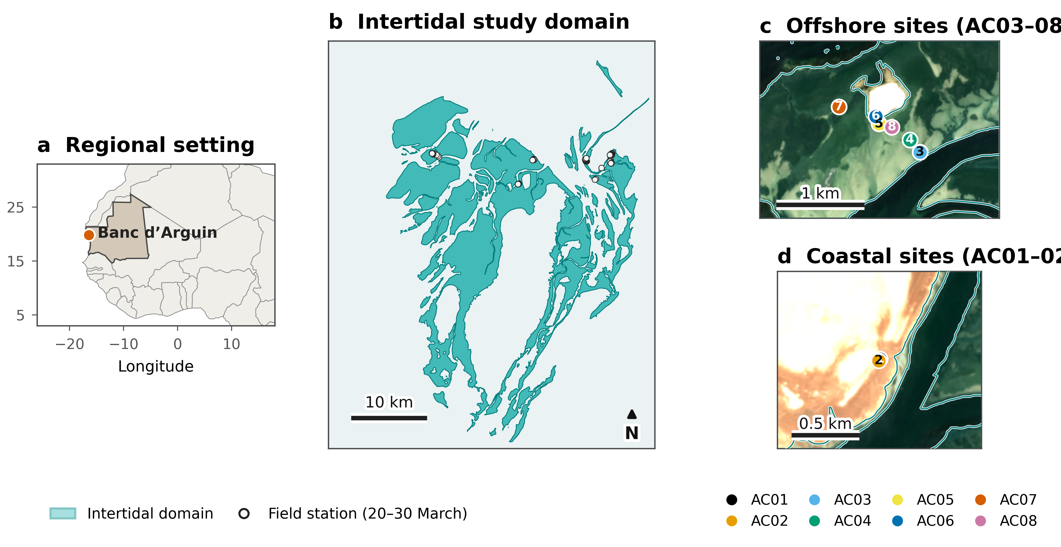
Figure 1: Study area and field-sampling design. a, Location of Banc d’Arguin on the north-western coast of Mauritania. b, Intertidal analysis domain (turquoise) and field stations occupied during the March 2026 campaign. c, Offshore validation stations AC03–AC08. d, Coastal validation stations AC01–AC02. Panels c and d use the Sentinel-2B Level-2A true-colour composite acquired on 27 March 2026; no contextual satellite imagery from outside the field-campaign window is used. Country boundaries are from Natural Earth.

3.2 Field data acquisition and spectral processing
Surface reflectance was measured with a portable ASD field spectroradiometer over the range 400–900 nm. The campaign acquisition configuration used 50 scans for the white reference, 20 scans for the dark-current measurement and 50 scans for each target measurement; 20 spectra were stored in each acquisition batch. Sampling encompassed the dominant exposed intertidal surfaces encountered during the campaign, including Zostera noltei, dry and white sand, microphytobenthos-rich mud and algal mud. Station coordinates, acquisition date and target description were linked to the spectral records using the field log and handheld-GPS waypoints.
The atmospheric-correction validation was conducted at eight stations (AC01–AC08) on 27 March 2026, contemporaneously with the Sentinel-2B overpass. At each station, five batches of 20 spectra were distributed within an area corresponding approximately to one 10-m Sentinel-2 pixel, providing a station-scale spectrum that reduced sensitivity to centimetre-scale surface heterogeneity. AC01–AC02 sampled dry coastal sand; AC03–AC04 sampled microphytobenthos-rich mud; AC05 sampled algal mud; AC06 sampled white sand; and AC07–AC08 sampled exposed seagrass.
To make the field and satellite measurements spectrally comparable, each hyperspectral station spectrum was convolved with the official 2024 Sentinel-2B spectral response function, $S_{b}(λ)$, for band $b$:
Rb=λ​R(λ)Sb(λ)λ​Sb(λ),
where $R(λ)$ is field-measured reflectance at wavelength $λ$. Only bands whose response functions overlapped the field instrument range were retained, yielding nine MSI bands from B1 to B8A. Figure 2 shows both the original station spectra and their Sentinel-2B-equivalent values. The convolution preserves the large reflectance contrast among surfaces while representing the spectral information actually available to the satellite comparison.
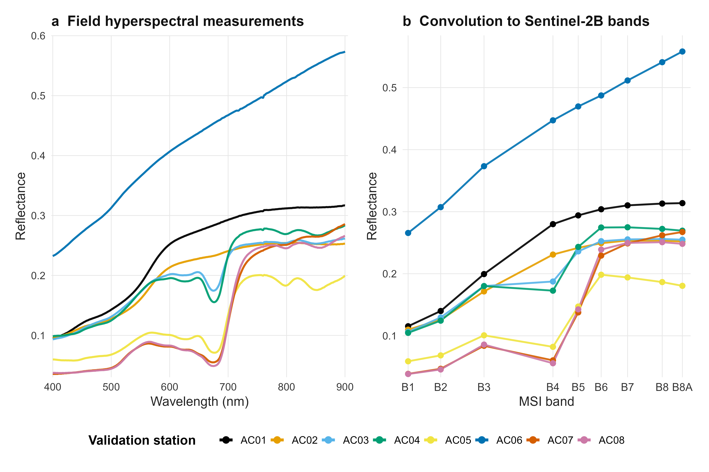
Figure 2: Field spectra used for atmospheric-correction validation. a, Mean hyperspectral reflectance measured at the eight validation stations on 27 March 2026. b, The same spectra after convolution with Sentinel-2B spectral response functions for bands B1–B8A. Colours identify stations and are used consistently in the study-area map.

3.3 Satellite imagery and atmospheric correction
The matchup used Sentinel-2B MSI acquisition S2B_MSIL2A_20260327T113319_N0512_R080_T28QCH_20260327T152639, sensed at 11:45:53 UTC on 27 March 2026. The Level-2A product belonged to processing baseline 05.12 and reported 0.0149% cloudy pixels over tile 28QCH. Restricting the initial comparison to this acquisition eliminated the multi-day surface-change term that would be introduced by imagery outside the field-campaign window.
Two independently corrected reflectance products were evaluated. First, the operational Level-2A bottom-of-atmosphere product generated with Sen2Cor was read from the SAFE archive (European Space Agency, 2021; Main-Knorn et al., 2017). Digital numbers were converted to reflectance using the product metadata, $(DN−1000)/10,000$. Each band was resampled bilinearly to a common 10-m grid before extraction at the field coordinates.
Second, the corresponding Level-1C acquisition was processed with ACOLITE (generic GitHub build c2026-04-07T11:45:24) using dark spectrum fitting (Vanhellemont, 2019). Aerosol optical thickness was estimated in tiled mode using 600 × 600-pixel tiles, the minimum-DRMSD aerosol-model selection and a three-pixel smoothing kernel. Processing used the ACOLITE 2021 lookup tables, produced 10-m surface reflectance (rhos) and did not apply adjacency or residual-glint correction. ACOLITE wavelengths were associated with the nearest Sentinel-2B equivalent band when their central wavelengths differed by no more than 5 nm. For both processors, reflectance was extracted at the same GPS location for each validation station and paired with its band-convolved field value.
Following the quality-control exclusion implemented in the source analysis, AC03 was removed before metric calculation; the retained dataset comprised seven stations and nine bands, or 63 paired observations per atmospheric-correction processor.

3.4 Statistical analysis
Agreement was evaluated using descriptive metrics calculated across the 63 station-by-band pairs for each processor. Let $F_{i}$ be ASD reflectance, $S_{i}$ satellite-derived reflectance and $d_{i}=S_{i}−F_{i}$ for pair $i$. An ordinary least-squares regression of $S_{i}$ on $F_{i}$ provided the coefficient of determination ($R^{2}$). Absolute radiometric agreement was quantified as root-mean-square deviation (RMSD), mean bias and mean absolute deviation (MAD):
$$RMSD=\sqrt{\frac{1}{n}\sum_{i=1}^{n}{d_{i}^{2}}}, bias=\frac{1}{n}\sum_{i=1}^{n}{d_{i}}, MAD=\frac{1}{n}\sum_{i=1}^{n}{|}d_{i}|.$$
Relative percentage difference (RPD) and absolute percentage difference (APD) were calculated as
$$RPD=\frac{100}{n}\sum_{i=1}^{n}{\frac{d_{i}}{F_{i}}}, APD=\frac{100}{n}\sum_{i=1}^{n}{\frac{|d_{i}|}{|F_{i}|}}.$$
These quantities were used as complementary diagnostics: $R^{2}$ measures the preservation of variation among field spectra, whereas RMSD, bias, MAD, RPD and APD measure proximity to the 1:1 relationship. Because bands were nested within stations, the comparison was treated as a processor-performance assessment rather than as an inferential test of independent observations. All reflectance values are dimensionless. Figure generation and metric calculation were scripted directly from the archived field spectra, official Sentinel-2B response functions and georeferenced image products.

4. Results

4.1 Field–satellite reflectance agreement on 27 March 2026
Both atmospheric-correction products preserved the strong variation among the exposed intertidal reference surfaces, but their radiometric agreement with the ASD measurements differed (Figure 3). Sen2Cor produced the higher coefficient of determination ($R^{2}=0.935$ versus 0.920 for ACOLITE), indicating slightly tighter linear covariation with the field spectra. However, its fitted relationship was displaced above the 1:1 line, particularly for the brighter near-infrared observations. This displacement resulted in a positive mean bias of 0.0448, an RMSD of 0.0619 and an MAD of 0.0464. The corresponding relative errors were 25.2% for RPD and 25.8% for APD.
ACOLITE yielded a lower positive bias (0.0152) and substantially smaller absolute errors (RMSD = 0.0389; MAD = 0.0267). Its RPD and APD were 11.9% and 17.0%, respectively. Thus, although Sen2Cor explained 1.5 percentage points more variance, ACOLITE reduced RMSD by 37%, MAD by 43% and APD by 34% relative to Sen2Cor. The comparison therefore distinguishes correlation from radiometric fidelity: Sen2Cor reproduced the ordering of surface reflectances marginally better, whereas ACOLITE retrieved values that were consistently closer to the same-day field measurements across the observed reflectance range.
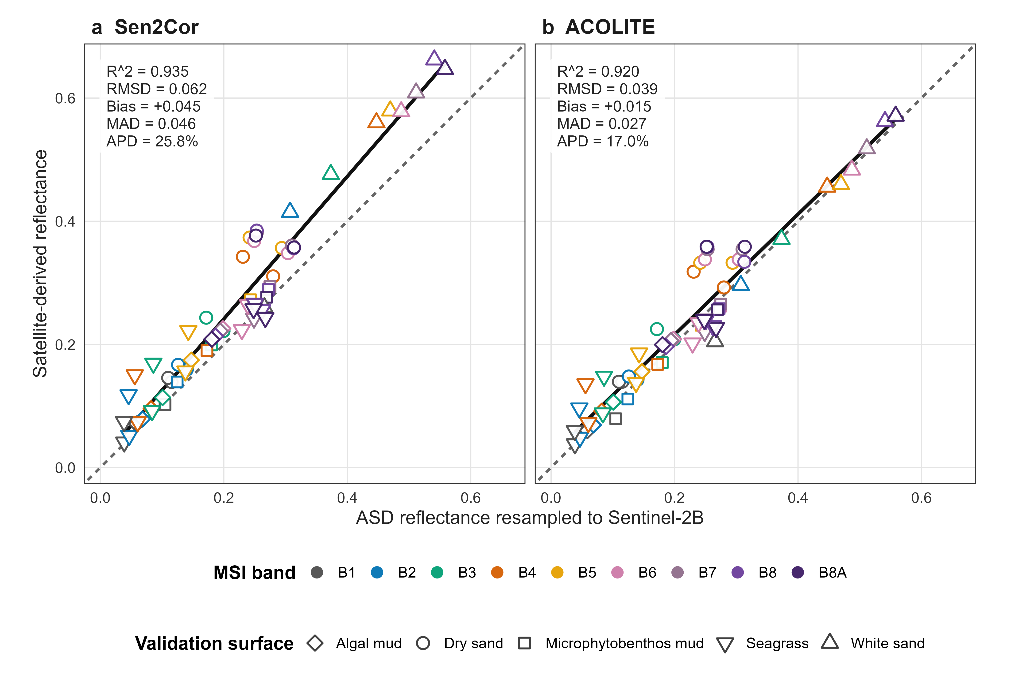
Figure 3: Same-day matchup between ASD field reflectance and satellite-derived reflectance on 27 March 2026. a, Sen2Cor Level-2A reflectance. b, ACOLITE dark-spectrum-fitting reflectance. Each panel contains 63 paired observations from seven validation stations and nine Sentinel-2B bands; AC03 was excluded during quality control. Point colour denotes MSI band and symbol denotes surface type. The dashed line is the 1:1 relationship and the solid line is the ordinary least-squares fit. RMSD, root-mean-square deviation; MAD, mean absolute deviation; APD, absolute percentage difference.
Barbier, E.B., Hacker, S.D., Kennedy, C., Koch, E.W., Stier, A.C., Silliman, B.R., 2011. The value of estuarine and coastal ecosystem services. Ecological Monographs 81, 169–193. https://doi.org/10.1890/10-1510.1
Bui, Q.-T., Jamet, C., Vantrepotte, V., Mériaux, X., Cauvin, A., Mograne, M.A., 2022. Evaluation of Sentinel-2/MSI atmospheric correction algorithms over two contrasted french coastal waters. Remote Sensing 14, 1099. https://doi.org/10.3390/rs14051099
Davies, B.F.R., Gernez, P., Geraud, A., Oiry, S., Rosa, P., Zoffoli, M.L., Barillé, L., 2023. Multi- and hyperspectral classification of soft-bottom intertidal vegetation using a spectral library for coastal biodiversity remote sensing. Remote Sensing of Environment 290, 113554. https://doi.org/10.1016/j.rse.2023.113554
Davies, B.F.R., Oiry, S., Rosa, P., Zoffoli, M.L., Sousa, A.I., Thomas, O.R., Smale, D.A., Austen, M.C., Biermann, L., Attrill, M.J., Román, A., Navarro, G., Barillé, A.-L., Harin, N., Clewley, D., Martinez-Vicente, V., Gernez, P., Barillé, L., 2024a. A sentinel watching over inter-tidal seagrass phenology across western europe and north africa. Communications Earth & Environment 5, 382. https://doi.org/10.1038/s43247-024-01543-z
Davies, B.F.R., Oiry, S., Rosa, P., Zoffoli, M.L., Sousa, A.I., Thomas, O.R., Smale, D.A., Austen, M.C., Biermann, L., Attrill, M.J., Román, A., Navarro, G., Barillé, A.-L., Harin, N., Clewley, D., Martinez-Vicente, V., Gernez, P., Barillé, L., 2024b. Intertidal seagrass extent from sentinel-2 time-series show distinct trajectories in western europe. Remote Sensing of Environment 312, 114340. https://doi.org/10.1016/j.rse.2024.114340
de Fouw, J., Govers, L.L., van de Koppel, J., van Belzen, J., Dorigo, W., Sidi Cheikh, M.A., Christianen, M.J.A., van der Reijden, K.J., van der Geest, M., Piersma, T., Smolders, A.J.P., Olff, H., Lamers, L.P.M., van Gils, J.A., van der Heide, T., 2016. Drought, mutualism breakdown, and landscape-scale degradation of seagrass beds. Current Biology 26, 1051–1056. https://doi.org/10.1016/j.cub.2016.02.023
Doxani, G., Vermote, E.F., Roger, J.-C., Skakun, S., Gascon, F., Collison, A., De Keukelaere, L., Desjardins, C., Frantz, D., Hagolle, O., Kim, M., Louis, J., Pacifici, F., Pflug, B., Poilvé, H., Ramon, D., Richter, R., Yin, F., 2023. Atmospheric correction inter-comparison exercise, ACIX-II land: An assessment of atmospheric correction processors for Landsat 8 and Sentinel-2 over land. Remote Sensing of Environment 285, 113412. https://doi.org/10.1016/j.rse.2022.113412
Duffy, J.E., Benedetti-Cecchi, L., Trinanes, J., Muller-Karger, F.E., Ambo-Rappe, R., Boström, C., Buschmann, A.H., Byrnes, J., Coles, R.G., Creed, J., Cullen-Unsworth, L.C., Diaz-Pulido, G., Duarte, C.M., Edgar, G.J., Fortes, M., Goni, G., Hu, C., Huang, X., Hurd, C.L., Johnson, C., Konar, B., Krause-Jensen, D., Krumhansl, K., Macreadie, P., Marsh, H., McKenzie, L.J., Mieszkowska, N., Miloslavich, P., Montes, E., Nakaoka, M., Norderhaug, K.M., Nordlund, L.M., Orth, R.J., Prathep, A., Putman, N.F., Samper-Villarreal, J., Serrão, E.A., Short, F., Pinto, I.S., Steinberg, P., Stuart-Smith, R., Unsworth, R.K.F., Keulen, M. van, Tussenbroek, B.I. van, Wang, M., Waycott, M., Weatherdon, L.V., Wernberg, T., Yaakub, S.M., 2019. Toward a coordinated global observing system for seagrasses and marine macroalgae. Frontiers in Marine Science 6, 317. https://doi.org/10.3389/fmars.2019.00317
Dunic, J.C., Brown, C.J., Connolly, R.M., Turschwell, M.P., Côté, I.M., 2021. Long-term declines and recovery of meadow area across the world’s seagrass bioregions. Global Change Biology 27, 4096–4109. https://doi.org/10.1111/gcb.15684
El-Hacen, E.-H.M., Sidi Cheikh, M.A., Bouma, T.J., Olff, H., Piersma, T., 2020. Long-term changes in seagrass and benthos at banc d’arguin, mauritania, the premier intertidal system along the east atlantic flyway. Global Ecology and Conservation 24, e01364. https://doi.org/10.1016/j.gecco.2020.e01364
European Space Agency, 2021. Sentinel-2 level-2A algorithm theoretical basis document (No. S2-PDGS-MPC-L2A-ATBD). European Space Agency.
Fourqurean, J.W., Duarte, C.M., Kennedy, H., Marbà, N., Holmer, M., Mateo, M.A., Apostolaki, E.T., Kendrick, G.A., Krause-Jensen, D., McGlathery, K.J., Serrano, O., 2012. Seagrass ecosystems as a globally significant carbon stock. Nature Geoscience 5, 505–509. https://doi.org/10.1038/ngeo1477
Friese, C.A., Does, M. van der, Merkel, U., Iversen, M.H., Fischer, G., Stuut, J.-B.W., 2016. Environmental factors controlling the seasonal variability in particle size distribution of modern saharan dust deposited off cape blanc. Aeolian Research 22, 165–179. https://doi.org/10.1016/j.aeolia.2016.04.005
Friese, C.A., Hateren, J.A. van, Vogt, C., Fischer, G., Stuut, J.-B.W., 2017. Seasonal provenance changes in present-day saharan dust collected in and off mauritania. Atmospheric Chemistry and Physics 17, 10163–10193. https://doi.org/10.5194/acp-17-10163-2017
Kaufman, Y.J., Tanré, D., Boucher, O., 2002. A satellite view of aerosols in the climate system. Nature 419, 215–223. https://doi.org/10.1038/nature01091
Knippertz, P., Todd, M.C., 2012. Mineral dust aerosols over the sahara: Meteorological controls on emission and transport and implications for modeling. Reviews of Geophysics 50, RG1007. https://doi.org/10.1029/2011RG000362
Lyons, M.B., Roelfsema, C.M., Phinn, S.R., 2013. Towards understanding temporal and spatial dynamics of seagrass landscapes using time-series remote sensing. Estuarine, Coastal and Shelf Science 120, 42–53. https://doi.org/10.1016/j.ecss.2013.01.015
Main-Knorn, M., Pflug, B., Louis, J., Debaecker, V., Müller-Wilm, U., Gascon, F., 2017. Sen2Cor for Sentinel-2, in: Image and Signal Processing for Remote Sensing XXIII. SPIE, p. 1042704. https://doi.org/10.1117/12.2278218
Moulin, C., Gordon, H.R., Chomko, R.M., Banzon, V.F., Evans, R.H., 2001. Atmospheric correction of ocean color imagery through thick layers of saharan dust. Geophysical Research Letters 28, 5–8. https://doi.org/10.1029/2000GL011803
Nordlund, L.M., Koch, E.W., Barbier, E.B., Creed, J.C., 2016. Seagrass ecosystem services and their variability across genera and geographical regions. PLOS ONE 11, e0163091. https://doi.org/10.1371/journal.pone.0163091
Orth, R.J., Carruthers, T.J.B., Dennison, W.C., Duarte, C.M., Fourqurean, J.W., Heck, K.L., Hughes, A.R., Kendrick, G.A., Kenworthy, W.J., Olyarnik, S., Short, F.T., Waycott, M., Williams, S.L., 2006. A global crisis for seagrass ecosystems. BioScience 56, 987–996. https://doi.org/10.1641/0006-3568(2006)56[987:AGCFSE]2.0.CO;2
Ould Dedah, S., 1993. Wind, surface water temperature, surface salinity and pollution in the area of the banc d’arguin, mauritania. Hydrobiologia 258, 9–19.
Pottier, A., Catry, T., Trégarot, E., Maréchal, J.-P., Fayad, V., David, G., Sidi Cheikh, M., Failler, P., 2021. Mapping coastal marine ecosystems of the national park of banc d’arguin (PNBA) in mauritania using Sentinel-2 imagery. International Journal of Applied Earth Observation and Geoinformation 102, 102419. https://doi.org/10.1016/j.jag.2021.102419
Roelfsema, C.M., Lyons, M., Kovacs, E.M., Maxwell, P., Saunders, M.I., Samper-Villarreal, J., Phinn, S.R., 2014. Multi-temporal mapping of seagrass cover, species and biomass: A semi-automated object based image analysis approach. Remote Sensing of Environment 150, 172–187. https://doi.org/10.1016/j.rse.2014.05.001
Senghor, H., Machu, É., Hourdin, F., Gaye, A.T., 2017. Seasonal cycle of desert aerosols in western africa: Analysis of the coastal transition with passive and active sensors. Atmospheric Chemistry and Physics 17, 8395–8410. https://doi.org/10.5194/acp-17-8395-2017
Song, C., Woodcock, C.E., Seto, K.C., Lenney, M.P., Macomber, S.A., 2001. Classification and change detection using landsat TM data: When and how to correct atmospheric effects? Remote Sensing of Environment 75, 230–244. https://doi.org/10.1016/S0034-4257(00)00169-3
Unsworth, R.K.F., McKenzie, L.J., Collier, C.J., Cullen-Unsworth, L.C., Duarte, C.M., Eklöf, J.S., Jarvis, J.C., Jones, B.L., Nordlund, L.M., 2019. Global challenges for seagrass conservation. Ambio 48, 801–815. https://doi.org/10.1007/s13280-018-1115-y
van der Heide, T., Govers, L.L., de Fouw, J., Olff, H., van der Geest, M., van Katwijk, M.M., Piersma, T., van de Koppel, J., Silliman, B.R., Smolders, A.J.P., van Gils, J.A., 2012. A three-stage symbiosis forms the foundation of seagrass ecosystems. Science 336, 1432–1434. https://doi.org/10.1126/science.1219973
Vanhellemont, Q., 2019. Adaptation of the dark spectrum fitting atmospheric correction for aquatic applications of the Landsat and Sentinel-2 archives. Remote Sensing of Environment 225, 175–192. https://doi.org/10.1016/j.rse.2019.03.010
Warren, M.A., Simis, S.G.H., Martinez-Vicente, V., Poser, K., Bresciani, M., Alikas, K., Spyrakos, E., Giardino, C., Ansper, A., 2019. Assessment of atmospheric correction algorithms for the Sentinel-2A MultiSpectral Imager over coastal and inland waters. Remote Sensing of Environment 225, 267–289. https://doi.org/10.1016/j.rse.2019.03.018
Waycott, M., Duarte, C.M., Carruthers, T.J.B., Orth, R.J., Dennison, W.C., Olyarnik, S., Calladine, A., Fourqurean, J.W., Heck, K.L., Hughes, A.R., Kendrick, G.A., Kenworthy, W.J., Short, F.T., Williams, S.L., 2009. Accelerating loss of seagrasses across the globe threatens coastal ecosystems. Proceedings of the National Academy of Sciences 106, 12377–12381. https://doi.org/10.1073/pnas.0905620106
Wolff, W.J., Van der Land, J., Nienhuis, P.H., De Wilde, P., 1993. The functioning of the ecosystem of banc d’arguin, mauritania: A review. Hydrobiologia 258, 211–222. https://doi.org/10.1007/BF00006198

