Impact of Marine and Atmospheric Heatwaves on Intertidal Seagrass: Experimental Spectroradiometry and Satellite-Based Insights
Simon Oiry
Bede Ffinian Rowe Davies¹
Philippe Rosa¹
Augustin Debly¹
Maria Laura Zoffoli
Anne-Laure Barillé
Nicolas Harin³
Pierre Gernez¹
Laurent Barillé¹
2024-12-17
Abstract
Seagrasses play a vital role in coastal ecosystems, providing habitat, stabilizing sediments, and contributing to carbon sequestration. However, climate change has increased the frequency and intensity of heatwaves, posing a significant threat to seagrass health. This study investigates the effects of marine and atmospheric heatwaves on the spectral reflectance of the intertidal seagrass Zostera noltei. Laboratory experiments were conducted under controlled heatwave conditions, where hyperspectral reflectance measurements were taken to assess the impacts over time. Heatwaves caused a substantial decline in seagrass reflectance, particularly in the green and near-infrared regions, corresponding to the browning of green leaves. Key vegetation indices, including the Normalized Difference Vegetation Index (NDVI) and Green Leaf Index (GLI), showed pronounced reductions under heatwave stress, with NDVI values decreasing by up to 34% and GLI by 57%. A novel metric, the Seagrass Heat Shock Index (SHSI), was developed to quantify the transition of seagrass leaves from green to brown, demonstrating a strong ability to capture the effects of heatwave exposure on seagrass coloration. These findings highlight the potential of spectral reflectance as a tool for detecting early signs of heatwave-induced stress in seagrasses, offering a valuable method for remote sensing-based habitat assessment. Multispectral satellite observations corroborated the laboratory results, revealing widespread browning of seagrass leaves during marine and atmospheric heatwave events in South Brittany, France. Notably, darkened seagrass patches were observed in intertidal areas exposed to temperatures exceeding 32°C for over 13.5 hours per day. This work highlights the need for continuous monitoring of seagrass meadows under the current and future climate regimes, underscoring the potential of remote sensing to capture rapid environmental changes in intertidal zones.

1. Abstract Long version (For LPS Submission)
Seagrasses meadows are important coastal ecosystems, serving as crucial habitats for marine biodiversity, stabilizing sediments to mitigate erosion, and acting as significant carbon sinks in global climate regulation. However, these vital ecosystems face mounting threats from climate change, with the intensification and increased frequency of marine and atmospheric heatwaves posing profound risks to their health and functionality. This study investigates the impact of these extreme thermal events on the intertidal seagrass, employing a combination of laboratory-controlled experiments and satellite-based remote sensing to capture changes in spectral reflectance and assess the broader ecological implications.
During laboratory experiments, seagrass of the species Zostera noltei were exposed to controlled simulated heatwave conditions to assess the physiological and structural impacts of extreme thermal stress. The experimental design involved placing seagrass samples in intertidal chambers that simulated natural tidal cycles, allowing to closely regulate temperature conditions during both high and low tides. One chamber served as a control, maintaining typical seasonal temperatures, while the other was used to simulate heatwave conditions with progressively increasing air and water temperatures to mimic an actual heatwave event observed in the field. Hyperspectral reflectance measurements were recorded at regular intervals during low-tide to monitor changes in the seagrass over time. Heatwave exposure resulted in a significant reduction in reflectance, particularly in the green (around 560 nm) and near-infrared (NIR) regions of the spectrum. This decline in reflectance was closely linked to visible leaf browning, suggesting alterations in pigment content, in the internal structure of seagrass leaves and their overall vitality. The green reflectance decline indicates a reduction in the plant’s health, while changes in NIR reflectance often relate to the internal arrangement of cells and air spaces, which are sensitive to heat-induced damage. Vegetation indices like the Normalized Difference Vegetation Index (NDVI) and the Green Leaf Index (GLI), which are indicative of the overall health and structural integrity of vegetation, showed marked decreases under heatwave conditions, with NDVI dropping by up to 34% and GLI by 57%. This significant reduction highlights the adverse effects on the seagrass’s ability to maintain its normal physiological processes under heat stress. To quantify these changes more effectively, a novel Seagrass Heat Shock Index (SHSI) was developed. The SHSI, applicable on emerged seagrass, was particularly effective in detecting the transition from green leaves to darkened, stressed leaves, providing a sensitive and reliable tool for assessing thermal stress effects on seagrass. By focusing on specific changes in reflectance across certain spectral bands, the SHSI allowed for a clear differentiation between unimpacted and impacted vegetation, capturing the onset of heat-induced stress with high accuracy. This sensitivity makes the SHSI valuable for early intervention, enabling managers and researchers to identify vulnerable seagrass meadows before substantial damage occurs, thereby facilitating more timely conservation measures.
Complementing the experimental data, Sentinel-2 observations provided clear evidence of the effects of a documented heatwave event in South Brittany, France, on natural seagrass meadows. These intertidal zones were exposed to extreme air temperatures up to 32°C for more than 13.5 hours per day, leading to significant leaf darkening, which affected up to 24% of the meadow’s area. The satellite-derived SHSI indicated a strong spatial correlation between prolonged heat exposure and areas experiencing spectral darkening, highlighting the susceptibility of intertidal seagrasses to extended thermal stress. Spatial analysis showed that darkening was especially pronounced in the higher intertidal regions, where seagrasses were exposed to air for longer durations during low tide, underlining the interaction between tidal exposure and thermal stress. However, Sentinel-2 data one month after the heatwave, showed partial recovery in some areas, suggesting a certain level of resilience in Zostera noltei. Despite this recovery, the seagrasses that had experienced the most severe darkening did not fully return to their original state, indicating that while seagrass meadows have some capacity for resilience, prolonged or repeated thermal stress can have lasting impacts, particularly in the more exposed intertidal regions. This highlights the need for focused conservation efforts to support their recovery and enhance their resilience in the face of increasing climate-driven thermal extremes.
The combination of laboratory-controlled experiments and satellite-based remote sensing provided a comprehensive understanding of the impacts of heatwaves on seagrass meadows at multiple scales, from individual leaf-level responses to entire meadow-wide effects. This integrated approach highlights the potential of leveraging both detailed local observations and large-scale satellite data to effectively monitor ecosystem changes, offering valuable insights for the management and conservation of these vulnerable habitats. The study underscores the critical role of spectral reflectance as an early warning indicator of heatwave-induced stress, laying the foundation for remote sensing-based monitoring and conservation efforts. By employing innovative indices like the Seagrass Heat Shock Index (SHSI), we capture subtle yet ecologically significant changes, advancing the precision of habitat assessments in intertidal zones. As climate scenarios predict more frequent and intense heatwaves, the need for continuous monitoring of intertidal seagrass meadows becomes increasingly urgent. This research demonstrates the efficacy of remote sensing in capturing rapid environmental changes, providing a framework for mitigating the impacts of climate-driven stressors and calling for adaptive conservation strategies. These strategies should integrate advancements in remote sensing technologies with targeted field-based interventions to preserve the resilience of intertidal seagrass meadows, thereby addressing the escalating challenges posed by climate change and ensuring the continued health of these indispensable coastal habitats.

2. Introduction
Seagrasses play a crucial role in coastal ecosystems by providing habitats and feeding grounds for various marine species, supporting marine biodiversity, and contributing to primary production and carbon sequestration (Sousa et al., 2019; Unsworth et al., 2022). Seagrasses are essential for several ecological functions, such as sediment stabilization (Infantes et al., 2022) or eutrophication mitigation (Gladstone-Gallagher et al., 2018). This justifies their use as indicators of environmental changes due to their sensitivity to water quality variations (Zoffoli et al., 2021). The interactions between seagrass meadows and their associated herbivores further enhance the delivery of ecosystem services, including coastal protection, fisheries support, and provision of habitat and resources for birds (Gardner and Finlayson, 2018; Jankowska et al., 2019; Unsworth and Butterwoth, 2021; Zoffoli et al., 2023). Understanding and preserving seagrass is vital for maintaining the biodiversity and productivity of coastal regions (Ramesh and Mohanraju, 2020; Scott et al., 2018).
Despite their crucial role in marine ecosystems, seagrasses face numerous threats that compromise their health and functionality. Coastal development and human activities are primary threats, reducing the available habitat for seagrasses and increasing water turbidity, limiting light penetration and photosynthesis (Waycott et al., 2009). Seagrasses are also threatened by runoff from agricultural fields and urban areas, leading to nutrient enrichment. Eutrophication promotes the growth of seaweed in coastal waters, causing macroalgal blooms that compete with seagrasses for light and nutrients (Oiry et al., 2024; Thomsen et al., 2023). Pollution from industrial and agricultural sources introduces harmful chemicals and heavy metals into coastal waters, posing toxic risks to seagrass health (Green et al., 2021; Bastos et al., 2023; Zahoor and Mushtaq, 2023). Among the manifold anthropogenic stressors, heatwaves (HWs), exacerbated by climate change, pose a severe threat to seagrasses, with catastrophic dieback events observed worldwide (Carlson et al., 2018; Marbà and Duarte, 2010; Moore and Jarvis, 2000; Thompson et al., 2015; Strydom et al., 2020).
Marine Heatwaves (MHWs) are defined by Hobday et al. (2016) as prolonged discrete anomalously warm water events while Atmospheric Heatwaves (AHWs) are defined by Perkins and Alexander (2013) as periods of at least three consecutive days with temperatures exceeding the 90th percentile of a time series covering at least 30 years. In shallow waters, subtidal seagrass meadows are exposed to MHWs, whereas at the interface between land and ocean, intertidal seagrasses are exposed to both MHWs and AHWs. HWs profoundly impact seagrass physiology, with effects varying between species and geographic location. Widespread seagrass species such as Zostera marina exhibits high susceptibility to elevated sea surface temperatures during winter and spring, leading to advanced flowering, high mortality rates, and reduced biomass (Sawall et al., 2021). Similarly, Cymodocea nodosa shows increased photosynthetic activity during HWs but suffers negative effects on photosynthetic performance and leaf biomass during recovery (Deguette et al., 2022). Additionally, different populations of Zostera marina along the European thermal gradient exhibit varied photophysiological responses during the recovery phase of HWs, indicating differential adaptation capabilities among populations (Winters et al., 2011). These events intensify other stressors, such as overgrazing and seed burial, compromising recruitment (Guerrero-Meseguer et al., 2020).

The increased occurrence of extreme climate events calls for the implementation of monitoring strategies able to provide detailed and spatially explicit assessments of HWs effects on seagrass meadows. In such context, remote sensing, whose ability to map seagrass distribution over a variety of spatio-temporal scales has been demonstrated (Davies et al., 2024a, 2024b; Oiry et al., 2024; Román et al., 2021), proved useful to study the changes in seagrass coverage caused by extreme HW events (Strydom et al., 2020). In complement to its ability to measure the spatial distribution of post-heatwave seagrass loss, we hypothesize that remote sensing has the potential to detect more subtle changes, such as the browning of seagrass leaves. The pigment composition of plants, such as chlorophylls, carotenoids, and anthocyanins, significantly influences their spectral signature in the visible range due to their specific light absorption properties (Davies et al., 2023; Douay et al., 2022; Olmedo-Masat et al., 2020; Ustin and Jacquemoud, 2020). During senescence phase, the degradation of chlorophyll and the unmasking of accessory pigments result in noticeable changes in leaf coloration and reflectance, including increased reflectance in the red and green wavelengths and shifts in the red-edge position (Boyer et al., 1988; Mariën et al., 2019; Peñuelas et al., 2004). Leaf browning, often observed after stress events, produces reflectance changes similar to those caused by senescence, enabling the detection of vegetation stress through remote sensing (Boyer et al., 1988; Peñuelas et al., 2004). Spectral indices such as the Brown Pigment Index (BPI) and the Photochemical Reflectance Index (PRI) have been developed to assess changes in terrestrial plant physiological status, including oxidative and drought stress (Garbulsky et al., 2011; Skendzic, 2023). While these effects are well-documented in terrestrial plants, the spectral reflectance changes associated with senescence and stress events such as MHWs or AHWs remain poorly studied on intertidal seagrasses.
This study aims to experimentally test the hypothesis that HWs alter the reflectance of the intertidal seagrass Zostera noltei. Controlled experiments in intertidal chambers were conducted to evaluate the direct impact of heat stress on seagrass reflectance. The findings were then applied to satellite remote sensing images, providing critical insights into the spatial extent and temporal dynamics of HW effects on seagrass meadows. By linking experimental results with large-scale observations of seagrass leaves’ browning, the study underscores the potential of remote sensing to enhance our understanding of seagrass responses to extreme thermal events across diverse settings and timescales.

3. Material & Methods

3.1 Laboratory Experiment

3.1.1 Sampling and acclimation of seagrasses
Seagrass samples were taken in summer 2024, at low tide, from a Zostera noltei (dwarf eelgrass) meadow located in Bourgneuf Bay, France (46°57’32.0”N, 2°10’37.0”W). A metal sampling box was used to sample seagrass from an area of 30 x 15 cm and 5 cm deep, maintaining the sediment structure and avoiding damage to seagrass rhizomes and leaves (Figure 1 A). This sampling box reduced variability between replicates. Samples including seagrass, sediment, meiofauna, and macrofauna, were placed in plastic trays. Keeping the entire biota allowed for natural interactions between components and reduced stress on the seagrass. Seawater was added to each tray to avoid hydric stress caused by insufficient moisture during transportation (1h drive to the laboratory). Simultaneously, seawater was sampled from a nearby site and transported to the lab, where it was filtered using a 0.22 µm nitrocellulose filter to remove suspended particulate matter. The filtered seawater was used in the acclimation tank and the intertidal chambers. The seagrasses were acclimated during one week with a water temperature of 17°C, matching the in situ temperature during sampling, and a photosynthetically active radiation (PAR) of 150 µmol.s⁻¹.m⁻² (Akbar et al., 2020).
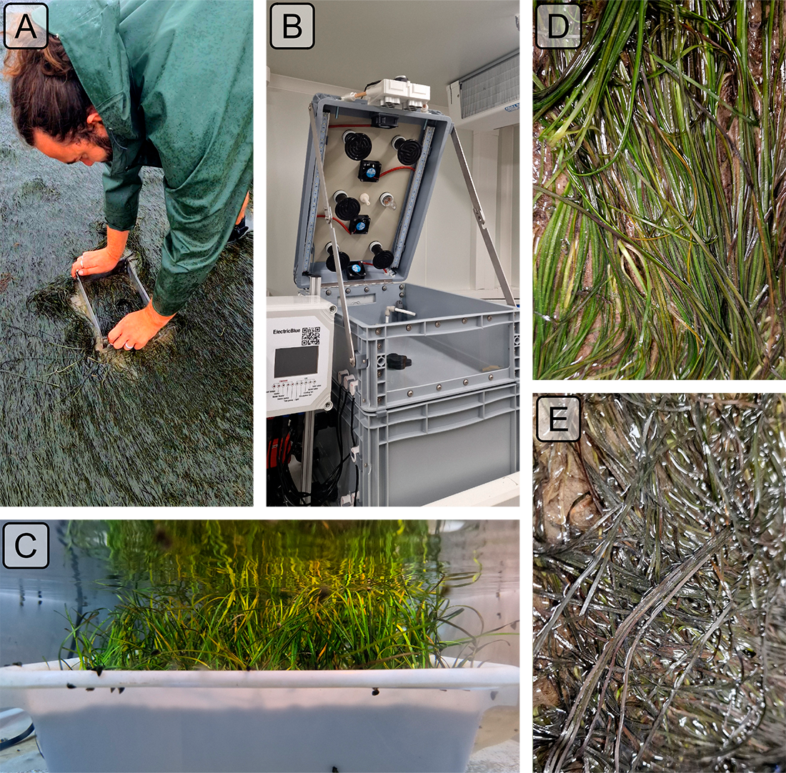
Figure 1: Illustrations of the experiment. A: Seagrass field sampling using a coring device; B: Intertidal chamber used during the experiment; C: Seagrass sample inside a chamber during the experiment at high tide; D: Treatment sample at the start of the experiment; E: Treatment sample at the end of the experiment, 2 days after the start of the HW event.

3.1.2 Experimental design
A tidal cycle (i.e., regularly alternating 6h of low tide and 6h of high-tide) was simulated in the laboratory using an intertidal chamber system from ElectricBlue® (Electric Blue, 2023). During the phase of high tide, a volume of VV L of filtered seawater was pumped and circulated through the chamber (Figure 1 B,C). During low tide, the seagrass sample was emerged. The acclimated seagrasses were split in two subsets and placed in two chambers used in parallel, with one chamber used for control and the other for the experimental treatment. The intertidal chambers were equipped with LED lights that emitted low red and infrared radiation. To achieve a PAR intensity of up to 400 μmol·m⁻²·s⁻¹, a filament bulb was added inside the chambers. During the experiment, the PAR was kept constant in both intertidal chambers.
Air temperature and water temperature were controlled inside the experimental chambers, in order to reproduce the range of variability observed in the field. Field temperature was measured using
in situ sensors (T7.3 EnvLoggers from ElectricBlue®) deployed at the sampling site in August 2024. In complement, the temperature daily maxima recorded in situ were compared with measurements from the nearest Meteo France weather station (Annexe A1, Section 7.1). The control chamber was kept at temperatures representing typical seasonal conditions, with a stable water temperature of 18°C, and air temperature varying from 19 – 23 °C, following natural daily temperature fluctuations (Figure 2). For the experimental treatment, the air temperature was adjusted to mimic an AHW that occurred in Quiberon, South Brittany, France (47°35’40.0”N, 3°07’30.0”W), from 2 – 6 September 2021. Air temperature in the experimental chamber was set to vary from 23°C (nighttime) to 35°C (daytime) during the first day of the experiment, and to increase by 1°C daily during three consecutive days. Water temperature in the experimental chamber was adjusted to mimic MHW conditions, starting at the seasonal baseline (18°C) and rising incrementally by 0.5°C daily to simulate the increasing temperatures during the event. This aimed to reproduce the thermal stress experienced by the seagrass meadow during a MHW (Figure 2). The experiment was repeated three times to obtain replicates (hereafter referred to as “Run”).
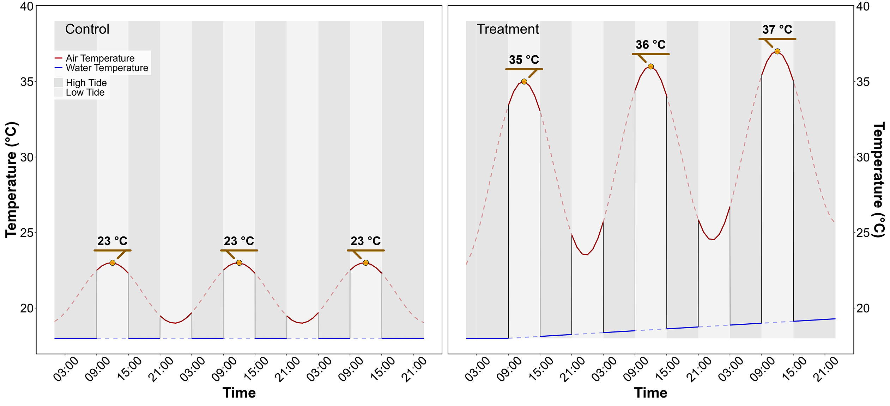
Figure 2: Temperature variation in the control (left) and treatment (right) intertidal chambers, during the HW experiment. The red line indicates air temperature, and the blue line water temperature. Due to the tidal cycle of immersion / emersion, the seagrasses experienced the temperatures represented by solid lines.

3.1.3 Optical measurements

3.1.3.1 Hyperspectral reflectance measurements
Throughout the experiment, the hyperspectral reflectance, R(λ), of both the control and treatment seagrasses was measured using an ASD HandHeld 2 equipped with a fiber optic extension place inside the chamber. The measurement set up made it possible to automatically acquire R(λ) without opening the chamber. An average of five R(λ) spectra, each with an integration time of 544 ms, was taken every minute during daytime (Malvern Panalytical, 2023). Every 10 minutes, the fiber optic was switched from one intertidal chamber to the other, in order to measure R(λ) in both the treatment and control. Light conditions were controlled inside of the chambers, and the reflectance calibration was performed each morning at the very first moment of low tide using a Spectralon white reference with 99% Lambertian reflectivity.

3.1.3.2 Spectrum post-processing
A Savitzky-Golay smoothing function with a 5 nm moving window was applied to each spectrum using the “hsdar” package in R (Lehnert et al., 2017). The second derivative at 665 nm (δδ665), showing the highest variability between the control and the treatment, was tested as an indicator of the spectral changes following HWs.
The effect of the HW on R(λ) was also quantified using two radiometric indices:
- The Normalized Difference Vegetation Index (NDVI, Rouse et al. (1974)), a proxy of chlorophyll-a concentration (Equation 1)
$$NDVI=\frac{R\left(840\right)-R\left(668\right)}{R\left(840\right)+R\left(668\right)} \left(1\right)$$
where $R\left(840\right)$ and $R\left(668\right)$ are the reflectance at 840 and 668 nm, respectively.
- The Green Leaf Index (GLI, Louhaichi et al. (2001)), a quantification of the seagrass leaves’ greenness (Equation 2)
$$GLI=\frac{\left[R\left(550\right)-R\left(668\right)\right]+\left[R\left(550\right)-R\left(450\right)\right]}{\left(2×R\left(550\right)\right)+R\left(668\right)+R\left(450\right)} \left(2\right)$$
where $R\left(550\right)$ and $R\left(450\right)$ are the reflectance in the green (at 550 nm) and in the blue (at 450 nm) spectral bands, respectively.
Based on the observed spectral changes in seagrasses exposed to HWs, we developed a new radiometric index to better detect the radiometric changes caused by the HW. As the browning of the leaves was characterized by substantial radiometric changes in both the green and red-edge spectral regions
, the Seagrass Heat Shock Index (SHSI) was introduced here as the reflectance line height at 740 nm, compared to the 560 – 842 nm baseline (Figure 3). Namely, the SHSI subtracts the reflectance observed at 740 nm to the interpolated reflectance between 560 and 842 nm, so that the index is positive in the case of brown, HW-impacted seagrass leaves, and negative in the case of green, non-impacted leaves:
$$\text{SHSI}=I_{SHSI}-R\left(740\right) \left(3\right)$$
where :
$$I_{SHSI}=R\left(560\right)+τ\left[R\left(842\right)-R\left(560\right)\right]$$
and :
$$τ=\frac{740-560}{842-560}$$
where $R\left(560\right)$, $R\left(740\right)$, and $R\left(842\right)$ represent the reflectance at 560, 740, and 842 nm, respectively. These wavelengths were selected to align with the spectral resolution of satellite missions such as Sentinel-2, for remote sensing application.
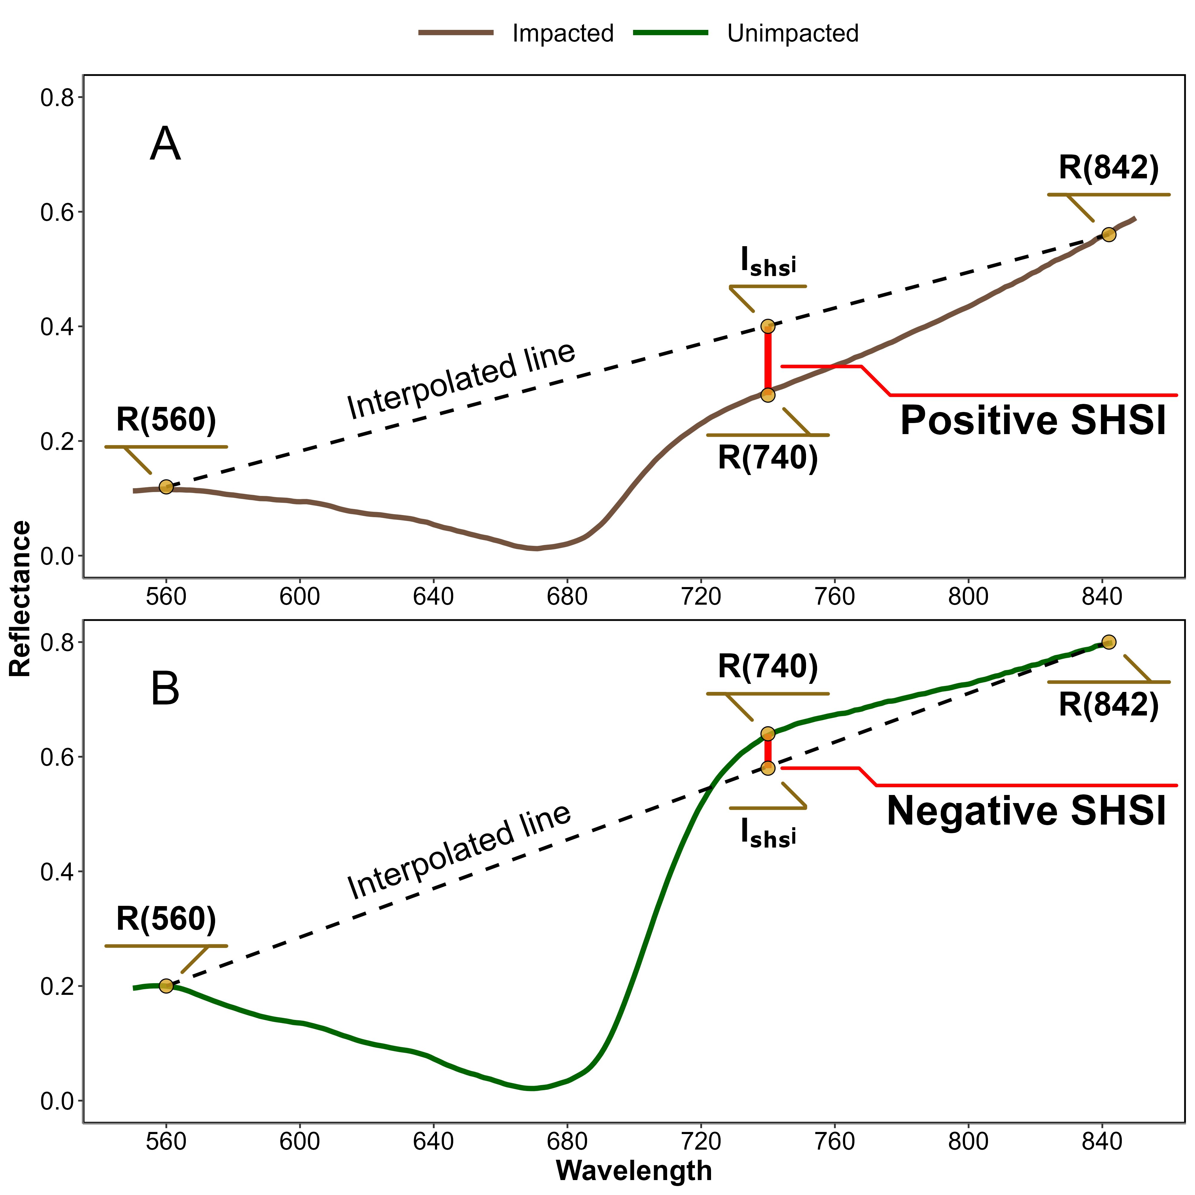
Figure 3: Computation of the reflectance Seagrass Heat Shock Index (SHSI) for impacted (A) and non-impacted (B) seagrass leaves. The dashed line represents the reflectance interpolation between 560 and 842 nm. The red vertical line at 740 nm represents the SHSI line height.

3.2 Observation of a seagrass bed impacted by a HWs
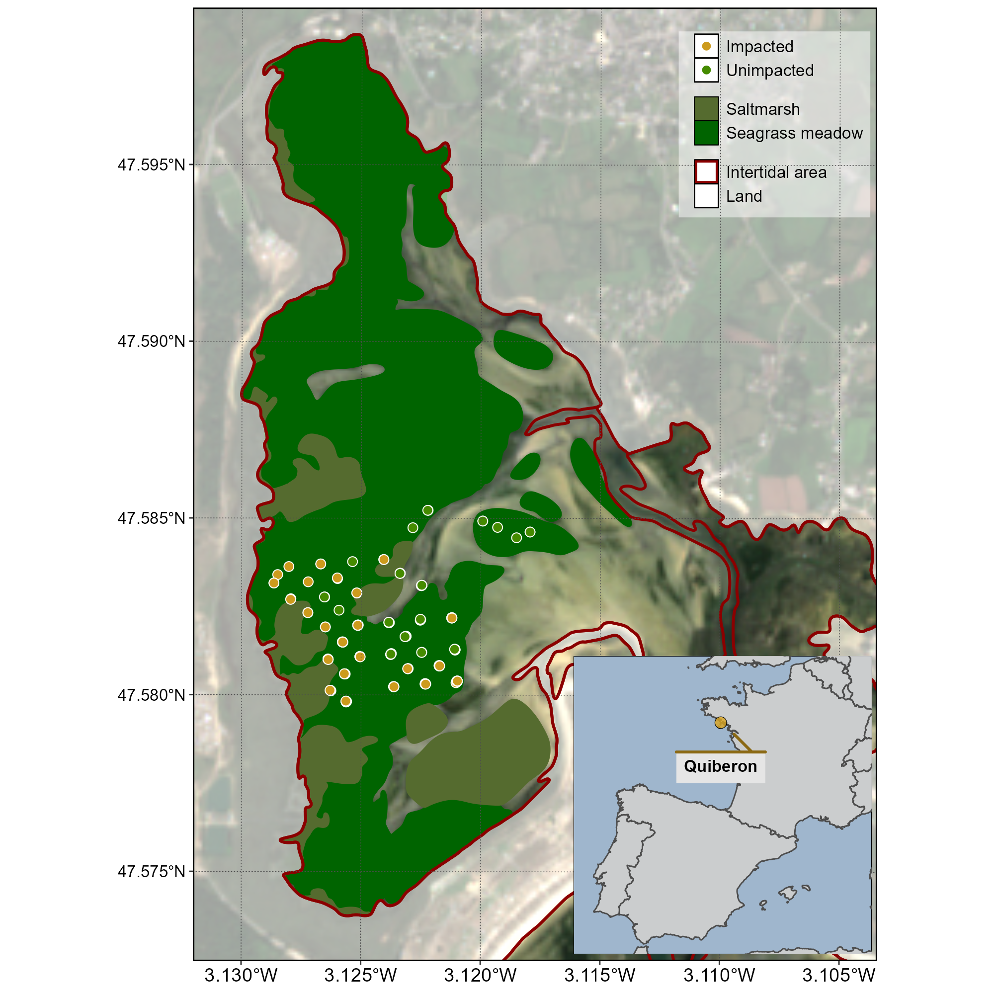
Figure 4: Location of field observation in a seagrass meadow impacted by a HW that occured on the 10th of September 2021 in Quiberon, South Brittany, France. The red line indicates the intertidal zone (Zone between high tide and low tide, exposed during low tide), white polygons indicates land areas, the dark green polygon indicates the extent of the seagrass meadow and the olive polygons indicates saltmarshes. Greendots indicate the location of quadrat picture over unimpacted seagrasses (i.e. showing a green colour on the field), while orange-red dots indicate the location of the quadrat taken over impacted seagrasses (i.e. showing a brown colour on the field).
A field campaign, aiming to map a seagrass meadow near Quiberon (France : 46°57’32.0”N, 2°10’37.0”W), occurred on September 10th 2021 after a AHW and a MHW (Figure 4). Seagrass leaves turning brown were observed over large areas of the meadow alongside normal green seagrass (Figure 5). A total of 96 Quadrat Points (QPs) were collected as georeferenced quadrat images across the meadow. These images allowed for visual assessment of vegetation type, density, and coloration. The quadrats were then divided into two categories: green seagrasses (henceforth: QPs unimpacted) and brown seagrasses (henceforth: QPs impacted), based on a visual estimation of the leaf coloration (Figure 4).
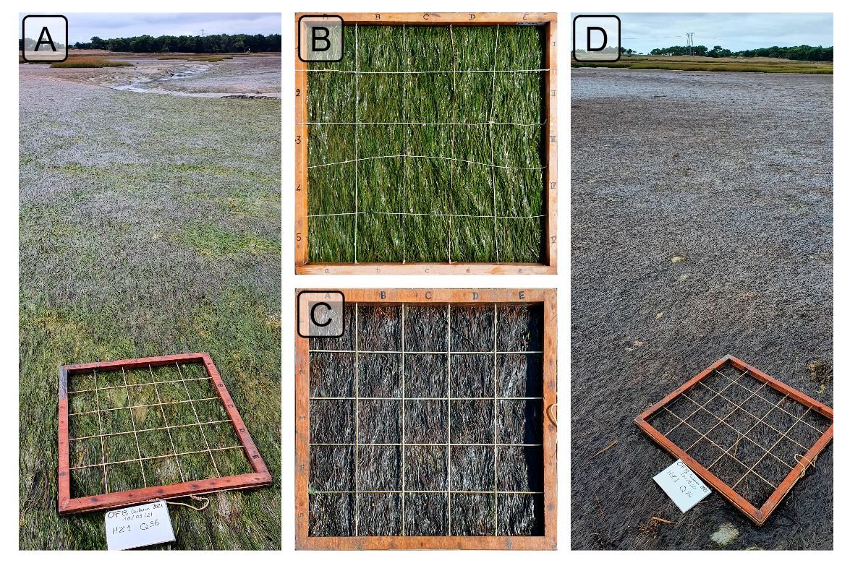
Figure 5: Illustrations of the two colorations of seagrass leaves observed in the field. A: View of a green meadow; B: Quadrat with green leaves; C: Quadrat with brown leaves; D: View of a meadow with all leaves turned brown. All images were taken on September 10th, 2021, in Quiberon, South Brittany, France, after a HW.

3.2.1 Temperature data and identification of the HW

3.2.1.1 Air temperature
Since January 1st, 2024, Meteo France weather data has been freely and openly accessible. Hourly air temperature data (°C) was retrieved using a custom script as no API was available at the time of this study. Data from the nearest weather station of our study site (Lorient-Lann Bihoue, 47°45’46”N 3°26’11”W) were downloaded. For this station more than 395000 hourly observations since the February 1st, 1952, were available.

3.2.1.2 Water temperature
SST data from the Copernicus CMEMS platform were downloaded for the French coast near Quiberon (47°29′03″N, 3°07′09″W), covering 1982-2022 (CMEMS, 2024). Only pixels within an area of 2700 km² around Quiberon, Brittany, France (47°29′03″N, 3°07′09″W) were extracted and analyzed. This area was large enough to minimize missing values caused by cloud cover yet small enough to avoid being influenced by the stability of offshore SST.

3.2.1.3 Heatwave detection and characterization
Marine and Atmospheric Heatwave detection was performed using the HeatwaveR package in R (Schlegel and Smit, 2018). This package utilizes the methodology proposed by Hobday et al. (2016) to detect HW events. The climatology of both air and water temperature for the year was computed using the temperature time series. An event was considered a HW each time the temperature exceeded the 90th percentile of the climatology for three consecutive days. The severity of each event has been assessed using the methodology proposed by Hobday et al. (2018).

3.2.2 Satellite observation
Three Sentinel-2 images covering the field campaign site (Figure 4) were downloaded from the Copernicus platform (European Space Agency, 2024a). The first image was taken before the HW event on September 1st, 2021, the second image during the event on September 6th, 2021 and the last one, one month after the events on the 8th of October 2021. Images were acquired as Level-2 product, in surface reflectance, and were orthorectified and atmospherically corrected to account for the effects of the atmosphere on reflectance values (European Space Agency, 2024b).
The satellite reflectance value (Figure 4) was extracted for each field QPs and compared before and after the HW event.

3.2.3 Emersion time of the seagrass meadow
To estimate the spatial distribution of emersion time of the seagrass meadow during low tide, bathymetric and water level data were used. The hypothesis was that the leaf’s discoloration follwing the HW was related to the emersion time and intertidal topography. Bathymetry data for the Quiberon intertidal meadow were sourced from the “Service Hydrographique et Océanographique de la Marine” (SHOM, 2021). It corresponds to the Litto3D® product, with a spatial resolution of 1 m per pixel, which is a three-dimensional land-sea elevation database, accurately depicting the coastal terrain along certain regions of the French shores. It uses the NGF/IGN69 reference “zero”, which corresponds to the mean sea level recorded at the Marseille tide gauge between 1885 and 1897, commonly known as the “Terrestrial Altimetric Zero”.
Water level at one-minute intervals data during the HW event were downloaded from the Intergovernmental Oceanographic Commission data portal (IOC, 2024), using measurements from the nearest tide gauge at Le Crouesty. In this dataset, the reference “zero” corresponds to the lowest astronomical tide, also known as the Hydrographic Zero.
Before calculating the emersion time, both datasets were intercalibrated to a common altitude reference. This involved applying a correction factor to the Litto3D data to align it with the Hydrographic zero. SHOM annually publishes a document called “Références Altimétriques Marines” (RAM, Shom, 2022), which provides these correction factors for each seaport along the French coastline. The correction factor for Le Crouesty port data from 2022 was 2.85 m.
Once aligned, the corrected elevation was compared to water height for each pixel and each time step during the HW event. The emersion time was then calculated as the daily total time each pixel remained exposed along the duration of the AHW.

3.3 Statistics
General Linear Models (GLMs) were used to assess relative differences over time in response variables (Spectral Indices) with different treatments (Impacted vs Unimpacted). For analysis of relative changes in indices calculated from experimental spectra the relative change in index was modelled as function of Days (1-3: Discrete) with Replicate (henceforth Runs; 1-3: Factor) and Timestep within Run (1-6: Factor) as cross random factors. Satellite derived indices were modelled as function of Date (1-3: Discrete) and Treatment (Impacted vs Unimpacted: Categorical). A General Additive Model (GAM) was used to assess the relationship between relative SHSI change with emersion time. SHSI was modelled as function of emersion time with a basis spline. All model parameters were estimated with a Bayesian framework using the “brms” and “RStan” packages in R to leverage the stan language (Bürkner, 2021; Carpenter et al., 2017; R Core Team, 2023; Stan Development Team et al., 2020). The response variables were modelled assuming a Gaussian distribution, with weakly informative priors (Student-T(3,0,2.5)). Model parameters were estimated using Markov Chain Monte Carlo (MCMC) sampling, with 4 chains of 5000 iterations and a warm-up of 500.

4. Results

4.1 Laboratory Experiment

4.1.1 Seagrass spectra variations related to a heatwave
In the Control group, reflectance remained relatively stable over time, with only minimal changes in magnitude and spectral features (Figure 6). Overall, the Control group’s reflectance spectra displayed a peak at 560 nm (green region), low values at 665 nm (indicative of strong chlorophyll-a absorption), and a high plateau in the near-infrared (NIR), beyond 705 nm (Figure 6, left).
In contrast, the Treatment group simulated HW showed more pronounced changes in reflectance throughout the experiment (Figure 6, right). At the beginning (Day 1), reflectance values were comparable to those in the Control group, especially in the visible region, with a notable peak around 560 nm and a pronounced trough at 665 nm. However, starting from day 2, reflectance began to decrease across all wavelengths, particularly around 560 nm and in the NIR. At day 3, the NIR reflectance appeared to stabilize at values like those observed during day 2. In the green region, however, reflectance continued to decline slightly until the experiment’s conclusion.
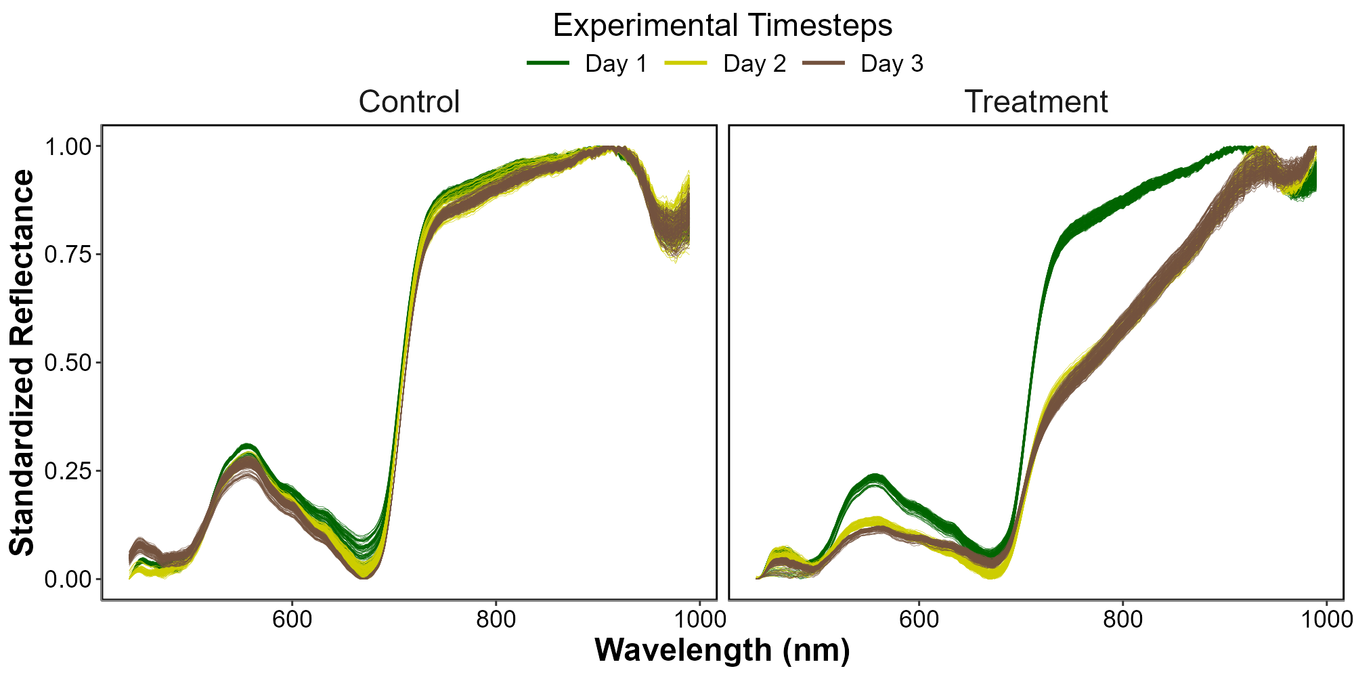
Figure 6: Standardized hyperspectral reflectance signature of Z. noltei leaves measured during the HW experiment for both the Control (Left) and the Treatment (Right). Color denotes the progression along the experiment from the beginning (Day 1: green), middle (Day 2: Yellow) and end (Day 3: Brown). A min-max standardization has been applied to each individual spectrum.

4.1.2 Evolution of spectral metrics
Similar patterns were found for the ($R″_{665 \text{nm}}$), NDVI and GLI, where the indices started similar to the control and consistently decline over the three days of experiment (Figure 7 A, B and C)
At the start of the experiment (day 1) $R″_{665 \text{nm}}$, NDVI and GLI in the Treatment group were on average 13% greater, 3% lower and 2% lower, respectively, than that of the Control. However, by day 2, the Treatment showed a rapid decease of approximately 27%, 17% and 28%, eventually reaching a total decline of 68%, 31% and 54% by day 3.
Unlike the other metrics, at the start of the experiment (day 1), the SHSI for the Treatment group was on average 55 % greater than that of the Control. By day 2, the SHSI for the Treatment exhibited a rapid decrease of approximately 241 %, eventually reaching a cumulative decline of 420 % by day 3 (Figure 7 D).
With a maximum deviation of 420 %, SHSI emerges as the most sensitive index for detecting seagrass browning. Consequently, only this index was considered for the next steps of this study.
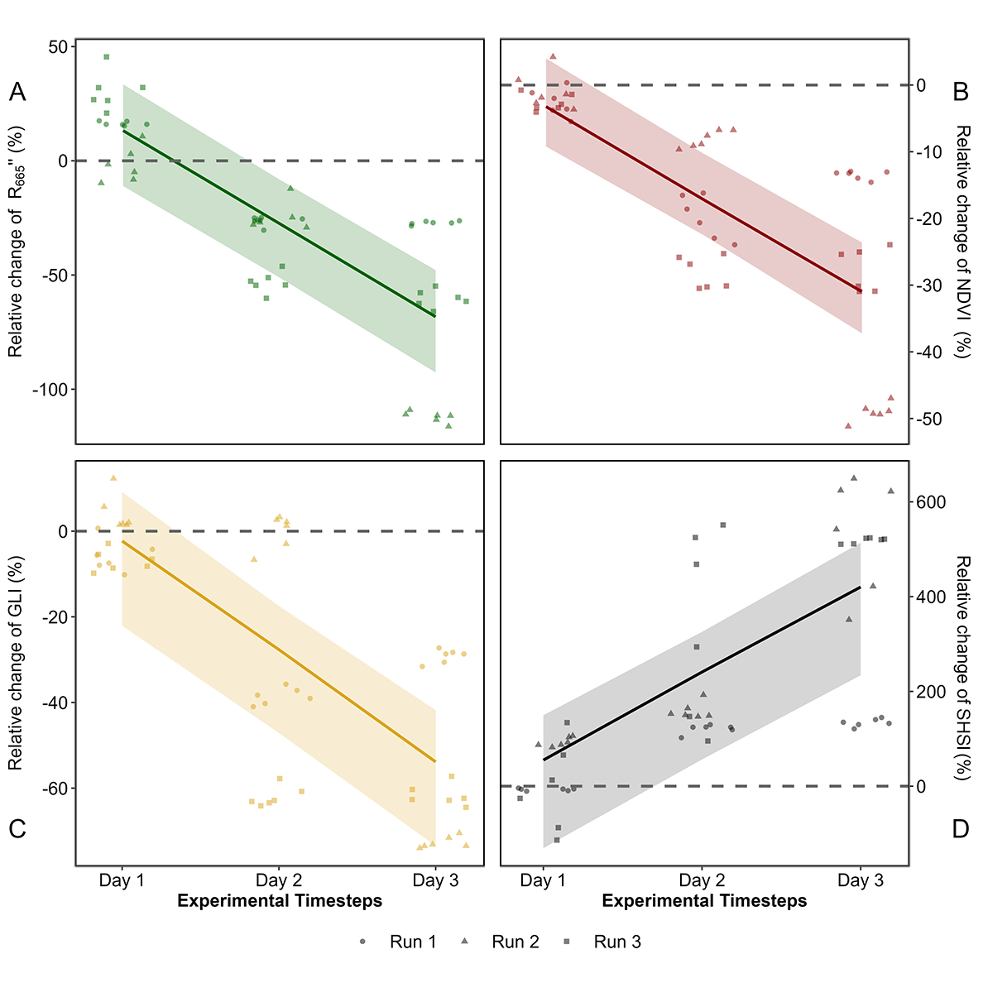
Figure 7: Comparison of spectral metrics for detecting reflectance changes of seagrass leaves after a HW. A: Relative difference of the second derivative at 665 nm between the Control and the Treatment over time; B: Relative difference of the NDVI; C: Relative difference of the GLI; D: Relative difference of the SHSI. Points indicate raw data, the line represents a generalized linear model, and the shaded area is the model’s standard error. The dased lines represent no difference between the Control and the Treatment.
Looking at raw SHSI values revealed clear distinctions between the Control and Treatment groups (Figure 8). At day 1, the SHSI of the Control and Treatment groups are comparable, with median values of -0.11 and -0.08, respectively. By the end of the experiment, seagrasses in the Treatment group exhibited a median SHSI of 0.15, consistent with their visibly darkened appearance. In contrast, the Control group retained a green appearance throughout the experiment, with a median SHSI of -0.07.
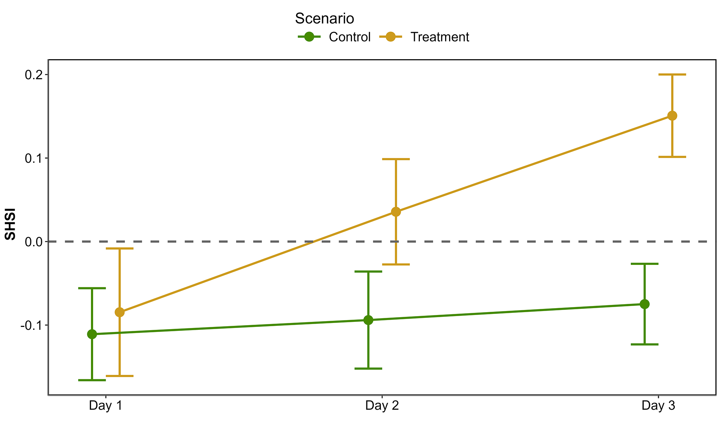
Figure 8: Median and standard deviation of the Seagrass Heat Shock Index (SHSI) across expimental runs, at each day of the experiment. The green line shows values of the Control group while the orange line indicates values of the Treatment group.

4.2 HW of September 2021 in Quiberon, South Brittany

4.2.1 Spectral changes
The Sentinel-2 images analyzed in this study corresponded to acquisitions on the 1st of September 2021 and the 6th of September 2021 (Figure 9 A and C, respectively). The Atmospheric Heat Wave (AHW) started on the 4th of September and lasted until the 7th of September, while the Marine Heat Wave (MHW) started on the 3rd of September and ended on the 8th of September 2021 (Figure 9 B). Both air and water temperatures experienced a sharp increase. Between September 1st and 6th, the daily average air temperature rose from 22.2 to 30.8 while the daily average water temperature increased from 17.7 to 19.3 °C. During this period, the 90th percentile temperatures were 25.3 °C for air and 18.8 °C for water. The air temperature anomaly of 9.9 °C classified the AHW as a strong event, whereas the 1.7 °C anomaly in water temperature classified the MHW as a moderate event.
The Sentinel-2 image from the 6th of September, captured two days after the start of the AHW already revealed brown seagrass leaves in the true-color composition (Figure 9 C). This contrasts with the reference image from the 1st of September 2021, taken before the HW began (Figure 9 A), where no brown patches can be observed. Before the event, all QPs appeared green on the Sentinel-2 image, with similar reflectance spectra, typical of green seagrass leaves (Figure 9 A and D). Their reflectance spectra showed a peak at 560 nm (in the green part of the spectra), low values at 665 nm and a high infrared plateau (> 705 nm). However, on the 6th of September, QPs classified as impacted during the field campaign, showed significant differences in their reflectance spectral shape compared to unimpacted QPs (Figure 9 C and E). The reflectance spectra of brown seagrass were characterized by the loss of the reflectance peak at 560 nm and a decrease in the infrared plateau, which was replaced by a steadily increasing slope up to 940 nm. The darkening of large areas within the meadow could also be observered in the true color composition (Figure 9 C)
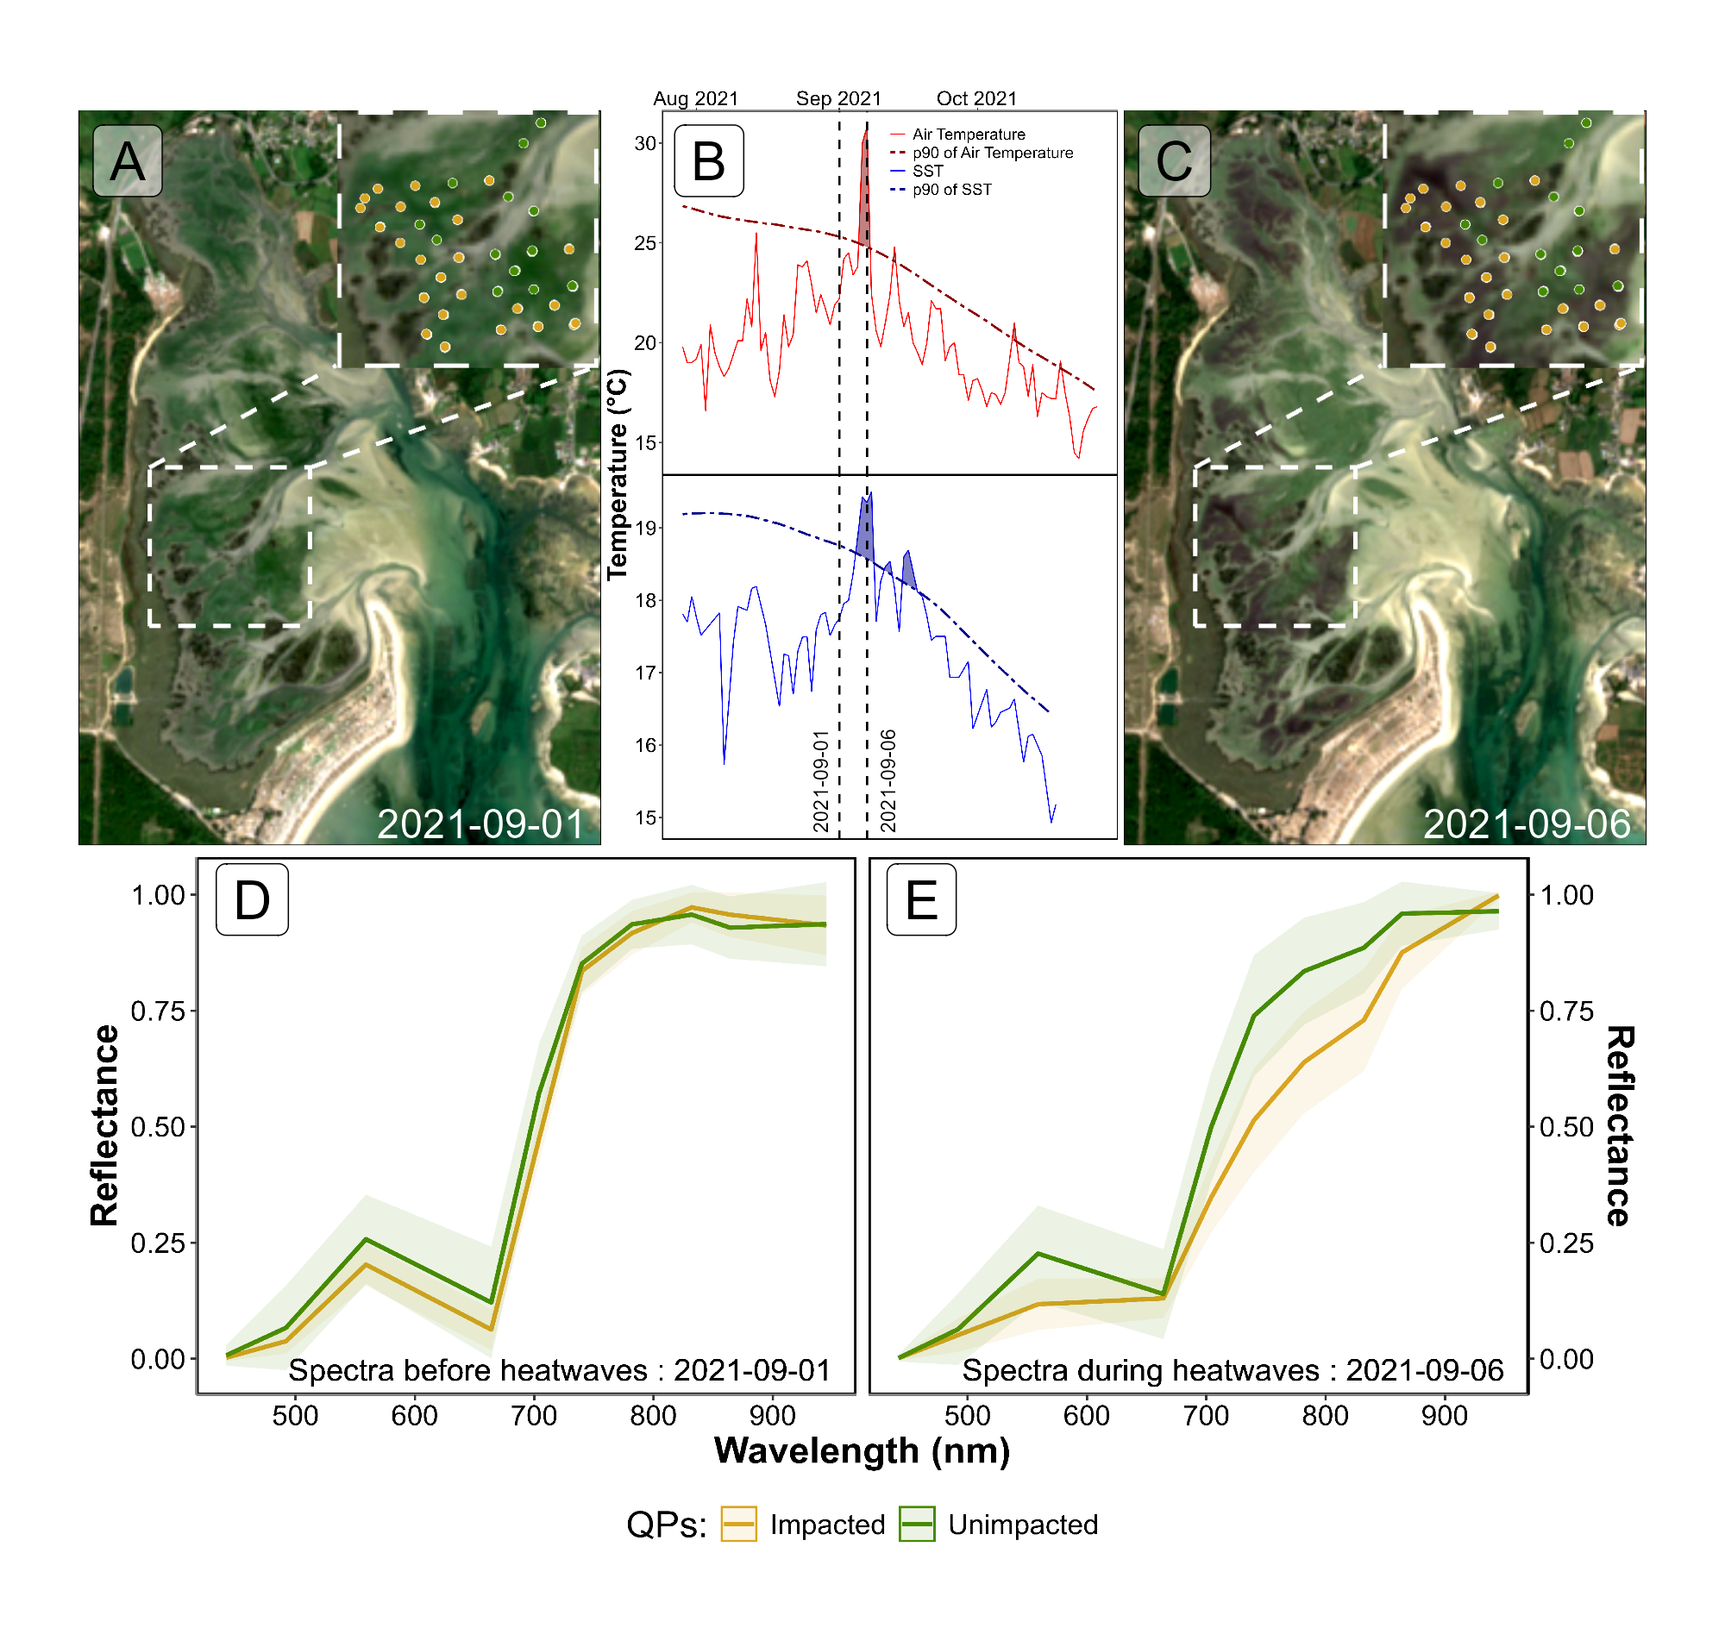
Figure 9: Intertidal seagrass meadow in South Brittany (France) observed before and during a heatwave (HW). A: RGB color composition of the Sentinel-2 image of the 1st of September 2021 before the HW; C: RGB color composition of the Sentinel-2 image of the 6th of September 2021 on the second day of a strong AHW. The circles correspond to Quadrat Points (QPs) collected on the 10th of September 2021, with unimpacted seagrass in green and impacted seagrass in orange; B: Detection of HW events based on both Air Temperature and Sea Surface Temperature (SST). The solid line represents the daily average temperature, while the dashed line indicates the 90th percentile of the climatology. Coloured areas identify HWs (marine in blue and atmospherical in red). The two vertical dashed lines represent the acquisition dates of the two Sentinel-2 images used in this analysis (01-09-2021 and 06-09-2021); D: Sentinel-2 reflectance of seagrass leaves before the HW for both categories of QPs; E: Sentinel-2 reflectance of seagrass leaves during the HW for both categories of QPs. Average spectral signatures were obtained in areas where QPs corresponded to green and brown seagrasses leaves (green and orange circles, respectively) as identified during the field survey. The shaded areas around the reflectance spectra represent the standard deviation.

4.2.2 SHSI metric applied to Sentinel-2
Using Sentinel-2 data and the QPs, SHSI was calculated for green seagrass unimpacted by the HW (QPs unimpacted Figure 9 C), showing minimal changes of 3 % between the 1st and the 6th of September (Figure 10). In contrast, seagrass impacted by the HW and turned brown (QPs impacted Figure 9 C) exhibited significant SHSI changes, showing an increase of 97 % during the HW exposure (Figure 10). One month after the event, on the 8th of October 2021, the SHSI of unimpacted seagrass had increased by 14 % compared to the 1st of September. Regarding impacted seagrass, one month after the event, the SHSI decreased to values comparable to those of unimpacted seagrass. This change reflects an increase of 15 % compared to values recorded on the 1st of September.
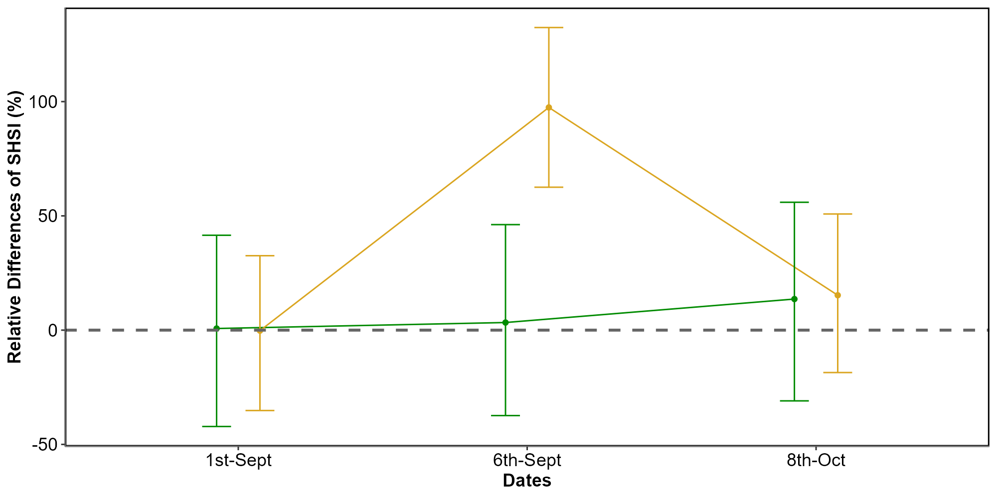
Figure 10: Changes in the relative Seagrass Heat Shock Index (SHSI) estimated from Sentinel-2, before (1st of September 2021), during (6th of September 2021) and after (8th of October 2021) a HW in the seagrass meadow of Quiberon (South Brittany, France). The relative SHSI difference was calulated using the 1st of September as a reference. SHSI was calculated for two categories of Quardrat Points (QPs; Figure 9): unimpacted seagrass (green) and impacted seagrass (orange). Points represent the predicted value of the metric using a Generalized Linear Model (GLM), while th error bar repsents the 89% confidence interval.
Using the SHSI (Equation 3), we detected large darkened seagrass patches in the meadow at the 6th of September (Figure 11). A total of 26.9 hectares of seagrass turned brown betwwen the 1st and the 6th of September. The largest brown patch covered nearly 8 hectares. Overall, 24 % of the total seagrass meadow area showed signs of darkening between the 1st and 6th of September 2021. Comparing the spatial distribution of darkened patches with the site’s topography revealed that 94.6 % of darkened areas were located above a bathymetric level of 3.9 meters (Figure 11, A and B). One month later, on the 8th of October, some of the previously darkened areas regained their green color (Figure 11 C).
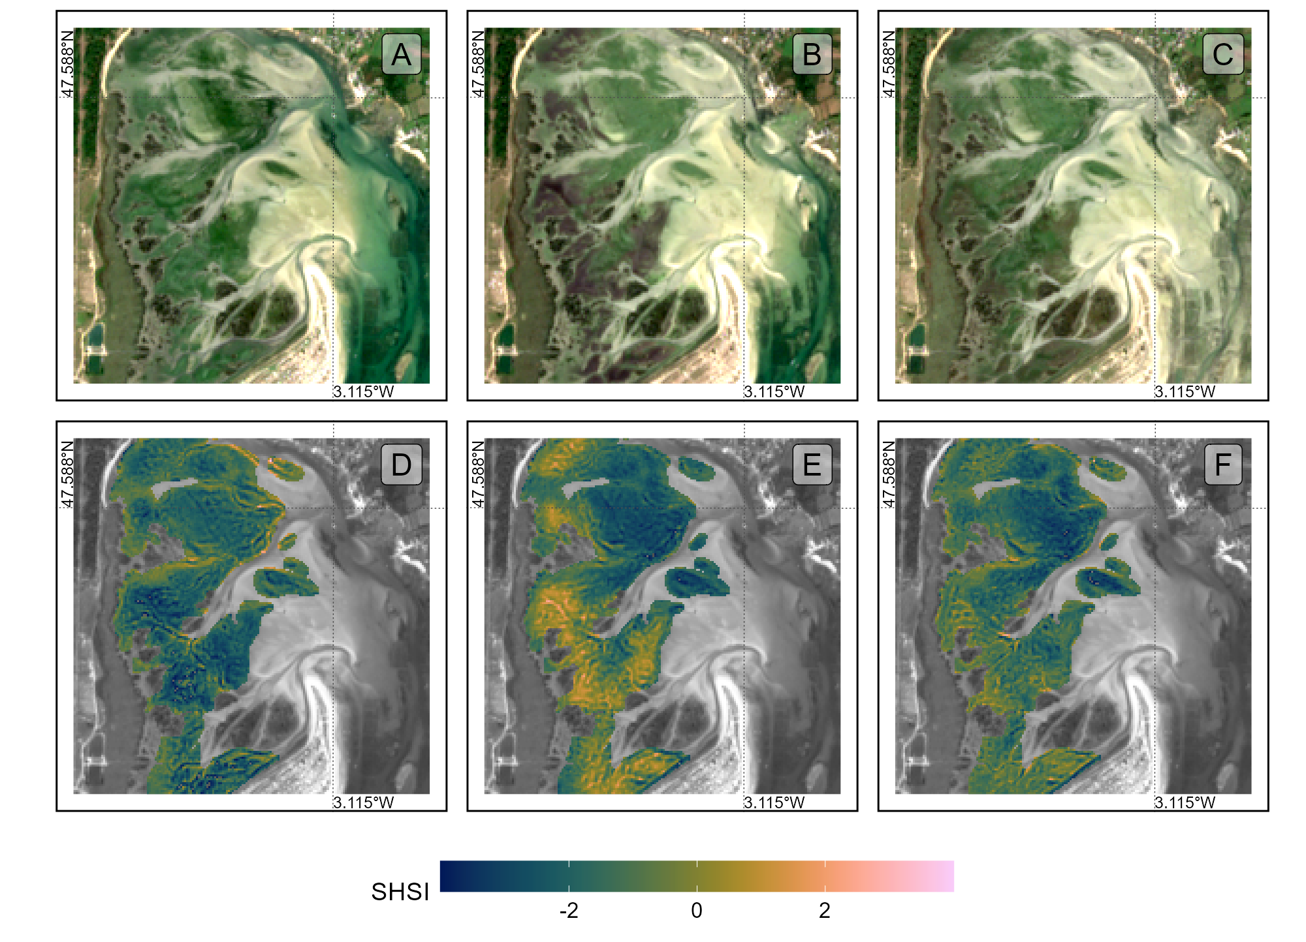
Figure 11: Sentinel-2 color composition of the seagrass meadow of Quiberon, South Brittany, France, Before (A), During (B) and After (C) the HW Seagrass Heat Shock Index applyed on Sentinel-2 images Before (D), During (E) and After (F) the HW.
Additionally, seagrass emersion time revealed a clear relationship between the duration of air exposure and seagrass darkening (Figure 12). During the HW, no significant darkening occurred with less than 13 hours of daily exposure. However, above 13 hours, seagrasses began to darken, reaching peak darkening at around 14.5 hours of daily exposure.
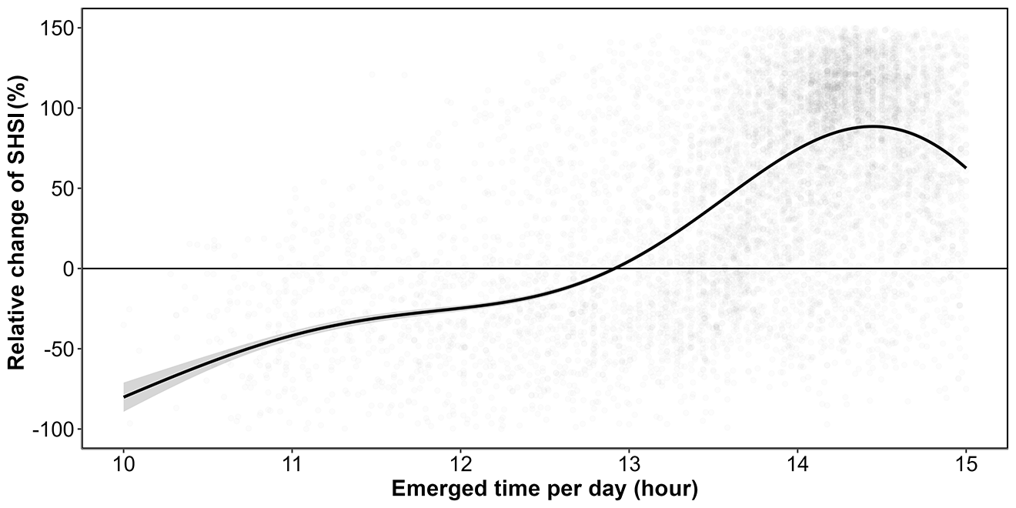
Figure 12: Relative change of the Seagrass Heat Shock Index (SHSI) before and during the HW events as a function of the daily emersion time of seagrass. The line represents a Generalized Additive Model (GAM) prediction, and the shaded area indicates the standard error. Shaded points represent raw data, each corresponding to a single pixel of the meadow.

5. Discussion

5.1 Physiological impacts of heatwaves on seagrasses
Although extensive research exists on marine heatwaves’ effects on subtidal seagrasses, little attention has been given to intertidal habitats and even less to the interaction between atmospherical extreme events and intertidal meadows. This study initiates an exploration of how intertidal seagrasses respond to the dual influence of MHWs and AHWs, underscoring the need for further investigation in this under explored area.
In the present study, significant changes in the reflectance of seagrasses exposed to HWs were observed experimentally. These changes mainly include a drop in reflectance around 560 nm and another drop around 740 nm in the near-infrared part of the spectrum (Figure 7). The second derivative at 665 nm (R’’665), NDVI, and GLI (Figure 7 B, C, and D) all demonstrated a clear decline over the experimental period (days 1-3).These changes suggest a progressive reduction in photosynthetic activity as well as structural or physiological changes in the leaves, such as degraded pigmentation or altered light absorption in the treatment group relative to the control as a consequence of the simulated HW event. In contrast, SHSI shows a marked increase, reaching up to 600% for some samples by day 3 (Figure 7 E). This positive trend in SHSI demonstrates its effectiveness as an index to quantify darkening of seagrass. While the general trends are consistent across experimental runs, there is some variability, particularly evident in the confidence intervals, which are wider for SHSI than for the other indices. This suggests that while darkening is a consistent response, it may vary in intensity between individual samples or experimental runs. Furthermore, the contrasting magnitudes of change—especially the pronounced increases in SHSI versus the declines in other indices—highlight the sensitivity of SHSI to changes associated with seagrass darkening, which could be indicative of stress or adaptation responses specific to the treatment conditions.
The change in color can be multifactorial and has been documented in plants under various stress conditions, including thermal stress (Dascaliuc et al., 2007; Jones and Clayton-Greene, 1992). Leaf blackening in angiosperms, as observed in Protea neriifolia, is primarily driven by oxidative processes involving the enzyme polyphenol oxidase (PPO) and the oxidation of phenolic compounds. When photosynthesis is inhibited by factors such as low light, chemical interference, or thermal stress, the plant’s production of essential carbohydrates and antioxidants diminishes, increasing oxidative stress and leading to darkening. Experimental essays have proved that low-oxygen environments and the addition of antioxydants like diphenylamine (DPA), have been effective in reducing these oxidative reactions. In the absence of photosynthesis, membrane integrity is also compromised, allowing PPO to interact with phenolic compounds, thereby accelerating darkening. Furthermore, high temperatures can destabilize membranes, especially in chloroplasts, disrupting photosystem II and impairing recovery of photosynthetic function. As chlorophyll-a degrades, the ratio of pigments shift; with pigments like carotenoids becoming more prominent, leading to a darkening of the leaves.
Zostera noltei, as a species inhabiting the intertidal zone and regularly exposed to air, has developed adaptations to minimize hydric stress. For example, it exhibits smaller, narrower leaves compared to species residing lower in the intertidal zone, such as Zostera marina, which helps reduce water loss during air exposure periods (Cabaço et al., 2009). However, during intense warming events and under high light conditions, desiccation can occur in certain parts of the meadow, particularly where seagrass leaves are exposed for prolonged periods (Figure 12). Under such hydric stress, cellular turgor pressure decreases (the internal cell water pressure that maintains cell shape), and concentrations of ions like Na+ and Cl– can reach toxic levels. These effects can impair cellular functions, enzymatic activity, and membrane stability.
High infrared reflectance in healthy plant leaves is primarly due to the internal cellular structure that scatters light. Once sunlight enters the leaf, it is diffused through various layers, particularly the spongy mesophyll, which contains air spaces and cell walls with different refractive indices. This scattering effect is intensified because there is minimal absorption in the near-infrared range (700 - 1300 nm), allowing light to reflect back through the leaf surface. Once the membranes (chloroplasts, thylakoids, cell walls) are destroyed due to oxidative stress, the reflectance in the Red Edge and the near-infrared regions of the spectrum (> 700 nm) decreases significantly (Knipling, 1970).
These unique reflectance properties of seagrasses under heat stress enable the detection of this darkening through remote sensing techniques. The SHSI (Equation 3) index developed in this study leverages key reflectance bands (560, 740 and 840 nm) to detect reductions in the green and the Red-Edge regions. SHSI can be used to assess the extent and severity of darkening events across intertidal seagrass meadows from space. Current multi-spectral satellite missions, including Sentinel-2, Pleiades-Neo, WorldView-3, SkySat, and GeoSat-2 along with upcoming missions (Sentinel-2 Next Generation and Landsat Next), capture reflectance in the three wavelengths used as input for SHSI. As climate change advances, remote sensing becomes a crucial tool for monitoring cumulative ecological impacts on seagrass meadows due to HWs. Although these physiological and structural changes occur at the cellular level over short temporal scales, their synchronously manifest across the entire meadow cause changes in large spatial extensions. Remote sensing, with its synoptic views and real-time acquisition capabilities, enables the monitoring of these rapid biological responses to natural stressors. However, cloud coverage can limit continuous observations, necessitating the integration of alternative tools, such as multi-spectral drone platforms. Combined approaches allow for precise, localized monitoring of damaged seagrass meadows immediately after extreme events, which is critical for the early detection of ecosystem degradation, quick actions for habitat conservation and targeted management strategies. Moreover, uninterrupted, multi-year data acquisition would strengthen predictive ecological models for future heatwave impacts, enhancing the capacity for adaptive management and supporting long-term resilience planning for seagrass ecosystems.

5.2 Climate change and heatwaves
The rapid global escalation of HW frequency, intensity and duration is a defining characteristic of the current climate crisis, heavily influenced by anthropogenic activities and greenhouse gas emissions (Devi et al., 2024; Russo and Domeisen, 2023). Recent research suggests that the magnitude of these events has surged in the recent decades, with climate projections predicting a continuation of this trend. For example, heatwaves that were once considered rare are now up to ten times more likely to occur, with some regions experiencing events three times as intense as those in the early 20th century. Cumulative indices that quantify heatwave intensity are based on total temperature exceedances and offer a more comprehensive understanding of event severity than average temperature alone. This is because the cumulative impact of prolonged high temperatures imposes more extensive stress on ecosystems than isolated peak temperatures (Russo and Domeisen, 2023).
From a hazard analysis perspective, the concurrent evaluation of intensity, frequency, and duration of atmospheric heatwaves allows for a partial understanding of their likely impacts. Models like the Heatwave Intensity Duration Frequency (HIDF) provide insights into various heatwave scenarios, indicating that both short intense and prolonged moderate events present unique risks depending on the region. For instance, in the Mediterranean, the frequency of high-intensity heatwaves has dramatically increased, leading to severe impacts on urban infrastructure, public health, energy consumption but also to terrestrial and intertidal ecosystems, such as seagrass meadows (Mazdiyasni et al., 2019; Smale et al., 2019). Sharper increase in extreme heat events are expected in regions experiencing large daily thermic amplitude, which underscores the role of atmospheric variability in local heatwave dynamics. In mid-latitudes, where daily variability is expected to decrease, heat extremes may stabilize at elevated levels, reducing cold extremes while allowing for increasingly frequent hot days (Simolo and Corti, 2022).
In the ocean, similar trends were observed with marine heatwaves (MHWs), which have increased by more than 50% in the total number of days per year since the early 20th century, and projections suggest that a near-permanent state of MHW, based on nowadays baselines, could develop by the end of the century if greenhouse gas emissions remain high (Oliver et al., 2019). Events like the “Blob” in the northeast Pacific (2013–2016) have underscored the ecological ramifications of such heat anomalies, including shifts in species distributions, mass mortalities, and habitat degradation across vast oceanic regions. The physical mechanisms driving MHWs, such as altered ocean circulation and air-sea heat flux, further illustrate the interconnection of atmospheric and marine systems in the context of climate-driven thermal extremes (Smale et al., 2019).
The escalating frequency and intensity of heatwaves represent not only an atmospheric anomaly but a profound disruption to ecological stability across diverse ecosystems (Devi et al., 2024; Stillman, 2019). The temperature spikes associated with these events occur over very short timescales, with limited recovery periods—giving organisms little to no opportunity to acclimate to rapidly changing conditions and often exceeding their tolerance limits. The sustained high temperatures associated with both atmospheric and marine heatwaves lead to physiological stress, habitat degradation, and increased mortality in many species, particularly those with limited thermal tolerance (Oliver et al., 2019; Simolo and Corti, 2022). Terrestrial and marine ecosystems experience shifts in species distributions, altered community dynamics, and reduced biodiversity as species are either forced to migrate or face local extinction under increasingly inhospitable conditions (Pansch et al., 2018). Similarly, in marine environments, prolonged heat stress from marine heatwaves has cascading effects on foundational species, including corals, kelps, and seagrasses, all of which are crucial for providing habitat, food, and shelter to diverse marine life (Oliver et al., 2019; Smale et al., 2019). Seagrasses, in particular, play a vital role in carbon sequestration and coastal protection but are especially vulnerable to extreme heat events. Elevated temperatures can disrupt seagrass photosynthesis and metabolic processes, leading to reduced growth and heightened susceptibility to disease (Deguette et al., 2022; Guerrero-Meseguer et al., 2020; Sawall et al., 2021; Winters et al., 2011). With repeated heatwave exposure and limited recovery periods, seagrass meadows may suffer severe declines, threatening their ability to deliver key ecosystem services such as carbon storage, sediment stabilization, and habitat provision (Mazdiyasni et al., 2019). The compounded impacts of atmospheric and marine heatwaves thus pose an existential threat to intertidal seagrass ecosystems, highlighting the urgent need for targeted climate adaptation measures to mitigate these escalating thermal stresses and preserve the resilience of these essential marine habitats (Russo and Domeisen, 2023; Stillman, 2019).

5.3 Seagrass resilience to heatwaves
Seagrass resilience to heatwaves is a complex and multifaceted issue shaped by species-specific traits, geographical location, and concurrent environmental stressors (Berger et al., 2024; Canadell and Jackson, 2021; Hatum et al., 2024). As climate change drives the frequency and intensity of marine heatwaves, understanding these dynamics becomes crucial, especially for temperate seagrass meadows composed of slow-growing, long-lived species like Posidonia spp., Amphibolis spp., and Zostera spp. These species, unlike their tropical counterparts, tend to be highly vulnerable to abrupt environmental changes, struggling to recover from disturbances due to their slower growth and longer lifespan. In contrast, colonizing species typical of tropical regions, such as Halodule spp., Halophila spp., and Syringodium spp., demonstrate greater resilience to warming events and marine heatwaves due to their rapid growth and more flexible life strategies (O’Brien et al., 2018).
The impact of HWs on seagrass ecosystems is further intensified by tidal variations, especially in temperate regions with large tidal ranges that can exceed 10 meters, such as Mont Saint Michel Bay , France. This pronounced tidal amplitude affects intertidal seagrasses like Zostera noltei, which experience varying durations of air exposure based on their position within the intertidal zone. During neap tides, seagrasses situated higher in the intertidal zone may remain exposed for extended periods, heightening their vulnerability to AHWs. Conversely, seagrasses in the lower intertidal zone experience prolonged immersion throughout the tidal cycle, making them susceptible to extreme MHWs. As a result, both marine and AHWs can increase stress on seagrass meadows, with effects that may be intensified by tidal timing and amplitude. In our study, we observed a darkening effect in the seagrasses, despite our experimental setup simulating tides with consistent 6-hour exposure periods. In natural settings, however, bathymetry plays a significant role, and depending on depth variations, seagrasses may be exposed for even longer periods during low tides. This suggests that in situ exposure times could exacerbate the stress effects observed, as seagrasses may endure prolonged air exposure beyond what our controlled conditions have replicated.
Species like Zostera noltei display distinct seasonal patterns that become increasingly pronounced at higher latitudes (Davies et al., 2024a, 2024b). These patterns reflect the species’ adaptation to seasonal variations in temperature and light, but they also make Z. noltei particularly sensitive to extreme events depending on their timing. For instance, if a heatwave coincides with early developmental stages or occurs after the biomass peak when leaf senescence has begun, the impact on meadow resilience can be severe.
Environmental conditions can moderate seagrass resilience to thermal stress. Seagrass meadows located in areas benefiting from tidal cooling or positioned further from the warmer edges of their geographical ranges often experience reduced heat stress, resulting in higher shoot densities and enhanced resilience (Berger et al., 2024; Canadell and Jackson, 2021). In these cooler areas, Zostera noltei exhibits high survival and photosynthetic performance up to 37°C, though temperatures above 39°C lead to near-total mortality within days, underscoring the species’ sensitivity to temperature thresholds that may become increasingly common under climate change scenarios (Franssen et al., 2014). Moreover, the frequency, duration, and intervals between heatwaves significantly affect seagrass biomass and recovery; prolonged and frequent heatwaves reduce resilience and complicate recovery processes (Hatum et al., 2024).
The influence of other stressors, such as eutrophication and sulfide accumulation, complicates this resilience. Increased sediment sulfide levels, which often accompany nutrient enrichment, can be toxic to seagrasses, particularly under elevated temperatures that amplify sulfide toxicity. Zostera noltei, for example, has a mutualistic relationship with lucinid clams that helps detoxify sulfides. However, this interaction is compromised at high temperatures, reducing the efficacy of sulfide removal and further inhibiting nutrient uptake, growth, and overall resilience (De Fouw et al., 2022).
In a simulated heatwave experiment on Zostera noltei, resilience was evident under short-term moderate stress, with no significant changes in photosynthetic performance or survival (Franssen et al., 2014; Massa et al., 2009). However, prolonged or more intense heat events posed a greater challenge, highlighting the species’ limited capacity to withstand chronic thermal stress. The long-term impact of heatwaves is especially evident in changes to seagrass cover (SC). Before the heatwave event on 1st September 2021, impacted seagrass patches exhibited higher SC than non-impacted areas. However, during the event on 6th September, the SC in the impacted patch experienced a sharp decline on impacted patches. By 8th October, one month post-event, the SC of impacted seagrasses, initially higher, had fallen below that of non-impacted seagrasses (Figure 10). The observed decrease in seagrass cover on 6th September was primarily due to leaf darkening. This darkening influenced the satellite NDVI measurements used to estimate SC (Zoffoli et al., 2020), creating an apparent decrease in SC in the impacted patch when, in reality, itremained stable (Figure 5). The bias introduced by remote sensing in this instance reflects a limitation in accurately capturing true seagrass cover during stress events. It was only after the heatwave that leaves began to detach, leading to an actual decline in seagrass density. This delayed physical response underscores how extreme events can compromise seagrass resilience, leaving previously robust patches in a weakened state compared to less disturbed areas (Figure 10).
On a physiological level, seagrasses possess coping mechanisms such as photoprotective responses and heat-responsive gene expression, including the activation of heat-shock proteins (HSPs) and other stress-related genes (Hughes and Stachowicz, 2004; Reusch et al., 2005). Zostera noltei, in particular, has shown differential gene expression responses to heat stress, with a variety of genes involved in protein folding, membrane stability, and reactive oxygen species scavenging playing critical roles. However, the rapid pace of climate change raises concerns about whether these adaptations can keep up with the increasing frequency and severity of thermal events (Franssen et al., 2014).

5.4 Big picture
Given the combined pressures of temperature extremes, eutrophication, and other anthropogenic impacts, targeted management strategies are essential for enhancing seagrass resilience (Loarie et al., 2009). Approaches such as reducing local stressors, cultivating heat-tolerant genotypes, and investing in restoration initiatives are vital to supporting these ecosystems in a warming climate. Although challenges remain, the adaptability and potential resilience of certain seagrass species offer hope for their persistence amid accelerating ecological shifts. In particular, regions that can buffer seagrasses from extreme stressors or provide cooler refuges may play a critical role in maintaining these valuable ecosystems in the face of global climate change (Canadell and Jackson, 2021; De Fouw et al., 2022).
Seagrass meadows function as foundational components of coastal ecosystems, sustaining diverse marine communities by providing essential habitats, nursery grounds, and trophic resources for fish, invertebrates, and migratory birds (Zoffoli et al., 2023). Their dense canopies stabilize sediment and protect shorelines from erosion, an increasingly crucial role as sea levels rise due to climate change (Folmer et al., 2012; Gacia et al., 1999). Recurrent HW events, which induce physiological stress like leaf darkening, can severely diminish seagrass density, thereby reducing their effectiveness in sediment stabilization and wave attenuation, ultimately increasing the risk of coastal erosion (Calleja et al., 2007). From a biodiversity perspective, degradation of these meadows disrupts intricate food webs, impacting commercially significant fish and shellfish populations that rely on seagrass for sustenance and refuge. This loss can reduce local fisheries’ productivity and threaten the livelihoods of coastal communities (Unsworth and Cullen-Unsworth, 2014). Furthermore, as seagrass meadows decline, their capacity to act as a blue carbon sink—critical for climate mitigation—also diminishes, inadvertently contributing to increased atmospheric carbon levels (Armitage and Fourqurean, 2016; Samper-Villarreal et al., 2020)

6. Conclusion
This research has investigated the effects of both marine and atmospheric heatwaves on the intertidal seagrass Zostera noltei, a critical component of coastal ecosystems facing increased thermal stress due to climate change. By examining reflectance and pigment composition under controlled experimental conditions and validating these findings with satellite data, we aimed to understand how extreme heat events affect seagrass health and assess the potential of remote sensing to monitor these impacts effectively. Our findings reveal that heatwaves lead to substantial declines in seagrass reflectance, particularly in the green and near-infrared regions, likely driven by pigment degradation and structural damage. This change is reflected in significant reductions in key vegetation indices such as NDVI and GLI. The Seagrass Heat Shock Index (SHSI), developed in this study, successfully detected seagrass darkening, a visible symptom of heatwave stress, demonstrating the viability of spectral monitoring to capture early-stage impacts of heat events on intertidal ecosystems. By connecting our findings with satellite data, we have also confirmed the broader spatial impact of heatwaves on seagrass meadows in Quiberon, France. The correlation between heatwave exposure and darkening of seagrass suggests that remote sensing, combined with targeted field observations, can enhance our understanding of ecosystem responses to climate-driven thermal events. These results advocate for integrating continuous spectral monitoring into conservation strategies, as it can help predict the resilience of these ecosystems and guide adaptive management practices. As climate change accelerates, with a predicted increase in the frequency and intensity of heatwaves, the vulnerability of intertidal zones to such events will likely intensify compromising meadows survival and their ecosystem functions. This study not only underscores the importance of seagrass meadows in coastal ecosystems but also highlights the urgency of protecting these critical habitats. Future work should focus on refining remote sensing tools and examining the cumulative effects of repeated heatwave events to support the conservation of intertidal seagrass meadows in a warming world.

7. Annexes

7.1 Annexes A - Temperatures of the experiment
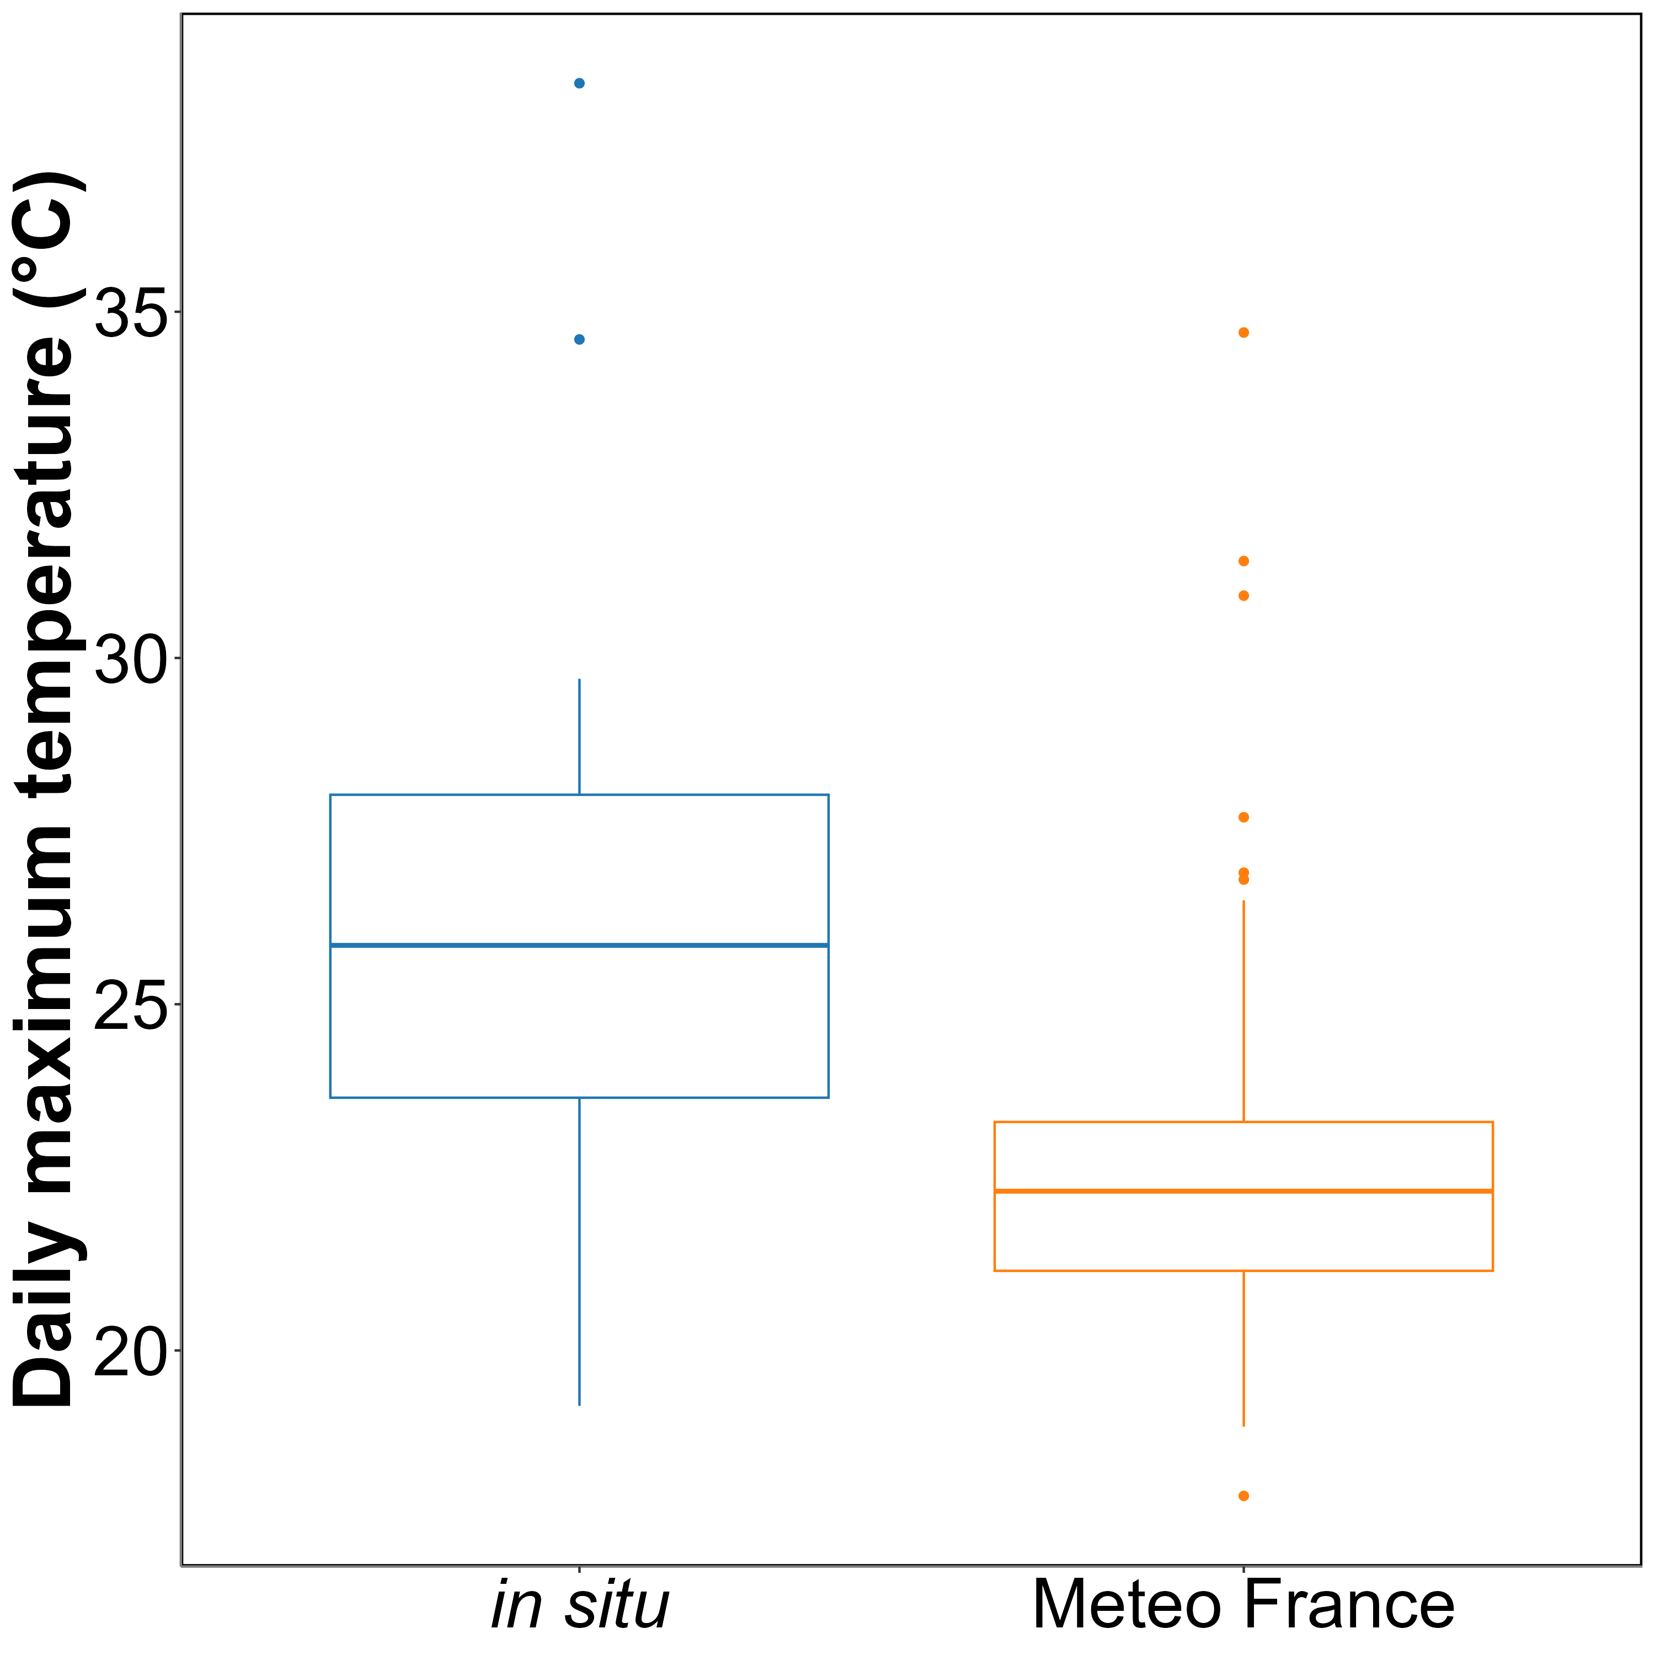
Annexe A1: Comparison of daily maximum temperatures in August measured using an in-situ sensor (blue) and retrieved from Meteo France (orange). The solid line in the middle of the boxplot represents the median, the two ends of the box represent the 25th and 75th percentiles, and the whiskers represent values that are no more than 1.5 times the interquartile range.
On average, in situ temperatures were 3 ± 3.2°C higher than those recorded by Meteo France. Additionally, temperatures recorded by Meteo France were more stable than those from the in situ sensors, likely due to the sheltered and shaded location of the Meteo France equipment. This difference was used to adjust heatwave temperatures measured by Meteo France to better reflect the conditions experienced by the seagrasses.

8. References
Akbar, M., Arisanto, P., Sukirno, B., Merdeka, P., Priadhi, M., Zallesa, S., 2020. Mangrove vegetation health index analysis by implementing NDVI (normalized difference vegetation index) classification method on sentinel-2 image data case study: Segara anakan, kabupaten cilacap, in: IOP Conference Series: Earth and Environmental Science. IOP Publishing, p. 012069.
Armitage, A., Fourqurean, J.W., 2016. Carbon storage in seagrass soils: Long-term nutrient history exceeds the effects of near-term nutrient enrichment. Biogeosciences 13, 313–321.
Bastos, M., Roebeling, P., Alves, F.L., Villasante, S., Magalhães Filho, L., 2023. High risk water pollution hazards affecting aveiro coastal lagoon (portugal)–a habitat risk assessment using InVEST. Ecological Informatics 76, 102144.
Berger, A.C., Berg, P., McGlathery, K.J., Aoki, L.R., Kerns, K., 2024. Eelgrass meadow response to heat stress. II. Impacts of ocean warming and marine heatwaves measured by novel metrics. Marine Ecology Progress Series 736, 47–62. https://doi.org/10.3354/meps14588
Boyer, M., Miller, J., Belanger, M., Hare, E., Wu, J., 1988. Senescence and spectral reflectance in leaves of northern pin oak (quercus palustris muenchh.). Remote Sensing of Environment 25, 71–87.
Bürkner, P.-C., 2021. Bayesian item response modeling in r with brms and stan. Journal of Statistical Software 100, 1–54. https://doi.org/10.18637/jss.v100.i05
Cabaço, S., Machás, R., Santos, R., 2009. Individual and population plasticity of the seagrass zostera noltii along a vertical intertidal gradient. Estuarine, Coastal and Shelf Science 82, 301–308.
Calleja, M.L., Marbà, N., Duarte, C.M., 2007. The relationship between seagrass (posidonia oceanica) decline and sulfide porewater concentration in carbonate sediments. Estuarine, Coastal and Shelf Science 73, 583–588.
Canadell, J.G., Jackson, R.B., 2021. Ecosystem collapse and climate change. Springer.
Carpenter, B., Gelman, A., Hoffman, M.D., Lee, D., Goodrich, B., Betancourt, M., Brubaker, M., Guo, J., Li, P., Riddell, A., 2017. Stan: A probabilistic programming language. Journal of Statistical Software 76, 1–32. https://doi.org/10.18637/jss.v076.i01
CMEMS, 2024. European north west shelf/iberia biscay irish seas – high resolution ODYSSEA sea surface temperature multi-sensor L3 observations reprocessed, e.u. Copernicus marine service information (CMEMS). Marine data store (MDS). (Accessed on 17-10-2024). https://doi.org/10.48670/moi-00311
Dascaliuc, A., Ralea, T., Cuza, P., 2007. Influence of heat shock on chlorophyll fluorescence of white oak (quercus pubescens willd.) leaves. Photosynthetica 45, 469–471. https://doi.org/10.1007/s11099-007-0084-3
Davies, B.F.R., Gernez, P., Geraud, A., Oiry, S., Rosa, P., Zoffoli, M.L., Barillé, L., 2023. Multi-and hyperspectral classification of soft-bottom intertidal vegetation using a spectral library for coastal biodiversity remote sensing. Remote Sensing of Environment 290, 113554.
Davies, B.F.R., Oiry, S., Rosa, P., Zoffoli, M.L., Sousa, A.I., Thomas, O.R., Smale, D.A., Austen, M.C., Biermann, L., Attrill, M.J., others, 2024a. A sentinel watching over inter-tidal seagrass phenology across western europe and north africa. Communications Earth & Environment 5, 382. https://doi.org/10.1038/s43247-024-01543-z
Davies, B.F.R., Oiry, S., Rosa, P., Zoffoli, M.L., Sousa, A.I., Thomas, O.R., Smale, D.A., Austen, M.C., Biermann, L., Attrill, M.J., others, 2024b. Intertidal seagrass extent from sentinel-2 time-series show distinct trajectories in western europe. Remote Sensing of Environment 312, 114340. https://doi.org/10.1016/j.rse.2024.114340
De Fouw, J., Rehlmeyer, K., Geest, M. van der, Smolders, A.J., Van Der Heide, T., 2022. Increased temperature reduces the positive effect of sulfide-detoxification mutualism on zostera noltii nutrient uptake and growth. Marine Ecology Progress Series 692, 43–52.
Deguette, A., Barrote, I., Silva, J., 2022. Physiological and morphological effects of a marine heatwave on the seagrass cymodocea nodosa. Scientific Reports 12, 7950.
Devi, R., Gouda, K., Lenka, S., 2024. Intensity duration and frequency of heat wave in different phases of MJO over india. Atmospheric Research 300, 107250.
Douay, F., Verpoorter, C., Duong, G., Spilmont, N., Gevaert, F., 2022. New hyperspectral procedure to discriminate intertidal macroalgae. Remote Sensing 14, 346.
Electric Blue, 2023. Intertidal chamber.
European Space Agency, 2024b. Sen2Cor: Sentinel-2 atmospheric correction processor.
European Space Agency, 2024a. Copernicus open access hub.
Folmer, E.O., Geest, M. van der, Jansen, E., Olff, H., Michael Anderson, T., Piersma, T., Gils, J.A. van, 2012. Seagrass–sediment feedback: An exploration using a non-recursive structural equation model. Ecosystems 15, 1380–1393.
Franssen, S.U., Gu, J., Winters, G., Huylmans, A.-K., Wienpahl, I., Sparwel, M., Coyer, J.A., Olsen, J.L., Reusch, T.B., Bornberg-Bauer, E., 2014. Genome-wide transcriptomic responses of the seagrasses zostera marina and nanozostera noltii under a simulated heatwave confirm functional types. Marine Genomics 15, 65–73.
Gacia, E., Granata, T., Duarte, C., 1999. An approach to measurement of particle flux and sediment retention within seagrass (posidonia oceanica) meadows. Aquatic Botany 65, 255–268.
Garbulsky, M.F., Peñuelas, J., Gamon, J., Inoue, Y., Filella, I., 2011. The photochemical reflectance index (PRI) and the remote sensing of leaf, canopy and ecosystem radiation use efficiencies: A review and meta-analysis. Remote sensing of environment 115, 281–297.
Gardner, R.C., Finlayson, C., 2018. Global wetland outlook: State of the world’s wetlands and their services to people, in: Ramsar Convention Secretariat. pp. 2020–5.
Guerrero-Meseguer, L., Marı́n, A., Sanz-Lázaro, C., 2020. Heat wave intensity can vary the cumulative effects of multiple environmental stressors on posidonia oceanica seedlings. Marine Environmental Research 159, 105001.
Hatum, P.S., McMahon, K., Mengersen, K., Kilminster, K., Wu, P.P.-Y., 2024. Predicting seagrass ecosystem resilience to marine heatwave events of variable duration, frequency and re-occurrence patterns with gaps. Aquatic Conservation: Marine and Freshwater Ecosystems 34, e4210. https://doi.org/10.1002/aqc.4210
Hobday, A.J., Alexander, L.V., Perkins, S.E., Smale, D.A., Straub, S.C., Oliver, E.C., Benthuysen, J.A., Burrows, M.T., Donat, M.G., Feng, M., others, 2016. A hierarchical approach to defining marine heatwaves. Progress in oceanography 141, 227–238.
Hobday, A.J., Oliver, E.C., Gupta, A.S., Benthuysen, J.A., Burrows, M.T., Donat, M.G., Holbrook, N.J., Moore, P.J., Thomsen, M.S., Wernberg, T., others, 2018. Categorizing and naming marine heatwaves. Oceanography 31, 162–173.
Hughes, A.R., Stachowicz, J.J., 2004. Genetic diversity enhances the resistance of a seagrass ecosystem to disturbance. Proceedings of the National Academy of Sciences 101, 8998–9002. https://doi.org/10.1073/pnas.0402642101
IOC, 2024. Intergovernmental oceanographic commission ; sea level monitoring station - le conquet, france (LECY).
Jankowska, E., Michel, L.N., Lepoint, G., Włodarska-Kowalczuk, M., 2019. Stabilizing effects of seagrass meadows on coastal water benthic food webs. Journal of Experimental Marine Biology and Ecology 510, 54–63.
Jones, R.B., Clayton-Greene, K.A., 1992. The role of photosynthesis and oxidative reactions in leaf blackening of protea neriifolia r. Br. leaves. Scientia Horticulturae 50, 137–145. https://doi.org/10.1016/S0304-4238(05)80016-0
Knipling, E.B., 1970. Physical and physiological basis for the reflectance of visible and near-infrared radiation from vegetation. Remote Sensing of Environment 1, 155–159. https://doi.org/10.1016/S0034-4257(70)80021-9
Lehnert, L.W., Meyer, H., Bendix, J., 2017. Hsdar: Manage, analyse and simulate hyperspectral data in r.
Loarie, S.R., Duffy, P.B., Hamilton, H., Asner, G.P., Field, C.B., Ackerly, D.D., 2009. The velocity of climate change. Nature 462, 1052–1055.
Louhaichi, M., Borman, M.M., Johnson, D.E., 2001. Spatially located platform and aerial photography for documentation of grazing impacts on wheat. Geocarto International 16, 65–70.
Malvern Panalytical, 2023. RS3 software.
Mariën, B., Balzarolo, M., Dox, I., Leys, S., Lorène, M.J., Geron, C., Portillo-Estrada, M., AbdElgawad, H., Asard, H., Campioli, M., 2019. Detecting the onset of autumn leaf senescence in deciduous forest trees of the temperate zone. New Phytologist 224, 166–176.
Massa, S., Arnaud-Haond, S., Pearson, G., Serrão, E., 2009. Temperature tolerance and survival of intertidal populations of the seagrass zostera noltii (hornemann) in southern europe (ria formosa, portugal). Hydrobiologia 619, 195–201.
Mazdiyasni, O., Sadegh, M., Chiang, F., AghaKouchak, A., 2019. Heat wave intensity duration frequency curve: A multivariate approach for hazard and attribution analysis. Scientific Reports 9, 14117. https://doi.org/10.1038/s41598-019-50643-w
O’Brien, K.R., Waycott, M., Maxwell, P., Kendrick, G.A., Udy, J.W., Ferguson, A.J., Kilminster, K., Scanes, P., McKenzie, L.J., McMahon, K., others, 2018. Seagrass ecosystem trajectory depends on the relative timescales of resistance, recovery and disturbance. Marine Pollution Bulletin 134, 166–176.
Oiry, S., Davies, B.F.R., Sousa, A.I., Rosa, P., Zoffoli, M.L., Brunier, G., Gernez, P., Barillé, L., 2024. Discriminating seagrasses from green macroalgae in european intertidal areas using high-resolution multispectral drone imagery. Remote Sensing 16. https://doi.org/10.3390/rs16234383
Oliver, E.C.J., Burrows, M.T., Donat, M.G., others, 2019. Projected marine heatwaves in the 21st century and the potential for ecological impact. Frontiers in Marine Science 6, 734. https://doi.org/10.3389/fmars.2019.00734
Olmedo-Masat, O.M., Raffo, M.P., Rodrı́guez-Pérez, D., Arijón, M., Sánchez-Carnero, N., 2020. How far can we classify macroalgae remotely? An example using a new spectral library of species from the south west atlantic (argentine patagonia). Remote Sensing 12, 3870.
Pansch, C., Scotti, M., Barboza, F.R., others, 2018. Heat waves and their significance for a temperate benthic community: A near-natural experimental approach. Global Change Biology 24, 4357–4367. https://doi.org/10.1111/gcb.14282
Peñuelas, J., Munné-Bosch, S., Llusià, J., Filella, I., 2004. Leaf reflectance and photo-and antioxidant protection in field-grown summer-stressed phillyrea angustifolia. Optical signals of oxidative stress? New Phytologist 162, 115–124.
Perkins, S.E., Alexander, L.V., 2013. On the measurement of heat waves. Journal of climate 26, 4500–4517.
R Core Team, 2023. R: A language and environment for statistical computing. R Foundation for Statistical Computing, Vienna, Austria.
Ramesh, C., Mohanraju, R., 2020. Seagrass ecosystems of andaman and nicobar islands: Status and future perspective. Environmental & Earth Sciences Research Journal 7.
Reusch, T.B., Ehlers, A., Hämmerli, A., Worm, B., 2005. Ecosystem recovery after climatic extremes enhanced by genotypic diversity. Proceedings of the National Academy of Sciences 102, 2826–2831. https://doi.org/10.1073/pnas.0500008102
Román, A., Tovar-Sánchez, A., Olivé, I., Navarro, G., 2021. Using a UAV-mounted multispectral camera for the monitoring of marine macrophytes. Frontiers in Marine Science 8, 722698.
Rouse, J.W., Haas, R.H., Schell, J.A., Deering, D.W., others, 1974. Monitoring vegetation systems in the great plains with ERTS. NASA Spec. Publ 351, 309.
Russo, E., Domeisen, D.I.V., 2023. Increasing intensity of extreme heatwaves: The crucial role of metrics. Geophysical Research Letters 50, e2023GL103540. https://doi.org/10.1029/2023GL103540
Samper-Villarreal, J., Bolaños, R.C., Heidemeyer, M., Vargas, M.M., Vargas, R.M., 2020. Characterization of seagrasses at two new locations in the eastern tropical pacific (el jobo and matapalito, costa rica). Aquatic botany 165, 103237.
Sawall, Y., Ito, M., Pansch, C., 2021. Chronically elevated sea surface temperatures revealed high susceptibility of the eelgrass zostera marina to winter and spring warming. Limnology and Oceanography 66, 4112–4124.
Schlegel, R.W., Smit, A.J., 2018. heatwaveR: A central algorithm for the detection of heatwaves and cold-spells. Journal of Open Source Software 3, 821. https://doi.org/10.21105/joss.00821
Scott, A.L., York, P.H., Duncan, C., Macreadie, P.I., Connolly, R.M., Ellis, M.T., Jarvis, J.C., Jinks, K.I., Marsh, H., Rasheed, M.A., 2018. The role of herbivory in structuring tropical seagrass ecosystem service delivery. Frontiers in Plant Science 9, 127.
Sevgi, K., Leblebici, S., 2022. Bitkilerde ağır metal stresine verilen fizyolojik ve moleküler yanıtlar. Journal of Anatolian Environmental and Animal Sciences 7, 528–536.
Shom, 2022. Service hydrographique et océanographique de la marine ; références altimétriques maritimes: Ports de france métropolitaine et d’outre-mer, cotes du zéro hydrographique et niveaux caractéristiques de la marée. Shom, Brest, France.
SHOM, 2021. Service hydrographique et océanographique de la marine ; bathymétrie Litto3D® bretagne 2018-2021.
Simolo, C., Corti, S., 2022. Quantifying the role of variability in future intensification of heat extremes. Nature Communications 13. https://doi.org/10.1038/s41467-022-35571-0
Skendzic, S., 2023. Drought stress in winter wheat-physiological responses and detection using remote and proximal sensing techniques, in: Smart Life Sciences and Technology for Sustainable Development. pp. 39–39.
Smale, D.A., Wernberg, T., Oliver, E.C.J., others, 2019. Marine heatwaves threaten global biodiversity and the provision of ecosystem services. Nature Climate Change 9, 306–312. https://doi.org/10.1038/s41558-019-0412-1
Sousa, A.I., Silva, J.F. da, Azevedo, A., Lillebø, A.I., 2019. Blue carbon stock in zostera noltei meadows at ria de aveiro coastal lagoon (portugal) over a decade. Scientific reports 9, 14387.
Stan Development Team, C., others, 2020. RStan: The r interface to stan. R package version 2.21. 2.
Stillman, J.H., 2019. Heat waves, the new normal: Summertime temperature extremes will impact animals, ecosystems, and human communities. Physiology 34, 86–100. https://doi.org/10.1152/physiol.00040.2018
Thomsen, E., Herbeck, L.S., Viana, I.G., Jennerjahn, T.C., 2023. Meadow trophic status regulates the nitrogen filter function of tropical seagrasses in seasonally eutrophic coastal waters. Limnology and Oceanography 68, 1906–1919.
Unsworth, R., Cullen-Unsworth, L.C., 2014. Biodiversity, ecosystem services, and the conservation of seagrass meadows. Coast. Conserv 19, 95.
Unsworth, R.K., Cullen-Unsworth, L.C., Jones, B.L., Lilley, R.J., 2022. The planetary role of seagrass conservation. Science 377, 609–613.
Ustin, S.L., Jacquemoud, S., 2020. How the optical properties of leaves modify the absorption and scattering of energy and enhance leaf functionality. Remote sensing of plant biodiversity 349–384.
Waycott, M., Duarte, C.M., Carruthers, T.J., Orth, R.J., Dennison, W.C., Olyarnik, S., Calladine, A., Fourqurean, J.W., Heck Jr, K.L., Hughes, A.R., others, 2009. Accelerating loss of seagrasses across the globe threatens coastal ecosystems. Proceedings of the national academy of sciences 106, 12377–12381.
Winters, G., Nelle, P., Fricke, B., Rauch, G., Reusch, T.B., 2011. Effects of a simulated heat wave on photophysiology and gene expression of high-and low-latitude populations of zostera marina. Marine Ecology Progress Series 435, 83–95.
Zahoor, I., Mushtaq, A., 2023. Water pollution from agricultural activities: A critical global review. Int. J. Chem. Biochem. Sci 23, 164–176.
Zoffoli, M.L., Gernez, P., Godet, L., Peters, S., Oiry, S., Barillé, L., 2021. Decadal increase in the ecological status of a north-atlantic intertidal seagrass meadow observed with multi-mission satellite time-series. Ecological Indicators 130, 108033.
Zoffoli, M.L., Gernez, P., Oiry, S., Godet, L., Dalloyau, S., Davies, B.F.R., Barillé, L., 2023. Remote sensing in seagrass ecology: Coupled dynamics between migratory herbivorous birds and intertidal meadows observed by satellite during four decades. Remote Sensing in Ecology and Conservation 9, 420–433. https://doi.org/10.1002/rse2.319
Zoffoli, M.L., Gernez, P., Rosa, P., Le Bris, A., Brando, V.E., Barillé, A.-L., Harin, N., Peters, S., Poser, K., Spaias, L., others, 2020. Sentinel-2 remote sensing of zostera noltei-dominated intertidal seagrass meadows. Remote Sensing of Environment 251, 112020.

Institut des Substances et Organismes de la Mer, ISOMer, Nantes Université, UR 2160, F-44000 Nantes, France
Consiglio Nazionale delle Ricerche, Istituto di Scienze Marine (CNR-ISMAR), 00133 Rome, Italy
Bio-littoral, Immeuble Le Nevada, 2 Rue du Château de l’Eraudière, 44300 Nantes, France

