Effect of Marine and Atmospheric Heatwaves on Reflectance and Pigment Composition of Intertidal Zostera noltei

Simon Oiry¹, Bede Ffinian Rowe Davies¹, Philippe Rosa¹, Augustin Debly¹, Maria Laura Zoffoli², Anne-Laure Barillé³, Nicolas Harin³, Pierre Gernez¹, and Laurent Barillé¹
¹Institut des Substances et Organismes de la Mer, ISOMer, Nantes Université, UR 2160, F-44000 Nantes, France
²Consiglio Nazionale delle Ricerche, Istituto di Scienze Marine (CNR-ISMAR), 00133 Rome, Italy
³Bio-littoral, Immeuble Le Nevada, 2 Rue du Château de l’Eraudière, 44300 Nantes, France

Author Note

Abstract
Seagrasses are critical to coastal ecosystems, providing habitat, stabilizing sediments, and aiding carbon sequestration. Climate change has increased the frequency and intensity of heatwaves, potentially threatening seagrass health. This study investigates the impact of marine and atmospheric heatwaves on the pigment composition and reflectance of the intertidal seagrass Zostera noltei. We performed laboratory experiments, exposing N. noltei samples to controlled heatwave conditions, while measuing hyperspectral reflectance and pigment concentration to assess impact over time. We found that heatwaves induced significant declines in seagrass reflectance, particularly in the green and near-infrared regions, most likely due to pigment degradation. Furthermore, key vegetation indices, such as the Normalized Difference Vegetation Index (NDVI) and Green Leaf Index (GLI), displayed marked reductions under heatwave stress, with NDVI values decreasing by up to 34% and GLI by 57%. A novel Seagrass Darkening Index (SDI) was developed to identify seagrass darkening, showing a strong correlation with heatwave exposure. This research suggests that spectral monitoring can effectively track the early impacts of heatwaves on seagrasses, providing a valuable tool for remote sensing-based habitat assessment. Multispectral satellite observations confirmed these findings, showing widespread seagrass darkening during atmospheric and marine heatwave events in Quiberon, France. Darkened seagrasses were observed in areas within the intertidal zone that were exposed to heatwaves for more than 13.5 hours a day. This work highlights the need for continuous monitoring of seagrass meadows under the current and future climate regimes, underscoring the potential of remote sensing to capture rapid environmental changes in intertidal zones.
Keywords: Remote Sensing, Pigment Composition, Seagrass, Coastal Ecosystems, Heatwaves

Effect of Marine and Atmospheric Heatwaves on Reflectance and Pigment Composition of Intertidal Zostera noltei

1. Introduction
Intertidal seagrasses play a crucial role in the ecosystem by providing habitats and feeding grounds for various marine species, supporting rich marine biodiversity, and contributing significantly to primary production and carbon sequestration (Sousa et al., 2019; Unsworth et al., 2022). These seagrasses are essential in maintaining the health of coastal ecosystems by stabilizing sediments, filtering water, and serving as indicators of environmental changes due to their sensitivity to water quality variations (Zoffoli et al., 2021). The interactions between seagrass meadows and their associated herbivores further enhance the delivery of ecosystem services, including coastal protection and fisheries support (Gardner and Finlayson, 2018; Jankowska et al., 2019; Zoffoli et al., 2023a). Understanding and preserving these ecosystems are vital for maintaining the biodiversity and productivity of coastal regions (Ramesh and Mohanraju, 2020; Scott et al., 2018).
Despite their crucial role in marine ecosystems, intertidal seagrasses face numerous threats that compromise their health and functionality. Coastal development and human activities are primary threats, which not only reduce the available habitat for seagrasses but also increase water turbidity, which limits light penetration and photosynthesis (Waycott et al., 2009). Seagrasses are also threatened by nutrient enrichment from agricultural and urban runoff, leading to eutrophication. This condition promotes the rapid growth of algae causing blooms that compete with seagrasses for light and nutrients, further stressing these important plants (Thomsen et al., 2023) (Oiry et al. 2024). Pollution from industrial and agricultural sources introduce harmful chemicals and heavy metals into coastal waters, posing toxic risks to seagrass health. These pollutants can affect the physiological processes of seagrasses, reducing their growth and survival rates (Sevgi and Leblebici, 2022). Additionally, invasive species can out compete native seagrasses for resources, altering community structure and function (Simpson et al., 2016).
Heatwaves, exacerbated by climate change, pose a growing threat to seagrasses. Marine Heatwaves (MHW), defined by Hobday et al. (2016) as prolonged discrete anomalously warm water events, and Atmospheric Heatwaves (AHW), defined by Perkins and Alexander (2013) as periods of at least three consecutive days with temperatures exceeding the 90th percentile, cause severe physiological stress on seagrasses (Deguette et al., 2022; Sawall et al., 2021). At the interface between the land and oceans, intertidal seagrasses are exposed to both MHW and AHW. Heatwaves have profound impacts on seagrasses, with their effects varying based on species and geographic location. For instance, the seagrass Zostera marina exhibits high susceptibility to elevated sea surface temperatures during winter and spring, leading to advanced flowering, high mortality rates, and reduced biomass (Sawall et al., 2021). Similarly, Cymodocea nodosa shows increased photosynthetic activity during heatwaves but suffers negative effects on photosynthetic performance and leaf biomass during recovery (Deguette et al., 2022). Additionally, different populations of Zostera marina along the European thermal gradient exhibit varied photophysiological responses during the recovery phase of heatwaves, indicating differential adaptation capabilities among populations (Winters et al., 2011). These events intensify other stressors, such as overgrazing and seed burial, compromisingrecruitment (Guerrero-Meseguer et al., 2020).
Remote sensing is increasingly being used to monitor marine ecosystems, including seagrass meadows. Spectral indices such as the Normalized Difference Vegetation Index (NDVI) and the Soil-Adjusted Vegetation Index (SAVI) are effective for quantifying vegetation health over time (Akbar et al., 2020; Cârlan et al., 2020; Huete, 2012; Kloos et al., 2021). By analyzing specific spectral patterns, remote sensing can track changes in seagrass meadows with high temporal and spatial resolution. The European Union (EU) promotes these techniques through frameworks like the Water Framework Directive and the Marine Strategy Framework Directive, which advocate for habitat mapping using remote sensing technologies to cover large areas and detect long-term trends (Papathanasopoulou et al., 2019).
This study aims to experimentally test the hypothesis that warm events, such as atmospheric heatwaves, alter the pigment composition and reflectance of the intertidal seagrass Zostera noltei. By linking these changes with satellite remote sensing data, the study seeks to provide insights into how heatwaves affect seagrass meadows and to assess the potential of remote sensing in monitoring these impacts.

2. Material & Methods

2.1 Laboratory Experiment

2.1.1 Sampling and acclimation of seagrasses
Seagrass samples were taken from a Zostera noltei (dwarf eelgrass) meadow on Noirmoutier Island, France (46°57’32.0”N, 2°10’37.0”W) at low tide in June 2024. A home-made inox sampling box was used to sample seagrass from an area of 30 cm by 15 cm and 5 cm deep, maintaining the sediment structure and avoiding damage to the rhizomes and the leafs of the seagrass (Figure 1 A). This sampling box limited sampling variability between replicates. The entire system, including seagrass, sediment, meiofauna, and macrofauna, was placed in plastic trays together. Keeping the entire system allowed for the natural interactions between components to be maintained and reduced stress to the seagrass. To avoid hydric stress during transportation, seawater was added to each tray. Simultaneously, seawater was sampled from a nearby site and transported to the lab, where it was filtered using a 0.22 µm nitrocellulose filter to remove all suspended particulate matter. This seawater was used in the acclimation tank and the intertidal chambers. The seagrasses were acclimated at high tide for one week with a water temperature of 17°C, matching the in situ temperature during sampling, and with light of 150 µmol.s-1.m-2 of PAR photons (Akbar et al., 2020). A wave generator was used in the tank to circulate and reoxygenate the water.

Figure 1
Example of the various steps of the experiment. A: Field sampling of seagrass using sampling box; B: Intertidal chambers used during the experiment; C: Seagrass sample inside a chamber during the experiment at high tide; D: Photo of the treatment sample at the start of the experiment; E: Photo of the treatment sample at the end of the experiment.
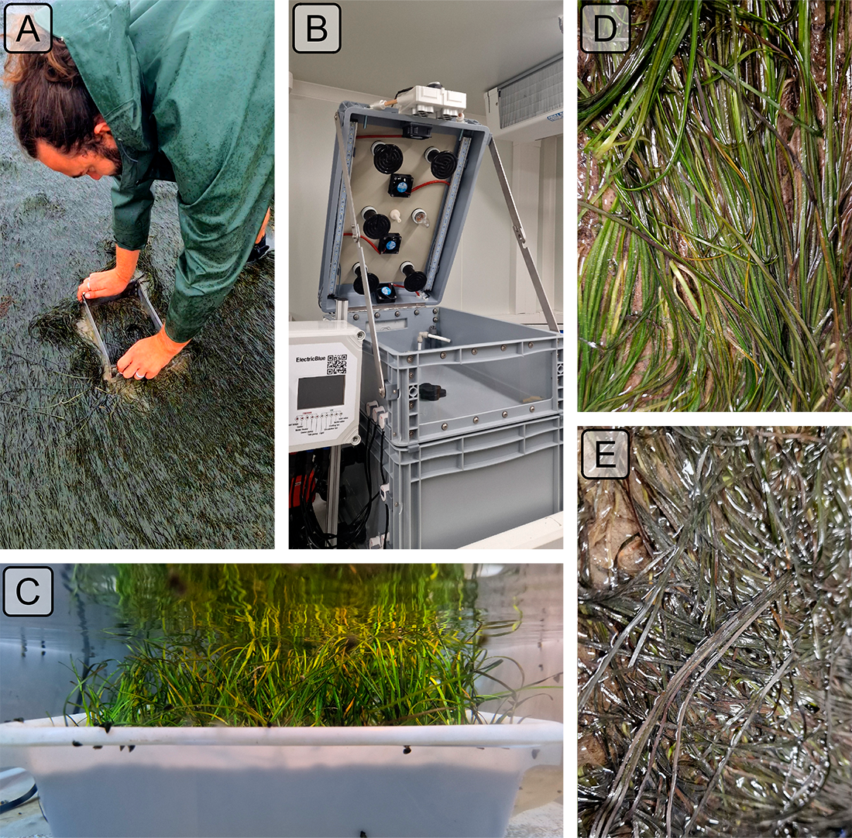

2.1.2 Experimental design
Two intertidal chambers from ElectricBlue were used to simulate tidal cycles and control water temperature during high tide and air temperature during low tide (Figure 1 B,C). Chambers were utilized in parallel with one chamber serving as the control, while the other was used for the experimental treatment.

Figure 2
Comparison of daily maximum temperatures in August measured using an in-situ sensor (blue) and retrieved from Meteo France (orange). The solid line in the middle of the boxplot represents the median, the two ends of the box represent the 25th and 75th percentiles, and the whiskers represent values that are no more than 1.5 times the interquartile range.
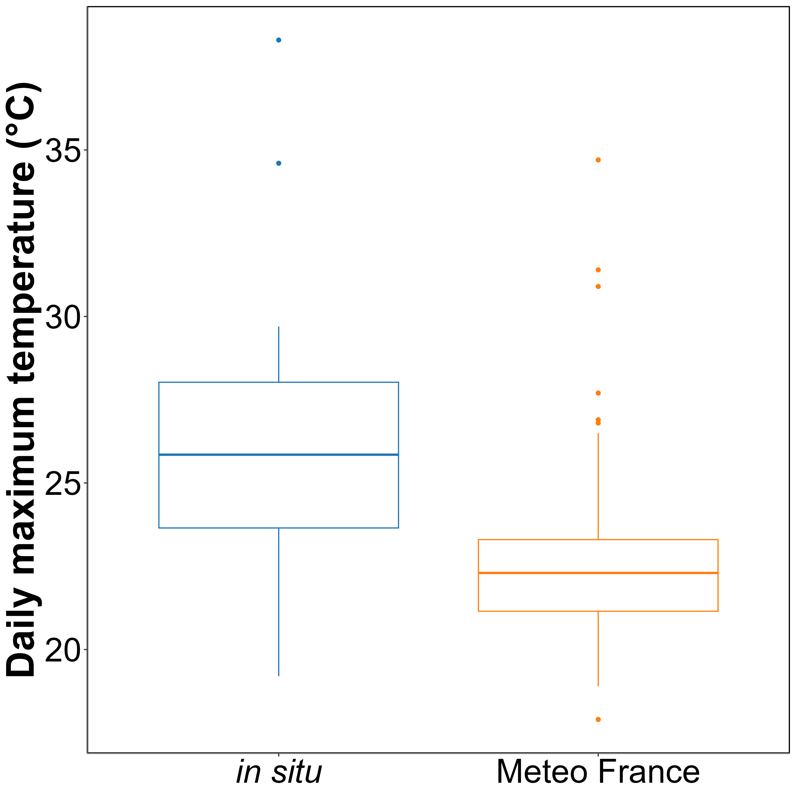
To closely replicate field temperatures experienced by seagrasses during the experiment, in situ temperature sensors were installed at the sampling site in Bourgneuf Bay in August 2024. Daily maximum temperatures recorded by these in situ sensors were compared to measurements from the nearest Meteo France weather station (Figure 2). On average, in situ temperatures were 3 ± 3.2°C higher than those recorded by Meteo France. Additionally, temperatures recorded by Meteo France were more stable than those from the in situ sensors, likely due to the sheltered and shaded location of the Meteo France equipment. This difference was used to adjust heatwave temperatures measured by Meteo France to better reflect the conditions experienced by the seagrasses.
The control chamber was kept at temperatures representing typical seasonal conditions, with water temperatures ranging from 18°C to 19°C and air temperatures from 18°C to 23°C (Figure 3). For the experimental treatment, air temperature was adjusted to replicate an atmospheric heatwave that affected the seagrass meadow in Quiberon, France (47°35’40.0”N, 3°07’30.0”W), from September 2 to September 6, 2021. On the first day of the experiment, air temperatures in the experimental chamber were set to range from 23°C at night to 35°C during the day, increasing by 1°C daily. Water temperature in the experimental chamber was also adjusted to mimic heatwave conditions, starting at the seasonal baseline (18°C) and rising incrementally by 0.5°C daily to simulate the increasing temperatures during the heatwave. This aimed to replicate the thermal stress experienced by the seagrass meadow during the actual heatwave event (Figure 3). The experiment concluded only when no changes in the reflectance of the treatment were observed for two consecutive days.

Figure 3
Temperature profiles of both the control (left) and the treatment (right) followed during the heatwave experiment. The red line indicates air temperature, whereas the blue line indicates water temperature. Due to the tidal cycle followed during the experiment, the seagrasses only experience temperatures representade by solid lines.
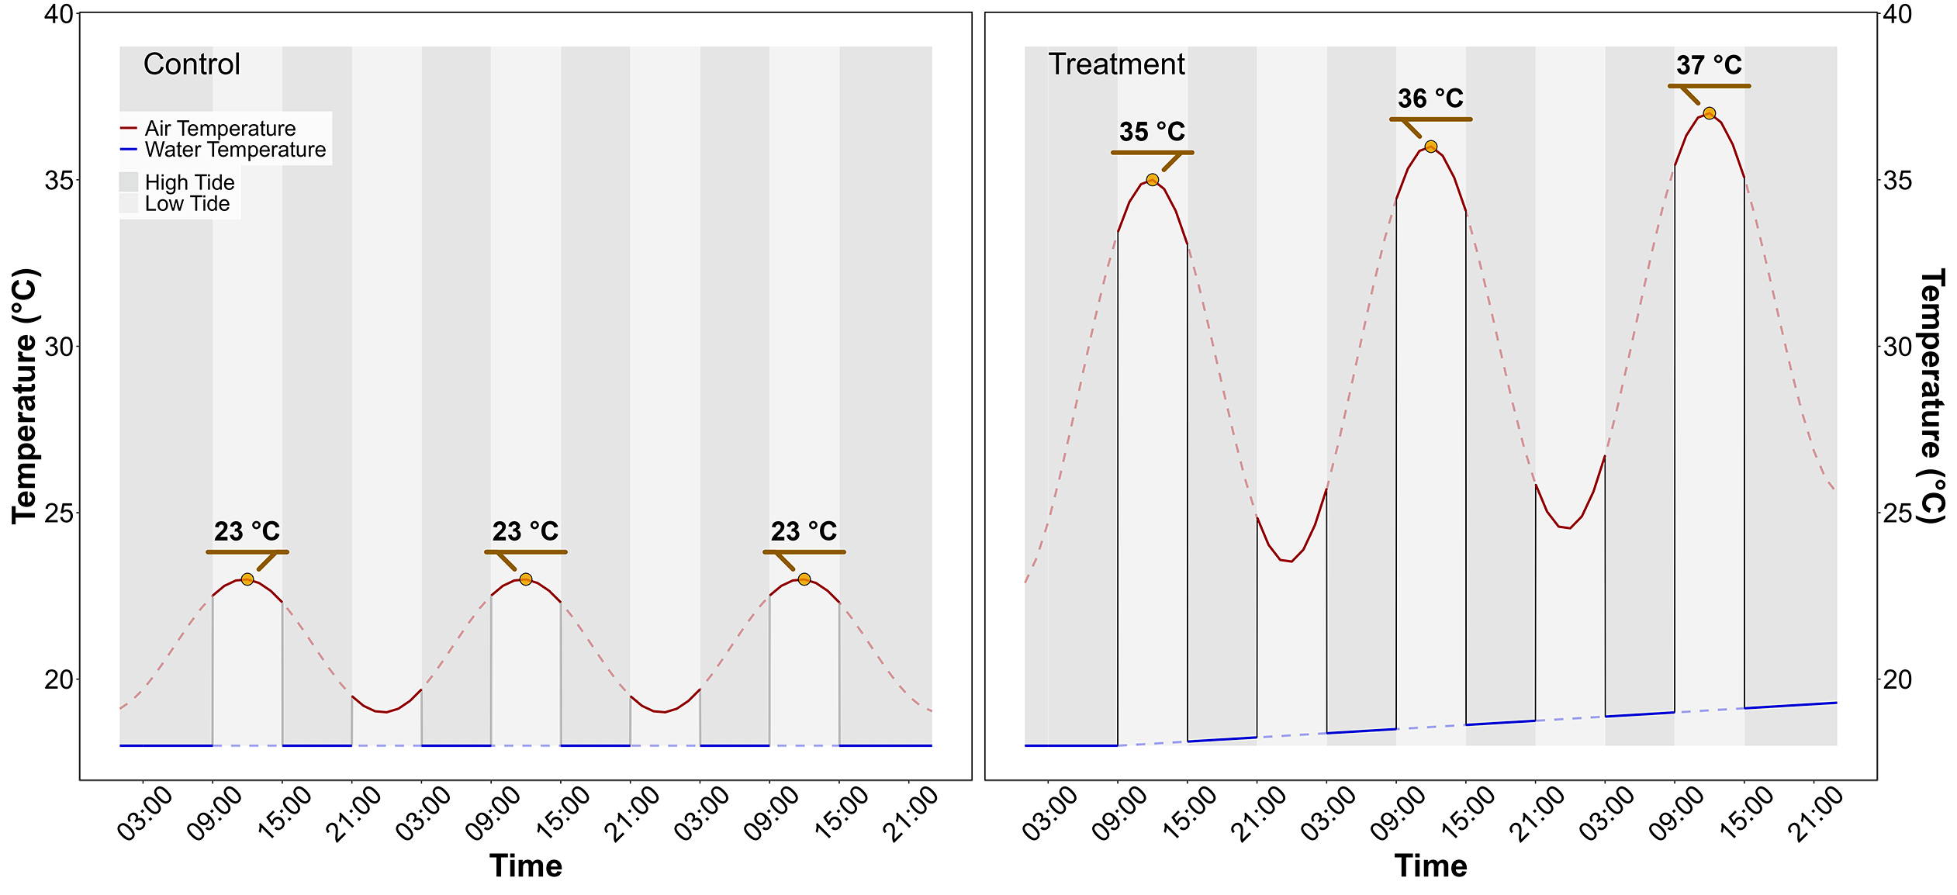

2.1.3 Bio-optical measurements

Throughout the experiment, hyperspectral signatures of both the control and treatment seagrasses were taken using an ASD HandHeld 2 equipped with a fiber optic lens, allowing measurements to be taken directly inside the chamber without opening it. Automatic spectra acquisition was carried out using the RS3 softaware . An average of five reflectance spectra ($R\left(λ\right)$), each with an integration time of 544 ms, was taken every minute throughout the day. Every 10 minutes, the fiber optic was switched from one benthic chamber to the other, in order to measure reflectance in both treatment and control. As light conditions were controlled inside of the chambers, reflectance calibration of the instrument was performed each morning at the very first moment of low tide using a Spectralon white reference with 99% Lambertian reflectivity.
The second derivative of RλR was calculated to retrieve absorption features and compare their variability over time. Two radiometric indices were also monitored throughout the experiment :
- Normalized Difference Vegetation Index (NDVI, Rouse et al. (1974)), a proxy of the concentration of chlorophyll-a (Equation 1)
$$NDVI=\frac{R\left(840\right)-R\left(668\right)}{R\left(840\right)+R\left(668\right)} \left(1\right)$$
where $R\left(840\right)$ and $R\left(668\right)$ are the reflectance at 840 nm and 668 nm respectively.
- Seagrass Cover, developed by Zoffoli et al. (2020), an estimate cover of seagrass (Equation 2):
SPC=172.06×NDVI-22.18 2
- Green Leaf Index (GLI, Louhaichi et al. (2001)), a measurement of the greenness of seagrass leaves (Equation 3)
$$GLI=\frac{\left[R\left(550\right)-R\left(668\right)\right]+\left[R\left(550\right)-R\left(450\right)\right]}{\left(2×R\left(550\right)\right)+R\left(668\right)+R\left(450\right)} \left(3\right)$$
where $R\left(550\right)$ and $R\left(450\right)$ are the reflectance in green at 550 nm and in the blue at 450 nm, respectively.

To assess changes in pigment concentration, a the beginning and the end of each diurnal low tide (09:00 am and 03:00 pm) leaves were taken from both the test and the control. Leaves were stored at -80°C. Before pigment extraction, each sample was lyophilized and its dry weight was measured. Pigment composition and biomass were analyzed using high-performance liquid chromatography (HPLC). The HPLC system (Alliance HPLC 248 System, Waters) was equipped with a reverse-phase C-18 separating column (SunFire C-18 Column, 100Å, 3.5 µm, 2.1 mm x 50 mm, Waters), preceded by a precolumn (VanGuard 3.9 mm x 5 mm, Waters). The system also included a photodiode array detector (2998 PDA) and a fluorimeter (Ex: 425 nm, Em: 655 nm; RF-20A, SH
Au secours Philippe !!!

2.2 Seagrass Darkening.

2.2.1 Field Observation

Figure 4
Location of the field campaign that occured on the 10th of September 2021. The light grey polygons indicate the intertidal zone and the dark grey polygon indicates the extent of the drone flight. Green circles indicate location of quadrat images of green seagrasses while red circles indicate location of quadrat images of darkened seagrasses.
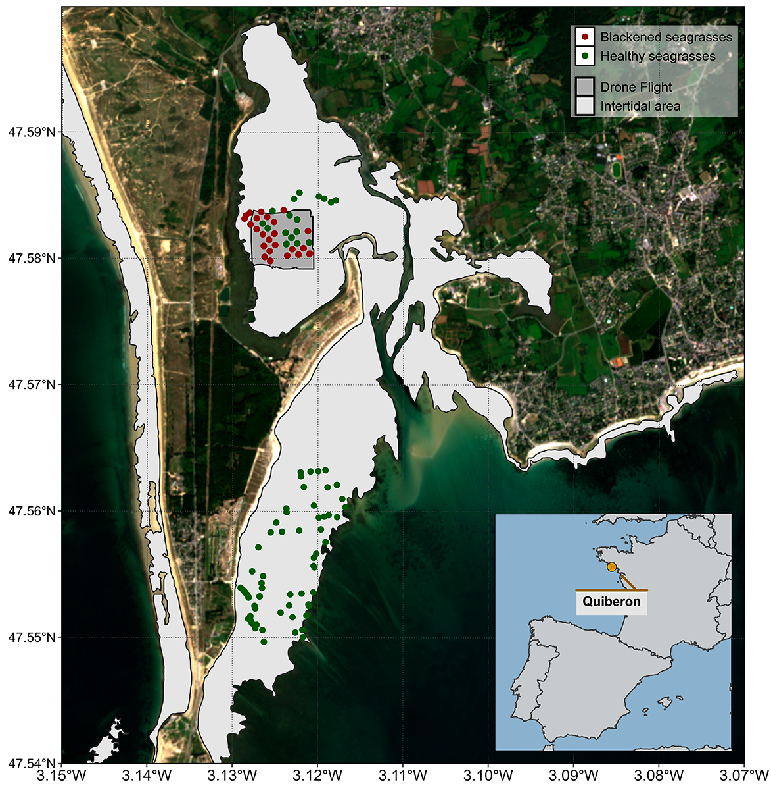
A field campaign, aiming to map a seagrass meadow near Quiberon (France : 46°57’32.0”N, 2°10’37.0”W), occurred on the 10th of September 2021 (Figure 4). During this campaign, significant darkening of seagrass leaves was observed over large areas of the meadow alongside normal green seagrass (Figure 5). A total of 122 Ground Control Points (GCPs) were collected in the form of georeferenced quadrat images across the meadow. These images allow for visual assessment of vegetation type, density, and health status. The images were then divided into two categories: green seagrasses (henceforth: GQ Green) and darkened seagrasses (), based on a visual estimation of the leaf colouration (Figure 4).

Figure 5
Illustrations of the two colourations of seagrasses observed in the field. A: View of a green green meadow; B: Quadrat image of green seagrasses; C: Quadrat image of darkened seagrasses; D: View of darkened area of the meadow. All images were taken on September 10th, 2021, in Quiberon.
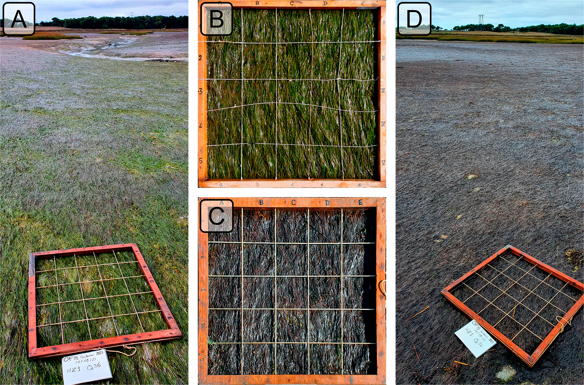

2.2.2 Temperature Data

Air temperature.
Since January 1, 2024, Meteo France weather data has been freely and openly accessible. Hourly air temperature data (°C) for the French Atlantic and Channel coasts were retrieved through a custom script (Supplementary Materials). Weather stations located within 10 kilometers of the coastline were considered, but only those with at least 30 years of data were included to ensure reliable climatological reconstruction. Of the 156 weather stations within 10 kilometers of the coast, only 36 had sufficient data for climatology reconstruction. The hourly data was then aggregated into daily mean temperatures for each station.
Heatwave detection was performed using the HeatwaveR package in R (Schlegel and Smit, 2018). This package utilizes the methodology proposed by Hobday et al. (2016) to detect heatwave events. The climatology for the year was computed using the temperature time series. An event was considered a heatwave each time the temperature exceeded the 90th percentile of the climatology for three consecutive days. The severity of each event has been assessed using the methodology proposed by Hobday et al. (2018). Following the methodology of Schlegel et al. (2017), coldspell events corresponding to temperature bellow the percentile 10th of the climatology during 3 consecutives days have also been measured.
Concerning heatwave events near Quiberon, this methodology was applied on the nearest weather station of our study site (Lorient-Lann Bihoue, 47°45’46”N 3°26’11”W , more than 395000 observation since the 1st of February 1952).

Water temperature.
SST data from the Copernicus CMEMS platform were downloaded for the French coast near Quiberon (47°29′03″N, 3°07′09″W), covering 1982-2022 (CMEMS, 2024). Only pixels within an area of 2700 km² around Quiberon, Brittany, France (47°29′03″N, 3°07′09″W) were extracted and analyzed. This area was large enough to minimize missing values caused by cloud cover, yet small enough to avoid being influenced by the stability of offshore SST. The multi-sensor Level 3S Sea Surface Temperature (SST) product that we used is built from nighttime infrared satellite data, including sources like ESA SST CCI, C3S, and EUMETSAT. Data from AVHRR, ATSR, and SLSTR radiometers are used, but only those with a quality level above 4. An intercalibration method ensures consistency, and a daily reference SST field is constructed by combining the best data with median values from other sources. A large-scale bias correction is applied, and daily single-sensor composites are merged into a multi-sensor file (L3S), selecting the best sensor for each grid cell. A daily average was computed for the time series, and the HeatwaveR package (Schlegel and Smit, 2018) was used to compute SST climatology and detect SST events using the same method as air temperature event detection.

2.2.3 Satellite Observation
Two Sentinel-2 images covering the field campaign site (Figure 4) were downloaded from the Copernicus platform (European Space Agency, 2024a). The first image was taken before the heatwave event on September 1, 2021, and the second image after the event on September 6, 2021. Both images were acquired as Level-2 products, in surface reflectance, and were orthorectified and atmospherically corrected to account for the effects of the atmosphere on reflectance values (European Space Agency, 2024b).
Reflectance values for each GCP (Figure 4) were extracted and compared before and after the heatwave event.

2.2.4 Emersion Time of Seagrasses
To estimate the emersion time of seagrasses during low tide, bathymetric and tidal data were used. Bathymetry data for the Quiberon intertidal meadow were sourced from the “Service Hydrographique et Océanographique de la Marine” (SHOM, 2021). It corresponds to the Litto3D® product, which is a three-dimensional land-sea elevation database, accurately depicting the coastal terrain along certain regions of the French shores. Litto3D data were collected through airborne bathymetric lidar over the sea and airborne topographic lidar extending up to 2 km inland and is available as a gridded digital terrain model. it uses the NGF/IGN69 reference “zero”, which corresponds to the mean sea level recorded at the Marseille tide gauge between 1885 and 1897, commonly known as the “Terrestrial Altimetric Zero”.
Tidal data during the heatwave event were downloaded from the Intergovernmental Oceanographic Commission data portal (IOC, 2024), using measurements from the nearest tide gauge at Le Crouesty. In this dataset, the reference “zero” corresponds to the lowest astronomical tide, also known as the Hydrographic Zero.
Before calculating the emersion time, both datasets were intercalibrated to a common altitude reference. This involved applying a correction factor to the Litto3D data to align it with the Hydrographic zero. SHOM annually publishes a document called “Références Altimétriques Marines” (RAM, Shom, 2022), which provides these correction factors for each seaport along the French coastline. For Le Crouesty port data from 2022, the correction factor was 2.85 m.
Once aligned, the corrected elevation was compared to water height for each pixel and each time step during the heatwave event. The emersion time was then calculated as the daily total time each pixel remained exposed.

3. Results

3.1 Laboratory Experiment

3.1.1 Spectral inspection
Hyperspectral signatures were acquired throughout the experiment for both the Control and Treatment groups. In the Control group, reflectance remained relatively stable over time, with only minimal changes in magnitude and spectral features (Figure 6). Slight variations in spectral shape observed in this group were attributed to differing levels of water evaporation during low tides. Immediately after the water level receded from high to low tide, samples were very wet but dried progressively, reaching maximum dryness just before the tide rose again. This fluctuation in water content induced variations in the reflectance spectra. Overall, the Control group’s reflectance spectra displayed a peak at 560 nm (green region), low values at 665 nm (indicative of strong chlorophyll-a absorption), and a high plateau in the near-infrared (NIR), beyond 705 nm (Figure 6, left).
In contrast, the Treatment group showed more pronounced changes in reflectance throughout the experiment. At the beginning (T0), reflectance values were comparable to those in the Control group, especially in the visible region, with a notable peak around 560 nm and a pronounced trough at 665 nm. However, starting from T24 (the second day), reflectance began to decrease across all wavelengths, particularly around 560 nm and in the NIR. Around T48, the NIR reflectance appeared to stabilize at values like those observed at T24. In the green region, however, reflectance continued to decline slightly until the experiment’s conclusion. Additionally, a slight increase in reflectance at 665 nm between T24 and T48 was observed, possibly associated with a reduction in chlorophyll-a concentration (Figure 6, right).

Figure 6
Standardised Hyperspectral Reflectance signature collected during the experiment for both the Control (Left) and the Treatment (Right). Colour denotes the progression along the experiment from beginning (T0: green) to one day (T24: yellowy green) to two days (T48: brown). .
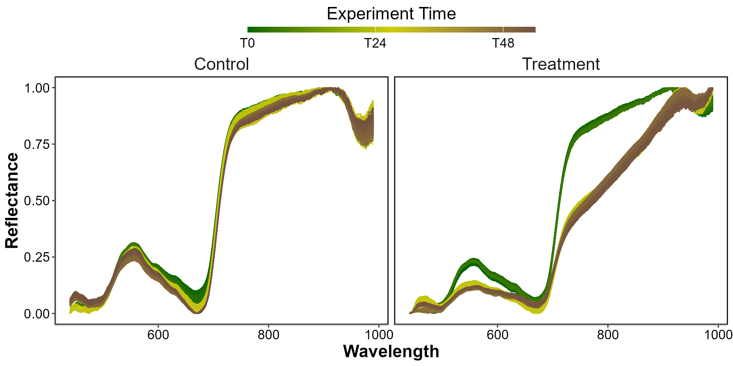

3.1.2 Radiometric indices
Clear differences emerged in the second derivative of the spectral signature between the two groups: the Control group exhibited more variability, reflecting more pronounced spectral features, whereas the Treatment group showed less variability, indicating fewer absorption features in its spectral signature (Figure 7). The maximum absorption for both groups occured at 665 nm, with values of $1.63×{10}^{-4}$ for the Control group and $8.08×{10}^{-5}$ for the Treatment group—a reduction of 50.31% by the experiment’s end.
Monitoring the second derivative at 665 nm ($R″_{665 \text{nm}}$) over time revealed a rapid drop in replicates 1 and 3, decreasing by 26 and 64 % respectively after 24 hours (T24) of treatment (Figure 7B). After T24 $R″_{665 \text{nm}}$ in these replicates stabilized for the remainder of the experiment. In contrast, replicate 2 shows a slower but more substantial decrease of 110 % by the experiment’s end. Overall, between the start and the end of the experiment, the $R″_{665 \text{nm}}$ decreased by 72 %.
NDVI showed the same trend, exhibiting an initial rapid decline of approximately 25% between T24 and T30, after which their values stabilized, with minimal further changes observed. In contrast, Replicate 2 remains relatively stable between 0 and 48 hours, showing little change during this period (drop of 9% at T24). However, after T48, Replicate 2 showed a substantial drop, ultimately reaching a reduction of approximately 48% (Figure 7 C).
The relative GLI showed similar trends across the replicates. Replicates 1 and 3 exhibited an initial rapid decline of approximately 50 and 68 %, respectively between T24 and T30, after which their values stabilized with minimal further changes observed until the end of the experiment. In contrast, Replicate 2 remained relatively constant between 0 and 48 hours, showing only a minor decline of around 5% by T24. However, after the T48 mark, Replicate 2 experiences a substantial decrease, ultimately reaching a reduction of 73% (Figure 7 D).

Figure 7
Change in second Derivative (A) the second derivative at 665 nm (B), the NDVI (C) and the GLI (D) over Time. A: Mean and standard deviation of the second derivative for both Control and Treatment groups on the final day of the experiment; B: Relative evolution of the second derivative at 665 nm between Treatment and Control groups over time across three replicates. Points indicate raw data, the line represents a generalized linear model, and the shaded area the model’s standard error; C: Relative evolution of NDVI for the Treatment group compared to the Control group over time across three replicates. Points indicate raw data, the line represents a generalized linear model, and the shaded area the model’s standard error; D: Relative evolution of GLI for the Treatment group relative to the Control group over time across three replicates. Points indicate raw data, the line represents a generalized linear model, and the shaded area the model’s standard error.
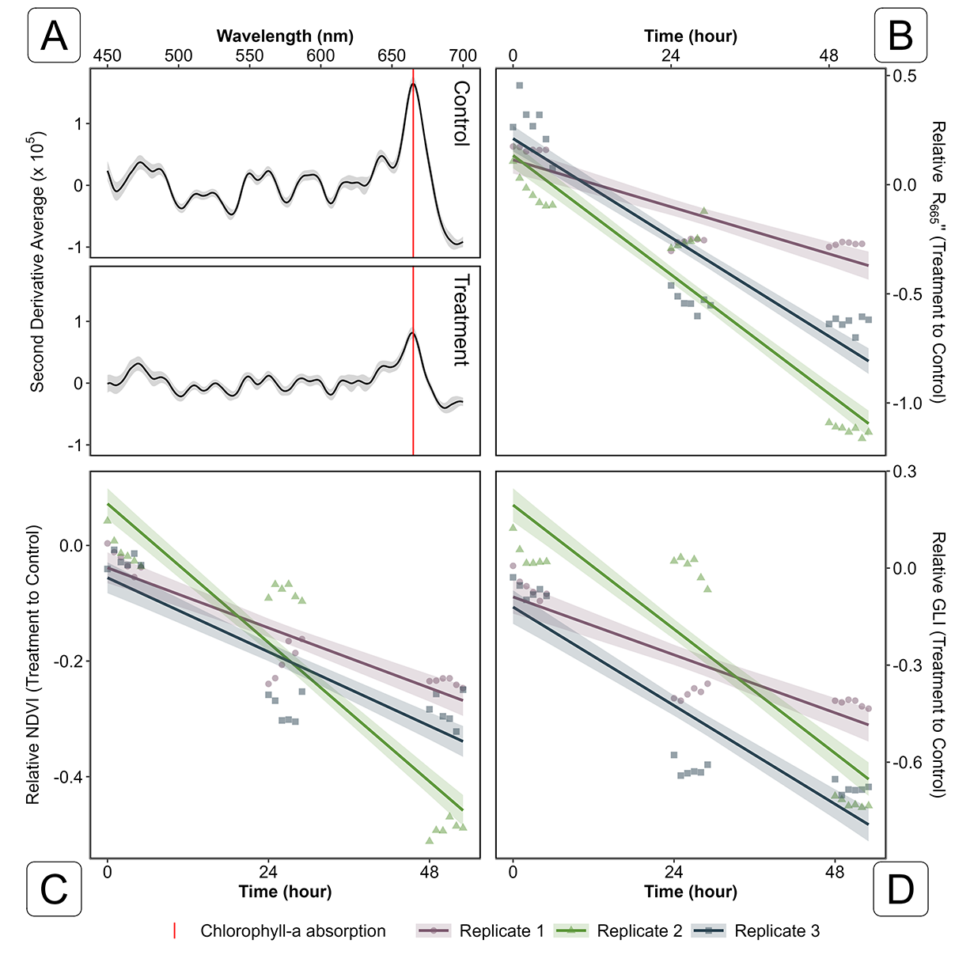

3.1.3 Building a Seagrass Darkening index
Based on the observed spectral changes in seagrasses exposed to extreme events, a radiometric index was developed to detect seagrass darkening events through remote sensing. This darkening is characterized by a reduction in reflectance within the green region, along with a substantial decrease in the red-edge portion of the electromagnetic spectrum. (Figure 7).
The Seagrass Darkening Index (SDI) is introduced here as a measure of the difference between the interpolated value between 560 and 842 nm and the observed value at 740 nm. This approach calculates the line height using a triplet of bands, where 560 nm and 842 nm serve as the ‘baseline’ and 740 nm represents the central peak. The SDI can be mathematically expressed as:
$$\text{SDI}=\left[R\left(560\right)+0.64⋅\left(R\left(842\right)-R\left(560\right)\right)\right]-R\left(740\right) \left(4\right)$$
Where $R\left(560\right)$, $R\left(740\right)$, and $R\left(842\right)$ represent reflectance values at 560, 740, and 842 nm, respectively. These wavelengths were selected to align with the spectral resolution of satellites like Sentinel-2, enabling the index to be used for mapping darkening events from satellite data. From SDI, negative values indicate green, healthy seagrasses, while positive values correspond to darkened seagrasses.

Figure 8
Development and Application of the Seagrass Darkening Index (SDI). The left panel displays the average reflectance values for both the Control and Treatment groups on the final day of the experiment. Shaded areas represent the standard deviation of reflectance, while markers indicate the spectral bands used to construct the SDI. The right panel shows the application of the SDI for both groups on the last day of the experiment.
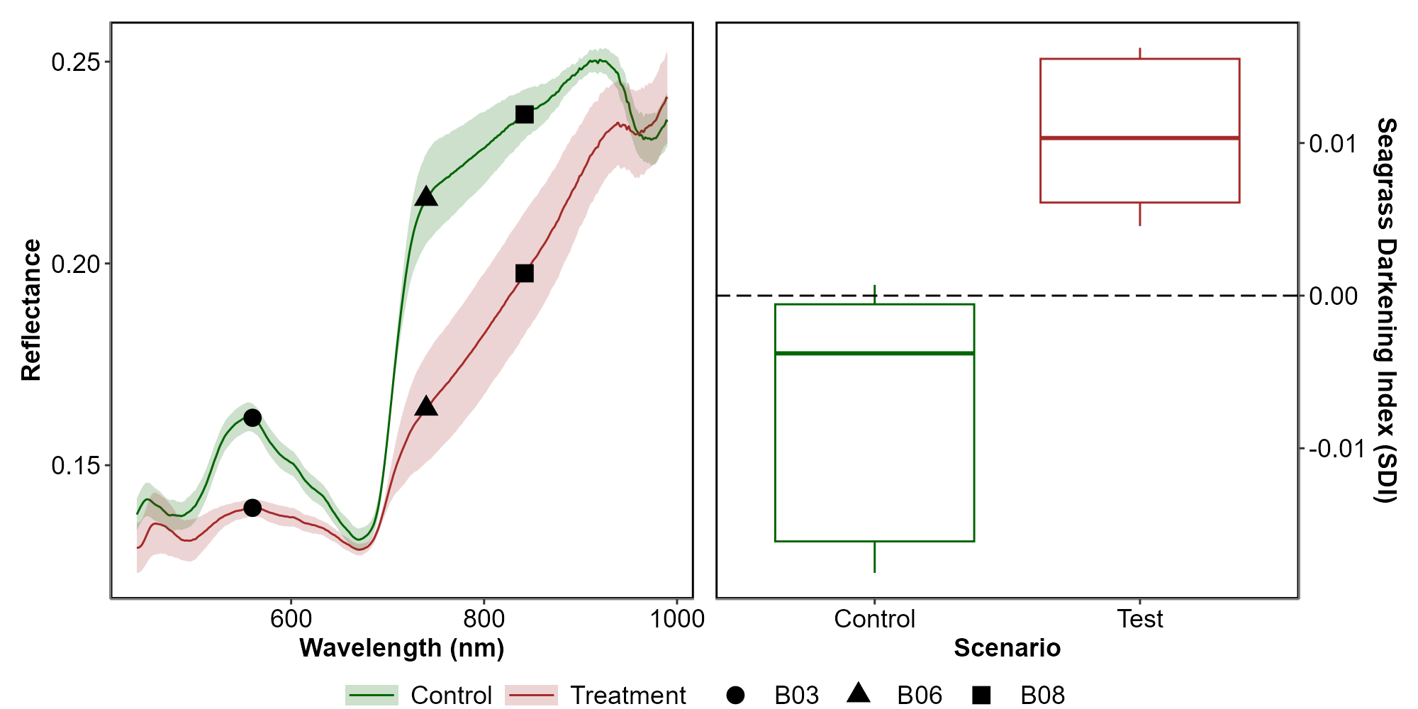
When applied to reflectance data collected during the experiment, the SDI revealed clear distinctions between the Control and Treatment groups. By the end of the experiment, seagrasses in the Treatment group exhibited a median SDI of 0.01, with no samples showing a negative SDI value, consistent with their visibly darkened appearance. In contrast, the Control group retained a green appearance throughout the experiment, with a median SDI of -0.003, and only 3% of samples displaying a positive SDI value (Figure 8, right).

3.1.4 Pigment composition evolution along the experiment
bla bla bla bla

3.2 Heatwave of Quiberon

3.2.1 Spectral inspection
The Sentinel-2 images used in this study are dated from the 1st of September 2021 and the 6th of September 2021 (Figure 9 A and C, respectively). The Atmospheric Heat Wave (AHW) started on 4 September and lasted until 7 September, while the Marine Heat Wave (MHW) started on 3 September and ended on 8 September 2021 (Figure 9 B). The AHW has been classified as a strong event and the MHW has been classified as moderate. Even though the Sentinel-2 of the 6th of September was captured only a few days after the start of the events, darkening of seagrass can already be observed in the true-color composition (Figure 9 C). Before the event, all GCPs appeared green un the images, with similar reflectance spectra, regardless of the class attributed to the GCPs in the field (Figure 9 A and D left). Their reflectance spectra showed a peak at 560 nm (in the green part of the spectra), low values at 665 nm, corresponding to the strong absorption by chlorophyll-a and a high infrared plateau (> 705 nm). However, GCPs classified as dark seagrass during the field campaign, showed significant differences in reflectance spectral shape compared to GCPs classified as green seagrass on the 10th of September, with corresponding differences in the true color composition (Figure 9 C and D right).. The reflectance spectra over dark seagrass were characterized by the loss of the reflectance peak at 560 nm and a decrease in the infared plateau, which was observed as a steady increasing slope up to 940 nm.

Figure 9
Spectral Comparison of Sentinel-2 Reflectance (D) of Ground Control Points (GCPs) Before (A) and During (B) Heatwave Events (C); A: RGB color composition of the Sentinel-2 image on the 1st of September 2021. The points correspond to GCPs collected on September 10, 2021; B: Detection of heatwave events based on both Air Temperature and Sea Surface Temperature (SST). The solid line represents the daily average temperature, while the dashed line indicates the 90th percentile of the climatology. Colored areas identify heatwaves (marine in blue and atmospherical in red). The two vertical dashed lines represent the acquisition dates of the two Sentinel-2 images used in this analysis (01-09-2021 and 06-09-2021); C : RGB color composition of the Sentinel-2 image on the 6th of September 2021. The points correspond to GCPs collected on September 10, 2021 Figure 4 ; D : Average spectral signatures of GCPs where dark and green seagrasses (blue and gold lines, respectively) were identified during the field survey. The left plot shows the reflectance of these GCPs before the heatwave impact, while the right plot shows the spectral signature during the heatwaves. The ribbons around the lines represent the standard deviation.
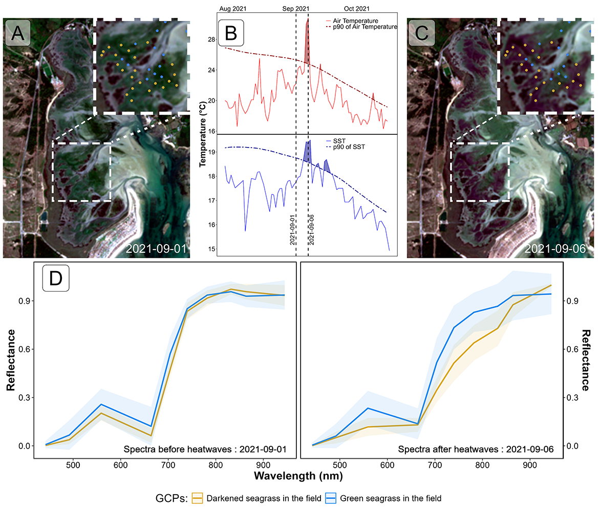

3.2.2 Sentinel-2 Radiometric indices
Using Sentinel-2 data, the spectral indices (NDVI and GLI) and SC estimated for pixels unaffected by the heatwave showed no significant differences before or during the event (Figure 10, left column). In contrast, seagrass darkened by the heatwave exhibited a significant decrease in both index values and SPC (Figure 10, right column). In this case, the NDVI dropped by approximately 34%, from a median of 0.61 to 0.40, while also becoming more homogeneous (the standard deviation decreased from 0.09 to 0.06) (Figure 10 B). Although the heatwave did not affect the observed seagrass density in the field, the drop in NDVI led to an underestimation of satellite-based SPC, from 83 to 48% (Figure 10 D). The GLI, the index that reflects the greenness of leaves, was the most affected by the event, with an important reduction from a median of 0.23 to 0.03 during the event (Figure 10 F). Interestingly, when comparing the initial seagrass density of both targets (i.e., seagrass density before the event) pixels affected by the heatwave (median SPC = 85%; Figure 10 D green) were denser than those that remained unchanged (median SPC = 65%; Figure 10 C green).

Figure 10
Comparaison of Sentinel-2 based radiometric indices at two different dates, before (2021-09-01, green) and after (2021-09-06, red) the heatwave event of Quiberon, for the two categories of GCPs: Green seagrasses (Left Column) and Darkened Seagrasses (Right column).
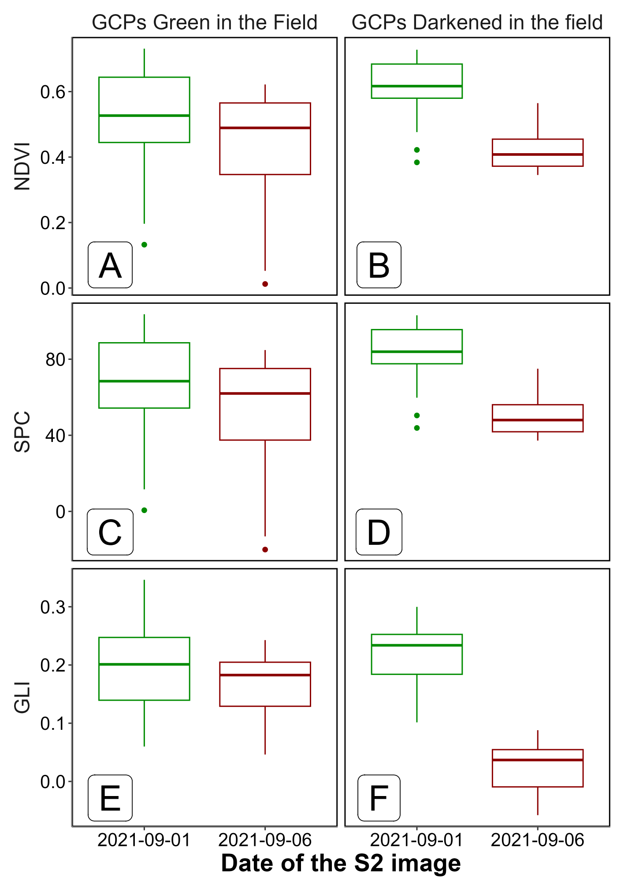

3.2.3 Mapping of the seagrass darkening
Using the SDI, we can detect seagrass patches that have darkened. Following the heatwave event, a total of 26.9 hectares of seagrass darkened, with the largest affected patch covering nearly 8 hectares. Overall, 25 % of the total seagrass meadow area showed signs of darkening between the 1st and 6th of September 2021. Comparing the spatial distribution of darkened patches with the site’s bathymetry reveals that 94.6 % of darkened areas are located above 3.8 meters of bathymetry (Figure 11, A and B).

Figure 11
Map of the Darkening of seagrasses during the heatwave events of September 2021 in Quiberon. A: 3.9 m bathymetry isobar (golden line); B: Result of the detection of darkened seagrass patches (Blue plolygons)
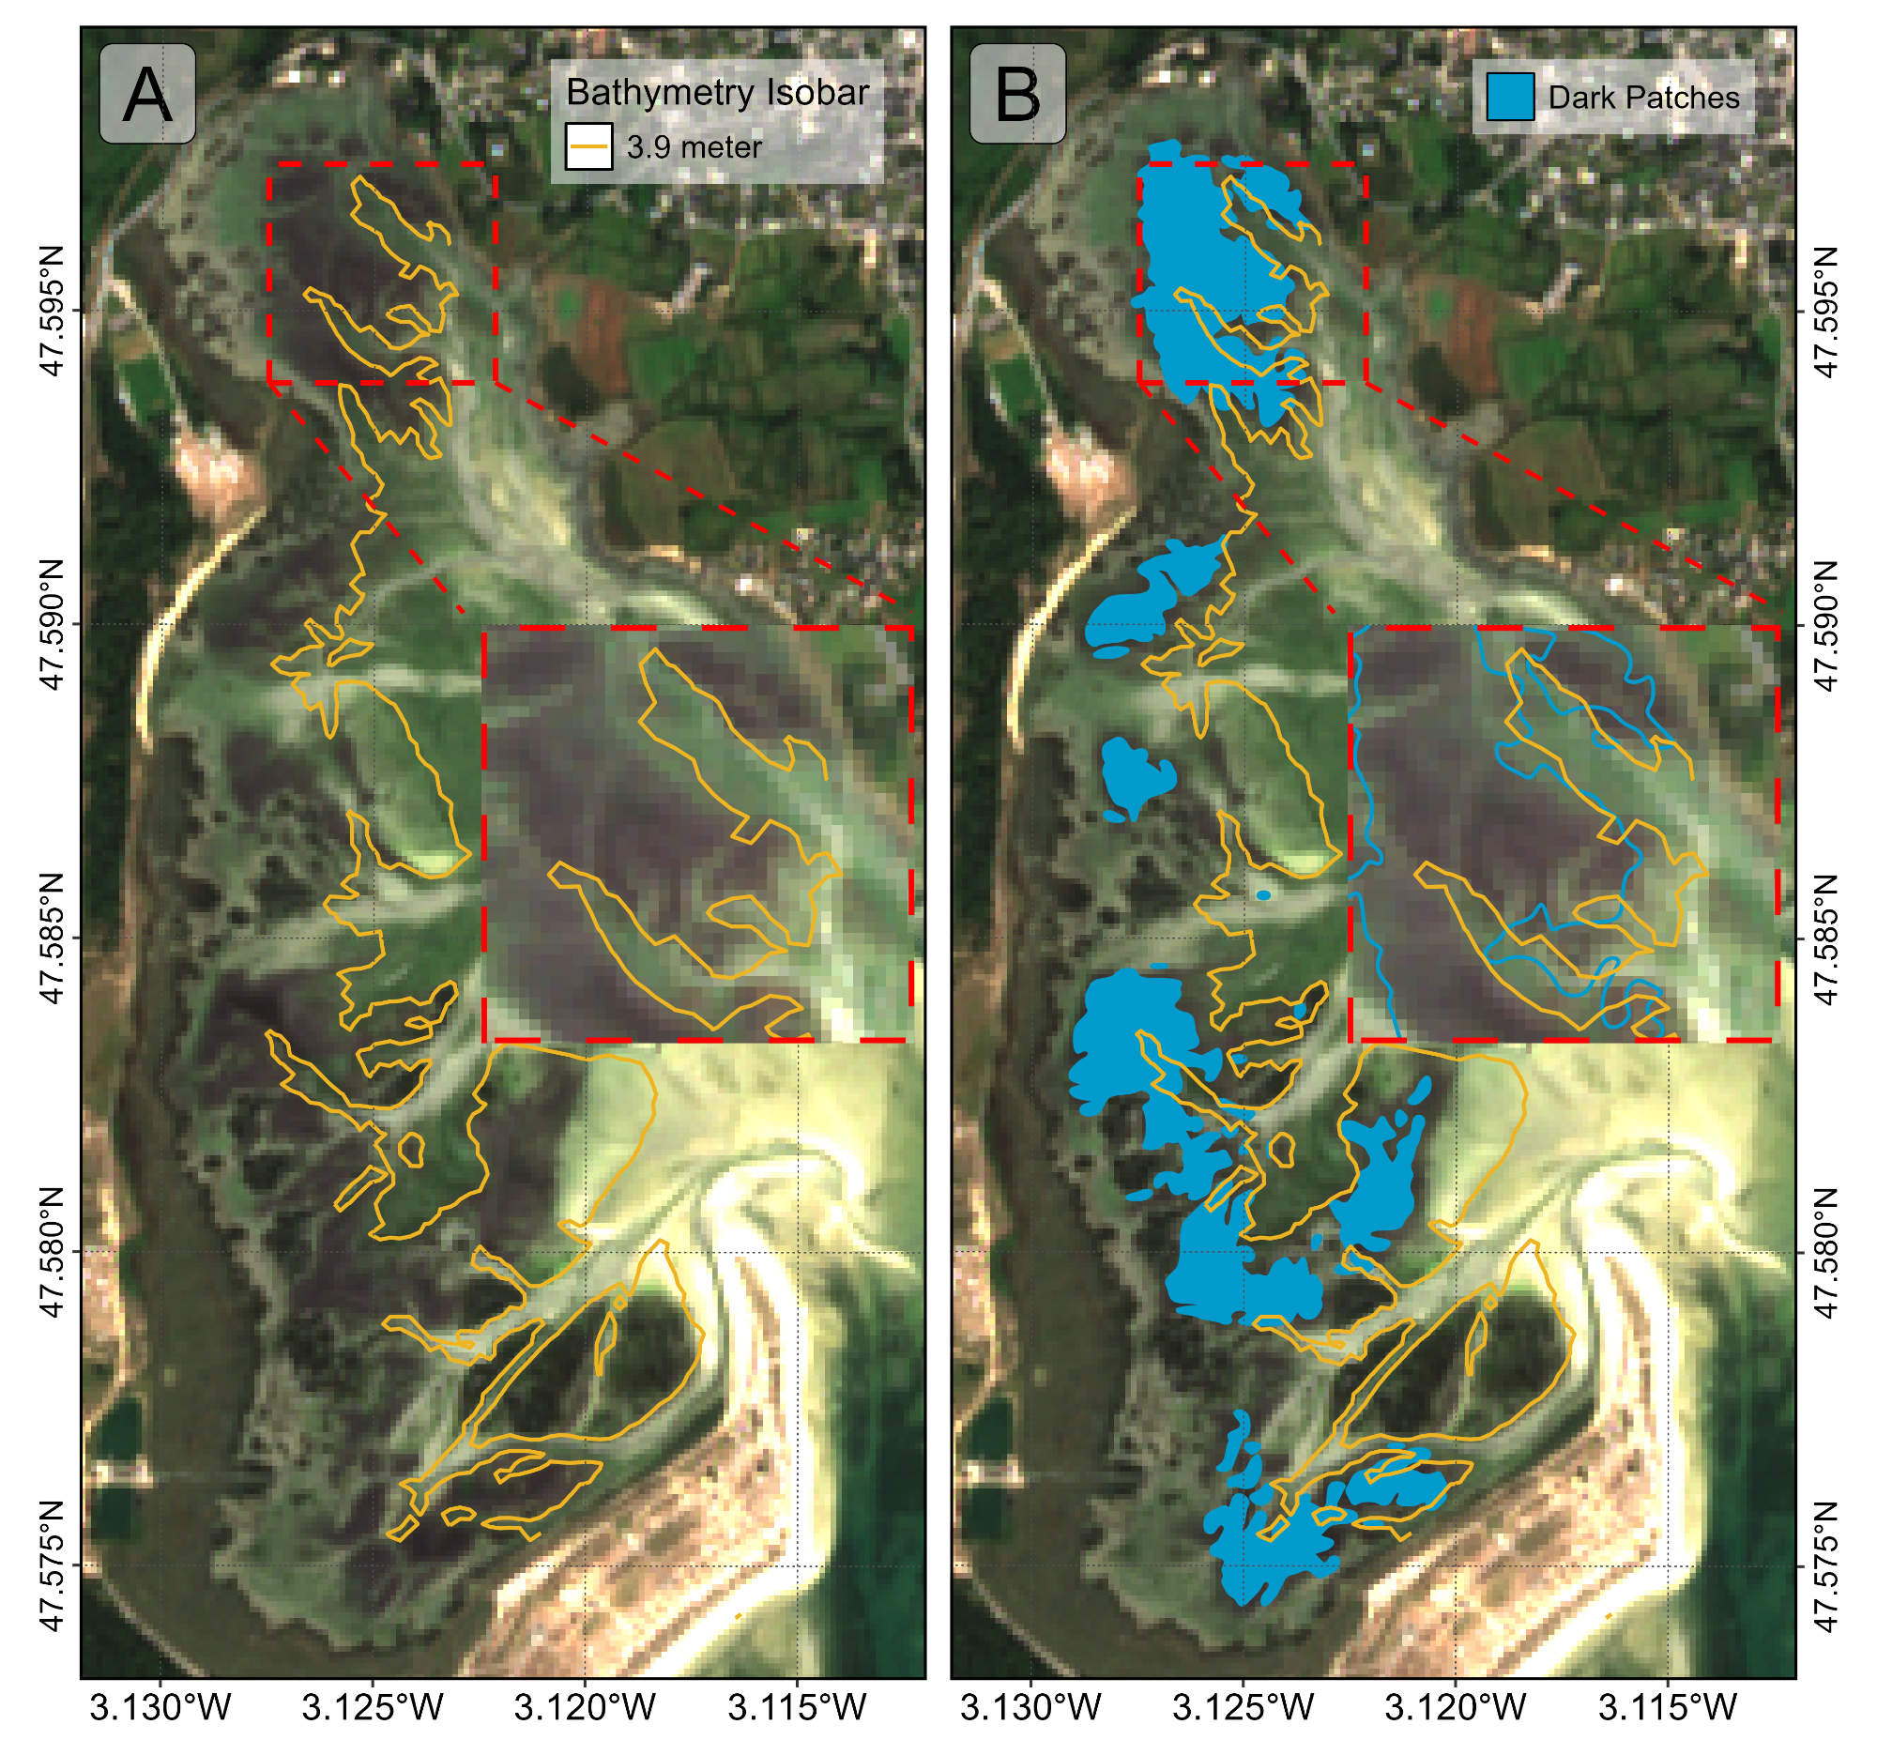
Additionally, there was a clear relationship between the time seagrass is exposed to air and its darkening. During the heatwave, no significant darkening occurred with daily exposure below 13.5 hours. However, when exposure reached 13.5 hours or more per day, seagrasses began to darken, peaking at around 14.5 hours of daily exposure (Figure 12).

Figure 12
Seagrass Darkening Index as a function of the daily emergence time of seagrasses. The line represents a Generalized Additive Model (GAM) prediction, and the shaded area indicates the standard error. Shaded points represent raw data, with each point corresponding to a single pixel of the meadow.
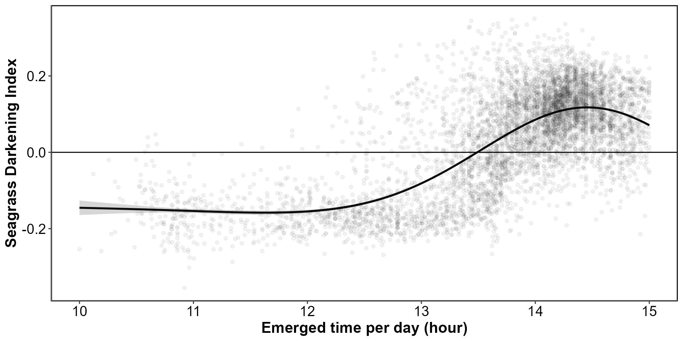

4. Discussion - WORK IN PROGRESS
Although extensive research exists on marine heatwaves’ effects on subtidal seagrasses, little attention has been given to intertidal regions and even less to the interaction between atmospherical extrem event and intertidal meadows. This study initiates an exploration of how intertidal seagrasses respond to the dual influence of marine and atmospheric heatwaves, underscoring the need for further investigation in this underexplored area.
In the present study, significant changes in the reflectance of seagrasses exposed to heatwaves were observed experimentally. These changes mainly include a drop in reflectance around 560 nm and another drop around 740 nm in the near-infrared part of the spectrum. The decrease in visible reflectance can be multifactorial and has been documented in plants under various stress conditions, including thermal stress. Leaf blackening in plants, as observed in Protea neriifolia, is primarily driven by oxidative processes involving the enzyme polyphenol oxidase (PPO) and the oxidation of phenolic compounds. When photosynthesis is inhibited by factors such as low light, chemical interference, or thermal stress, the plant’s production of essential carbohydrates and antioxidants diminishes, increasing oxidative stress and leading to darkening. In the absence of photosynthesis, membrane integrity is compromised, allowing PPO to interact with phenolic compounds, thereby accelerating darkening. Low-oxygen environments and antioxidant treatments, like diphenylamine (DPA), have been effective in reducing these oxidative reactions. Furthermore, high temperatures can destabilize membranes, especially in chloroplasts, disrupting photosystem II and impairing recovery of photosynthetic function (Dascaliuc et al., 2007; Jones and Clayton-Greene, 1992). Furethemore, has the chlorophyll-a is degraded, other pigments like carotenoids become more visible, renforcing the dark color of leaves. The destruction of membranes (Chloroplasts, thylakoids, cell walls) due to oxidative stress also contributes to the drop in reflectance in the Red Edge and near-infrared regions of the spectrum (> 700 nm). Infrared reflectance in plant leaves is high primarily due to the internal cellular structure that scatters light within the leaf. When sunlight enters the leaf, it is diffused and scattered through various layers, particularly the spongy mesophyll, which contains air spaces and cell walls with different refractive indices. This scattering effect is intensified because there is minimal absorption in the near-infrared range (700 – 1300 nm), allowing light to reflect back through the leaf surface. Once the structure of these walls is compromised, the infrared plateau decreases significantly (Knipling, 1970).
The unique reflectance properties of seagrasses under heat stress facilitate the detection of this stress through remote sensing techniques (Equation 4). The SDI index developed in this study allows for remote sensing assessment of the extent and severity of darkening events across intertidal seagrass meadows. Requiring only three spectral bands (560, 740, and 840 nm), this index can be applied to data from various current satellite missions, including Sentinel-2, Pleiades-Neo, WorldView-3, SkySat, and GeoSat-2 and will also be compatible with upcoming missions such as Sentinel-2 Next Generation and Landsat Next. As climate change progresses, the frequency and intensity of heatwave events are projected to increase, positioning remote sensing as an essential tool for monitoring cumulative ecological impacts on seagrass meadows. While satellite platforms provide extensive spatial coverage, limitations such as cloud interference may restrict the continuity of observations, particularly during peak heatwave periods. Integrating satellite-derived data with drone-based observations, which offer enhanced spatial resolution and flexible deployment, could address these limitations by filling temporal gaps in satellite revisit cycles. This combined approach enables precise, localized monitoring of seagrass meadows immediately following extreme events, thus capturing rapid physiological and structural changes that might otherwise remain undetected. Such datasets are critical for the early detection of ecosystem degradation, facilitating timely conservation interventions and enabling targeted management strategies. Moreover, continuous, multi-year data acquisition would bolster the development of predictive models to forecast future heatwave impacts, enhancing the capacity for adaptive management and long-term resilience planning for seagrass ecosystems.
- make a link with the batymetry and modelisation of futur impact regarding heatwaves and sealevel rise

4.1 Frequency and Intensity of Heatwaves: Implications for Seagrasses and Their Resilience.
The rapid escalation of heatwave frequency and intensity globally is a defining characteristic of the current climate crisis, influenced heavily by anthropogenic activities and greenhouse gas emissions. Rising temperatures have led to the intensification of extreme weather events, particularly heatwaves, which are not only becoming more frequent but also lasting longer and reaching higher temperature peaks. Recent research suggests that the magnitude of these events has surged in the past decades, and projections indicate a continuation of this trend well into the future. For example, heatwaves that were once considered rare are now up to ten times more likely to occur, with some regions experiencing events three times as intense as those in the early 20th century (Devi et al., 2024; Russo and Domeisen, 2023). In our study site in Quiberon, a similar pattern emerges at the local scale. Data from a local weather station indicate an increasing trend in both the frequency and cumulative intensity of atmospheric heatwaves, while the same parameters for coldspells—defined as extreme low temperatures below the 10th percentile—show a marked decline in both frequency and intensity Figure 13.

Figure 13
Frequency and intensity of atmospheric heatwaves (red) and cold spells (blue) over time at the Lorient-Lann Bihoué weather station. The left column displays the annual frequency of heatwaves and cold spells as the total number of events per year. The right column illustrates event intensity, represented by the cumulative temperature anomaly throughout the year, measured in degrees Celsius.
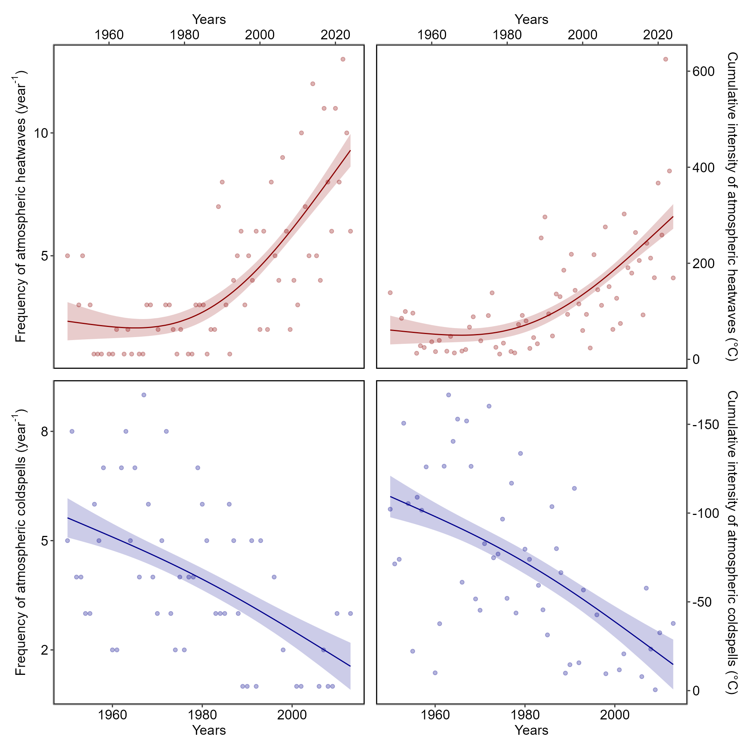
Metrics used to quantify heatwave intensity, such as cumulative indices based on total temperature exceedances over time, reveal a more comprehensive understanding of the severity and duration of these events compared to average temperature measures (Russo and Domeisen, 2023). This is particularly relevant, as the cumulative impact of sustained high temperatures exerts more extensive stress on ecosystems, infrastructure, and human health than individual peak temperatures alone.
From a hazard analysis perspective, the concurrent evaluation of intensity, frequency, and duration of heatwaves allows for a nuanced understanding of their likely impacts. Models like the Heatwave Intensity Duration Frequency (HIDF) curves provide insights into the probability of various heatwave scenarios, indicating that both short but intense events and prolonged moderate events present unique risks depending on the region. In places such as the Mediterranean, for instance, the frequency of high-intensity heatwaves has dramatically increased, leading to severe impacts on urban infrastructure, public health, and energy consumption (Mazdiyasni et al., 2019; Smale et al., 2019). Regions experiencing significant daily temperature variability are projected to see a sharper increase in extreme heat events, which underscores the role of atmospheric variability in shaping local heatwave dynamics. Specifically, in the mid-latitudes, where variability is expected to decrease, heat extremes may stabilize at elevated levels, thereby reducing cold extremes while allowing for increasingly frequent hot days (Simolo and Corti, 2022).
In the ocean, similar trends are observed with marine heatwaves. These events are equally, if not more, consequential as atmospheric heatwaves, with widespread impacts on marine biodiversity, fisheries, and carbon cycling. MHWs have increased by over 50% in annual days since the early 20th century, and projections suggest that a near-permanent state of marine heatwaves could develop by the end of the century if greenhouse gas emissions remain high (Oliver et al., 2019). Events like the “Blob” in the northeast Pacific (2013–2016) have underscored the ecological ramifications of such heat anomalies, including shifts in species distributions, mass mortalities, and habitat degradation across vast oceanic regions. The physical mechanisms driving MHWs, such as altered ocean circulation and air-sea heat flux, further illustrate the interconnectedness of atmospheric and marine systems in the context of climate-driven thermal extremes (Smale et al., 2019).
The escalating frequency and intensity of heatwaves represent not only an atmospheric anomaly but a profound disruption to ecological stability across diverse ecosystems (Devi et al., 2024; Stillman, 2019). The sustained high temperatures associated with both atmospheric and marine heatwaves lead to physiological stress, habitat degradation, and increased mortality in many species, particularly those with limited thermal tolerance (Oliver et al., 2019; Simolo and Corti, 2022). Terrestrial ecosystems experience shifts in species distributions, altered community dynamics, and reduced biodiversity as species are either forced to migrate or face local extinction under increasingly inhospitable conditions (Pansch et al., 2018). Similarly, in marine environments, prolonged heat stress from marine heatwaves has cascading effects on foundational species, including corals, kelps, and seagrasses, all of which are crucial for providing habitat, food, and shelter to diverse marine life (Oliver et al., 2019; Smale et al., 2019). Seagrasses, in particular, play a vital role in carbon sequestration and coastal protection but are especially vulnerable to extreme heat events. Elevated temperatures can disrupt seagrass photosynthesis and metabolic processes, leading to reduced growth and heightened susceptibility to disease (Deguette et al., 2022; Guerrero-Meseguer et al., 2020; Sawall et al., 2021; Winters et al., 2011). With repeated heatwave exposure and limited recovery periods, seagrass meadows may suffer severe declines, threatening their ability to deliver key ecosystem services such as carbon storage, sediment stabilization, and habitat provision (Mazdiyasni et al., 2019). The compounded impacts of atmospheric and marine heatwaves thus pose an existential threat to seagrass ecosystems, highlighting the urgent need for targeted climate adaptation measures to mitigate these escalating thermal stresses and preserve the resilience of these essential marine habitats (Russo and Domeisen, 2023; Stillman, 2019).
Seagrass resilience to heatwaves is a complex and multifaceted issue shaped by species-specific traits, geographical location, and concurrent environmental stressors (Berger et al., 2024; Canadell and Jackson, 2021; Hatum et al., 2024). As climate change drives the frequency and intensity of marine heatwaves, understanding these dynamics becomes crucial, especially for temperate seagrass meadows composed of slow-growing, long-lived species like Posidonia, Amphibolis, and Zostera. These species, unlike their tropical counterparts, tend to be highly vulnerable to abrupt environmental changes, struggling to recover from disturbances due to their slower growth and longer lifespan. In contrast, colonizing species typical of tropical regions, such as Halodule, Halophila, and Syringodium, demonstrate greater resilience to warming events and marine heatwaves due to their rapid growth and more flexible life strategies (O’Brien et al., 2018).
The impact of heatwaves on seagrass ecosystems is further intensified by tidal variations, especially in temperate regions with tidal ranges that can exceed 10 meters, such as Mont Saint Michel Bay in France. This pronounced tidal amplitude affects intertidal seagrasses like Zostera noltei, which experience varying durations of air exposure based on their position within the intertidal zone. During neap tides, seagrasses situated higher in the intertidal zone may remain exposed for extended periods, heightening their vulnerability to atmospheric heatwaves. Conversely, seagrasses in the lower intertidal zone, although submerged longer, experience prolonged emersion during low tides, making them susceptible to extreme marine heat events. As a result, both marine and atmospheric heatwaves can increase stress on seagrass meadows, with effects that may be intensified by tidal timing and amplitude. In our study, we observed a darkening effect in the seagrasses, despite our experimental setup simulating tides with consistent 6-hour exposure periods. In natural settings, however, bathymetry plays a significant role, and depending on depth variations, seagrasses may be exposed for even longer durations during low tides. This suggests that in situ exposure times could exacerbate the stress effects observed, as seagrasses may endure prolonged air exposure beyond what our controlled conditions have replicated.
Species like Zostera noltei display distinct seasonal patterns that become increasingly pronounced at higher latitudes (Davies et al., 2024a, 2024b). These patterns reflect the species’ adaptation to seasonal variations in temperature and light, but they also make N. noltei particularly sensitive to extreme events depending on their timing. For instance, if a heatwave coincides with early developmental stages or occurs after the biomass peak when leaf senescence has begun, the impact on meadow resilience can be severe
Environmental conditions can moderate seagrass resilience to thermal stress. Seagrass meadows located in areas benefiting from tidal cooling or positioned further from the warmer edges of their geographical ranges often experience reduced heat stress, resulting in higher shoot densities and enhanced resilience (Berger et al., 2024; Canadell and Jackson, 2021). In these cooler areas, Nanostera noltei exhibits high survival and photosynthetic performance up to 37°C, though temperatures above 39°C lead to near-total mortality within days, underscoring the species’ sensitivity to temperature thresholds that may become increasingly common under climate change scenarios (Franssen et al., 2014). Moreover, the frequency, duration, and intervals between heatwaves significantly affect seagrass biomass and recovery; prolonged and frequent heatwaves reduce resilience and complicate recovery processes (Hatum et al., 2024).
The influence of other stressors, such as eutrophication and sulfide accumulation, complicates this resilience. Increased sediment sulfide levels, which often accompany nutrient enrichment, can be toxic to seagrasses, particularly under elevated temperatures that amplify sulfide toxicity. Zostera noltei, for example, has a mutualistic relationship with lucinid clams that helps detoxify sulfides. However, this interaction is compromised at high temperatures, reducing the efficacy of sulfide removal and further inhibiting nutrient uptake, growth, and overall resilience (De Fouw et al., 2022).
In a simulated heatwave experiment on Zostera noltei, resilience was evident under short-term moderate stress, with no significant changes in photosynthetic performance or survival. However, prolonged or more intense heat events posed a greater challenge, highlighting the species’ limited capacity to withstand chronic thermal stress (Franssen et al., 2014; Massa et al., 2009). The long-term impact of heatwaves is especially evident in changes to seagrass cover (SPC). Before the heatwave event on 1st September 2021, impacted seagrass patches exhibited higher SPC than non-impacted areas. However, during the event on 6th September, SPC in the impacted patch experienced a sharp decline. By 7th October, one month post-event, the SPC of impacted seagrasses, initially higher, had fallen below that of non-impacted seagrasses Figure 14. The observed decrease in seagrass cover (SPC) on 6th September was primarily due to leaf darkening, which influenced the NDVI measurements used to estimate SPC. This darkening effect reduced the NDVI values, creating an apparent decrease in SPC in the impacted patch when, in reality, the density of seagrass remained stable. The bias introduced by remote sensing in this instance reflects a limitation in accurately capturing true seagrass cover during stress events. It was only after the heatwave that leaves began to detach, leading to an actual decline in seagrass density. This delayed physical response underscores how extreme events can compromise seagrass resilience, leaving previously robust patches in a weakened state compared to less disturbed areas Figure 14.

Figure 14
Comparison of the seagrass percent cover before (left), during (center) and after (right) the heatwaves for seagrasses that have not been impacted by heatwaves (i.e. remains green) and seagrasses that have been impacted by the events (i.e. seagrasses that darkened).
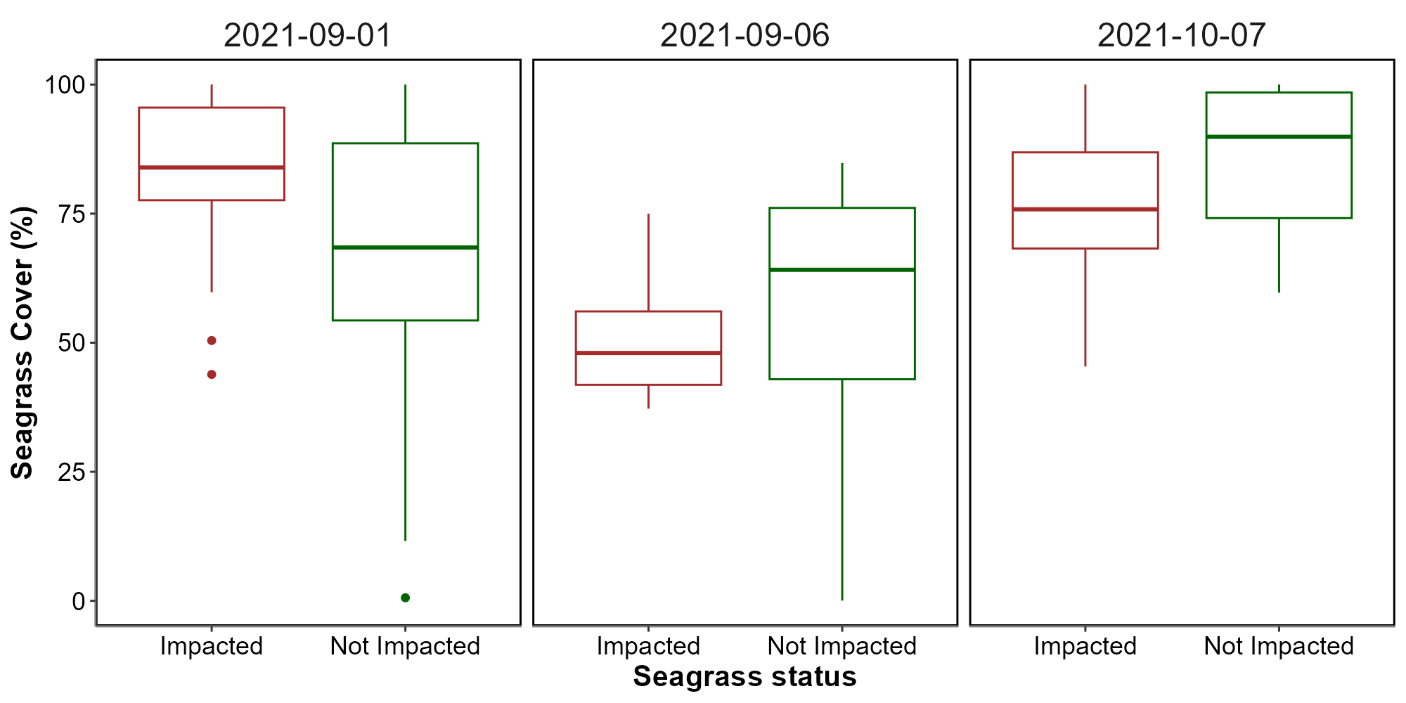
On a physiological level, seagrasses possess coping mechanisms such as photoprotective responses and heat-responsive gene expression, including the activation of heat-shock proteins (HSPs) and other stress-related genes (Hughes and Stachowicz, 2004; Reusch et al., 2005). Zostera noltei, in particular, has shown differential gene expression responses to heat stress, with a variety of genes involved in protein folding, membrane stability, and reactive oxygen species scavenging playing critical roles. However, the rapid pace of climate change raises concerns about whether these adaptations can keep up with the increasing frequency and severity of thermal events (Franssen et al., 2014).
Given the combined pressures of temperature extremes, eutrophication, and other anthropogenic impacts, targeted management strategies are essential for enhancing seagrass resilience (Loarie et al., 2009). Approaches such as reducing local stressors, cultivating heat-tolerant genotypes, and investing in restoration initiatives are vital to supporting these ecosystems in a warming climate. Although challenges remain, the adaptability and potential resilience of certain seagrass species offer hope for their persistence amid accelerating ecological shifts. In particular, regions that can buffer seagrasses from extreme stressors or provide cooler refuges may play a critical role in maintaining these valuable ecosystems in the face of global climate change (Canadell and Jackson, 2021; De Fouw et al., 2022).
Seagrass meadows function as foundational components of coastal ecosystems, sustaining diverse marine communities by providing essential habitats, nursery grounds, and trophic resources for fish, invertebrates, and migratory birds (Zoffoli et al., 2023b). Their dense canopies stabilize sediment and protect shorelines from erosion, an increasingly crucial role as sea levels rise due to climate change (Folmer et al., 2012; Gacia et al., 1999). Recurrent heatwave events, which induce physiological stress like leaf darkening, can severely diminish seagrass density, thereby reducing their effectiveness in sediment stabilization and wave attenuation, ultimately increasing the risk of coastal erosion (Calleja et al., 2007). From a biodiversity perspective, degradation of these meadows disrupts intricate food webs, impacting commercially significant fish and shellfish populations that rely on seagrass for sustenance and refuge. This loss can reduce local fisheries’ productivity and threaten the livelihoods of coastal communities (Unsworth and Cullen-Unsworth, 2014). Furthermore, as seagrasses decline, their capacity to act as a blue carbon sink—critical for climate mitigation—also diminishes, inadvertently contributing to increased atmospheric carbon levels (Armitage and Fourqurean, 2016; Samper-Villarreal et al., 2020)

5. Bibliography
Akbar, M., Arisanto, P., Sukirno, B., Merdeka, P., Priadhi, M., Zallesa, S., 2020. Mangrove vegetation health index analysis by implementing NDVI (normalized difference vegetation index) classification method on sentinel-2 image data case study: Segara anakan, kabupaten cilacap, in: IOP Conference Series: Earth and Environmental Science. IOP Publishing, p. 012069.
Armitage, A., Fourqurean, J.W., 2016. Carbon storage in seagrass soils: Long-term nutrient history exceeds the effects of near-term nutrient enrichment. Biogeosciences 13, 313–321.
Berger, A.C., Berg, P., McGlathery, K.J., Aoki, L.R., Kerns, K., 2024. Eelgrass meadow response to heat stress. II. Impacts of ocean warming and marine heatwaves measured by novel metrics. Marine Ecology Progress Series 736, 47–62. https://doi.org/10.3354/meps14588
Calleja, M.L., Marbà, N., Duarte, C.M., 2007. The relationship between seagrass (posidonia oceanica) decline and sulfide porewater concentration in carbonate sediments. Estuarine, Coastal and Shelf Science 73, 583–588.
Canadell, J.G., Jackson, R.B., 2021. Ecosystem collapse and climate change. Springer.
Cârlan, I., Mihai, B.-A., Nistor, C., Große-Stoltenberg, A., 2020. Identifying urban vegetation stress factors based on open access remote sensing imagery and field observations. Ecological Informatics 55, 101032.
CMEMS, 2024. European north west shelf/iberia biscay irish seas – high resolution ODYSSEA sea surface temperature multi-sensor L3 observations reprocessed, e.u. Copernicus marine service information (CMEMS). Marine data store (MDS). (Accessed on 17-10-2024). https://doi.org/10.48670/moi-00311
Dascaliuc, A., Ralea, T., Cuza, P., 2007. Influence of heat shock on chlorophyll fluorescence of white oak (quercus pubescens willd.) leaves. Photosynthetica 45, 469–471. https://doi.org/10.1007/s11099-007-0084-3
Davies, B.F.R., Oiry, S., Rosa, P., Zoffoli, M.L., Sousa, A.I., Thomas, O.R., Smale, D.A., Austen, M.C., Biermann, L., Attrill, M.J., others, 2024a. A sentinel watching over inter-tidal seagrass phenology across western europe and north africa. Communications Earth & Environment 5, 382. https://doi.org/10.1038/s43247-024-01543-z
Davies, B.F.R., Oiry, S., Rosa, P., Zoffoli, M.L., Sousa, A.I., Thomas, O.R., Smale, D.A., Austen, M.C., Biermann, L., Attrill, M.J., others, 2024b. Intertidal seagrass extent from sentinel-2 time-series show distinct trajectories in western europe. Remote Sensing of Environment 312, 114340. https://doi.org/10.1016/j.rse.2024.114340
De Fouw, J., Rehlmeyer, K., Geest, M. van der, Smolders, A.J., Van Der Heide, T., 2022. Increased temperature reduces the positive effect of sulfide-detoxification mutualism on zostera noltii nutrient uptake and growth. Marine Ecology Progress Series 692, 43–52.
Deguette, A., Barrote, I., Silva, J., 2022. Physiological and morphological effects of a marine heatwave on the seagrass cymodocea nodosa. Scientific Reports 12, 7950.
Devi, R., Gouda, K., Lenka, S., 2024. Intensity duration and frequency of heat wave in different phases of MJO over india. Atmospheric Research 300, 107250.
European Space Agency, 2024b. Sen2Cor: Sentinel-2 atmospheric correction processor.
European Space Agency, 2024a. Copernicus open access hub.
Folmer, E.O., Geest, M. van der, Jansen, E., Olff, H., Michael Anderson, T., Piersma, T., Gils, J.A. van, 2012. Seagrass–sediment feedback: An exploration using a non-recursive structural equation model. Ecosystems 15, 1380–1393.
Franssen, S.U., Gu, J., Winters, G., Huylmans, A.-K., Wienpahl, I., Sparwel, M., Coyer, J.A., Olsen, J.L., Reusch, T.B., Bornberg-Bauer, E., 2014. Genome-wide transcriptomic responses of the seagrasses zostera marina and nanozostera noltii under a simulated heatwave confirm functional types. Marine Genomics 15, 65–73.
Gacia, E., Granata, T., Duarte, C., 1999. An approach to measurement of particle flux and sediment retention within seagrass (posidonia oceanica) meadows. Aquatic Botany 65, 255–268.
Gardner, R.C., Finlayson, C., 2018. Global wetland outlook: State of the world’s wetlands and their services to people, in: Ramsar Convention Secretariat. pp. 2020–5.
Guerrero-Meseguer, L., Marı́n, A., Sanz-Lázaro, C., 2020. Heat wave intensity can vary the cumulative effects of multiple environmental stressors on posidonia oceanica seedlings. Marine Environmental Research 159, 105001.
Hatum, P.S., McMahon, K., Mengersen, K., Kilminster, K., Wu, P.P.-Y., 2024. Predicting seagrass ecosystem resilience to marine heatwave events of variable duration, frequency and re-occurrence patterns with gaps. Aquatic Conservation: Marine and Freshwater Ecosystems 34, e4210. https://doi.org/10.1002/aqc.4210
Hobday, A.J., Alexander, L.V., Perkins, S.E., Smale, D.A., Straub, S.C., Oliver, E.C., Benthuysen, J.A., Burrows, M.T., Donat, M.G., Feng, M., others, 2016. A hierarchical approach to defining marine heatwaves. Progress in oceanography 141, 227–238.
Hobday, A.J., Oliver, E.C., Gupta, A.S., Benthuysen, J.A., Burrows, M.T., Donat, M.G., Holbrook, N.J., Moore, P.J., Thomsen, M.S., Wernberg, T., others, 2018. Categorizing and naming marine heatwaves. Oceanography 31, 162–173.
Huete, A.R., 2012. Vegetation indices, remote sensing and forest monitoring. Geography Compass 6, 513–532.
Hughes, A.R., Stachowicz, J.J., 2004. Genetic diversity enhances the resistance of a seagrass ecosystem to disturbance. Proceedings of the National Academy of Sciences 101, 8998–9002. https://doi.org/10.1073/pnas.0402642101
IOC, 2024. Intergovernmental oceanographic commission ; sea level monitoring station - le conquet, france (LECY).
Jankowska, E., Michel, L.N., Lepoint, G., Włodarska-Kowalczuk, M., 2019. Stabilizing effects of seagrass meadows on coastal water benthic food webs. Journal of Experimental Marine Biology and Ecology 510, 54–63.
Jones, R.B., Clayton-Greene, K.A., 1992. The role of photosynthesis and oxidative reactions in leaf blackening of protea neriifolia r. Br. leaves. Scientia Horticulturae 50, 137–145. https://doi.org/10.1016/S0304-4238(05)80016-0
Kloos, S., Yuan, Y., Castelli, M., Menzel, A., 2021. Agricultural drought detection with MODIS based vegetation health indices in southeast germany. Remote Sensing 13, 3907.
Knipling, E.B., 1970. Physical and physiological basis for the reflectance of visible and near-infrared radiation from vegetation. Remote Sensing of Environment 1, 155–159. https://doi.org/10.1016/S0034-4257(70)80021-9
Loarie, S.R., Duffy, P.B., Hamilton, H., Asner, G.P., Field, C.B., Ackerly, D.D., 2009. The velocity of climate change. Nature 462, 1052–1055.
Louhaichi, M., Borman, M.M., Johnson, D.E., 2001. Spatially located platform and aerial photography for documentation of grazing impacts on wheat. Geocarto International 16, 65–70.
Massa, S., Arnaud-Haond, S., Pearson, G., Serrão, E., 2009. Temperature tolerance and survival of intertidal populations of the seagrass zostera noltii (hornemann) in southern europe (ria formosa, portugal). Hydrobiologia 619, 195–201.
Mazdiyasni, O., Sadegh, M., Chiang, F., AghaKouchak, A., 2019. Heat wave intensity duration frequency curve: A multivariate approach for hazard and attribution analysis. Scientific Reports 9, 14117. https://doi.org/10.1038/s41598-019-50643-w
O’Brien, K.R., Waycott, M., Maxwell, P., Kendrick, G.A., Udy, J.W., Ferguson, A.J., Kilminster, K., Scanes, P., McKenzie, L.J., McMahon, K., others, 2018. Seagrass ecosystem trajectory depends on the relative timescales of resistance, recovery and disturbance. Marine Pollution Bulletin 134, 166–176.
Oliver, E.C.J., Burrows, M.T., Donat, M.G., others, 2019. Projected marine heatwaves in the 21st century and the potential for ecological impact. Frontiers in Marine Science 6, 734. https://doi.org/10.3389/fmars.2019.00734
Pansch, C., Scotti, M., Barboza, F.R., others, 2018. Heat waves and their significance for a temperate benthic community: A near-natural experimental approach. Global Change Biology 24, 4357–4367. https://doi.org/10.1111/gcb.14282
Papathanasopoulou, E., Simis, S., Alikas, K., Ansper, A., Anttila, J., Barillé, A., Barillé, L., Brando, V., Bresciani, M., Bučas, M., others, 2019. Satellite-assisted monitoring of water quality to support the implementation of the water framework directive. EOMORES white paper.
Perkins, S.E., Alexander, L.V., 2013. On the measurement of heat waves. Journal of climate 26, 4500–4517.
Ramesh, C., Mohanraju, R., 2020. Seagrass ecosystems of andaman and nicobar islands: Status and future perspective. Environmental & Earth Sciences Research Journal 7.
Reusch, T.B., Ehlers, A., Hämmerli, A., Worm, B., 2005. Ecosystem recovery after climatic extremes enhanced by genotypic diversity. Proceedings of the National Academy of Sciences 102, 2826–2831. https://doi.org/10.1073/pnas.0500008102
Rouse, J.W., Haas, R.H., Schell, J.A., Deering, D.W., others, 1974. Monitoring vegetation systems in the great plains with ERTS. NASA Spec. Publ 351, 309.
Russo, E., Domeisen, D.I.V., 2023. Increasing intensity of extreme heatwaves: The crucial role of metrics. Geophysical Research Letters 50, e2023GL103540. https://doi.org/10.1029/2023GL103540
Samper-Villarreal, J., Bolaños, R.C., Heidemeyer, M., Vargas, M.M., Vargas, R.M., 2020. Characterization of seagrasses at two new locations in the eastern tropical pacific (el jobo and matapalito, costa rica). Aquatic botany 165, 103237.
Sawall, Y., Ito, M., Pansch, C., 2021. Chronically elevated sea surface temperatures revealed high susceptibility of the eelgrass zostera marina to winter and spring warming. Limnology and Oceanography 66, 4112–4124.
Schlegel, R.W., Oliver, E.C., Wernberg, T., Smit, A.J., 2017. Nearshore and offshore co-occurrence of marine heatwaves and cold-spells. Progress in Oceanography 151, 189–205.
Schlegel, R.W., Smit, A.J., 2018. heatwaveR: A central algorithm for the detection of heatwaves and cold-spells. Journal of Open Source Software 3, 821. https://doi.org/10.21105/joss.00821
Scott, A.L., York, P.H., Duncan, C., Macreadie, P.I., Connolly, R.M., Ellis, M.T., Jarvis, J.C., Jinks, K.I., Marsh, H., Rasheed, M.A., 2018. The role of herbivory in structuring tropical seagrass ecosystem service delivery. Frontiers in Plant Science 9, 127.
Sevgi, K., Leblebici, S., 2022. Bitkilerde ağır metal stresine verilen fizyolojik ve moleküler yanıtlar. Journal of Anatolian Environmental and Animal Sciences 7, 528–536.
Shom, 2022. Service hydrographique et océanographique de la marine ; références altimétriques maritimes: Ports de france métropolitaine et d’outre-mer, cotes du zéro hydrographique et niveaux caractéristiques de la marée. Shom, Brest, France.
SHOM, 2021. Service hydrographique et océanographique de la marine ; bathymétrie Litto3D® bretagne 2018-2021.
Simolo, C., Corti, S., 2022. Quantifying the role of variability in future intensification of heat extremes. Nature Communications 13. https://doi.org/10.1038/s41467-022-35571-0
Simpson, T.S., Wernberg, T., McDonald, J.I., 2016. Distribution and localised effects of the invasive ascidian didemnum perlucidum (monniot 1983) in an urban estuary. PLoS One 11, e0154201.
Smale, D.A., Wernberg, T., Oliver, E.C.J., others, 2019. Marine heatwaves threaten global biodiversity and the provision of ecosystem services. Nature Climate Change 9, 306–312. https://doi.org/10.1038/s41558-019-0412-1
Sousa, A.I., Silva, J.F. da, Azevedo, A., Lillebø, A.I., 2019. Blue carbon stock in zostera noltei meadows at ria de aveiro coastal lagoon (portugal) over a decade. Scientific reports 9, 14387.
Stillman, J.H., 2019. Heat waves, the new normal: Summertime temperature extremes will impact animals, ecosystems, and human communities. Physiology 34, 86–100. https://doi.org/10.1152/physiol.00040.2018
Thomsen, E., Herbeck, L.S., Viana, I.G., Jennerjahn, T.C., 2023. Meadow trophic status regulates the nitrogen filter function of tropical seagrasses in seasonally eutrophic coastal waters. Limnology and Oceanography 68, 1906–1919.
Unsworth, R., Cullen-Unsworth, L.C., 2014. Biodiversity, ecosystem services, and the conservation of seagrass meadows. Coast. Conserv 19, 95.
Unsworth, R.K., Cullen-Unsworth, L.C., Jones, B.L., Lilley, R.J., 2022. The planetary role of seagrass conservation. Science 377, 609–613.
Waycott, M., Duarte, C.M., Carruthers, T.J., Orth, R.J., Dennison, W.C., Olyarnik, S., Calladine, A., Fourqurean, J.W., Heck Jr, K.L., Hughes, A.R., others, 2009. Accelerating loss of seagrasses across the globe threatens coastal ecosystems. Proceedings of the national academy of sciences 106, 12377–12381.
Winters, G., Nelle, P., Fricke, B., Rauch, G., Reusch, T.B., 2011. Effects of a simulated heat wave on photophysiology and gene expression of high-and low-latitude populations of zostera marina. Marine Ecology Progress Series 435, 83–95.
Zoffoli, M.L., Gernez, P., Godet, L., Peters, S., Oiry, S., Barillé, L., 2021. Decadal increase in the ecological status of a north-atlantic intertidal seagrass meadow observed with multi-mission satellite time-series. Ecological Indicators 130, 108033.
Zoffoli, M.L., Gernez, P., Oiry, S., Godet, L., Dalloyau, S., Davies, B.F.R., Barillé, L., 2023b. Remote sensing in seagrass ecology: Coupled dynamics between migratory herbivorous birds and intertidal meadows observed by satellite during four decades. Remote Sensing in Ecology and Conservation 9, 420–433. https://doi.org/10.1002/rse2.319
Zoffoli, M.L., Gernez, P., Oiry, S., Godet, L., Dalloyau, S., Davies, B.F.R., Barillé, L., 2023a. Remote sensing in seagrass ecology: Coupled dynamics between migratory herbivorous birds and intertidal meadows observed by satellite during four decades. Remote Sensing in Ecology and Conservation 9, 420–433.
Zoffoli, M.L., Gernez, P., Rosa, P., Le Bris, A., Brando, V.E., Barillé, A.-L., Harin, N., Peters, S., Poser, K., Spaias, L., others, 2020. Sentinel-2 remote sensing of zostera noltei-dominated intertidal seagrass meadows. Remote Sensing of Environment 251, 112020.

