3.1 Spatio-temporal variability of seaweed production
Across the lagoon, the daily growth rate (DGR) of cultivation plots displayed a marked spatial structure (Figure 4). Higher mean DGR values were generally observed in plots located along the eastern side of the lagoon, closer to the coral barrier, where several plots reached approximately 4 %.day⁻¹. In contrast, plots positioned toward the central channel and the inner lagoon showed consistently lower DGR values, in some cases close to 2 %.day⁻¹. This pattern was visible both at the scale of individual module but also between modules, suggesting that DGR may be influenced by a dominant environmental gradient across the lagoon. Within several modules, DGR also varied among adjacent plots, indicating substantial fine-scale heterogeneity. The main exception to the overall spatial gradient was the northernmost cultivation module, where low DGR values were observed across most plots, irrespective of their relative position within the module.
Cultivation plots were harvested at an average biomass of ca. 2900 kg (Figure 5 A). Depending on plot-specific daily growth rates (DGR), this target biomass was generally reached after 4 to 6 weeks of cultivation. However, there was a large variability of harvested biomass ranging from 1000 to 5000 kg per cultivation plot.
Temporal patterns in DGR differed according to the position of cultivation plots within the lagoon (Figure 5 B). Plots located closest to the reef barrier showed relatively stable DGR throughout the year, with an average of 3.57 %.day⁻¹ in 2025. In these plots, DGR was higher in aOctober, reaching 3.88 %.day⁻¹. In contrast, plots located closest to the channel displayed a stronger seasonal variability. Their maximum DGR was observed in April, when values were comparable to those recorded near the coral reef barrier. However, during the austral summer autumn, and winter, DGR in channel-adjacent plots was significantly lower than in reef-adjacent plots, with values as low as 2.25 %.day⁻¹ in December and January.
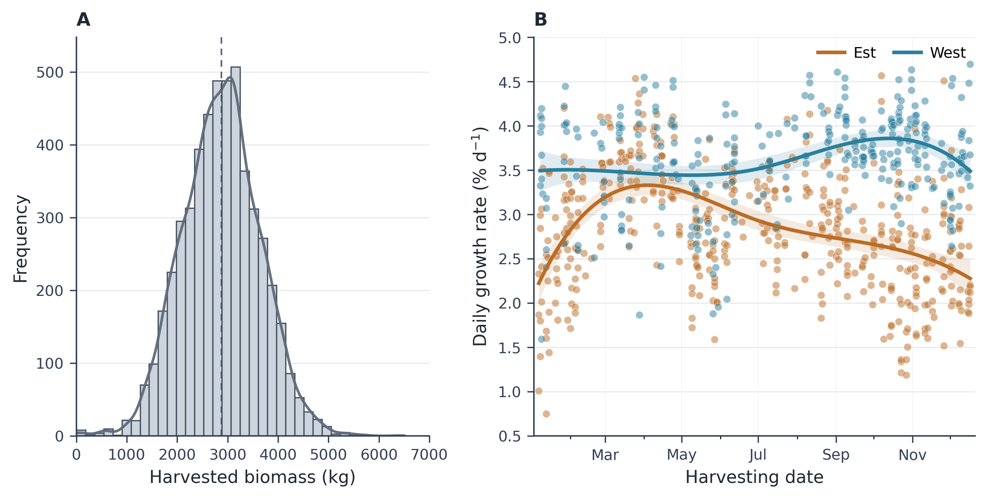
Figure 5: Harvested biomass of cultivation modules in 2025. (A) Frequency distribution of harvested biomass. (B) Seasonal variability of Daily growth rate (DGR) of harvested modules throughout 2025. Colors distinguish Est and West module positions, solid curves show generalized additive model (GAM) trends fitted with cubic regression splines, and shaded envelopes indicate 95% confidence intervals.

3.2 Random Forest Classification
The first step of the MadaKapPy workflow consists of identifying Kappaphycus cultivation lines from the drone imagery provided by the user. This step is based on a Random Forest classifier trained to discriminate Kappaphycus from other image targets using RGB information. Figure 6 illustrates the classification output for a single cultivation plot. The RGB orthomosaic shows that the cultivated seaweed is organized along regularly spaced lines, although individual thalli and line structures are locally heterogeneous in density and optical appearance (@fig-rf-classification-map A). The classification output reproduced this spatial organization, with most cultivation lines correctly assigned to the Kappaphycus class (Figure 6 B). The inset further shows that the classifier was able to detect fine-scale discontinuities within the cultivation lines, corresponding to gaps or lower-density areas visible in the RGB image.
Overall, the Random Forest classification provided a coherent delineation of cultivated Kappaphycus biomass at the plot scale. However, some specific cases highlight the distinction between detecting Kappaphycus pixels and identifying harvestable biomass. During the cultivation cycle, cultivation ropes may break (Figure 6, green arrow), and fragments of Kappaphycus thalli may detach from the ropes and accumulate on the seafloor (Figure 6, blue arrow). In these situations, the classifier can still correctly assign these pixels to the Kappaphycus class, because their spectral and visual characteristics remain similar to attached cultivated thalli. However, detached or stranded material is unlikely to be recovered during harvest. Therefore, although these classifications are not necessarily errors from an image-classification perspective, they may introduce uncertainty when classified Kappaphycus area is subsequently used as a proxy for harvestable biomass.
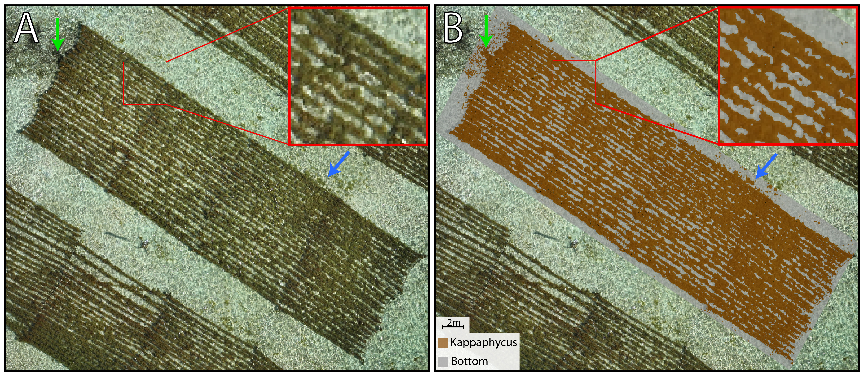
Figure 6: RGB drone orthomosaics (A). Random Forest classification result for a cultivation plot (B). Brown polygons represent pixels classified as Kappaphycus while grey polygons represent bottom pixels.
?? VALIDATION ??

3.3 Biomass estimation

3.4 The MadaKapPy application

4. Bibliography
Breiman, L., 2001. Random forests. Machine Learning 45, 5–32.
FAO, 2024. The state of world fisheries and aquaculture 2024: Blue transformation in action. Food; Agriculture Organization of the United Nations, Rome. https://doi.org/10.4060/cd0683en
Hayashi, L., Reis, R.P., Santos, A.A. dos, Castelar, B., Robledo, D., Vega, G.B. de, Msuya, F.E., Eswaran, K., Yasir, S.Md., Ali, M.K.M., Hurtado, A.Q., 2017. The cultivation of kappaphycus and eucheuma in tropical and sub-tropical waters, in: Hurtado, A.Q., Critchley, A.T., Neish, I.C. (Eds.), Tropical Seaweed Farming: Trends, Problems and Opportunities, Developments in Applied Phycology. Springer International Publishing, Cham, Switzerland, pp. 55–90. https://doi.org/10.1007/978-3-319-63498-2_4
Hurtado, A.Q., Critchley, A.T., Neish, I.C. (Eds.), 2017. Tropical seaweed farming: Trends, problems and opportunities: Focus on kappaphycus and eucheuma of commerce, Developments in applied phycology. Springer International Publishing, Cham, Switzerland. https://doi.org/10.1007/978-3-319-63498-2
Innocentini, M.M., Rodrigues, E.F., Mathion, J.K., Caritá, E.C., Simão, L., Marins, M., 2024. Analysis of multispectral indices as a tool for segmenting and quantifying the seaweed kappaphycus alvarezii in a commercial cultivation system. Biomass 4, 933–946. https://doi.org/10.3390/biomass4030052
Joyce, K.E., Fickas, K.C., Kalamandeen, M., 2023. The unique value proposition for using drones to map coastal ecosystems. Cambridge Prisms: Coastal Futures 1, e6. https://doi.org/10.1017/cft.2022.7
Langford, A., Waldron, S., Saleh, H., others, 2021. Monitoring the COVID-19-affected indonesian seaweed industry using remote sensing data. Marine Policy 127, 104431. https://doi.org/10.1016/j.marpol.2021.104431
Msuya, F.E., Bolton, J., Pascal, F., Narrain, K., Nyonje, B., Cottier-Cook, E.J., 2022. Seaweed farming in africa: Current status and future potential. Journal of Applied Phycology 34, 985–1005. https://doi.org/10.1007/s10811-021-02676-w
Nurdin, N., Alevizos, E., Syamsuddin, R., Asis, H., Zainuddin, E.N., Aris, A., Oiry, S., Brunier, G., Komatsu, T., Barillé, L., 2023. Precision aquaculture drone mapping of the spatial distribution of kappaphycus alvarezii biomass and carrageenan. Remote Sensing 15, 3674. https://doi.org/10.3390/rs15143674
Nurdin, N., Aris, A., AS, M.A., 2025. Seasionality of kappaphycus alvarezii production trends in south sulawesi using UAV monitoring. Remote Sensing Applications: Society and Environment 101659. https://doi.org/10.1016/j.rsase.2025.101659
Oiry, S., Barillé, L., 2021. Using sentinel-2 satellite imagery to develop microphytobenthos-based water quality indices in estuaries. Ecological Indicators 121, 107184. https://doi.org/10.1016/j.ecolind.2020.107184
Oiry, S., Davies, B.F.R., Stiger-Pouvreau, V., Gernez, P., Barillé, L., 2025. Mapping the distribution of the alien invasive gracilaria vermiculophylla at the site of its first european introduction. Journal of Environmental Management 392, 126726. https://doi.org/10.1016/j.jenvman.2025.126726
Román, M., Davies, B.F., Rosa, P., Oiry, S., Gernez, P., Santiago, J.A., Olabarria, C., Barillé, L., 2026. From pixels to peaks: Integrating LiDAR and RGB drone imagery to map mussel spat on intertidal rocky shores. Estuarine, Coastal and Shelf Science 109671. https://doi.org/10.1016/j.ecss.2025.109671
Setyawidati, N., Liabot, P., Perrot, T., Radiarta, N., Deslandes, E., Bourgougnon, N., Rossi, N., Stiger-Pouvreau, V., 2017. In situ variability of carrageenan content and biomass in the cultivated red macroalga kappaphycus alvarezii with an estimation of its carrageenan stock at the scale of the malasoro bay (indonesia) using satellite image processing. Journal of Applied Phycology 29, 2307–2321. https://doi.org/10.1007/s10811-017-1200-9
Urbina-Barreto, I., Alevizos, E., Randrianary, T.M., Museux, M., Randriamaroson, R.A.M., Chauvin, A., Rakotoniaina, S., Jan, S., Barillé, L., Tribollet, A., 2026. Mapping coastal marine habitats with RGB and multispectral UAS imagery to support seaweed aquaculture management and ecosystem conservation. Drones 10, 276. https://doi.org/10.3390/drones10040276
Vadassery, N., Neish, I.C., 2024. Integration of precision technology into adaptive phyconomy systems for extensive tropical red seaweed farming, in: Tropical Phyconomy Coalition Development: Focus on Eucheumatoid Seaweeds. Springer Nature Switzerland, pp. 239–254. https://doi.org/10.1007/978-3-031-47806-2_19
Zhang, J., Langford, Z., Waldron, S., 2023. The global carrageenan industry, in: Globalisation and Livelihood Transformations in the Indonesian Seaweed Industry. Routledge, pp. 23–50. https://doi.org/10.4324/9781003183860-3

